Workings and final answer.

What have we learned?

What other mathematical techniques do we need to apply?

What useful information do we know?

**REMEMBER**! Accuracy and spelling of key words * Appropriate paragraphing and sequencing of information presented * Correct phrasing – capitals, punctuation.

What do we want to find out?

Mathematics Unit 41: Shoes for Kids

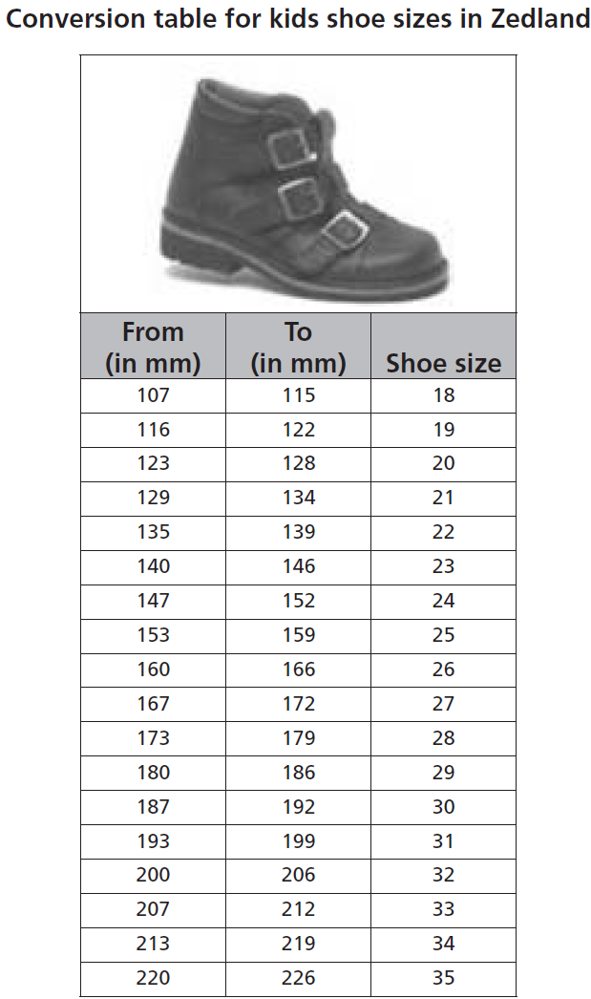

The following table shows  
the recommended Zedland  
shoe sizes corresponding to  
various foot lengths.

**QUESTION 41.1**  
Marina’s feet are 163 mm long.  
Use the table to determine  
which Zedland shoe size  
Marina should try on.