Workings and final answer.

What have we learned?

What other mathematical techniques do we need to apply?

What useful information do we know?

**REMEMBER**! Accuracy and spelling of key words * Appropriate paragraphing and sequencing of information presented * Correct phrasing – capitals, punctuation.

What do we want to find out?

Mathematics Unit 42: Table Tennis Tournament

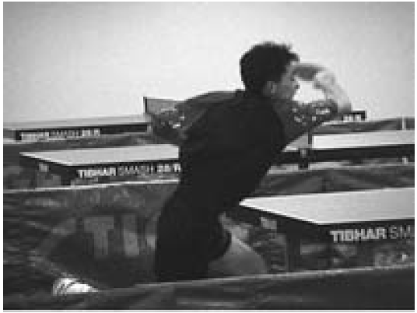  
**QUESTION 42.1**  
Teun, Riek, Bep and Dirk have formed a practice group in a table tennis club. Each player wishes to play against each other player once. They have reserved two practice tables for these matches.

Complete the following match schedule; by writing the names of the players in each match.  
