Workings and final answer.

What have we learned?

What other mathematical techniques do we need to apply?

What useful information do we know?

**REMEMBER**! Accuracy and spelling of key words * Appropriate paragraphing and sequencing of information presented * Correct phrasing – capitals, punctuation.

What do we want to find out?

Mathematics Unit 44: Decreasing CO2 levels

Many scientists fear that the increasing level of CO2 gas in our atmosphere is causing climate change.  
The diagram below shows the CO2 emission levels in 1990 (the light bars) for several countries (or regions), the emission levels in 1998 (the dark bars), and the percentage change in emission levels between 1990 and 1998 (the arrows with percentages).  
 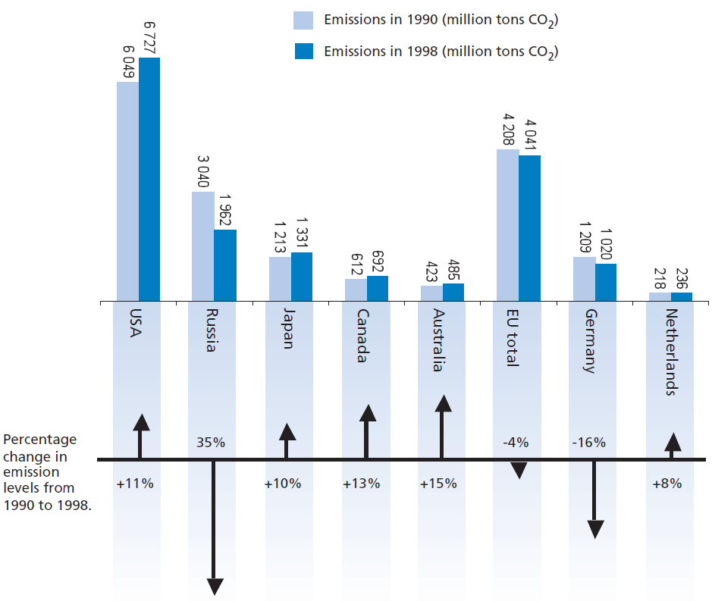

Workings and final answer.

What have we learned?

What other mathematical techniques do we need to apply?

What useful information do we know?

**REMEMBER**! Accuracy and spelling of key words * Appropriate paragraphing and sequencing of information presented * Correct phrasing – capitals, punctuation.

What do we want to find out?

Mathematics Unit 44: Decreasing CO2 levels

  
**QUESTION 44.1**In the diagram you can read that in the USA, the increase in CO2 emission level from 1990 to 1998 was 11%. Show the calculation to demonstrate how the 11% is obtained.

What have we learned?

What other mathematical techniques do we need to apply?

What useful information do we know?

**REMEMBER**! Accuracy and spelling of key words * Appropriate paragraphing and sequencing of information presented * Correct phrasing – capitals, punctuation.

What do we want to find out?

Mathematics Unit 7: Speed of Racing Car

What have we learned?

What other mathematical techniques do we need to apply?

What useful information do we know?

**REMEMBER**! Accuracy and spelling of key words * Appropriate paragraphing and sequencing of information presented * Correct phrasing – capitals, punctuation.

What do we want to find out?

Mathematics Unit 44: Decreasing CO2 levels

**QUESTION 44.2**

Mandy analysed the diagram and claimed she discovered a mistake in the percentage change in emission levels: “The percentage decrease in Germany (16%) is bigger than the percentage decrease in the whole European Union (EU total, 4%). This is not possible, since Germany is part of the EU.”

Do you agree with Mandy when she says this is not possible? Give an explanation to support your answer.

Workings and final answer.

What have we learned?

What other mathematical techniques do we need to apply?

What useful information do we know?

**REMEMBER**! Accuracy and spelling of key words * Appropriate paragraphing and sequencing of information presented * Correct phrasing – capitals, punctuation.

What do we want to find out?

Mathematics Unit 44: Decreasing CO2 levels

Workings and final answer.

**QUESTION 44.2**

Mandy and Niels discussed which country (or region) had the largest *increase* of CO2 emissions. Each came up with a different conclusion based on the diagram.

Give two possible ‘correct’ answers to this question, and explain how you can obtain each of these answers.