Workings and final answer.

What have we learned?

What other mathematical techniques do we need to apply?

What useful information do we know?

**REMEMBER**! Accuracy and spelling of key words * Appropriate paragraphing and sequencing of information presented * Correct phrasing – capitals, punctuation.

What do we want to find out?

Mathematics Unit 45: Twisted Building

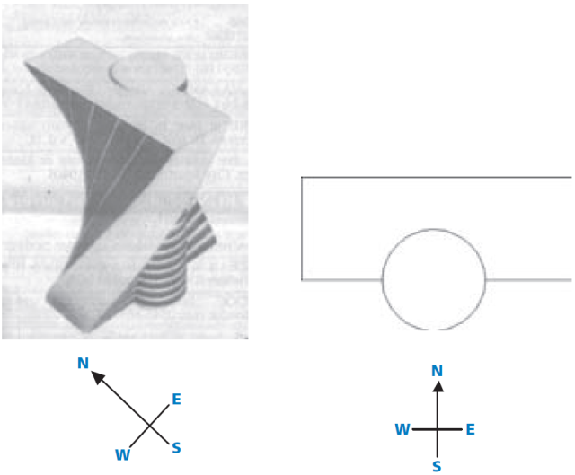

In modern architecture,buildings  
often have unusual shapes. The  
picture here shows a computer  
model of a ‘twisted building’ and  
a plan of the ground floor. The  
compass points show the  
orientation of the building.  
   
The ground floor of the building  
contains the main entrance and  
has room for shops. Above the  
ground floor there are 20 storeys  
containing apartments.

The plan of each storey is similar to the plan of the ground floor, but each has a slightly different orientation from the storey below. The cylinder contains the elevator shaft and a landing on each floor.

**QUESTION 45.1**

Estimate the total height of the building, in metres. Explain how you found your answer.

Workings and final answer.

What have we learned?

What other mathematical techniques do we need to apply?

What useful information do we know?

**REMEMBER**! Accuracy and spelling of key words * Appropriate paragraphing and sequencing of information presented * Correct phrasing – capitals, punctuation.

What do we want to find out?

Mathematics Unit 45: Twisted Building

The following pictures include a sideview of the twisted building.

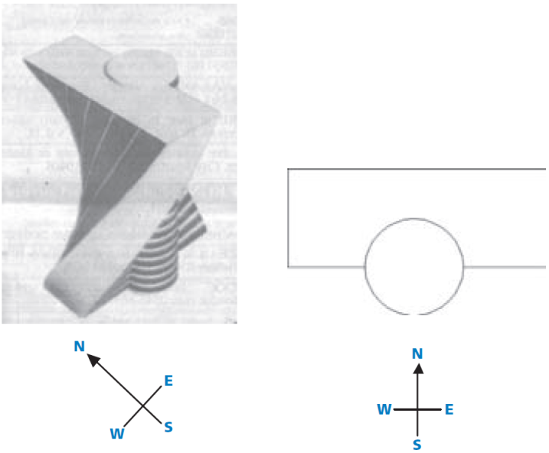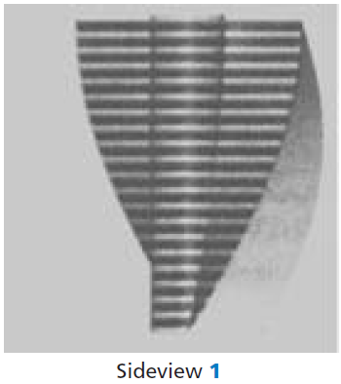  
**QUESTION 45.2**  
From which direction has Sideview 1 been drawn?

1. From the North.
2. From the West.
3. From the East.
4. From the South.

The following pictures include another sideview of the twisted building.

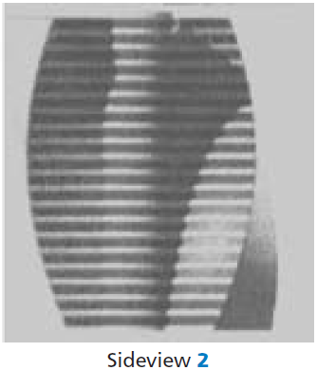  
**QUESTION 45.3**  
From which direction has Sideview 2 been drawn?

1. From the North West.
2. From the North East.
3. From the South West.
4. From the South East.

Workings and final answer.

What have we learned?

What other mathematical techniques do we need to apply?

What useful information do we know?

**REMEMBER**! Accuracy and spelling of key words * Appropriate paragraphing and sequencing of information presented * Correct phrasing – capitals, punctuation.

What do we want to find out?

Mathematics Unit 7: Speed of Racing Car

Workings and final answer.

What have we learned?

What other mathematical techniques do we need to apply?

What useful information do we know?

**REMEMBER**! Accuracy and spelling of key words * Appropriate paragraphing and sequencing of information presented * Correct phrasing – capitals, punctuation.

What do we want to find out?

Mathematics Unit 45: Twisted Building

**QUESTION 45.4**  
Each storey containing  
apartments has a certain  
‘twist’ compared to the  
ground floor. The top floor  
(the 20th floor above the  
ground floor) is at right  
angles to the ground floor.

The drawing below represents  
the ground floor.

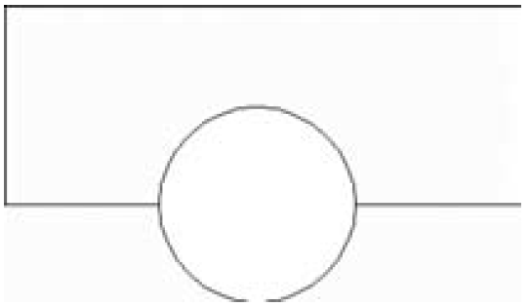

Draw in this diagram the plan of the 10th floor above the ground floor, showing how this floor is situated compared to the ground floor.

Workings and final answer.

What have we learned?

What other mathematical techniques do we need to apply?

What useful information do we know?

**REMEMBER**! Accuracy and spelling of key words * Appropriate paragraphing and sequencing of information presented * Correct phrasing – capitals, punctuation.

What do we want to find out?

Mathematics Unit 45: Twisted Building

