Workings and final answer.

What have we learned?

What other mathematical techniques do we need to apply?

What useful information do we know?

**REMEMBER**! Accuracy and spelling of key words * Appropriate paragraphing and sequencing of information presented * Correct phrasing – capitals, punctuation.

What do we want to find out?

Mathematics Unit 50: Postal Charges

The postal charges in Zedland are based on the weight of the items (to the nearest gram), as shown in the table below:  
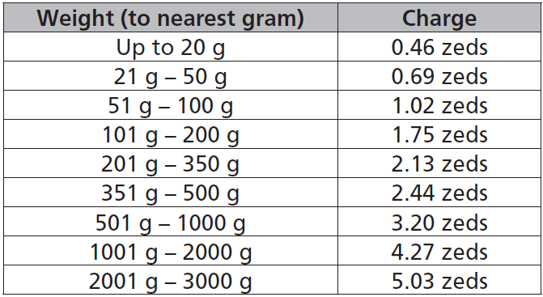  
**QUESTION 50.1**  
Which one of the following graphs is the best representation of the postal charges in Zedland? (The horizontal axis shows the weight in grams, and the vertical axis shows the charge in zeds.)  
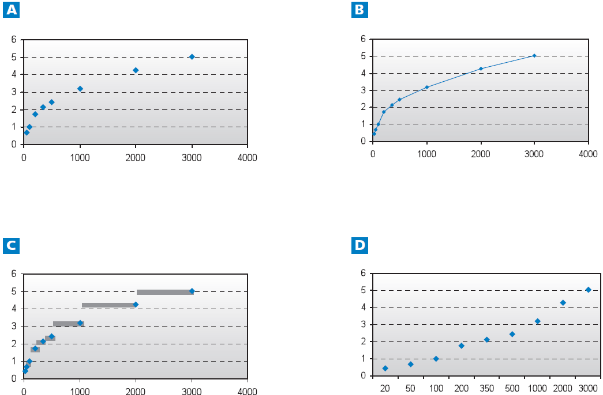

The postal charges in Zedland are based on the weight of the items (to the nearest gram), as shown in the table below:  


**QUESTION 50.2**  
Jan wants to send two items, weighing 40 grams and 80 grams respectively, to a friend.  
According to the postal charges in Zedland, decide whether it is cheaper to send the two items as one parcel, or send the items as two separate parcels. Show your calculations of the cost in each case.

Workings and final answer.

What have we learned?

What other mathematical techniques do we need to apply?

What useful information do we know?

**REMEMBER**! Accuracy and spelling of key words * Appropriate paragraphing and sequencing of information presented * Correct phrasing – capitals, punctuation.

What do we want to find out?

Mathematics Unit 50: Postal Charges