




 Calculating The Estimate of the Mean
Suggested year group | Year 10/11 Intermediate/Higher tier
Suggested time scale | 1 hour
Learning objectives | - Investigate methods for finding the mean of ungrouped data and grouped data in a frequency table.  - Develop problem solving skills.
Learning outcomes | Learners will be able to correctly work out the mean of ungrouped data from a frequency table and find the estimated mean of grouped data.
Prior knowledge | Calculate the mean of raw data.

PPT Slide | Teacher Activity | Learner Activity
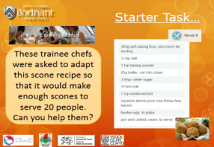  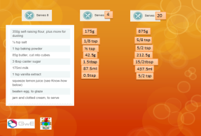 | Use the starter task to settle learners and to provide a practice and review of ratio in a real life scenario.  Facilitate discussion regarding the learner’s strategies.  Encourage learners to reflect upon their answers. Ask questions such as:  ‘Are there any problems with these answers?’ | Learners to attempt the starter individually, using a calculator.  Contribute to whole class discussion about strategies used to answer the question.  Think about answers in the context of the problem. Round answers to make them sensible in real life.
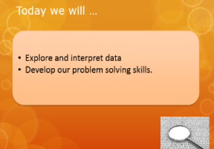 | Share learning objectives.  Ask questions like:  Why we are exploring data rather than me telling you what to do?  How does this help you?  Why is it important for YOU to think? | Consider the questions.  Respond to the questions and listen to others views.
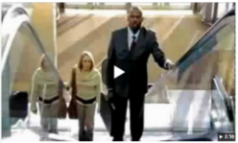 | Play the ‘Stuck on an escalator’ video clip  Ask questions like:  Why is this funny or frustrating?  How can we link this to our learning?  Try to encourage learners to think about finding the problems and turning them into solutions. One learner suggested they had not used their prior knowledge to help them – they had forgotten that they knew how to walk!  Discuss that when we give up, we are like these people! | Watch the video clip.  Whole class discussion about how this video clip can relate to our learning.
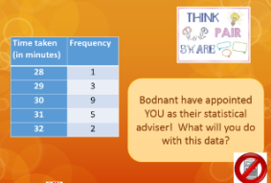  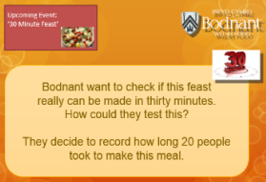 | Set the scene -  Give learners the role of Statistical Adviser for Bodnant. Set the problem of finding the mean from an ungrouped set of data.  NOTE: the data has been chosen so that it can be listed if learners need to take it back to their prior knowledge of finding the mean. Appropriate numbers have been chosen so that no calculators are required. | Learners decide how to use the data and attempt to find the mean.  Think, pair and share their solutions.
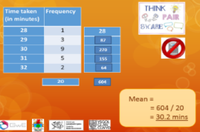 | Encourage learners to take charge of discussion – teacher acts as facilitator.  Use answers on the slide to assist with explanations if needed. | Whole class discussion to review and evaluate findings.
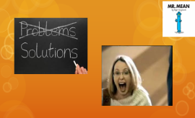  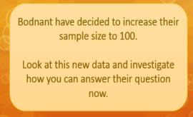  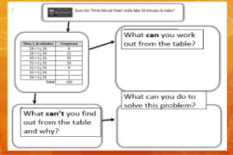 | Present updated problem and data.  Questions to ask:  ‘Why would Bodnant increase their sample size?’  ‘What is different about the new data?’  Encourage learners to think about how they may approach this question now that the layout of the data has changed.  On the PPT the last question has purposely been placed outside the solution box as a hint to think outside the box at this point. Discuss this fact with the learners before they start their investigations.  Teacher to facilitate and aid discussion but NOT tell learners what to do.  Remind learners of the escalator clip! | Consider the reasons for an increased sample size and how the format of the data has changed.  Learners to work in groups on the problem solving sheet to work out how to find an estimate of the mean.  Learners should use skills discussed earlier:  - Identify the problem and use that as a starting point  - Apply prior knowledge  - Don’t be like the people stuck on the escalator!
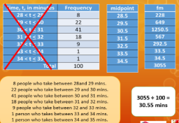 | Facilitate class discussion regarding group work methods and solutions.  Learners can use this slide to help them explain their thoughts. | Explain methods and evaluate findings.  Learners can use this slide to help them explain their thoughts.
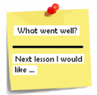  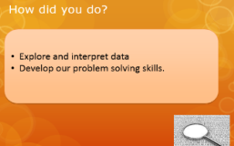 | Reflect upon the learning objectives.  Hand out Post-It notes for review questions. | Reflect upon whether objectives have been met or not.  Evaluate by answering the questions on a Post It note.

Resources:
Starter Task Think, pair, share task Investigation Task
Calculators Post It Notes

