THE GARDEN LESSON

Suggested year group | Year 11 Higher Tier
Suggested time scale | 1 hour
Learning objectives | Develop ability to answer challenging questions.
Learning outcomes | Learners will be able to identify relevant methods and correctly apply them in context.
Prior knowledge | - Calculating the length of an arc.  - Sine rule.

PPT Slide | Teacher Activity | Learner Activity
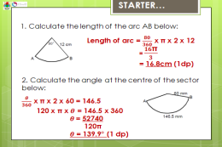 | Display starter on the board for immediate engagement.  This is a re-cap of a topic previously covered which also provides a useful hint to some of the work required during the lesson.  Answers (with workings) on PPT for a swift review of the topic. | Learners to complete the starter task independently, using a calculator.  Learners to check their answers and inform the teacher if they are not getting the correct answers. This is important as this understanding is required later during the lesson.
 | Play the video clip from ‘Indiana Jones & The Last Crusade’  Purpose: to illustrate the concept of having a go, even when unsure.  Possible questions to ask after the clip:  ‘Why am I showing you this clip?’  ‘What could have happened to Indie?’  ‘What could happen to you if you try something in Maths that you are unsure of?’  ‘What analogy can be placed on the part of the clip when Indie throws the sand? | Learners are to watch the video clip.  Contribute towards a whole class discussion to identify the purpose of playing the video clip.
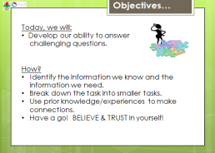 | Share learning objectives and ask learners ‘What things do we need to be able to do to achieve this?’  Facilitate whole class discussion about how to achieve the objective. Use bullet points on slide to help summarise/prompt if needed. | Learners are to think independently about how they can achieve this objective.  Share thoughts with the class and listen to others’ thoughts about achieving the objective.
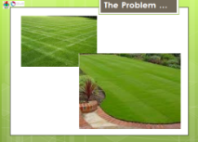  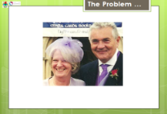 | Introduce the problem:  Explain that parents are the problem!  Tell the class that your parents want to formalise their garden and have a brick border to their lawn. | Learners are to listen to the explanation of the problem and consider possible approaches.
 | Lead the discussion about how the problem would be straight forward if the garden was shaped like a rectangle and a semi- circle.  Set a ‘think, pair, share’ activity to find out what information is needed. | Think about how the shape is more complex than a rectangle and a semi-circle.  ‘Think, pair, share’ to decide what information is needed to begin solving the problem.
 | Give the learners these pieces of information and tell them that their task is to find the cost of the brick border.  If they haven’t already spotted this, explain that some details are missing and that the missing information will only be given out if the learners ask the appropriate questions.  Place the 4 clues in envelopes on each table. If the learners require them, they may open one or more of them. These must be opened in order, 1 to 4.  If learners ask the size or cost of a brick, they may be given the relevant information card. | Consider the question ‘How much will it cost?’  Learners are to try to work out the cost of the brick border by:  - Identifying the information they know and the information they need. (They are to ask for the missing information from the teacher).  - Breaking down the task into smaller tasks.  - Using prior knowledge/experiences to make connections.  - Having a go! BELIEVING & TRUSTING in themselves!  They may open one or more of the clue cards on the desk to help with their methods. These must be opened in order, 1 to 4.
 | Give pupils worked solutions to assess their work (blank slide for working to be written on the board if required). | Learners are to self asses their work and reflect upon the strategies used.  EXTENSION QUESTIONS –  Learner’s to think about where marks might be given in an exam and how this task could be more cost effective?
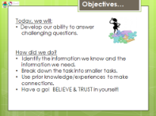 | Review objectives as a whole class. | Reflect upon whether their work today meets the objective of the lesson.
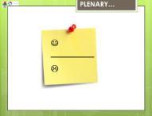 | Hand out Post-It notes for plenary. | On Post-It note, write one like and one dislike of the lesson today.
 | Hand out homework task – taken from WJEC Additional Maths paper 2 June 2010. Remind learners to use their problem solving skills to answer this question. | Record homework in planner.
Resources:
4 x Clue cards in envelopes for each group. 2 x Information cards for each group.
Homework task
Calculators.

