Cwestiwn/Question
TGAU/GCSE

5 marc/mark x 2 PEAS
8 marc/mark x 3 PEAS
15 marc/mark x 4 PEAS
+ Casgliad /Conclusion

Pwy neu beth ddywedodd hyn?
S
Source of
Wisdom

Who or what said this?

Pwy neu beth ddywedodd hyn?

S
Source of
Wisdom
Who or what said this?

Sut mae hyn yn effeithio pobl?

Action
A

How does this affect people?

Esboniwch y farn yma

Explain
E

Explain this viewpoint

Pwynt neu farn crediniwr

Point
P

A believers opinion or argument

Sut mae hyn yn effeithio pobl?
A
Action

How does this affect people?

Pwy neu beth ddywedodd hyn?

S
Source of
Wisdom
Who or what said this?

Pwynt neu farn crediniwr
P
Point

A believers opinion or argument

Pwy neu beth ddywedodd hyn?

S
Source of
Wisdom
Who or what said this?

Esboniwch y farn yma
E
Explain

Explain this viewpoint

Pwy neu beth ddywedodd hyn?
S
Source of
Wisdom

Who or what said this?

Pwy neu beth ddywedodd hyn?
S
Source of
Wisdom

Who or what said this?

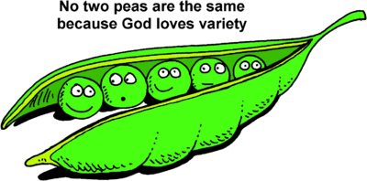

S

A

E

P

P

