ENW:

DYDDIAD:

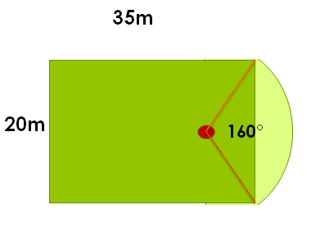

How much will it cost to put a brick border around this garden?

