Geography Conceptual Fieldwork (Flows and Cycles)
2016-2018
An Investigation into the Flow of Traffic Between Anglesey and Bangor
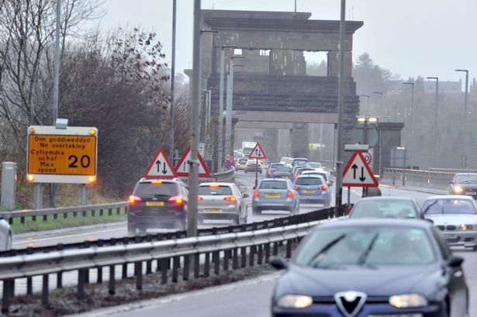

- You need to complete an investigation that will help you practise your geographical enquiry skills.
- All your work will be kept in your fieldwork portfolio.
- Questions will be set on the fieldwork and these are worth 20% of your GCSE.
- You may include up to 5 tasks from your portfolio as evidence when answering these questions therefore they must be correct and neat.
- The teacher can’t help you and you must not work in groups or pairs (apart from when collecting data).
- The tasks below will help you to complete the investigation.

Task 1: Choosing Aims
Choose two or three questions that will lead your investigation. These must be relevant to your theme of the flow of traffic and you must be able to collect data to answer them. Here are some ideas:
- Traffic at different times of the day
- Traffic different days of the week
- Reasons why traffic flows between Anglesey and Bangor
- Solutions to the problems caused by the flow of traffic

Task 2: Hypothesis
What do you expect to find as answers to these questions? Write a paragraph for each aim to guess what the answer will be. You must explain why you predict this for each aim.

Task 3: Secondary Data
Some secondary data has been provided for you from the North Wales Trunk Roads Agency. This data shows traffic flow in both directions at different locations on the 1st of February 2017 and the 4th of February 2017. You will need to collect more secondary information. Find relevant articles online and keep a list of the websites you use. These things could be useful:
- Maps of the area
- Census / population data
- Photographs of traffic congestion
- Articles
How reliable is this secondary data?

Task 4: Primary Data
In groups, design a questionnaire to collect local people’s opinions on the flow of traffic between Anglesey and Bangor. The questions need to be relevant to your aims. The results will help you to answer your aims in your conclusion.
Choose the most appropriate sampling technique for your questionnaire.

Task 5: Presenting Data
Draw a variety of graphs to show your results. You will need to graph the primary data results (questionnaires) and the secondary data (traffic data). Your choice is what sort of graphs to draw but it’s important to include a variety. If you have any maps or photographs, they should be annotated.

Task 6: Analyse and Interpret Trends and Patterns (what do your results tell you?)
For each graph, you should write a paragraph to describe and explain the patterns shown in them. You can do this by annotating your graphs as well, but the annotations must be detailed.

Task 7: Conclusion
What do your results tell you are the answers to your aims? You need to answer each one in a paragraph using your data to support and refer back to your hypothesis noting if your predictions were correct or not.

Task 8: Evaluation
Discuss the strengths and limitations of your investigation. How accurate are your results and what can you do to improve them? Was your investigation bias-free? Remember to discuss the reliability of your primary and secondary research.

