V ocabulary | Drought, unreliable rainfall, over grazing, soil erosion,  Over population, fragile ecosystem, climate, expanding, semi-arid.
C onnectives | …. So that… consequently… therefore….this means… because… resulting in…..
O peners | There are a number of factors…………  As a consequence the land…….  The effect of ………. has lead to……..  Farmers and cattle herders find that they have to……  The savanna has a…….
P unctuation | 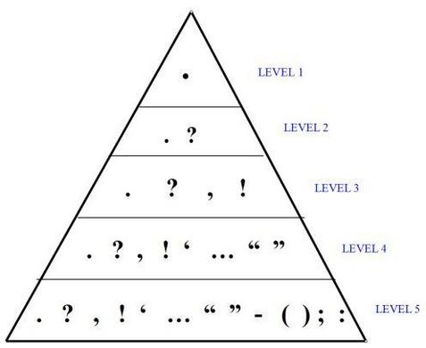

V ocabulary | Drought, unreliable rainfall, over grazing, soil erosion,  Over population, fragile ecosystem, climate, expanding, semi-arid.
C onnectives | …. So that… consequently… therefore….this means… because… resulting in…..
O peners | There are a number of factors…………  As a consequence the land…….  The effect of ………. has lead to……..  Farmers and cattle herders find that they have to……  The savanna has a…….
P unctuation

