What is the Kippah? | What is the Tallit?
What is the Tefillin? | Should women be allowed to wear these?
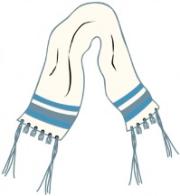
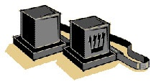
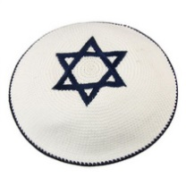
WHAT DO JEWS WEAR DURING WORSHIP?

