WHAT THE JEWS WEAR WHEN THEY WORSHIP?
Many Jews believe that they have a duty to wear certain items for worship. Within Judaism attitudes vary as to when these items should be worn, and by whom.
KIPPAH (PLURAL KIPPOT)
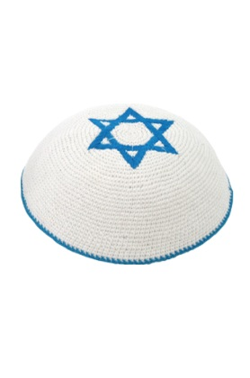
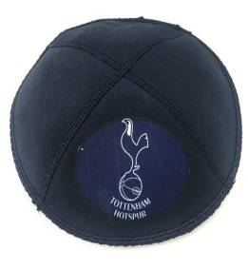
Jews wear the Kippah to show respect to God. It is also a way to show that there is always something between them and God. For many Jews, the Kippah has become a symbol of identity. Some Jews wear the Kippah all the time, other Jews only wear it for worship.

TALLIT-
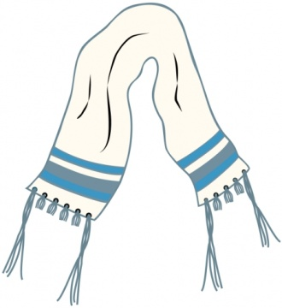
This is an item of clothing which Jews wear to pray. It has four corners will tassels (tzizit) on the four corners. The tzizit remind the Jews of the rule in Numeri 15:37-41 where Jews are commanded to wear tassels on the edges of their clothes. The tzizit remind the Jews of the 613 rules which Jews must observe.

There are two different types of Tallit:
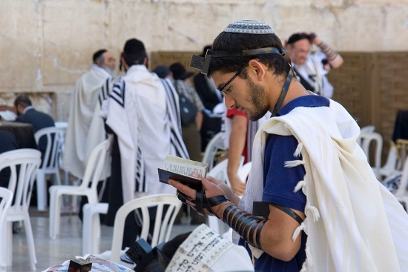
The Tallit Gadol (large) – a shawl made from silk or wool. It is worn over the back and arms. It is often called a prayer shawl as it is only worn for prayers. After death the body is often wrapped in the tallit. Sometimes it is placed over the head to show that God is everywhere.
.
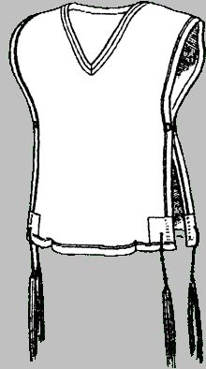
Tallit Katkan (small)-
Many strict male Jews wear the tallit katkan under their clothes every day. It has a hole in the middle which goes over the head and it covers the front and back of the body, with the tzizit hanging from the sides.

TEFILLIN.
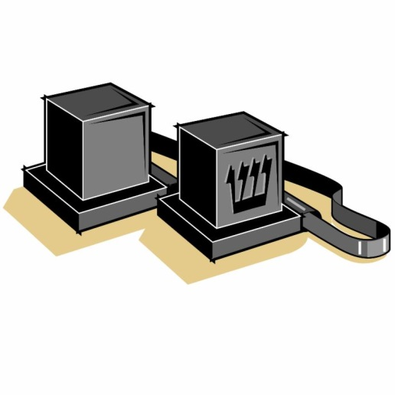
The tefillin is worn by male Orthodox Jews during morning prayers, every day apart from Shabbat and during festivals. The Tefillin is made from two leather boxes. The Tefillah shel rosh is tied to the forehead with a strap. In each corner there is a scroll which has been written by hand and includes the two first paragraphs of the Shema. The Tefillah shel rosh reminds Jews that they should serve God with their thoughts and develop good thoughts. The second box is called the Tefillah shel yad. It is tied on top of the arm and points towards the heart. Inside is has one piece where a scroll is kept with the same paragraph of the shema. This reminds Jews that they should serve God with their hearts through acts of compassion.
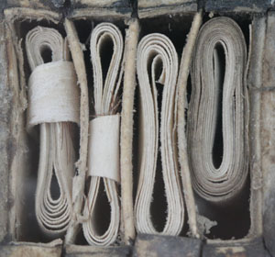
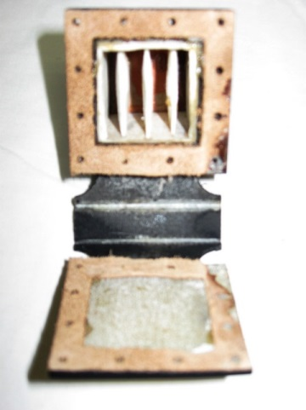
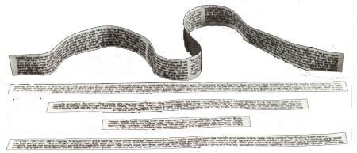

When the tefillin is put in place a prayer is said:

‘Blessed are your Lord our God, King of the universe, who has sanctified us with His commandments to put on tefillin’
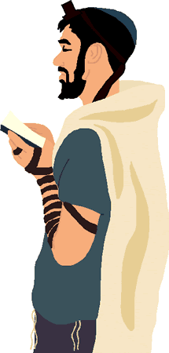

Today, more and more women wish to wear the tefillin and tallit for worship. This has lead to a number of different opinions from different Jews:

X
Mishna says that women do not need to wear the tefillin:  ‘Women, slaves and minors are exempt from recitation of Shema and from Tefillin, but are obligated for the Amidah prayer, mezuzah, and grace after meals.’ Berakhot 3.3 | There is an example of a girl wearing the tefillin in the Talmud;  ‘Mikhal the daughter of King Saul used to wear the Tefillin, and the sages did not protest.’ Eruvin 96a
Men and women are prohibited from wearing each others clothes. The Tefillin is for men and therefore women should not wear them. | Women should be allowed to do whatever men are allowed to.
By wearing the tallit and teffilin women are drawing attention to themselves and this goes against Jewish teaching. | In the Torah in Numeri 15:38-39 it does not say that only men shall wear the tallit.
 | Maimoides has said that is fine for women to ear the tzizit but only to say the blessing

