WHAT DO THE JEWS BELIEVE ABOUT GOD?

A central belief in Judaism is that there is only One God (Monotheism). They also believe that this One God is Omniscient, Omnipotent, Omnibenevolent and Omipresent.
ONE GOD
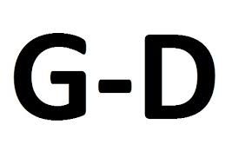
Jews show so much respect to God that some strict Jews use the word Hashem or write the word G-d instead of ‘God’ in order to show their respect. Maimonides said that there is no language to describe how unique God is. In the 12th century, Rabbi InJudah ha-Levi also said that human being cannot understand God when he said, ‘If I understood him, I would be him’. Rabbi Akiba also said that God’s unique nature is shown as he knows the mind and character of every person.

Judaism is a religion which believes in One God/Monotheism. The first sentence of the Shema says that Jews should worship One God.

‘Hear, Oh Israel: the Lord our God, the Lord is One.’ (Deut 6:4).

Judaism does not permit any images of picture of people e.g. in synagogues or stained glass windows as they believe that only God should be worshipped.

⁴ You shall not make for yourself an image in the
form of anything in heaven above or on the earth beneath, or in the waters below.⁵ You shall not bow down to them or worship them’ (Exodus 20:4-5)

Although Monotheism is a central belief in Judaism, Jews believe the God as different natures to his character and so they use different titles for God when they describe him:

GOD AS CREATOR

The Torah tells us that God created the world :

'In the beginning God created the heaven and earth’ (Genesis 1:1)

It goes on to describe how God created day and night, the world, flowers and all the animals.

‘And God said, “Let there be light!” and there was light. ⁴ God saw that the light was good and he separated the light from the darkness. ⁵God called the light ‛day‛, and the darkness he called ‛night‛, and there was evening and there was morning, the first day.’ (Genesis 1:3-5)

He continues to create different things each day, until on the sixth day he creates human beings and gives them special responsibilities, namely to look after his creation (be good stewards):
^{“26} Then God said, “Let us make mankind in our image, in our likeness; so that they may rule over the fish in the sea and the birds in the sky, over the livestock and all the wild animals, and over all the creatures that move along the ground.”
²⁷ So God created mankind in his own image,
in the image of God he created them,
male and female he created them.
²⁸ God blessed them and said to them, “Be fruitful and increase in number; fill the earth and subdue it. Rule over the fish in the sea, and the birds in the sky and over every living creature that moves on the ground.”

Some Jews believe that everything which has been written in the story of the creation is true and that God literally created the world in 6 days. While other Jews believe that the details are examples of what could have happened, and that they are not to be taken literally. To them, what is important is that God is responsible for creating everything on the earth.
For many Jews the world is too complex and beautiful to have been created by accident, so it must have had a creator.

AS LAWGIVER
The Jews believe that God laws and rules to Moses which all Jews must observe. These are recorded in the Torah. The 10 Commandments which God gave Moses on Mount Sinai are the framework which every fair society should follow. Jews believe that God judges every Jew on how he observes the laws. By keeping to the laws Jews are doing what God wants them to do and also they develop a closer relationship with God. Jews have 613 Mitzvot which they must abide by. There are 248 positive Mitzvot, which are rules that every Jew is expected to observe and there are 365 negative Mitzvot which are things which Jews are not supposed to do.
God expects man to observe these commandments by showing discipline in life. Jews also, by trying to abide by these rules are showing their desire to communicate with God and they regard every act as a way of serving God. The Mitzvot deal with worship, observing festivals and subjects such as divorce and food. By abiding by the Mitzvot therefore, Jews are worshipping God. Judaism teaches that every Jew should live, or try to live, a good life, as God is good, but it also teaches that there is evil in the world and that man has the ability to perform evil.
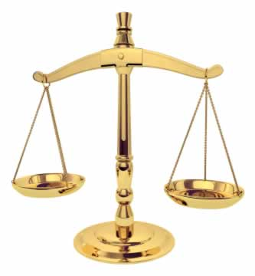
AS JUDGE
Judaism teaches that God is the God of justice and is a Compassionate God who will judge every person. Although people will not always understand God’s ways, the things which God does will always be fair. In Judaism God does not enjoy judging people wrongly so every judgement is made justly.

‘For you are not a God who is pleased with wickedness;’ (Psalm 5:4)

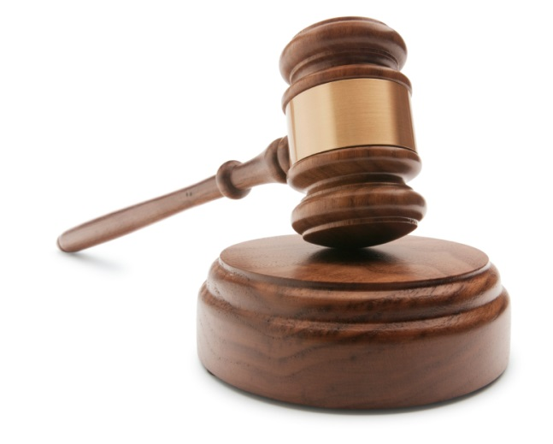
The festival of Rosh Hashanah celebrates the creation of the world and God will judge everyone during this festival. The Talmud describes God coming with scales to weigh the Mizvot in every person. He will put their good deeds on one side and their bad deeds on the other.
As God is a just God, the Jews have 10 days between Rosh Hashanah and another festival called Yom Kippur (Day of Atonement). During these 10 days the Jews have a change to apologise for the bad things which they have done and ask for forgiveness. It is impossible to repent after death so this period gives humans the chance to repent for their bad deeds.

OMNIPRESENT

SHEKHINAH- Where God’s presence rests and it is possible to feel it
The term Shekhinah is used to describe God’s presence in the world. There are different opinions regarding where the Shekhinah rests after the Temple is destroyed. Some believe that it followed the Jews in the Exodus, but others believe that it did not leave the Temple in Jerusalem- that is why Israel is so important to the Jews.

