WHY IS THE HOME IMPORTANT AS A PLACE OF WORSHIP FOR JEWS
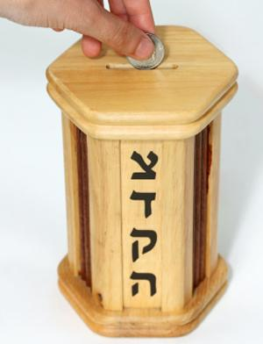
Many Jews believe that the home is very important. It is a place where Jewish values and creeds are taught and reinforced.
The home is also a place where Jewish values are taught to the next generation, as parents pass on the traditions to their children as a way of ensuring that the religion continues. One example of this is the PUSHKE box which is found in most Jewish homes. In this box money is collected toward charities. In Judaism giving to charities is regarded as an act which ensures justice or Tzedakah. It is not regarded as an act of charity.
The home is also a place to worship and pray, which are important aspect of everyday life. Many Orthodox Jews thank God when they wake up, by reciting the Modeh ani while they are still in bed. They also recite the Shema, the Jewish confession of faith 3 times a day.

MEZUZAH
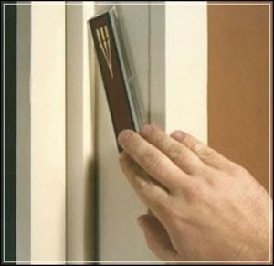
Many Jewish families have the Mezuzah on the right-hand door post, as well as on the door posts inside the house, apart from on the door of the toilet. The Mezuzah should be placed on the post at an angle, with the largest part pointing towards the house and the bottom pointing towards the outside. Jews will often touch the box as they pass the door and will then kiss their fingers to remind them that they should live according to the words of the Shema. For many Jews the Mezuzah is a symbol that God is protecting the house.
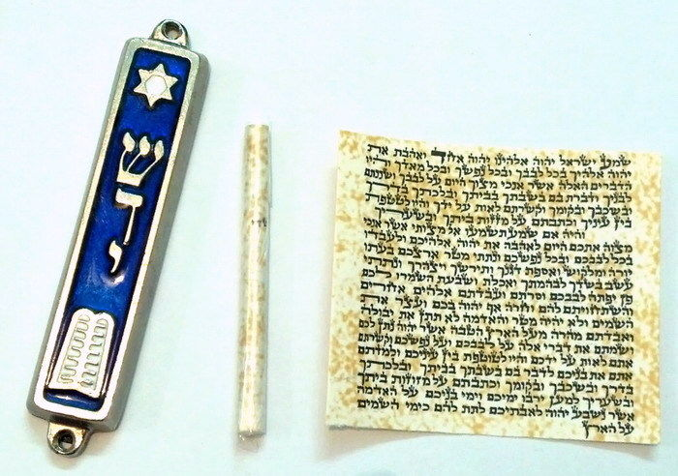
The Mezuzah is a scroll which is placed in a box. The Shema is written on the scroll. The scroll has been prepared and written by a scribe, called a Sofer. The scroll must be made from the skin of a Kosher animal such as a cow, sheep or goat. Usually the word Shaddai is written on the back of the scroll. This means ‘Almighty’ -one of the names given to God.

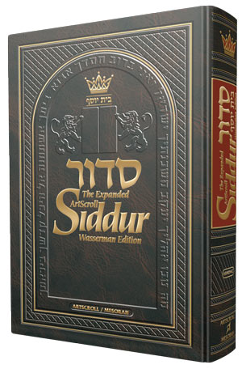
The Siddur is an important part of Judaism which leads Jews through their daily prayers at home and in the synagogue. It is a Prayer Book. It begins with the Modeh ani and includes prayers for daily services, the Shabbat and other festivals. The Siddur is seen as a gift to God. It is regarded as holy and if it is dropped on the floor by mistake, it is lifted at once and kissed.

HOW DO THE JEWS WORSHIP GOD?
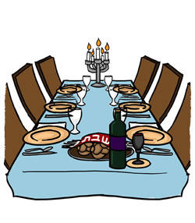
SHABBAT – the Jewish day of worship.

Shabbat is celebrated from sunset on Friday evening to sunset on Saturday evening.

HOW DO JEWS PREPARE FOR THE SHABBAT?
Jews regard Shabbat as a special visitor to their home, so they prepare as though there is a visitor coming to their home. They will clean the house, wash and wear clean clothes as they see the Shabbat as a visitor.
Jews will also prepare food so that they do not have to work on the Shabbat.

The set electrical items in the house on automatic timers so that they have light and heating without having to light a spark. Jews are not permitted to do any work on the Shabbat, and they regard lighting a spark as work.

PREPARING FOR THE SHABBAT
Jews are not permitted to do any work on the Shabbat. So Friday afternoon is a very busy time as all the preparations must be made for the Shabbat. The father will come home from work early, and the children from school. They clean the house and prepare food for the following day. As lighting radiators involves making a spark, which is not permitted on the Shabbat, they will set automatic timers around the house.

As they regard Shabbat as a visitor to the home, after preparing the food and cleaning the house they will take a shower and wear clean/best clothes.
WELCOMING THE SHABBAT
Before the evening, the father and son will go to the synagogue to welcome the Shabbat. The mother and daughter will stay at home.
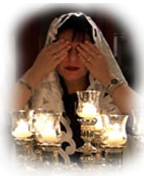
It is the mother’s responsibility to welcome the Shabbat to the home. She will do this by lighting a few candles before sunset on Friday evening to show that Shabbat has begun. She will also wave her arms around the candles. This is called a gesture.

She will say a blessing and cover her eyes. This is a very special moment in the Jewish home as this signifies the beginning of Shabbat.

No other work is permitted once the candles have been lit.

In the synagogue the father and son welcome Shabbat. The regard this as a visitor or bride meeting her bridegroom, the Jewish people. At the end of the service the Rabbi (Jewish teacher) will drink a cup of wine and recite the Kiddush. Kiddush is the blessing to thank God for Shabbat. As they leave the synagogue they will wish each other ‘Shabbat Shalom’, which means a peaceful Shabbat.

NO WORK!
Once Shabbat starts Jews are not allowed to do any form of work. But what constitutes work? The Torah notes 39 Melachah (work) which are not permitted on Shabbat. They are the 39 types of work which were needed to build the temple, the portable temple which the Israelis built in the desert. The Talmud has added to these as times have changed since the days of Moses.
- Here are some of the things which are not permitted on Shabbat,
- Igniting a spark e.g. starting a car
- Making someone else work
- Using a phone - unless it is an emergency.
- Watching television
- Listening to the radio
- Making food and washing dishes – they will keep food which has been prepared on Friday afternoon on a ‘hot plate’.

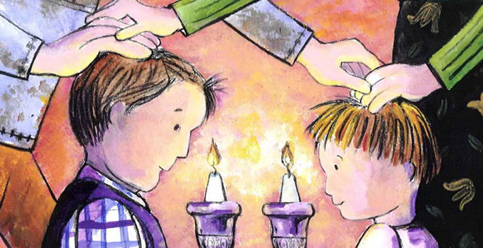
FRIDAY EVENING CELEBRATIONS
After the service the father will bless the children.

He will recite the Kiddush. Then they will wash their hands as a sign of purification. They will sit around the table ready for the shabat feast.

Here are some important items on the table at shabbat:
Two loaves of bread.
These are called Manna or challot/challah. They represent the miraculous bread which God gave them on their day home from Egypt to Israel. God gave them one loaf every day except for Friday morning. He gave them two loaves on that day as he was resting on Shabbat.

There are 12 plaits on the manna which represent the twelve loaves which were laid out in the Temple by the people at Shabbat.
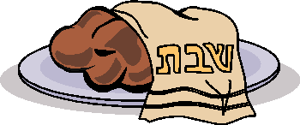
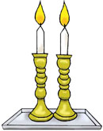
Cloth over the manna- This represents the dew which kept the bread fresh on their return from the desert.

Candles- The candles on the table represent the command, ‘Remember the Sabbath day by keeping it holy’ (Exodus 20:8)
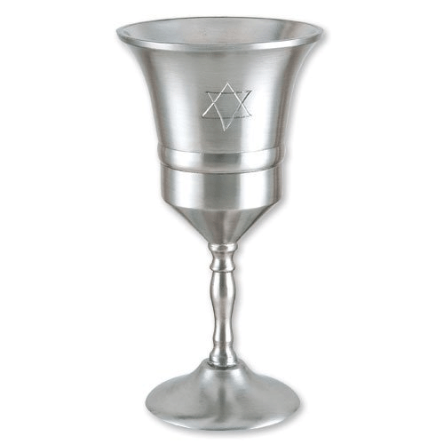
Glass of wine – They will say the blessing (Kiddush) over the wine. It is a symbol of the sweetness and happiness of Shabbat.

Before eating the manna they thank God for the food. The father breaks the bread and places pieces in salt. The salt reminds them of the sacrifices which were made on the altar in the Temple. Everyone eats some of the bread with the salt.
During the meal they sing Hebrew songs and recite stories from the Tenakh.
SHABBAT MORNING
The family will all go to a special service in the synagogue. During the service the Rabbi will read the Sidra (part) of the Torah for that week.
After returning home they will have a meal which is similar to that of Friday evening Then the father and son will return to the synagogue for the afternoon service which is much shorter. Sometimes the wives will visit each other in their homes to study parts of the Torah. If a Jew is on his/her own he/she will be invited to the house of another Jew on Shabbat. Although Shabbat may appear as a rather dull day for some of us, this is not how the Jews see it. For them, it is a day of pleasure. They enjoy themselves in different ways during the week. Every week when celebrating Shabbat they think that the Rabbis of olden times were absolutely right:
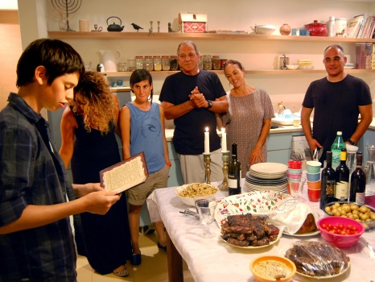
‘Every day of the week is blessed by Shabbat’.
They chat with the family and invite people who have no family to come over to celebrate Shabbat.

THE END OF SHABBAT
HAVDALAH- ‘Separation’ Ceremony to end Shabbat

When the stars appear in the sky on Saturday night, Shabbat ends. The ceremony which ends Shabbat is called Havdalah. This means ‘separation’ and this is exactly what the ceremony does, it separates Shabbat from the remainder of the week.
IN THE HOME
Havdalah CANDLE: The woman of the house will light the Havdalah. The lighting of the candle signifies that Shabbat is over and it is no longer necessary to stick to the rules e.g. igniting a spark.
BOX OF HERBS/SPICES
The sweet smell of the box will be dispersed around the home. This represents the hope that the remainder of the week will be as sweet as Shabbat. The scent will also reminder them of the joy of Shabbat.

IN THE SYNAGOGUE
In the synagogue they pray to God to bless them during the coming week. The Rabbi will say a blessing over a cup of wine, another over a box of spices and another over a candle. He will say another blessing and then the separation between Shabbat and the remainder of the week will be complete. The Jews may return home to do whatever ‘work’ they wish after this.

WHY OSBERVE SHABBAT?
- It is one of the 10 Commandments
‘Remember the Sabbath day by keeping it holy. Six days you shall labour and do all your work, but the seventh day is a Sabbath to the LORD your God; on it you shall not do any work …’(Exodus 20:8-10)

- The believe that God created the world in six days and rested on the seventh day. The story is told in Genesis (the First Book of the Torah). So, the Jews rest in the same way that God did after creating the world.

‘By the seventh day God had finished the work he had been doing; so on the seventh day he rested from all his work’ (Genesis 2:2)
- The believed that God had given them Shabbat as a gift

- It is also a time to worship God and enjoy the company of the family.

Shabbat is a festival which is celebrated every week. It beings on sunset on Friday evening and ends on sunset on Saturday night. By observing Shabbat they observe the Mitzvot (rule) in Exodus 20:8:
‘Remember the Sabbath day by keeping it holy.
⁹ Six days you shall labour and do all your work,
¹⁰ but the seventh day is a Sabbath to the LORD your God.
On it you shall not do any work –
neither you, nor your son or daughter, nor your male or female servant;
nor your animals, nor any foreigner residing in your towns.
¹¹ For in six days the LORD made the heavens and the earth,
the sea, and all that is in them;
but he rested on the seventh day.
Therefore the LORD blessed the Sabbath day,
and made it holy.

Shabbat is an opportunity for Jews to celebrate God’s creation of the world. Many Jews believe that Shabbat is the most important festival. It is seen as a gift from God when you can forget about the problems of the week. Even when the Jews were being persecuted many continued to try to celebrate it. Orthodox Jews believe that no one should carry out any work at all on this day unless it is a matter of life or death. They also do not carry things in their hands from place to place or push things e.g. house keys, mobile phones, prams, wheel chairs. Some communities have a special place called Eruv which has been created using walls, hedges in order to close areas off and create one area. In order to keep to the strict rules this area must be closed off completely.

