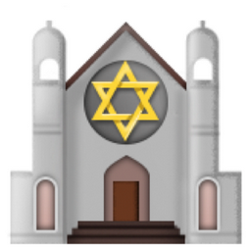
WHY IS THE SYNAGOGUE IMPORTANT TO JEWS?
SYNAGOGUE- Meeting place, house of learning and prayer

The Synagogue is central to Jewish life. In Hebrew it is called Beth ha Knesset which means meeting place.

Synagogues usually serve three main purposes,

BEIT HA TEFILAH- House of prayer
3 daily services are held in the synagogue. This is to commemorate the three sacrifices which were made in the Temple. They can no longer make sacrifices since the Temple was destroyed, so they pray instead.
It is place where Jews come together for services and communal prayers. Although Jews can worship anywhere, there are specific prayers which can only be said in the presence of the MINYAN (a quorum of 10 men which must be present in order to hole a service in an orthodox synagogue)
For this reason many strict Jews go to the synagogue every evening.

BEIT HA MIDRASH- HOUSE OF LEARNING.
Most synagogues have libraries of sacred texts where members of the synagogue can study. The synagogue is also where Jewish children receive lessons about the Jewish religion and learn Hebrew. It is also where they go to prepare for the Bar/Bat Mitzvah ceremony. Jews believe that learning about God is a way to worship God. They believe that they never stop learning about God, and so there are study classes for every age in synagogues.

MEETING PLACE
It is a place where Jews can meet other Jews. This is important as it gives then a sense of belonging to a special community. They might not meet other Jews in their everyday lives, so going to the synagogue gives them an opportunity to do this. It also provides them with the opportunity to discuss any problems they may have regarding observing the rules of the religion.
The synagogue is also a social centre for religious and non-religious activities. It is a place where important social issues can be discussed. Every synagogue usually has a busy programme of social events for the members which include opportunities to learn more about religious and cultural issues. They are also centres for raising money towards charities or items to be given to certain good causes for the poor and needy in society. Some synagogues offer a shopping service for the elderly or those who are unable to go out shopping themselves. They offer respite to people who care for disabled people or other in need. A number of synagogues offer support and financial advice and can offer financial support to those members who are in financial difficulty. Some synagogues provide Kosher food in lunch clubs for the elderly or provide ‘meals on wheels’. One synagogue in Liverpool provides 5000 kosher meals every yera to those in need/elderly in the city. The synagogue can also organise keep fit sessions for its members or organise visits to various places. The synagogue is also a place where funeral services are held.
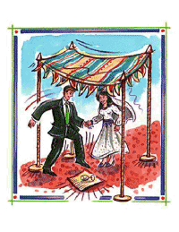
The synagogue is also a place to celebrate various events e.g. marriages, festivals and Bar and Bat mitzvah cermonies.

