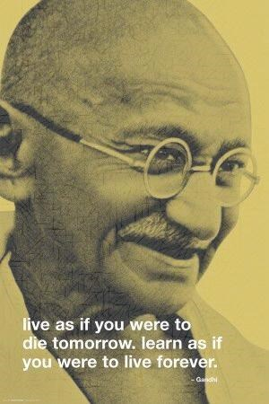

Theme One: Issues of Life and Death

Beliefs about death and the afterlife

Christianity and Judaism

Name
:
____________________________________________
____

Class: _________________________________________________

Teacher: _______________________________________________

Contents page

Pages 3 – 5: | Key concepts and terms list
Page 6: | Christian and Jewish beliefs about the soul
Page 7: | Muslim beliefs about the soul
 | Materialism and Dualism
 | Humanist beliefs about the soul
Pages 8 and 9: | Exam practice question: ‘There is no such thing as a soul; the body is all there is.’
Pages 10 – 12: | Christian, Jewish and Muslim perspectives about ensoulment
Pages 13 and 14: | Life after death
 | Christian perspective on life after death
Page 15: | Jewish perspective on life after death
Page 16: | Humanist perspective on life after death
Page 17: | Summary mind map for religious and non-religious perspectives on life after death
Page 18: | Exam practice question: ‘Believing in life after death is a waste of time.’
Page 19: | Christian and Jewish perspectives on heaven and hell
Pages 20 and 21: | Christian teachings about Judgement
Pages 22 and23: | Jewish teachings about Judgement  Religious and non-religious perspectives on Judgement summary sheet
Pages 24 and 25: | Christian funeral rites
Pages 26 and 27: | Jewish funeral rites
Page 28: | Non-religious funeral rites
Page 29: | End of booklet review

Key concepts and terms
From the study of this unit, you should have an understanding of the following concepts and terms.
To help you explain and apply these concepts and terms in exam questions, write your own explanations and definitions next to the word as you progress through the booklet. Afterlife

Bet Hayyim

Bet Olam

Bodily resurrection (Evangelicals)

Chevra kaddisha

Cremation

Dualism

Ensoulment

Eulogy

Funeral

Heaven

Hell

Holy Communion
Immortality

Judgement

Kaddish

Kittel

Keriah

Materialism

Messiah

Neshama

Olam ha-ba

Parable of the Sheep and the Goats

Purgatory

Reminiscences

Resurrection

Rite

Sanctity of life
Sheloshim

Shema

Sheol

Shiva

Soul

Spiritual bodies (1 Corinthians 15:42-44)

Tachrichim

Taharah

Tallit

Yahrzeit

1 Corinthians 15:42-44

John 11:24-27

Luke 14: 15-24

Job 12:10

Genesis 2:7

The Soul
SOUL The spiritual aspect of a being; that which connects someone to God. The soul is often regarded as non-physical and as living on after physical death, in an afterlife.

Belief in the existence of a soul is a central feature of many religious and philosophical traditions. The soul, in many religions, spiritual traditions and philosophies is the spiritual and eternal part of a living being. The soul is separate from the body which is material.
The ancient Greeks were great philosophers, and it is thought that the idea of a soul developed from their thinking.
Plato
Plato considered the soul as the essence of a person - that which decides how we behave. For Plato, the soul consists of the Logos (mind), Thymos (emotion) and Eros (desire). Plato believed that the soul was eternal and could exist without the body.
Plato believed the mind part of the soul had to keep emotion and desire under control or it would lead to a person’s ruin.
Aristotle
Aristotle, following Plato, defined the soul as the core or essence of a living thing. A thing has a soul because it lives and because it is active.
Christianity, Judaism and Islam
Christians, Jews and Muslims believe that only human beings have immortal souls.
And the LORD God formed man from the dust of the ground, and breathed into his nostrils the breath of life; and man became a living soul.
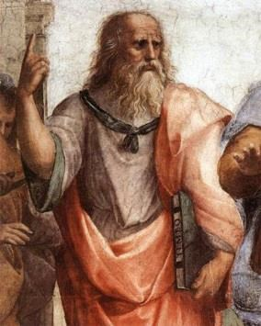
Genesis 2:7

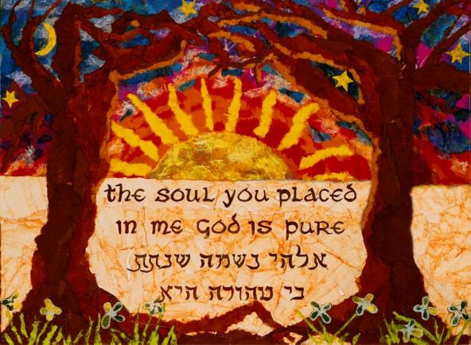
Christians regard the soul as the immortal essence of a human and that after death, God either rewards or punishes the soul.
Jews do not have any clear teachings about the relationship between the body and soul. It is not considered to be important. Judaism teaches that God breathed the soul into Adam’s body. The Rabbis teach that the soul leaves the body while the person is asleep and visits heaven for refreshment. During Shabbat, God gives everyone an extra soul.
Many Jews also believe that when they die, they will be judged by God and their body and soul are reunited. The soul will blame the body for its actions. Jews therefore believe that the importance of life is the way in which it is lived on earth.

Muslims believe human beings are Allah’s greatest physical creation. They also believe that humans are different from other animals because we know we will die. Islam teaches that every soul (ruh) is unique and has free will. At Yawmuddin, it is the soul that will be judged, as it is the soul that is our consciousness. Our body is thought of a ‘vehicle for the soul.’
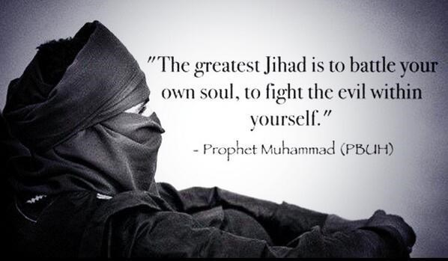
The soul (the spiritual part of God) and the body (the material part of use which craves pleasure) are often in conflict. This is similar to Plato’s idea of the soul.

There are two distinct views about the soul and its relationship with our physical body:
- Dualism is the belief that we are made of two separate parts:
  - A physical body
  - A spiritual soul
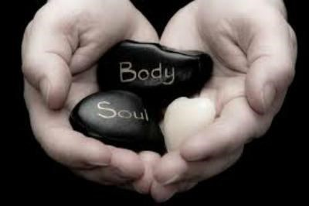
Dualists believe that our soul or spirit lives in our physical body. This soul is the true, inner part of us and it will live on after our material body dies.
- Materialism is the view that nothing else exists apart from matter. All we have, as human beings, is a physical body; there is no soul or spirit.
The conscience is believed by some Christians to be the voice of God in us which warns us to follow the spiritual and not material path.

Other ideas on the soul
Humanists deny the existence of a soul.
The belief amongst scientists is that the mind, or consciousness, is the operation of the brain. Some scientists think that the brain is to the mind as computer hardware is to computer software.

Exam question
‘There is no such thing as a soul; the body is all there is.’ (15)
Discuss this statement showing that you have considered more than one point of view. (You must refer to religion and belief in your answer.)

Use the prompts on the stick man below to plan your response to the question, and then write your answer on the next page.

I think
………………………………………………………..……………………………………………………….
………………………………………………………..………………………………………………………...
because

………………………………………………………..
………………………………………………………..

…………………………………………………………
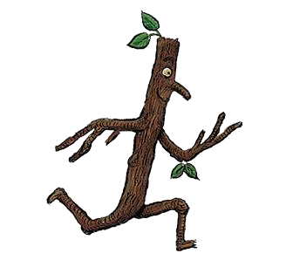

…………………………………………………………

One the other hand, some other
believers may

think
………………………………………………………..

………………………………………………………...

………………………………………………………..

………………………………………………………...
because

………………………………………………………..

………………………………………………………..

………………………………………………………..

………………………………………………………...

On the one hand, some believers
may think
………………………………………………………..

………………………………………………………...

………………………………………………………..

………………………………………………………...
because

………………………………………………………..

………………………………………………………...

………………………………………………………..

………………………………………………………...

The strengths and weaknesses of t
his
Therefore, my conclusion is
argument are
……………………………………………………….. ………………………………………………………..
………………………………………………………... ………………………………………………………...
……………………………………………………….. ………………………………………………………..
………………………………………………………... ………………………………………………………...
because because
……………………………………………………….. ………………………………………………………..
………………………………………………………...
_______________________________________________________________________________________
_______________________________________________________________________________________
_______________________________________________________________________________________ _______________________________________________________________________________________
_______________________________________________________________________________________
_______________________________________________________________________________________ _______________________________________________________________________________________
_______________________________________________________________________________________
_______________________________________________________________________________________ _______________________________________________________________________________________
_______________________________________________________________________________________
_______________________________________________________________________________________ _______________________________________________________________________________________
_______________________________________________________________________________________
_______________________________________________________________________________________ _______________________________________________________________________________________
_______________________________________________________________________________________
_______________________________________________________________________________________ _______________________________________________________________________________________
_______________________________________________________________________________________
_______________________________________________________________________________________ _______________________________________________________________________________________ _______________________________________________________________________________________
_______________________________________________________________________________________ ____________________________________________________________________________________________________________________________________________________________________________
_______________________________________________________________________________________ ____________________________________________________________________________________________________________________________________________________________________________
_______________________________________________________________________________________
____________________________________________________________________________________________________________________________________________________________________________
_______________________________________________________________________________________
_______________________________________________________________________________________
_______________________________________________________________________________________
_______________________________________________________________________________________
_______________________________________________________________________________________
_______________________________________________________________________________________
_______________________________________________________________________________________
_______________________________________________________________________________________
_______________________________________________________________________________________
_______________________________________________________________________________________ _______________________________________________________________________________________
_______________________________________________________________________________________
_______________________________________________________________________________________

Ensoulment
ENSOULMENT The moment when the human soul is said to enter the baby’s body (usually thought to happen in the womb, at an early point in pregnancy).

In religious terms, ensoulment is the moment when a human being gains a soul. Some religions say that a soul is newly created within a developing child and others, especially in religions that believe in reincarnation, that the soul is pre-existing and added at a particular stage of development.
The Greek Philosopher Pythagoras believed that the soul was infused at the time of conception, and for many Christians in the 2nd and 3rd centuries, this was the view that they held.
In the time of Aristotle, it was widely believed that the human soul entered the forming body at 40 days (male embryos) or 90 days (female embryos) and the first movements of the child in the womb felt by the mother where the indication of the presence of a soul. Other religious views are that ensoulment happens at various times through the pregnancy such as:
 at the moment of conception ,
 when the child takes the first breath after being born,
 at the formation of the nervous system and brain,
 at the first brain activity,
 or when the fetus is able to survive independently of the uterus.

Christianity
Many early Christian writings were based on the work of Philosophers and other Christian thinkers so, as can be seen above, in the early centuries of Christianity, many people believed that the soul was present from conception.
However, as Christianity progressed, so did the thoughts of prominent Christian writers. By the 13th century, Thomas Aquinas (1225 – 1274) had considered the views of others that had gone before him and in his main work Summa Theologica, stated:
That the intellectual soul is created by God at the end of the human generation.
Question 118 article 2 ad 2

Many contemporary readers interpret this passage to mean that Aquinas believed the end of the human generation was 40 or 80 days after conception. This belief was confirmed by the Church in 1312 by the Council of Vienne.
In 1679, Pope Innocent XI condemned the writings of other Christians, denouncing sixty-five propositions they had made. One of the condemned proposition was:
It seems probable that the fetus (as long as it is in the uterus) lacks a rational soul and begins to first have one when it is born.
Proposition 35

By condemning this proposal, Pope Innocent XI again showed that most Catholics believe that the fetus has a soul from the time of conception.
In its official declarations, the Catholic Church expands on the 1974 Declaration on Procured Abortion and states:
“From the time that the ovum is fertilised, a new life is begun which is neither that of the father nor of the mother; it is rather the life of a new human being with his own growth. It would never be made human if it were not human already. To this perpetual evidence …
modern genetic science brings valuable confirmation. It has demonstrated that, from the first instant, the programme is fixed as to what this loving being will be: a man, this individual-man with his characteristic aspects already well determined. Right from
fertilisation is begun the adventure of a human life, and each of its great capacities requires time … to find its place and to be in a position to act.”
This teaching remains valid and is further confirmed, if confirmation were needed, by recent findings of human biological science which recognise that in the zygote resulting
from fertilisation the biological identity of a new human individual is already constituted. Certainly, no experimental datum can be in itself sufficient to bring us to the recognition of a spiritual soul; nevertheless, the conclusions of science regarding the human embryo provide a valuable indication for discerning by the use of reason a personal presence at
the moment of this first appearance of a human life: how could a human individual not be a human person?

Judaism
Jewish views regarding ensoulment vary. Some Jews believe that the question of the timing of ensoulment is unanswerable. Some Jews however, interpret Job 10:12 as meaning that the soul (neshama) must enter the body at conception. On the other hand, some interpret this passage to mean that the soul entered the body only at birth.
You have granted me life and steadfast love, and your care has preserved my spirit.
Job 10:12

Other passages in the Talmud such as Yevamot 69a and Nidda 30b have been interpreted to mean that ensoulment occurs only after forty days of gestation.
Another Jewish view regarding ensoulment is the idea of the soul joining the body at birth and leaving it again at death. Yet some Jews put ensoulment even later than birth, saying that it occurs when the child first answers “Amen”.
There is no definitive answer nor theory as to the exact timing or nature of ensoulment, with most agreeing that the reason for this being that Judaism does not believe in strict separation of soul and body.

Islam (again, this section is included to help you understand the differences between religions only)
Islam does not traditionally hold that ensoulment occurs at the point of conception. Two passages of the Qur’an describe the fetal development process:
We created man from an essence of clay, then We placed him as a drop of fluid (nutfah) in a safe place, then We made that drop into a clinging form (alaqah), as We made that form into a lump of flesh (mudghah), and We made that lump into bones (idhaam), and We clothed those bones with flesh (lahm), and later We made him into other forms…
(23:12-14)
We created you from dust, then from a drop of fluid (nutfah), then a clinging form
(alaqah), then a lump of flesh (mudghah), both shaped and unshaped: We mean to make
Our power clear to you. Whatever We choose We cause to remain in the womb for an appointed time, then We bring you forth as infants and then you grow and reach maturity…
(22:5)

Most Muslims are taught that ensoulment occurs anywhere between 40 and 120 days after conception, due to a Hadith of Prophet Muhammad,
When42 nights have passed over the conceptus, God sends an angel to it, who shapes it (into human form) and makes its hearing, sight, muscles and bones…

Use the information above to summarise the Christian, Jewish and Muslim teachings about ensoulment.
Christianity | Judaism | Islam
When does ensoulment occur? | When does ensoulment occur? | When does ensoulment occur?
Evidence to support this belief | Evidence to support this belief | Evidence to support this belief

Life after death
Every religion in the world has something to say about death and what they say can influence the way people live their lives.
Some people believe that when you die, you are dead forever; your body will decay and you cease to exist. Others believe that, although your body may die and decay, your soul can live on that is, you move on to a different kind of existence. However, it is not always easy to decide exactly when someone is dead, for example, are those who are on a life-support machine and unlikely to ever regain consciousness really alive?
There are many reasons why people do or do not believe in life after death:
- Certain religions teach that we all move on to an afterlife of some kind, for some people, this will be enough to make them believe in life after death – they have faith in what their religion teaches them.
- Other people use the example of near-death experiences (NDEs) to argue that a soul exists after death. A near-death experience usually involves someone having an out-of-body experience when they are close to death. While apparently physically dead, they may have glimpsed what they believe to be an afterlife or heaven, or spoken to long-dead family members.
https://www.youtube.com/watch?v=ML2QgU4WstQ
Elizabeth Taylor describes her near-death experience to Oprah Winfrey

- Not everyone thinks of near-death experiences as proof of life after death. Some people believe that the visions are a result of the chemical activity in the brain when it is short of oxygen.
- The paranormal (things that science cannot explain e.g. ghosts) is sometimes used as evidence of life after death. Some people claim they can talk to the dead ‘beyond the grave’, and use this as proof of an afterlife.
- Other people say that events we call paranormal have a scientific explanation. Perhaps we do not yet know what that explanation is, but there will be one. Some people do not believe that these events happen in the first place.
Christianity
Christians have two basic concepts about life after death
RESURRECTION – after death nothing happens, but at a time in the future (often called the Last Day or the Day of Judgement) the dead will be brought back to life (raised) and be given an immortal (eternal) body.

IMMORTALITY OF THE SOUL – the belief that humans have a body and soul. The soul survives the death of the body and goes to a spiritual place where God is.

I look for the resurrection of the dead and the life of the world to come.
Nicene Creed

I believe in … the resurrection of the body and the life everlasting.
Apostle’s Creed
Christians believe that faith in Jesus can overcome death and evil.
Christ has indeed been raised from the dead, the first fruits of those who have fallen asleep. For since death came through a man, the resurrection of the dead comes also through a man. For as in Adam all men die, so in Christ all will be made alive … But
someone may ask, ‘How are the dead raised? With what kind of body will they come?’ How foolish! What you sow does not come to life unless it dies. When you sow, you do not plant the body that will be, but just a seed, perhaps of wheat or something else. But
God gives it a body as he has determined … So it will be with the resurrection of the dead.
The body that is sown perishable, it is raised imperishable; it is sown in dishonour, it is raised in glory; it is sown in weakness, it is raised in power; it is sown in a natural body, it is raised a spiritual body.
I Corinthians 15:20-22, 35-38, 42-44

Then he (the criminal crucified with Jesus) said, ‘Jesus, remember me when you come into your kingdom.’ Jesus answered him, ‘I tell you the truth, today you will be with me in paradise.’
Luke 23:42-43

In my Father’s house there are many rooms; if it were not so I would have told you. I am going there to prepare a place for you.
John 14:2

Then I saw a great white throne and him who was seated on it. Earth and sky fled from his presence, and there was no place for them. And I saw the dead, great and small,
standing before the throne and books were opened … The dead were judged according to
what they had done as recorded in the books … Then death and hades were thrown into the lake of fire. The lake of fire is the second death. If anyone’s name was not found
written in the book of life, he was thrown into the lake of fire. Then I saw a new heaven
and a new earth, for the first earth had passed away, and there was no longer any sea. I saw the Holy City, the new Jerusalem, coming down out of heaven from God.
Revelation 20:11-15, 21:1-2

Exam question
Explain Christian beliefs about the afterlife (8)

_______________________________________________________________________________________
_______________________________________________________________________________________
_______________________________________________________________________________________ _______________________________________________________________________________________
_______________________________________________________________________________________
_______________________________________________________________________________________ _______________________________________________________________________________________
_______________________________________________________________________________________
_______________________________________________________________________________________ _______________________________________________________________________________________
_______________________________________________________________________________________
_______________________________________________________________________________________ _______________________________________________________________________________________ _______________________________________________________________________________________
_______________________________________________________________________________________ Jewish perspectives on life after death (Olam Ha-Ba)
Jews have similar teachings to Muslims and Christians on life after death (Olam Ha-Ba). Originally, there was a belief amongst Jews that you would be punished for the sins of your parents or grandparents.
Our fathers sinned and are no more, and we bear their punishment.
Lamentations 5:7

However, this view was eventually changed and it was believed that it was how you lived your own life that mattered.
This world is like an antechamber to the world to come; prepare thyself in the antechamber that thou mayest enter into the hall.
Mishnah

Jewish belief in life after death gives life meaning and purpose. A Jew knows that if they worship God and follow his laws in their life, then God will reward them.
I believe with perfect faith that there will be a resurrection of the dead at a time when it will please the Creator, blessed be his name, and exalted be the remembrances of him for ever and ever.
Number 13 of the Thirteen Principles of Faith

O Lord of compassion remember unto him (her) for good all the meritorious and pious deeds which he (she) wrought while on earth. Open unto him (her) the gates of
righteousness and light, the gates of pity and grace. O shelter him (her) for evermore
under the cover of thy wings; and let his (her) soul be bound up in the bond of eternal life Prayer for home service prior to a funeral, The Authorised Daily Prayer Book

Exam question
Explain Jewish beliefs about the afterlife (8)

_______________________________________________________________________________________
_______________________________________________________________________________________
_______________________________________________________________________________________
_______________________________________________________________________________________
_______________________________________________________________________________________
_______________________________________________________________________________________
_______________________________________________________________________________________
_______________________________________________________________________________________
_______________________________________________________________________________________
_______________________________________________________________________________________
_______________________________________________________________________________________
_______________________________________________________________________________________ _______________________________________________________________________________________
_______________________________________________________________________________________
_______________________________________________________________________________________ _______________________________________________________________________________________
_______________________________________________________________________________________

Humanist views on life after death
http://understandinghumanism.org.uk/films/?film=5pWEoOXdYIE
Humanism4schools – Afterlife: Is this the only life we have?

Humanists are materialists, so they dismiss any suggestion that we have a soul. They believe in a scientific description of human life and they reject beliefs about our spiritual existence. We are physical beings who will decompose when we die. No eternal, supernatural part of us will live on.
Humanists believe this life is the one life we have: it is not a ‘dress rehearsal’. Evidence is important to humanists when deciding what to believe and they see no good evidence that we live on after we die. Because this is the only life we know we have, humanists think we should make the most of it.
Humanists cite the scientific definition of death – i.e. the point at which our brain activity stops. They understand that some people believe in religious teachings regarding the after-life but feel that they were written before scientific developments and so therefore do not present a complete understanding.
Humanists do not believe that any claims of evidence for an afterlife are strong enough to take it seriously. That is, NDEs, sightings of ghosts or channelling via a medium can be explained through science and investigations for example, many sightings have been proved to be hoaxes or could be hallucinations; mediums can ‘read’ people and there are scientific explanations for near-death experiences (tests have shown that oxygen deprivation can create the sensations associated with near-death experiences). Humanists believe there is clear evidence that our body has ceased to be alive when we die (our bodies decay and eventually nothing survives) and there is no good evidence that anything lives on.
https://www.youtube.com/watch?v=yHNq4SQxyv0
Derren Brown – How to read someone’s mind

Humanists believe that the idea of life after death results from people’s fear of death. The belief that death is not the end comforts people when a loved one dies and makes them less afraid of their own death.
Humanists also believe that the idea of reward and punishment after death has been used to control people’s behaviour in the past, and that for most Humanists, the fear of punishment in the next life is not a good reason to behave well. Humanists believe that people should treat others as they would like to be treated, being good makes us feel good, and being good helps to make the world a better place.
‘An individual human existence should be like a river-
Small at first, narrowly contained within its banks, and rushing passionately past boulders and over waterfalls.
Gradually the river grows wider, the banks recede, the waters flow more quietly, and- in the end- without any visible break, they become merged in the sea, and painlessly lose their individual being
The man or woman who in old age, can see his or her life in this way, will not suffer from the fear of death,
since the things they care for will continue.’

Bertrand Russell (1872 – 1970)

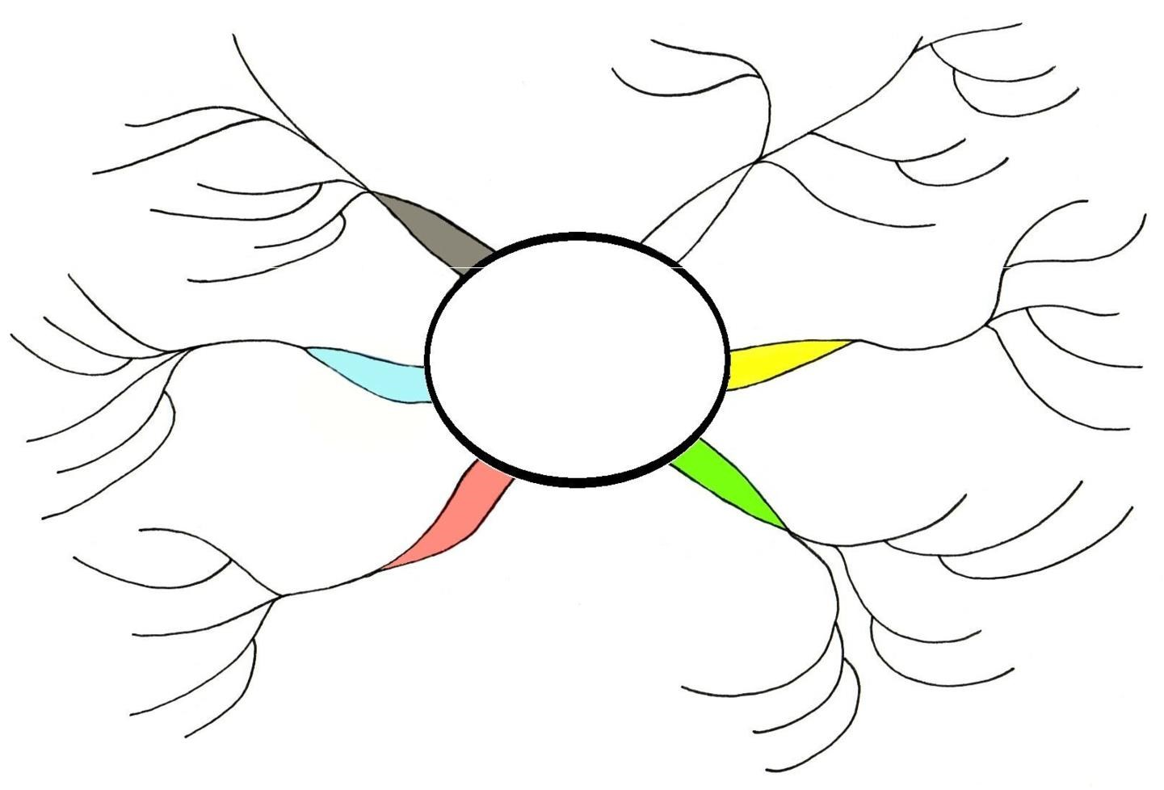

Summarise

the Christian,
Jewish and Humanist beliefs on life after death on the mind map below.

Exam question
‘Believing in life after death is a waste of time.’ (15)
Discuss this statement showing that you have considered more than one point of view. (You must refer to religion and belief in your answer.)

_______________________________________________________________________________________
_______________________________________________________________________________________ _______________________________________________________________________________________
_______________________________________________________________________________________
_______________________________________________________________________________________ _______________________________________________________________________________________
_______________________________________________________________________________________
_______________________________________________________________________________________ _______________________________________________________________________________________
_______________________________________________________________________________________
_______________________________________________________________________________________ _______________________________________________________________________________________
_______________________________________________________________________________________
_______________________________________________________________________________________ _______________________________________________________________________________________ _______________________________________________________________________________________
_______________________________________________________________________________________ ____________________________________________________________________________________________________________________________________________________________________________
_______________________________________________________________________________________ ______________________________________________________________________________________ ______________________________________________________________________________________
_______________________________________________________________________________________ ____________________________________________________________________________________________________________________________________________________________________________
_______________________________________________________________________________________
_______________________________________________________________________________________
_______________________________________________________________________________________
_______________________________________________________________________________________
_______________________________________________________________________________________
_______________________________________________________________________________________
_______________________________________________________________________________________ _______________________________________________________________________________________
_______________________________________________________________________________________ _______________________________________________________________________________________ _______________________________________________________________________________________

Heaven and Hell
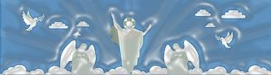
Jews and Christians believe that, as humans, we only live one earthly existence, followed by eternal life in the world to come. Many traditional believers hold that after death we will rise from the dead to be judged by God, with those who God deems worthy (good) being raised to eternal life. There is less agreement
among Jewish and Christian believers about the existence of hell.

Judaism | Christianity
- When the earliest Jewish scriptures were written, it was believed that after death everyone would go to a place called Sheol – where the dead lived as shadows.  - Sheol was believed to be dark and damp, and your soul would stay there for eternity.  - However, Jews later began to believe in an afterlife spent in places called Heaven and Hell – God would judge people after death and send them to the place they deserved.  - If you have lived a good life and performed worthy deeds, you will spend eternity with God in Heaven.  - Those who have failed to lead good lives will go to hell – a place of suffering and punishment.  Judaism teaches that the body and soul stay together after death, and that Heaven and Hell are open to both Jews and non-Jews.  Although most of these beliefs are held by all Jews, there are a few important differences between the traditions.  Orthodox They believe that the physical body will be resurrected, intact, at the end of the Messianic Age. Because of this, the body should not be cut after death (post-mortems are frowned upon) and cremation is forbidden. A Jewish cemetery is called the House of Life (Bet ha-Hayyim) and this also reaffirms the opinion that the body will be resurrected. Liberal Liberal Jews believe that the body is simply a vessel for the soul, and it is the soul that will be judged by God. This is why some liberal Jews are now not so strongly against cremation. Reform Reform Jews are more concerned with the earthly life than with the afterlife. Their attitude is summed up by this phrase from a Reform prayer book: ‘What can we know of death, we who cannot understand life.’ | - Christianity teaches that the soul lives on after death (immortality of the soul). After death, your soul will go to either Heaven or Hell – depending upon how you lived your life on Earth.  - Heaven is often portrayed as a place of great beauty and serenity, a paradise where you will spend eternity with God – as long as you have lived a good life and followed the teachings of Jesus. Those in Heaven are said to belong to the Communion of Saints.  - Hell, on the other hand, is a place of torment and pain – the final destination of nonbelievers and those who have led bad lives.  - However, not all Christians believe that these are real places; many Christians see Heaven and Hell as states of mind. In Heaven you will be happy and know God, in Hell, you will be unable to know God’s love.  Some believe those who God finds unacceptable will be annihilated. They had no interest in spiritual things when they were alive, therefore their spirits were never awakened and cannot survive death.  - Roman Catholics also believe in a place called Purgatory. Here sins are punished before the soul is able to move on to Heaven. This concept isn’t in the Bible, so Protestants reject it.  - Some Christians believe even those who led sinful lives may find salvation thanks to God’s saving power.  - Roman Catholics also believe in a place called Purgatory. Here sins are punished before the soul is able to move on to Heaven. This concept isn’t in the Bible, so Protestants reject it.  - Some Christians believe even those who led sinful lives may find salvation thanks to God’s saving power.  Are humans born sinners? How do we get to heaven?  Traditionally, Christianity has taught that as human beings, we are born with a sinful nature. This is called original sin. Because Adam and Eve sinned by eating the forbidden fruit in the Garden of Eden, all generations to follow will inherit this sin. For humans to get to heaven we must be reconciled with God; we need to be saved and forgiven. This can only happen through believing that Jesus died on the cross to cleanse us from our sins. Liberal Christians do not accept the concept of ‘original sin’. They argue that we need to take responsibility for our own sin. It is nothing to do with a mythical Adam!

Christian and Jewish beliefs about Judgement
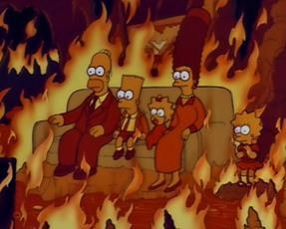
Christians believe in resurrection and eternal life; death is not the end, but a gateway to a perfect existence. Some Christians say that heaven is our true home and our lives here on earth are the testing ground for life in eternity.
Christians believe that just as Jesus rose again after death, so will we. The Bible teaches that God is the Divine Judge and on Judgement Day he will decide who will be rewarded with eternal life in paradise and who will be punished. Those who believe in Jesus and have lived a good life will be taken to heaven. Those who have rejected God’s love and caused harm to others will be sent to hell.
Some Christians are dualists. They believe that at the moment of death our soul separates and leaves the body. The body will decay while the immortal soul is united with God in heaven.
Other Christians, for example, Evangelicals, say that after death we will experience a bodily resurrection, like Jesus, who came back to life in physical form. In his letter to the Corinthians, St Paul says that, after our deaths, we will be raised as spiritual bodies, not just disembodied souls.
So it will be with the resurrection of the dead. The body that is sown perishable, it is raised imperishable; it is sown in dishonour, it is raised in glory; it is sown in weakness, it is raised in power; it is sown in a natural body, it is raised a spiritual body.
I Corinthians 15:42-44

Many Christians ask what St Paul means when he talks about a spiritual body. The closest we can get to understand this idea is to picture an angel. Angels are thought to be physical, but they are also spiritual and immortal. They can be seen, but they are not of this world. Therefore, some Christians believe that St Paul infers that we will exist for eternity like angels.
Christians believe that there will be a Judgement Day when people will be judged by God for the quality of their lives. Christians believe that on this day, Jesus will return to earth in a second coming. This will mark the end of human existence on the earth. This belief is known as the Parousia. The quotation below from Matthew describes how Jesus will separate the people who will go to heaven from those who go to hell, just as a shepherd separates the sheep from the goats.
When the Son of Man comes in his glory, and all the angels with him, he will sit on his glorious throne. All the nations will be gathered before him, and he will separate the
people from one another as a shepherd separates the sheep from the goats. He will put the sheep on his right and the goats on his left.
Then the King will say to those on his right, ‘Come, you who are blessed by my Father; take your inheritance, the kingdom prepared for you since the creation of the world. For I was hungry and you gave me something to eat, I was thirsty and you gave me something
to drink, I was a stranger and you invited me in, I needed clothes and you clothed me, I was sick and you looked after me, I was in prison and you visited me.’
Then the righteous will answer him, ‘Lord, when did we see you hungry and feed you, or thirsty and give you something to drink? When did we see you a stranger and invite you
in, or needing clothes and clothe you? When did we see you sick or in prison and go to visit you?’
The King will reply, ‘Truly I tell you, whatever you did for one of the least of these brothers and sisters of mine, you did for me.
Then he will say to those on his left, ‘Depart from me, you who are cursed, into the eternal fire prepared for the devil and his angels. For I was hungry and you gave me
nothing to eat, I was thirsty and you gave me nothing to drink, I was a stranger and you
did not invite me in, I needed clothes and you did not clothe me, I was sick in in prison and you did not look after me.’
They also will answer, ‘Lord, when did we see you hungry or thirsty or a stranger or needing clothes or sick or in prison, and did not help you?’
He will reply, ‘Truly, I tell you, whatever you did not do for one of the least of these, you did not do for me.’
Then they will go away to eternal punishment, but the righteous to eternal life.
Matthew 25:31-46

- Summarise the parable of the sheep and the goats in no more than four sentences.
- Explain what the parable teaches Christians about how Jesus’s followers should live their lives.
- Explain what the parable teaches Christians about Judgement.
- Read Luke 14:15-24 and explain in your own words what this teaches Christians about the afterlife.

Judaism
Judaism teaches that body and the soul are one; they are inseparable. The soul has no existence without the body. When Adam was created it says that God ‘breathe into his nostrils the soul of life’ (Genesis 2:7). Jews see this ‘soul’ as the ‘aliveness’ of a person. It is a metaphor for what makes us living beings; is it not a separate thing that has a life of its own without the body.
Early Judaism
The Jewish scriptures say almost nothing about the afterlife: there is no reference to figures like Adam, Abraham, Moses and David living on after death. It was accepted that when they died, although they would live on in the memories of the generations to come, their body and soul passed away forever. If there was any understanding of an afterlife, it was that the dead were transported to Sheol, a shadowy, dreary underworld existence, but this was not a common idea.
Modern Judaism
More recently, Jewish thinking has come to accept the idea of an afterlife, Olam Ha-Ba. Today, Judaism tends to teach that at death there will be a temporary separation of body and soul, but they will be reunited on the Day of Judgement.
The previous table summarises the different responses to the concept of resurrection. Many Jewish people believe that this judgement and resurrection will take place after the coming of the Messiah.
For both Judaism and Christianity, explain in detail religious teachings about the concepts of afterlife and judgement using the writing frame below as a guide.

All/many/most Christians believe that …………………………………. This comes from the teaching/ Bible quote…………………..
This means that/Because of this they……………………………………………………………………............................................................

Some/other Christians such as ……………. believe that ……………………… This comes from the teaching/ Bible quote………….. This means that/Because of this they……………………………………………………………………............................................................

Finally, Christians such as …………..……. believe that …..…………..…………. This means that/Because of this they………….…… Their beliefs do/do not differ because………………………………………..

Use the table below to summarise all you have learnt about Heaven, Hell and Judgement from the three traditions listed.
Tradition | Belief | 3 word summary
Humanists
Christians
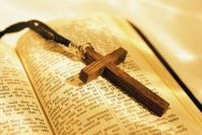
Jews
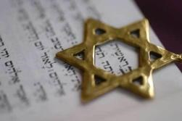

Death and Funeral Rites
RITE – a ritual or solemn ceremony

When people die, it is common to mark their death and celebrate their life in some sort of ceremony. Different religions have their own specific rituals and practices. This section gives details of how these ceremonies reflect beliefs about the afterlife.
Read the descriptions of each traditions’ funeral rites and around the boxes, explain the meaning and significance of each aspect. Two examples have been written for you.

It is God who gives life and takes life | Christianity   The time of an individual’s death is decided by God:  ‘In His hand is the life of every living  thing and the breath of all mankind.’  Job 12:10 away.  - When someone is close to death, if it is possible, a priest is called to say the last rites. Prayers are said for the dying person and they can ask God for forgiveness. The last rites is a catholic practice, which might also involve Holy Communion.  - The funeral service will take place in a Church or Chapel, where the Priest or Minister conducts the service. They will be dressed in white.  - The coffin is carried into the Church either by friends and family of the deceased or and resurrection. pallbearers. The coffin is left at the front of the Church. Flowers are displayed and candles may be lit.  - Most funerals open with the words of John 11 – when Jesus raises Lazarus from the dead.  Jesus said, ‘I am the resurrection and the life. The one who believes in me will live, even though they die; and whoever lives by believing in me will never die.’ John 11: 25-26  - After this, hymns that reflect the belief in life after death, or ones that offer comfort will be sung. Other readings that reflect Christian beliefs may be included too. Popular readings are:  ‘Even though I walk through the dark valley of death,  I will not be afraid, because you are with me.’ Psalm 23:4  ‘For everything there is a season, and a time for every matter under heaven: A time to be born, and a time to die;  A time to plant, and a time to pluck up what is planted;  A time to kill, and a time to heal;  A time to break down, and a time to break up;  A time to weep, and a time to laugh;  A time to mourn, and a time to dance Ecclesiastes 3:1-4  - The minister will say a few words about the deceased’s life and how they will be missed. They will also give words of comfort to the family and remind them of the importance of the resurrection and the new life to come.  - Catholics may hold a Mass (Communion service) with bread and wine during the funeral.  - After the Church part of the service is over, the coffin is taken to a crematorium or cemetery. Interment (burial in the ground) is the choice that some Christians make. Today, many Christians prefer to be cremated, but traditionally, the dead had to be buried.  - If burial is chosen, as the coffin is lowered into the ground, the coffin may be sprinkled with holy water whilst the Minister says:  ‘In the waters of baptism … died with Christ and rose with him to new life.  May he / she now share with him eternal glory.’  - The burial service is normally concluded with the words:  ‘Earth to earth, ashes to ashes, dust to dust: in sure and certain hope of the resurrection and eternal life through our Lord Jesus Christ, who died, was buried and rose again for us. To him be the glory forever and ever.  - Cremation services normally end with different words but the meaning is much the same.  - After the service, the family normally puts on refreshments where guests will share in their sorrows, but also their memories and beliefs. | White is a symbol of life

- Explain the meaning of:
  - Resurrection
  - Interment
  - Crematorium
- Read Ecclesiastes 3:1-4. Why do you think that some people might choose to have this read at a funeral?
- Why do you think that some Christians choose to be buried, whilst others cremated? Explain what might affect their choice.
- ‘Religious people are more likely to try to live a moral life than non-religious people.’ (15)
Discuss this statement showing that you have considered more than one point of view. (You must refer to religion and belief in your answer.)

In Judaism, the focus is on what happens during life, rather than being concerned about what may happen in the afterlife. Although most Jews do believe in the judgement of the deceased and their being reunited with God after death, there is not the emphasis on resurrection that is found in Christian ceremonies.
Judaism
- Reform and Orthodox Jews have different views and practices. However, both stress the importance of the synagogue in the funeral, and try to bury the body within 24 hours of death. However, not on Shabbat or the first or last days of a festival.
- If possible, the last words they hear should be the Shema:

‘Hear o Israel, the Lord is our God, the Lord is one.’

- Jews believe that someone who is dying or dead should not be left alone; the person should be given respect and company. The family should not bear all responsibility for this. Membership of a synagogue usually includes membership of a burial society, who makes the necessary arrangements.
- Many communities have such a society, made up of men and women considered worthy of attending to the dying and dead. It is called a chevra kaddisha. Those present will bless God as the True Judge and will make a small tear in their clothes as a sign of their grief (keriah).
- Members of the chevra kaddisha are not paid for staying with the body or preparing the body for burial. This assistance, which can never be repaid, is regarded as a privilege.
- Once the person has died, the body will not be left alone. The body will be washed thoroughly, male bodies by men, females by women, either in the tahara, home or mortuary.
- The body is clothes in the plainest of white garments (tachrichim), including a kittel.
- It is then placed in a simple unpolished box with no handles or padding. This is to show that in death, all are equal. If the person is male, a tallit will be placed around the shoulders. One of the shawl’s fringes is cut. The coffin is covered with a plain black sheet.
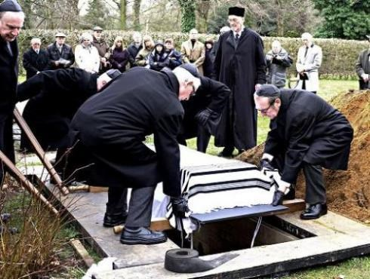
- The funeral itself is a simple affair. The Rabbi conducts the service in a hall at the cemetery (Bet Hayyim or Bet Olam).
- Prayers are said, Psalms are read and the merits of the person who has died and their trust in God’s justice is stressed.
- Everyone then fulfils the mitzvah of escorting the body to the grave. Everyone will throw a spadeful of earth into the grave. Afterwards they wash their hands to show they are separated from the dead.
- In Biblical times, and still in Israel, the body is buried without a coffin, in direct contact with the soil.
- The end of the funeral marks the beginning of mourning.
- The other sign that mourning has begun is the reciting of the Kaddish. This is a prayer which affirms the holiness of God:
Magnified and sanctified be his great Name in the world which he hath created according to his will

- Children are obliged to recite Kaddish at the funeral of a parent and then daily for 11 months. When there are no children, it is recited by other relatives or someone specially engaged for the purpose.
- Kaddish shows that children and parents are united in their loyalty to God; it focusses not on the dead but on God’s name, praying that the world will acknowledge its holiness. It points forward to the establishment of God’s kingdom with its promise of resurrection.
- Greetings are offered by mourners at this point, and during the week after the funeral:

‘May God comfort you among those who mourn for Zion and for Jerusalem’

‘I wish you a long life’

- These expressions show the important Jewish belief in the sanctity of life. Life is to be lived.
- On returning home, often a meal including hard-boiled eggs is served, seudat havra'ah. The egg, which has no opening, symbolises the inability of the mourners to open their mouths and put their grief into words.
https://www.youtube.com/watch?v=9X-HnkZ-PUQ [2:53 – 6:14, 7:04 - 8:05]
- The close family of the deceased will stay at home for seven days and allow friends to take care of every day chores. This period is called shiva and allows people to withdraw from daily life and grieve.

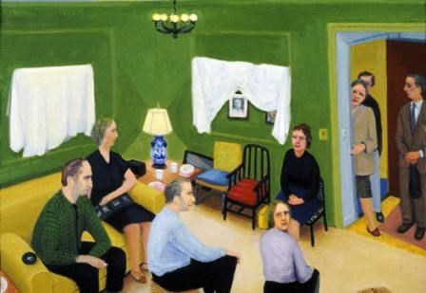
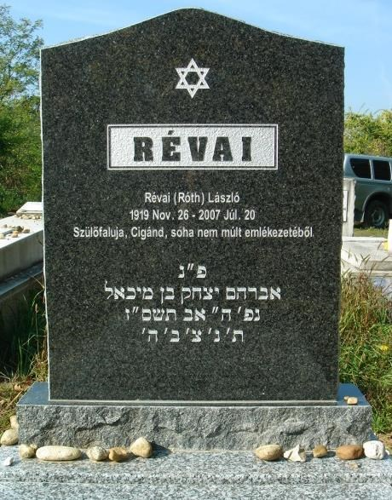
- Mourners will sit on special low chairs, will not cut their hair or nails and cover mirrors to avoid tending to personal appearance. Sexual relations during this time are forbidden.
- During this week, music is not listened to and the wearing of leather shoes is avoided. A candle is kept burning day and night.
- Following shiva is sheloshim. It lasts for 30 days after the funeral. The mourner returns to work, but things such as parties and dances are avoided.
- All festivals during sheloshim are observed.
- After 30 days, normal life is resumed, except for someone mourning a parent. In this case, the restrictions of sheloshim continue for a full year after the funeral.
- During the year, a tombstone will be placed on the grave and there will be a short ceremony to mark the occasion.
- At the end of the year, the children will observe Yahrzeit (anniversary). This is a day of reflection and repentance, and so some Jews fast on it.
- On the eve of Yahrzeit, they burn a special Yahrzeit candle, which burns for 24 hours. This represents the souls of the departed. They may attend synagogue and recite Kaddish. They may also study the Torah and give to charity.
- On Yarzheit, the children visit the grave, often leaving a small stone on the tombstone.

- Give the Hebrew words for the following and explain their meaning in the context of Jewish funerals:  Sacred society
  - Seven
  - Thirty
- Why are Orthodox Jews not cremated?
- What are the meanings of the terms Bet Hayyim and Bet Olam? What message about death do they convey? d) How are sheloshim and Yahrzeit designed to help the bereaved?
e) Not all Jews sit shiva for a full week. What do you think might be gained and what lost by reducing this period of mourning?

Non-religious funeral services
Many people today are uncomfortable with religious ceremonies and, as a result, non-religious funeral services are becoming increasingly popular. Many people want a more informal, personal ceremony, where they can choose the songs and readings and where there is no mention of God.
At a humanist funeral, those present will remember the life of the person who has died, reflecting on their contribution to the world and to others. It may include:
Music
A non-religious reflection on death
Readings of poetry
Reminiscences about the person
A eulogy (a description of why they were special)
Lighting candles
Moments of quiet reflection
The service will be led by a humanist celebrant and it will try to show respect for the dead person without suggesting that they are going to a better place. They will be remembered for their special, unique qualities, the life they led and the achievements they made.
Read the extracts from humanist funerals below. In different colours, highlight or underline words and phrases that refer to key humanist attitudes towards death:
Death is the end of individual existence
Funerals can celebrate a life that has been lived as well as acknowledge sadness at saying goodbye Funerals are an occasion for the living
The absence of an afterlife makes this life more meaningful and means we need to make the most of the one life we have
We can live on after we die through our atoms, genes, works, shared ideas and experiences.

Extracts:

- A humanist ceremony is an opportunity to join in taking leave of someone we have loved … but it is more than that. It is a celebration of the life and personality that has been.
- We know that the value and meaning in life consist of living it – and living it well. People who have been a strength and comfort to others and have worked for future generations, deriving fulfilment and satisfaction from doing so, these are the people who create value and meaning in life.
- All that has life has its beginning and its end. Life exists in the time span between birth and death and, for those of us who believe that death brings the end of individual existence, life’s significance lies in the experiences and satisfactions we achieve in that span of time.
- The comfort of having a friend may indeed be lost, but the comfort of having had that friend is never lost. To match the grief in losing him you have the joy of having known him.
- For those of us who believe that death brings the end of individual existence, recognition of our responsibility for, and dependence on, each other gives life a purpose and significance.
- No life is ever completely lost: we live on through the influence we have had on the lives of those who remain.
- What matters is not that someone has died, but that they have lived. Let us concentrate today on the delight and wonder of their lives.
- I now ask you to remain silent for a moment or two so that you can each remember him in your own way.
- His body we commit to its natural end, its transformation into the ultimate elements of the universe.
- We have been remembering with love and with gratitude a life that has ended. Let us now return to our homes and our work, resolved that we who live on will use our lives more fully and to better purpose for having known him and for having shared in him life.
- We have been remembering and reminding ourselves that the dead reside not in the grave, but in the hearts and minds of the living.

