BOOK 1

NAME:
TEACHER:

GERMANY IN TRANSITION, 1919-39
The Impact of the First World War
Recovery of the Weimar

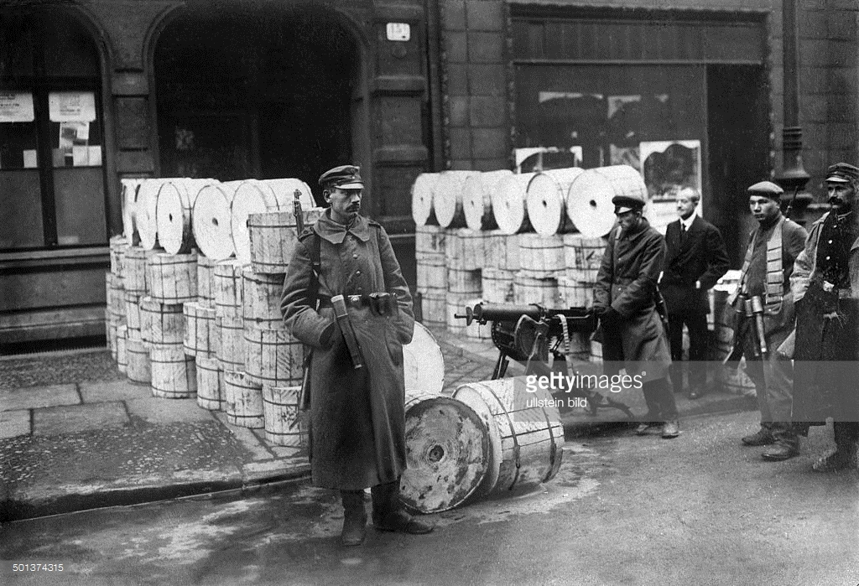

Date marked | Comment

Put syllabus from specification on this page

Key Question 1 - Impact of the First World War
What challenges were faced by the Weimar Republic from 1919-1923
Topics covered: | Topic covered  Tick once you have understood each topic
Impact of the Treaty of Versailles
Weaknesses of the Weimar government
Political instability – Spartacist revolt, Kapp Putsch
Munich Beer Hall Putsch
Hyperinflation, events in the Ruhr 1923

Weaknesses of the Weimar Government

Pages

Read the relevant pages in your text book and complete the following task:


Match up the key word with the correct definition.

System of government based on freedom and equality. | Believers in the ideas of Karl Marx. Economic system built around public ownership | Voting system in which parties win seats in relation to the percentage of votes they win. | A town in Germany which gave it’s name to the new Republic.
The German Emperor. | Ex soldiers with extreme beliefs | A country without a monarch. | German Parliament.
To give up the throne. | A government where one person has total power and does not allow any opposition | A cease fire. | The laws of a country, by which it is governed, written down in a document

Republic
Kaiser
Democracy
Dictatorship
Abdicate
Armistice
Weimar
Constitution
Proportional Representation
Reichstag
Communists
Freikorps
The Problems of Proportional Representation

Look at the following election results for the 20th May 1928 and answer the questions that follow:
Party | % of the vote | Seats
Nazis NSDAP | 2.6% | 12
German National Party | 14.2 | 73
Germans Peoples Party | 8.7 | 45
Catholic Centre | 15.1 | 78
German Democratic Party | 3.8 | 25
Social Democrats | 29.8 | 153
Communists | 10.6 | 54
Bavarian People's Party | 2 | 7
Christian People's Party | 3 | 10
German Farmers' Party | 1 | 5
Independent Social Democratic Party of Germany | 5 | 14
German Hanoverian Party | 2.2 | 8
Economic Party of the German Middle Classes | 2 | 7

- How many deputies, in total, were there in the Reichstag in 1928?

- Which party has the greatest percentage of the vote?

- Does the party with the greatest percentage of the vote have enough seats to gain a majority and rule on their own? If not who are they likely to join up with?
- Would this coalition now have a majority?

- What problems does this system of proportional representation create?

The Weimar Constitution
Write out a definition for:
Proportional representation:
………………………………………………………………………………………………………………………………………………………………………………………………………………………………………………………………….............................................................................................
Article 48:
…………………………………………………………………………………………………………………………………………………………………………………………………………………………

Fill in the table using the list below:
 | Strengths | Weaknesses
Proportional representation
Article 48

Voting system based on fairness | Made it easier for small parties to be formed
Decisions could be made quickly in an emergency | Made it difficult for one party to win a majority and form a government
It contributed to instability | Led to weak coalition governments
Very democratic. Both men and women over the age of 20 had the vote | The head of the government (the Chancellor) had to have the support of most of the politicians of the Reichstag
A strong President was necessary to keep control over the government and to protect the country in a crisis | It could be misused to form a dictatorship and become non-democratic
Exam question 1
This question is about the impact of the First World War
Source A
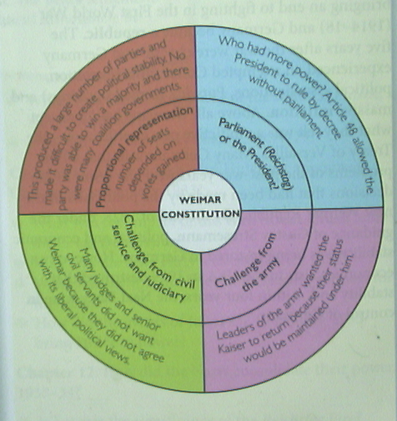

[A diagram from a GCSE textbook illustrating the flaws of the Weimar Constitution]

Use Source A and your own knowledge to describe the weaknesses of the Weimar Constitution. [6]

--------------------------------------------------------------------------------------------------------------------------------------------------------------------------------------------------------------------------------------------------------------------------------------------------------------------------------------------------------------------------------------------------------------------------------------------------------------------------------------------------------------------------------------------------------------------------------------------------------------------------------------------------------------------------------------------------------------------------------------------------------------------------------------------------------------------------------------------------------------------------------------------------------------------------------------------------------------------------

Pages

Impact of the Treaty of Versailles

Read the relevant pages and fill in the boxes on the map using the information below:
Germany lost all her colonies
North Schleswig given to Denmark
Danzig was to be run by the League of Nations
Germany was forbidden to unite with Austria
Posen, rich farmland given to Poland
Saar coalfields given to France for 15 years
Eupen and Malmedy given to Belgium
Demilitarised zone
Poland was given a corridor to the Baltic sea cutting off East Prussia from Germany
New German government met here
Alsace Lorraine was given back to France. They had lost it to Germany in the 1871 war

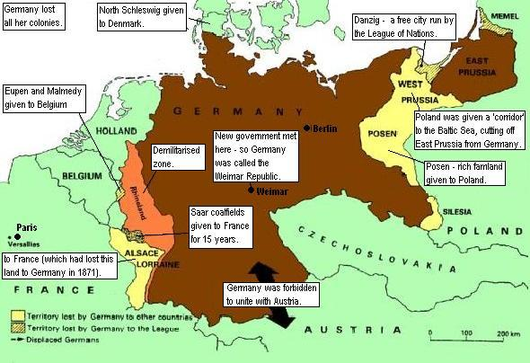

Exam question 1
Study the source below and then answer the question which follows.
Source B
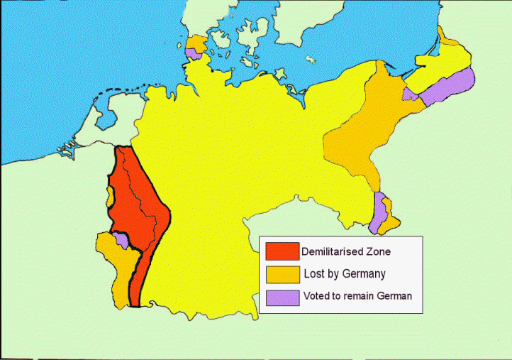

[Map showing the territorial terms of the Treaty of Versailles]
Use Source B and your own knowledge to describe the territorial clauses of the Treaty of Versailles [6]
Examiner only
- For this answer you just need to describe the various territorial clauses of the Treaty
- DO NOT discuss financial or military clauses
- Use the map first to help you
- Then bring in your own knowledge
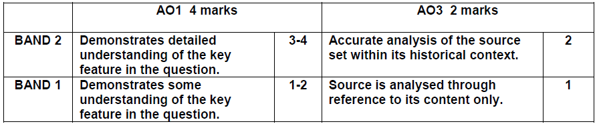

------------------------------------------------------------------------------------------------------------------------------------------------------------------------------------------------------------------------------------------------------------------------------------------------------------------------------------------------------------------------------------------------------------------------------------------------------------------------------------------------------------------------------------------------------------------------------------------------------------------------------------------------------------------------------------------------------------------------------------------------------------------------------------------------------------------------------------------------------------------------------------------------------------------------------------------------------------------------------------------------------------------------------------------------------------------------------------------------------------------------------------------------------------------------------------------------------------------------------------------------------------------------------------------------------------------------------------------------------------------------------------------------------------------------------------------------------------------------------------------------------------------------------------------------------------------------------------------------------------------------------------------------------------------------------------------------------------------------------------------------------------------------------------------------------------------------------------------------------------------------------------------------------------------------------------------------------------------------------------------------------------------------------------------------------------------------------------------------------------------------------------------------------------------------------------------------------------------------------------------------------------------------------------------------------------------------------------------------------------------------------------------------------------------------------------------------------------------------------------------------------------

Exam question 3
Study the source below and then answer the question which follows.
Source C
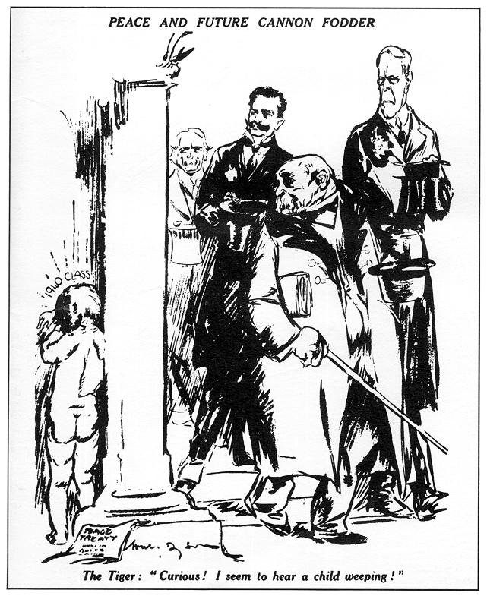

[Cartoon from the Daily Herald, 17th May 1919. (The Daily Herald was a popular British newspaper selling to the working class)]

What was the purpose of Source B?
When answering this question you need to follow the plan below:
- Provide a brief answer to the question in your introduction
- Put the source into context by discussing the invasion of the Ruhr
- Discuss the content of the source. What is the message in the cartoon?
- Finally, reach a judgment by explaining why the cartoon has been produced. Consider its audience and purpose.

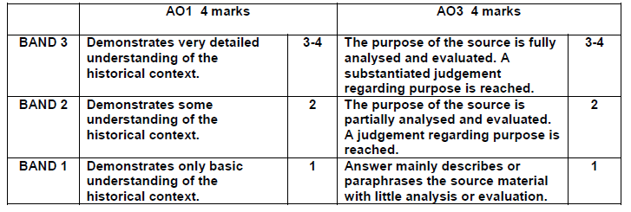

[8]
[Use details from Source B and your own knowledge and understanding of the historical context to answer the question.]
----------------------------------------------------------------------------------------------------------------------------------------------------------------------------------------------------------------------------------------------------------------------------------------------------------------------------------------------------------------------------------------------------------------------------------------------------------------------------------------------------------------------------------------------------------------------------------------------------------------------------------------------------------------------------------------------------------------------------------------------------------------------------------------------------------------------------------------------------------------------------------------------------------------------------------------------------------------------------------------------------------------------------------------------------------------------------------------------------------------------------------------------------------------------------------------------------------------------------------------------------------------------------------------------------------------------------------------------------------------------------------------------------------------------------------------------------------------------------------------------------------------------------------------------------------------------------------------------------------------------------------------------------------------------------------------------------------------------------------------------------------------------------------------------------------------------------------------------------------------------------------------------------------------------------------------------------------------------------------------------------------------------------------------------------------------------------------------------------------------------------------------------------------------------------------------------------------------------------------------------------------------------------------------------------------------------------------------------------------------------------------------------------------------------------------------------------------------------------------------------------------------------------------------------------------------------------------------------------------------------------------------------------------------------------------------------------------------------------------------------------------------------------------------------------------------------------------------------------------------------------------------------------------------------------------------------------------------------------------------------------------------------------------------------------------------------------------------------------------------------------------------------------------------------------------------------------------------------------------------------------------------------------------------------------------------------------------------------
Pages

The Spartacist revolt

Read the relevant pages about the Spartacist revolt and fill in the table below:
Who were the Spartacists?
Why did they revolt?
What did they do?
When did the revolt happen?
Where did the revolt take place?
What were the consequences of the revolt?

Exam question 1
Source D

[Spartacists outside the governments newspaper offices during their revolt in January 1919]

Use Source D and your own knowledge to describe the Spartacist revolt in January 1919. [6]
-----------------------------------------------------------------------------------------------------------------------------------------------------------------------------------------------------------------------------------------------------------------------------------------------------------------------------------------------------------------------------------------------------------------------------------------------------------------------------------------------------------------------------------------------------------------------------------------------------------------------------------------------------------------------------------------------------------------------------------------------------------------------------------------------------------------------------------------------------------------------------------------------------------------------------------------------------------------------------------------------------------------------------------------------------------------------------------------------------------------------------------------------------------------------------------------------------------------------------------------------------------------------------------------------------------------------------------------------------------------------------------------------------------------------------------------------------------------------------------------------------------------------------------------------------------------------------------------------------------------------------------------------------------------------------------------------------------------------------------------------------------------------------------------------------------
Who was Wolfgang Kapp?
Why did he call a revolt?
What was his plan?
How was the revolt put down?
Pages

The Kapp Putsch

Events in the Ruhr, 1923 - Hyperinflation

Pages

Read the relevant pages and answer the question that follows:

Exam question 4
This question is about the events in the Ruhr 1923.
Study the sources below and then answer the question that follows.
Source E
By January 1923 the French had lost patience with the Germans. French and Belgium troops marched into the Ruhr to take the goods they needed in compensation for Germany failing to pay reparations. The German government called for a policy of ‘passive resistance’ and payed workers by printing more money. The caused inflation to rise and by April 1923 the government was spending seven times more that it was receiving in revenue. The result was hyperinflation, the value of the mark fell rapidly and became worthless.

[Historians Greg Lacey and Keith Shephard, writing in a history GCSE textbook, Germany 1918-1945 (1997)]
Source F
I vividly remember pay days at that time. I used to have to accompany the manager to the bank in an open six seater Benz which we filled to the brim with bundles and bundles of million mark notes. We drove back through the narrow streets quite unmolested. And when they got their wages, the workmen did not even bother to count the number of notes in each bundle.

[A question from a Nazi math’s textbook, 1933]

[A worker in a transport firm interviewed for a book made up of personal memories, Life during the Weimar (1968)]

Which of the sources is more useful to an historian studying the Weimar economy and the events of 1923?
[12]
[You should refer to both sources in your answer and use your knowledge and understanding of the historical context.]
When answering this question you need to follow the plan below:
- Read both sources and consider content and look carefully at attribution
- Start with source E
- Begin by considering if the source is useful by discussing content. What does the source say about the Weimar economy and the events of 1923? Can you learn anything from the source?

- Now look at who wrote the source. Consider why it was written and look at the strengths and weaknesses in terms of reliability.

- Complete the same steps for source F

- Make a judgment at the end. Which source do you consider to be most useful.
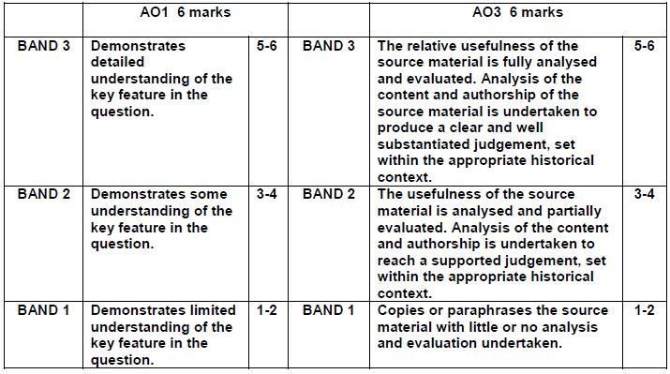

------------------------------------------------------------------------------------------------------------------------------------------------------------------------------------------------------------------------------------------------------------------------------------------------------------------------------------------------------------------------------------------------------------------------------------------------------------------------------------------------------------------------------------------------------------------------------------------------------------------------------------------------------------------------------------------------------------------------------------------------------------------------------------------------------------------------------------------------------------------------------------------------------------------------------------------------------------------------------------------------------------------------------------------------------------------------------------------------------------------------------------------------------------------------------------------------------------------------------------------------------------------------------------------------------------------------------------------------------------------------------------------------------------------------------------------------------------------------------------------------------------------------------------------------------------------------------------------------------------------------------------------------------------------------------------------------------------------------------------------------------------------------------------------------------------------------------------------------------------------------------------------------------------------------------------------------------------------------------------------------------------------------------------------------------------------------------------------------------------------------------------------------------------------------------------------------------------------------------------------------------------------------------------------------------------------------------------------------------------------------------------------------------------------------------------------------------------------------------------------------------------------------------------------------------------------------------------------------------------------------------------------------------------------------------------------------------------------------------------------------------------------------------------------------------------------------------------------------------------------------------------------------------------------------------------------------------------------------------------------------------------------------------------------------------------------
------------------------------------------------------------------------------------------------------------------------------------------------------------------------------------------------------------------------------------------------------------------------------------------------------------------------------------------------------------------------------------------------------------------------------------------------------------------------------------------------------------------------------------------------------------------------------------------------------------------------------------------------------------------------------------------------------------------------------------------------------------------------------------------------------------------------------------------------------------------------------------------------------------------------------------------------------------------------------------------------------------------------------------------------------------------------------------------------------------------------------------------------------------------------------------------------------------------------------------------------------------------------------------------------------------------------------------------------------------------------------------------------------------------------------------------------------------------------------------------------------------------------------------------------------------------------------------------------------------------------------------------------------------------------------------------------------------------------------------------------------------------------------------------------------------------------------------------------------------------------------------------------------------------------------------------------------------------------------------------------------------------------------------------------------------------------------------------------------------------------------------------------------------------------------------------------------------------------------------------------------------------------------------------------------------------------------------------------------------------------------------------------------------------------------------------------------------------------------------------------------------------------------------------------------------------------------------------------------------------------------------------------------------------------------------------------------------------------------------------------------------------------------------------------------------------------------------------------------------------------------------------------------------------------------------------------------------------------------------------------------------------------------------------------------------------

QUESTION 3
This question is about the invasion of the Ruhr 1923
Study the source below and then answer the question which follows.
Source G
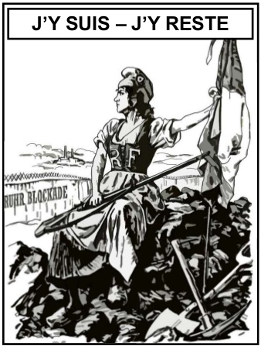

[A British cartoon from Punch 1923, the writing translates ‘Here I am – Here I stay’]

What was the purpose of Source B? [8]

[Use details from Source B and your own knowledge and understanding of the historical context to answer the question.]

------------------------------------------------------------------------------------------------------------------------------------------------------------------------------------------------------------------------------------------------------------------------------------------------------------------------------------------------------------------------------------------------------------------------------------------------------------------------------------------------------------------------------------------------------------------------------------------------------------------------------------------------------------------------------------------------------------------------------------------------------------------------------------------------------------------------------------------------------------------------------------------------------------------------------------------------------------------------------------------------------------------------------------------------------------------------------------------------------------------------------------------------------------------------------------------------------------------------------------------------------------------------------------------------------------------------------------------------------------------------------------------------------------------------------------------------------------------------------------------------------------------------------------------------------------------------------------------------------------------------------------------------------------------------------------------------------------------------------------------------------------------------------------------------------------------------------------------------------------------------------------------------------------------------------------------------------------------------------------------------------------------------------------------------------------------------------------------------------------------------------------------------------------------------------------------------------------------------------------------------------------------------------------------------------------------------------------------------------------------------------------------------------------------------------------------------------------------------------------------------------------------------------------------------------------------------------------------------------------------------------------------------------------------------------------------------------------------------------------------------------------------------------------------------------------------------------------------------------------------------------------------------------------------------------------------------------------------------------------------------------------------------------------------------------------------

Pages
The Munich Beer Hall Putsch

The Munich Beer Hall Putsch – Success or Failure?
Read the relevant pages in the text book and fill in the table below:
Success | Failure

Exam question 5
Was the Munich Beer Hall Putsch a great success for Hitler and the Nazis? [16]
Use your own knowledge and understanding of the issue to support your answer. Marks for spelling, punctuation and the accurate use of grammar and specialist language are allocated to this question. [3]
- You need to develop a two-sided answer which has balance and good support
- You should start by discussing the factor mentioned in the question, using your factual knowledge to explain why the Munich Beer Hall Putsch was a great success for Hitler and the Nazis
- You then need to consider the counter argument by using you knowledge to examine other relevant factors. Discuss why Munich Beer Hall Putsch wasn’t a great success for Hitler and the Nazis
- Aim to link each paragraph by using words such as ‘other factors include’, ‘also important’, ‘in addition to’, ‘however’.
- Conclude your answer with a link back to the question, making a judgement about the success of the Munich Beer Hall Putsch for Hitler and the Nazis
- Aim to write between one and two sides of A4
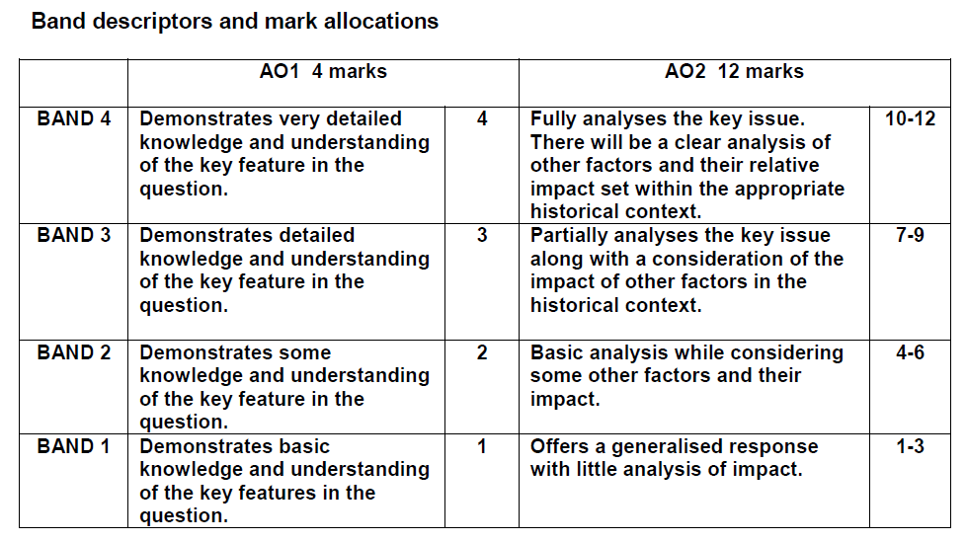

------------------------------------------------------------------------------------------------------------------------------------------------------------------------------------------------------------------------------------------------------------------------------------------------------------------------------------------------------------------------------------------------------------------------------------------------------------------------------------------------------------------------------------------------------------------------------------------------------------------------------------------------------------------------------------------------------------------------------------------------------------------------------------------------------------------------------------------------------------------------------------------------------------------------------------------------------------------------------------------------------------------------------------------------------------------------------------------------------------------------------------------------------------------------------------------------------------------------------------------------------------------------------------------------------------------------------------------------------------------------------------------------------------------------------------------------------------------------------------------------------------------------------------------------------------------------------------------------------------------------------------------------------------------------------------------------------------------------------------------------------------------------------------------------------------------------------------------------------------------------------------------------------------------------------------------------------------------------------------------------------------------------------------------------------------------------------------------------------------------------------------------------------------------------------------------------------------------------------------------------------------------------------------------------------------------------------------------------------------------------------------------------------------------------------------------------------------------------------------------------------------------------------------------------------------------------------------------------------------------------------------------------------------------------------------------------------------------------------------------------------------------------------------------------------------------------------------------------------------------------------------------------------------------------------------------------------------------------------------------------------------------------------------------------------------------
------------------------------------------------------------------------------------------------------------------------------------------------------------------------------------------------------------------------------------------------------------------------------------------------------------------------------------------------------------------------------------------------------------------------------------------------------------------------------------------------------------------------------------------------------------------------------------------------------------------------------------------------------------------------------------------------------------------------------------------------------------------------------------------------------------------------------------------------------------------------------------------------------------------------------------------------------------------------------------------------------------------------------------------------------------------------------------------------------------------------------------------------------------------------------------------------------------------------------------------------------------------------------------------------------------------------------------------------------------------------------------------------------------------------------------------------------------------------------------------------------------------------------------------------------------------------------------------------------------------------------------------------------------------------------------------------------------------------------------------------------------------------------------------------------------------------------------------------------------------------------------------------------------------------------------------------------------------------------------------------------------------------------------------------------------------------------------------------------------------------------------------------------------------------------------------------------------------------------------------------------------------------------------------------------------------------------------------------------------------------------------------------------------------------------------------------------------------------------------------------------------------------------------------------------------------------------------------------------------------------------------------------------------------------------------------------------------------------------------------------------------------------------------------------------------------------------------------------------------------------------------------------------------------------------------------------------------------------------------------------------------------------------------------------------------------

Key Question 2 – Recovery of the Weimar
Why were the Stresemann years considered a ‘golden age’?

Topics covered: | Topic covered  Tick once you have understood each topic
Recovery form hyperinflation
Dawes and Yong Plans
The Locarno Pact
Relations with the League of Nations
US investment
Social and political investments

Pages

Recovery form hyperinflation

Source A
In comparison with what we expected after Versailles, Germany has raised herself up to shoulder the terrific burden of this peace in a way we would never have thought possible. So that today after ten years we may say with certainty ‘Even so, it might have been worse ‘. The stage of convalescence from Versailles is a very long road to go and we have travelled it surprisingly quickly.

[From a German journalist, written in 1930]

Source B
The economic position is only flourishing on the surface. Germany is in fact dancing on a volcano. If the short term loans are called in by America, a large section of our economy would collapse.

[From a speech by Stresemann, 1929]

Source C
However, the German recovery still had serious weaknesses. It depended on American loans which could be withdrawn at any time. Unemployment was a serious problem. The economy might be growing, but it wasn’t creating jobs fast enough for Germanys rising population. Some sectors of the economy were in trouble, throughout the 1920s, farming in particular.

[From a school textbook entitled A History of Germany 1918-45, written in 1997]
Using the text book and the sources above fill in the table below:

Evidence for economic recovery | Evidence against economic recovery

Exam question 4
Study sources A and B and then answer the question that follows.
Which of the sources is more useful to an historian studying the Weimar economy and the events of 1923?

--------------------------------------------------------------------------------------------------------------------------------------------------------------------------------------------------------------------------------------------------------------------------------------------------------------------------------------------------------------------------------------------------------------------------------------------------------------------------------------------------------------------------------------------------------------------------------------------------------------------------------------------------------------------------------------------------------------------------------------------------------------------------------------------------------------------------------------------------------------------------------------------------------------------------------------------------------------------------------------------------------------------------------------------------------------------------------------------------------------------------------------------------------------------------------------------------------------------------------------------------------------------------------------------------------------------------------------------------------------------------------------------------------------------------------------------------------------------------------------------------------------------------------------------------------------------------------------------------------------------------------------------------------------------------------------------------------------------------------------------------------------------------------------------------------------------------------------------------------------------------------------------------------------------------------------------------------------------------------------------------------------------------------------------------------------------------------------------------------------------------------------------------------------------------------------------------------------------------------------------------------------------------------------------------------------------------------------------------------------------------------------------------------------------------------------------------------------------------------------------------------------------------------------------------------------------------------------------------------------------------------------------------
-------------------------------------------------------------------------------------------------------------------------------------------------------------------------------------------------------------------------------------------------------------------------------------------------------------------------------------------------------------------------------------------------------------------------------------------------------------------------------------------------------------------------------------------------------------------------------------------------------------------------------------------------------------------------------------------------------------------------------------------------------------------------------------------------------------------------------------------------------------------------------------------------------------------------------------------------------------------------------------------------------------------------------------------------------------------------------------------------------------------------------------------------------------------------------------------------------------------------------------------------------------------------------------------------------------------------------------------------------------------------------------------------------------------------------------------------------------------------------------------------------------------------------------------------------------------------------------------------------------------------------------------------------------------------------------------------------------------------------------------------------------------------------------------------------------------------------------------------------------------------------------------------------------------------------------------------------------------------------------------------------------------------------------------------------------------------------------------------------------------------------------------------------------------------------------------------------------------------------------------------------------------------------------------------------------------------------------------------------------------------------------------------------------------------------------------------------------------------------------------------------------------------------------------------------------------------------------------------------------------------------------------------

The Locarno Pact

Pages

Exam Question 1
Study the source below and then answer the question which follows.
Source D
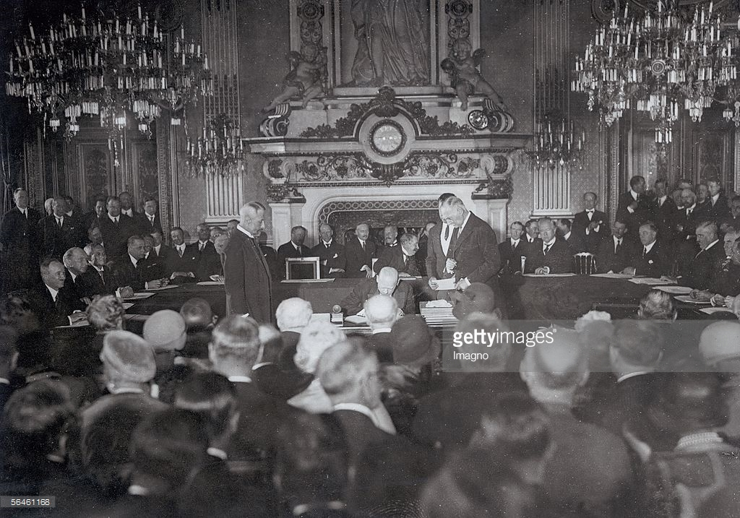

[Stresemann signing the Locarno Pact, 1925]
Use source D and your own knowledge to describe the Locarno Pact of 1925
-----------------------------------------------------------------------------------------------------------------------------------------------------------------------------------------------------------------------------------------------------------------------------------------------------------------------------------------------------------------------------------------------------------------------------------------------------------------------------------------------------------------------------------------------------------------------------------------------------------------------------------------------------------------------------------------------------------------------------------------------------------------------------------------------------------------------------------------------------------------------------------------------------------------------------------------------------------------------------------------------------------------------------------------------------------------------------------------------------------------------------------------------------------------------------------------------------------------------------------------------------------------------------------------------------------------------------------------------------------------------------------------------------------------------------------------------------------------------------------------------------------------------------------------------------------------------------------------------------------------------------------------------------------------------------------------------------------------------------------------------------------------------------------------------------------------------------------------------------------------------------------------------------------------------------------------------------------------------------------------------------------------------------------------------------------------------------------------------------------------------------------------------------------------------------------------------------------------------------------------------------------------------------------------------------------------------------------------------------------------------------------------------------------------------------------------------------------------------------------------------------------

Relations with the League of Nations

Exam Question 1
Study the source below and then answer the question which follows.
Source E
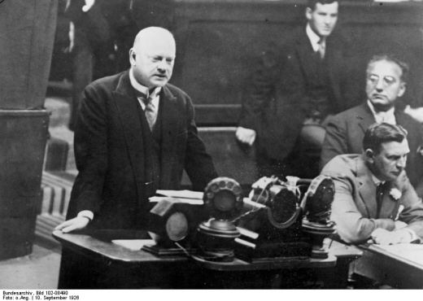

[Gustav Stresemann, German Minister for Foreign Affairs gives his inaugural speech on the occasion of Germany being admitted to the League of Nations.]

Use source E and your own knowledge to describe the why joining the League of Nations was a success for Germany
-----------------------------------------------------------------------------------------------------------------------------------------------------------------------------------------------------------------------------------------------------------------------------------------------------------------------------------------------------------------------------------------------------------------------------------------------------------------------------------------------------------------------------------------------------------------------------------------------------------------------------------------------------------------------------------------------------------------------------------------------------------------------------------------------------------------------------------------------------------------------------------------------------------------------------------------------------------------------------------------------------------------------------------------------------------------------------------------------------------------------------------------------------------------------------------------------------------------------------------------------------------------------------------------------------------------------------------------------------------------------------------------------------------------------------------------------------------------------------------------------------------------------------------------------------------------------------------------------------------------------------------------------------------------------------------------------------------------------------------------------------------------------------------------------------------------------------------------------------------------------------------------------------------------------------------------------------------------------------------------------------------------------------------------------------------------------------------------------------------------------------------------------------------------------------------------------------------------------------------------------------------------------------------------------------------------------------------------------------------------------------------------------------------------------------------------------------------------------------------------------------------

Pages

Social and political developments

Read the relevant pages and make notes explaining how housing, unemployment and insurance changed in the year 1924-29.

Wages | Housing | Insurance

Pages

The position of women

Read the relevant pages in your text book answer the question that follows:

Exam Question 3
Study the source below and then answer the question which follows.
Source F

[A photograph showing women in a bar, in Berlin in 1930. It appeared in a German magazine about changing lifestyles during the Weimar period]

What was the purpose of Source F? [8]

[Use details from Source B and your own knowledge and understanding of the historical context to answer the question.]

.
----------------------------------------------------------------------------------------------------------------------------------------------------------------------------------------------------------------------------------------------------------------------------------------------------------------------------------------------------------------------------------------------------------------------------------------------------------------------------------------------------------------------------------------------------------------------------------------------------------------------------------------------------------------------------------------------------------------------------------------------------------------------------------------------------------------------------------------------------------------------------------------------------------------------------------------------------------------------------------------------------------------------------------------------------------------------------------------------------------------------------------------------------------------------------------------------------------------------------------------------------------------------------------------------------------------------------------------------------------------------------------------------------------------------------------------------------------------------------------------------------------------------------------------------------------------------------------------------------------------------------------------------------------------------------------------------------------------------------------------------------------------------------------------------------------------------------------------------------------------------------------------------------------------------------------------------------------------------------------------------------------------------------------------------------------------------------------------------------------------------------------------------------------------------------------------------------------------------------------------------------------------------------------------------------------------------------------------------------------------------------------------------------------------------------------------------------------------------------------------------------------------------------------------------------------------------------------------------------------------------------------------------------------------------------------------------------------------------------------------

Cultural changes

Read the relevant changes in the text book and make a mind map summarising the main changes in art, architecture, the cinema and literature.

Cultural changes

Weimar Art
Annotate the paining below entitled Grey Day by George Grosz

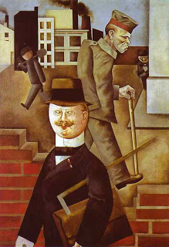

Annotate the paining below entitled Big City by Otto Dix

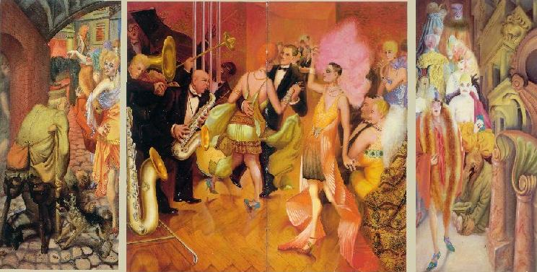

Exam Question 1
Study the source below and then answer the question which follows.
Source D
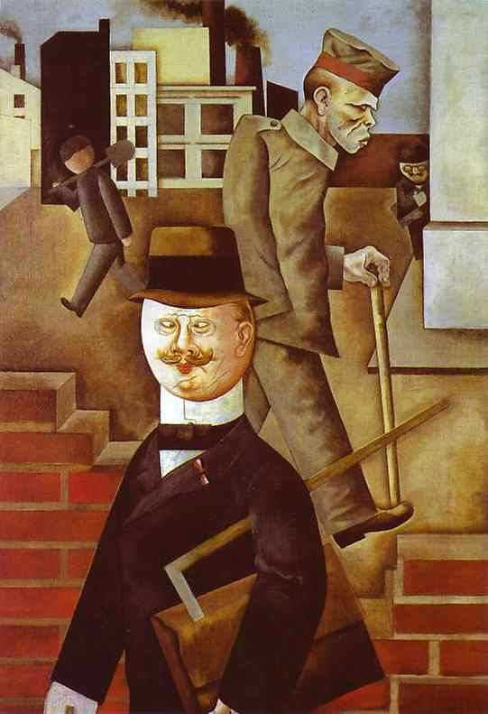

[Grey Day by George Grosz, 1921]
Use source D and your own knowledge to describe Weimar Art

--------------------------------------------------------------------------------------------------------------------------------------------------------------------------------------------------------------------------------------------------------------------------------------------------------------------------------------------------------------------------------------------------------------------------------------------------------------------------------------------------------------------------------------------------------------------------------------------------------------------------------------------------------------------------------------------------------------------------------------------------------------------------------------------------------------------------------------------------------------------------------------------------------------------------------------------------------------------------------------------------------------------------------------------------------------------------------------------------------------------------------------------------------------------------------------------------------------------------------------------------------------------------------------------------------------------------------------------------------------------------------------------------------------------------------------------------------------------------------------------------------------------------------------------------------------------------------------------------------------------------------------------------------------------------------------------------------------------------------------------------------------------------------------------------------------------------------------------------------------------------------------------------------------------------------------------------------------------------------------------------------------------------------------------------------------------------------------------------------------------------------------------------------------------------------------------------------------------------------

Exam question 5
‘By 1929 the Weimar Republic had overcome its early problems and become firmly established in Germany.’
To what extent do you agree with this interpretation? [16]
Use your own knowledge and understanding of the issue to support your answer. Marks for spelling, punctuation and the accurate use of grammar and specialist language are allocated to this question. [3]
- You need to develop a two-sided answer which has balance and good support
- You should start by discussing the factor mentioned in the question, using your factual knowledge to explain how and why the Weimar had overcome its problems.
- You then need to consider the counter argument by using your knowledge to examine other relevant factors. Discuss why the Weimar still faced problems.
- Aim to link each paragraph by using words such as ‘other factors include’, ‘also important’, ‘in addition to’, ‘however’.
- Conclude your answer with a link back to the question, making a judgement about the extent of recovery.
- Aim to write between one and two sides of A4

------------------------------------------------------------------------------------------------------------------------------------------------------------------------------------------------------------------------------------------------------------------------------------------------------------------------------------------------------------------------------------------------------------------------------------------------------------------------------------------------------------------------------------------------------------------------------------------------------------------------------------------------------------------------------------------------------------------------------------------------------------------------------------------------------------------------------------------------------------------------------------------------------------------------------------------------------------------------------------------------------------------------------------------------------------------------------------------------------------------------------------------------------------------------------------------------------------------------------------------------------------------------------------------------------------------------------------------------------------------------------------------------------------------------------------------------------------------------------------------------------------------------------------------------------------------------------------------------------------------------------------------------------------------------------------------------------------------------------------------------------------------------------------------------------------------------------------------------------------------------------------------------------------------------------------------------------------------------------------------------------------------------------------------------------------------------------------------------------------------------------------------------------------------------------------------------------------------------------------------------------------------------------------------------------------------------------------------------------------------------------------------------------------------------------------------------------------------------------------------------------------------------------------------------------------------------------------------------------------------------------------------------------------------------------------------------------------------------------------------------------------------------------------------------------------------------------------------------------------------------------------------------------------------------------------------------------------------------------------------------------------------------------------------------------------------
------------------------------------------------------------------------------------------------------------------------------------------------------------------------------------------------------------------------------------------------------------------------------------------------------------------------------------------------------------------------------------------------------------------------------------------------------------------------------------------------------------------------------------------------------------------------------------------------------------------------------------------------------------------------------------------------------------------------------------------------------------------------------------------------------------------------------------------------------------------------------------------------------------------------------------------------------------------------------------------------------------------------------------------------------------------------------------------------------------------------------------------------------------------------------------------------------------------------------------------------------------------------------------------------------------------------------------------------------------------------------------------------------------------------------------------------------------------------------------------------------------------------------------------------------------------------------------------------------------------------------------------------------------------------------------------------------------------------------------------------------------------------------------------------------------------------------------------------------------------------------------------------------------------------------------------------------------------------------------------------------------------------------------------------------------------------------------------------------------------------------------------------------------------------------------------------------------------------------------------------------------------------------------------------------------------------------------------------------------------------------------------------------------------------------------------------------------------------------------------------------------------------------------------------------------------------------------------------------------------------------------------------------------------------------------------------------------------------------------------------------------------------------------------------------------------------------------------------------------------------------------------------------------------------------------------------------------------------------------------------------------------------------------------------------------------

