BOOK 2

NAME:
TEACHER:

GERMANY IN TRANSITION, 1919-39
End of the Weimar
Consolidation of Power

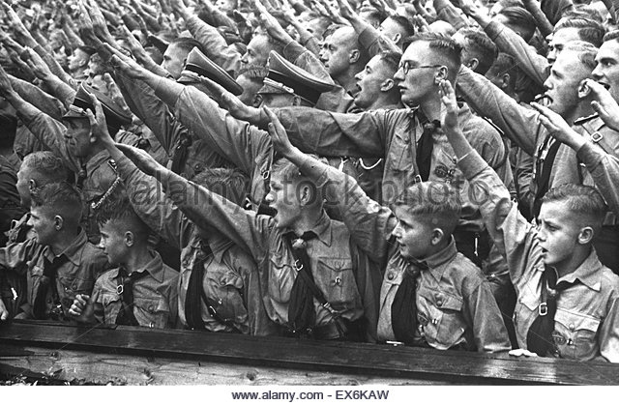

Date marked | Comment

Put syllabus from specification on this page

Key Question 3 - The end of the Weimar
How and why did the Weimar Republic collapse between 1929 and 1933
Topics covered: | Topic Tick once you have understood each topic
Social and political impact of the depression on the Weimar Republic
The reasons for growing support for the Nazis
The role of the SA
Propaganda
Political extremism and scheming 1929-32

Social and political impact of the depression on the Weimar Republic

Exam question 1
Study the source below and then answer the question which follows.
Source A

[A table illustrating election results from 1924 to 1933]
Use source E and your own knowledge to describe what happened to the Nazi vote from 1924 to 1933. [6]
---------------------------------------------------------------------------------------------------------------------------------------------------------------------------------------------------------------------------------------------------------------------------------------------------------------------------------------------------------------------------------------------------------------------------------------------------------------------------------------------------------------------------------------------------------------------------------------------------------------------------------------------------------------------------------------------------------------------------------------------------------------------------------------------------------------------------------------------------------------------------------------------------------------------------------------------------------------------------------------------------------------------------------------------------------------------------------------------------------------------------------------------------------------------------------------------------------------------------------------------------------------------------------------------------------------------------------------------------------------------------------------------------------------------------------------------------------------------------------------------------------------------------------------------------------------------------------------------------------------------------------------------------------------------------------------------------------------------------------------------------------------------------------------------------------------------------------------------------------------------------------------------------------------------------------------------------------------------------------------------------------------------------------------------------------------------------------------------------------------------------------------------------------------------------

Page

Exam question 1
This question is about the end of the Weimar Republic
Study the source below and then answer the question which follows.
Source B
Where two Englishmen will, in nine cases out of ten, begin a conversation by discussing sport, two Germans will ask each other why they and their families should go hungry in a world stuffed with food.....This explains the keen interest which all classes in Germany are taking in politics...........When men and women in their tens of thousands will sit for hours listening to National Socialist and Communists, it means that politics have become a matter of bread and butter.

[From Slump! A Study of Stricken Europe Today written By H, H Tiltman, a US journalist, 1932]
Use source B and your own knowledge to describe the political situation in Germany in 1932. [6]
------------------------------------------------------------------------------------------------------------------------------------------------------------------------------------------------------------------------------------------------------------------------------------------------------------------------------------------------------------------------------------------------------------------------------------------------------------------------------------------------------------------------------------------------------------------------------------------------------------------------------------------------------------------------------------------------------------------------------------------------------------------------------------------------------------------------------------------------------------------------------------------------------------------------------------------------------------------------------------------------------------------------------------------------------------------------------------------------------------------------------------------------------------------------------------------------------------------------------------------------------------------------------------------------------------------------------------------------------------------------------------------------------------------------------------------------------------------------------------------------------------------------------------------------------------------------------------------------------------------------------------------------------------------------------------------------------------------------------------------------------------------------------------------

The reasons for growing support for the Nazis
Page
Use the text book to make notes in the relevant boxes
The weakness of the Weimar

The affects of the depression

Role of the SA

Financial support for the Nazis

The role of Josef Goebbels

The role of Hitler

Exam question 1
This question is about the end of the Weimar Republic
Study the source below and then answer the question which follows.
Source C
After 1929 there a terrible economic crisis began in Germany which developed into the Great Depression. Unemployment soared and prices of agricultural products and consumer goods fell sharply causing financial hardship for farmers, small businesses and the self-employed. The Great Depression brought misery to millions of Germans. This explains why so many people started to vote for the extremist parties

[From a school textbook]

Use source C and your own knowledge to describe why the Great Depression had a serious impact on life in Germany in the early 1930s. [6]
------------------------------------------------------------------------------------------------------------------------------------------------------------------------------------------------------------------------------------------------------------------------------------------------------------------------------------------------------------------------------------------------------------------------------------------------------------------------------------------------------------------------------------------------------------------------------------------------------------------------------------------------------------------------------------------------------------------------------------------------------------------------------------------------------------------------------------------------------------------------------------------------------------------------------------------------------------------------------------------------------------------------------------------------------------------------------------------------------------------------------------------------------------------------------------------------------------------------------------------------------------------------------------------------------------------------------------------------------------------------------------------------------------------------------------------------------------------------------------------------------------------------------------------------------------------------------------------------------------------------------------------------------------------------------------------------------------------------------------------------------------------------------------------

Exam question 4
This question is about the end of the Weimar Republic
Study the sources below and then answer the question that follows.

Source D

[A photograph of Hitler addressing a mass rally of Nazi Party members in 1932]

Source E
Several of my meetings have been disrupted and a considerable section of the audience had to be taken away badly injured. I urgently request the cancellation of
the meeting with me as speaker. As things are, there is obviously no longer any police protection able to stop the aggressive actions of the SA.

[A report written by a member of the Social Democratic Party in Berlin (February 1932)]

Which of the sources is more useful to an historian the reasons why the Nazi Party gained support in Germany [12]
[You should refer to both sources in your answer and use your knowledge and understanding of the historical context.]

.........................................................................................................………………………..................................................................................................................................................................................................................................................................................................................................................................................................................................................................................................................................................................................................................................……………………….............................................................................................................................................................................................................................................................................................................................................................................................................
.........................................................................................................………………………......................................................................................................................................................................................................................................................................................................................................................................................................................................................................................................................................................................................................................
….........................................................................................................................................................................................................................................................................................................................................................................................................................................................................................................................................................................................................
.........................................................................................................………………………..................................................................................................................................................................................................................................................................................................................................................................................................................................................................................................................................................................................................................................……………………….............................................................................................................................................................................................................................................................................................................................................................................................................
.........................................................................................................………………………................................................................................................................................................................................................................................................................................................................ .........................................................................................................………………………..................................................................................................................................................................................................................................................................................................................................................................................................................................................................................................................................................................................................................................……………………….............................................................................................................................................................................................................................................................................................................................................................................................................
.........................................................................................................………………………......................................................................................................................................................................................................................................................................................................................................................................................................................................................................................................................................................................................................................

QUESTION 3
This question is about the end of the Weimar
Study the source below and then answer the question which follows.
Source F
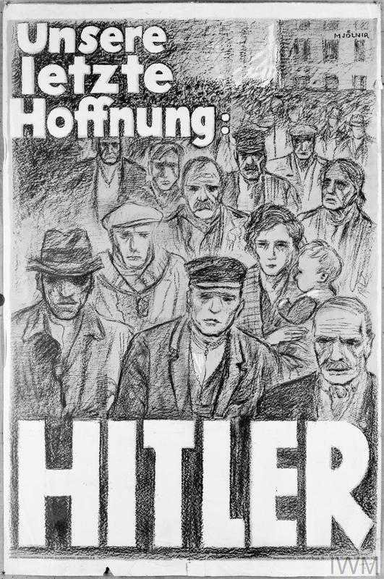

[A Nazi election poster from 1932. The words translate as 'Our last hope: Hitler']

What was the purpose of Source B? [8]

[Use details from Source F and your own knowledge and understanding of the historical context to answer the question.]

.........................................................................................................………………………..................................................................................................................................................................................................................................................................................................................................................................................................................................................................................................................................................................................................................................……………………….............................................................................................................................................................................................................................................................................................................................................................................................................
.........................................................................................................………………………......................................................................................................................................................................................................................................................................................................................................................................................................................................................................................................................................................................................................................
….........................................................................................................................................................................................................................................................................................................................................................................................................................................................................................................................................................................................................
.........................................................................................................………………………..................................................................................................................................................................................................................................................................................................................................................................................................................................................................................................................................................................................................................................……………………….............................................................................................................................................................................................................................................................................................................................................................................................................

Page

Political scheming

Read the relevant pages in your text book. The events surrounding the political scheming of 1932 are complex. To simplify things complete the table below. In each box write the main actions of each individual from mid 1932 to 1933.

Hitler | Von Papen | Von Schleicher | Hindenburg

Create a flow chart summarising the key political developments of 1932-22 that bought Hitler to power in January 1933.

Exam question 1
Source G
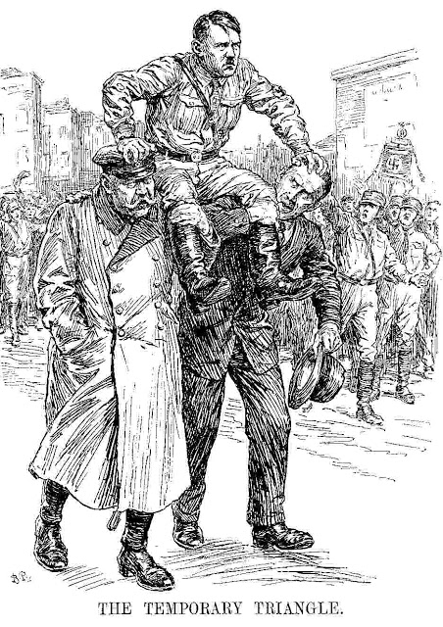

[Cartoon from the British magazine, Punch, January 1933, which shows Hitler being carried on the shoulders of Hindenburg and von Papen]
Use source C and your own knowledge to describe the relationship between Hitler, Hindenburg and von Papen [6]
------------------------------------------------------------------------------------------------------------------------------------------------------------------------------------------------------------------------------------------------------------------------------------------------------------------------------------------------------------------------------------------------------------------------------------------------------------------------------------------------------------------------------------------------------------------------------------------------------------------------------------------------------------------------------------------------------------------------------------------------------------------------------------------------------------------------------------------------------------------------------------------------------------------------------------------------------------------------------------------------------------------------------------------------------------------------------------------------------------------------------------------------------------------------------------------------------------------------------------------------------------------------------------------------------------------------------------------------------------------------------------------------------------------------------------------------------------------------------------------------------------------------------------
QUESTION 5
This question is about life in Nazi Germany.
Was the Great Depression the main reason why the Nazis came to power in 1933? Explain your answer fully.
Use your own knowledge and understanding of the issue to support your answer. Marks for spelling, punctuation and the accurate use of grammar and specialist language are allocated to this question. [3]

------------------------------------------------------------------------------------------------------------------------------------------------------------------------------------------------------------------------------------------------------------------------------------------------------------------------------------------------------------------------------------------------------------------------------------------------------------------------------------------------------------------------------------------------------------------------------------------------------------------------------------------------------------------------------------------------------------------------------------------------------------------------------------------------------------------------------------------------------------------------------------------------------------------------------------------------------------------------------------------------------------------------------------------------------------------------------------------------------------------------------------------------------------------------------------------------------------------------------------------------------------------------------------------------------------------------------------------------------------------------------------------------------------------------------------------------------------------------------------------------------------------------------------------------------------------------------------------------------------------------------------------------------------------------------------------------------------------------------------------------------------------------------------------------------------------------------------------------------------------------------------------------------------------------------------------------------------------------------------------------------------------------------------------------------------------------------------------------------------------------------------------------------------------------------------------------------------------------------------------------------------------------------------------------------------------------------------------------------------------------------------------------------------------------------------------------------------------------------------------------------------------------------------------------------------------------------------------------------------------------------------------------------------------------------------------------------------------------------------------------------------------------------------------------------------------------------------------------------------------------------------------------------------------------------------------------------------------------------------------------------------------------------------------------------------------------------------------------------------------------------------------------------------------------------------------------------------------------------------------------------------------------------------------------------------------------------------------------------------------------------------------------------------------------------------------------------------------------------------------------------------------------------------------------------------------------------------------------------------------------------------------------------------------------------------------------------------------------------------------------------------------------------------------------------------------------------------------------------------------------------------------------------------------------------------------------------------------------------------------------------------------------------------------------------------------------------------------------------------------------------------------------------------------------------------------------------------------------------------------------------------------------------------------------------------------------------------------------------------------------------------------------------------------------------------------------------------------------------------------------------------------------------------------------------------------------------------------------------------------------------------------------------------------------------------------------------------------------------------------------------------------------------------------------------------------------------------------------------------------------------------------------------------------------------------------------------------------------------------------------------------------------------------------------------------------------------------------------------------------------------------------------------------------------------------------------------------------------------------------------------------------------------------------------------------------------------------------------------------------------------------------------------------------------------------------------------------------------------------------------------------------------------------------------------------------------------------------------------------------------------------------------------------------------------------------------------------------------------------------------------------------------------------------------------------------------------------------------------------------------------------------------------------------------------------------------------------------------------------------------------------------------------------------------------------------------------------------------------------------------------------------------------------------------------------------------------------------------------------------------------------------------------
Key Question 4 – Consolidation of power
How did the Nazis consolidate their power between 1933 and 1934?
Topics covered: | Topic Tick once you have understood each topic
Hitler as Chancellor
The Reichstag Fire
The 1933 election and Enabling Act
Trade unions and political parties
Night of the Long Knives
Hitler becomes Fuhrer
In the period January 1933 to August 1934, Hitler and the Nazis secured control of all aspects of the German state. By August 1934, Hitler had combined posts of chancellor and president and was safe in the knowledge that he army supported him. Moreover, the banning of political parties, the control of the media, trade unions and police ensured that there was little or no opposition to the Nazi regime. Once more Hitler pointed out that his actions were always with the legal framework of the time. So how did he do it?

THE REICHSTAG FIRE – 27TH FEBRUARY 1933
Description of events

How did the Reichstag fire consolidate Hitler’s power and make Hitler more powerful?

THE 1933 ELECTION AND ENABLING ACT – 23RD MARCH 1933
Description of the Enabling Act and explanation as to how it was passed.

How did the Enabling Act consolidate Hitler’s power and make Hitler more powerful?

Draw a mind map to illustrate how Hitler removed all opposition following the passing of the enabling Act

The removal of opposition

THE NIGHT OF THE LONG KNIVES – 30TH JUNE 1934
Description of The Night of the Long Knives

How did the Night of the Long Knives consolidate Hitler’s power and make Hitler more powerful?

THE DEATH OF HINDENBURG – August 1934
How did Hindenburg’s death consolidate Hitler’s power and make Hitler more powerful?

Exam questions
QUESTION 1
Study the source below and then answer the question which follows.
Source A
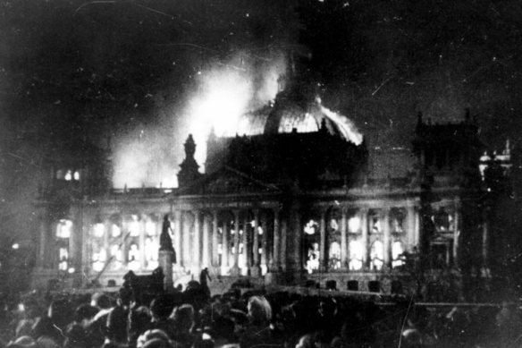

[A photograph showing the Reichstag building on fire, February 1933]

Use Source A and your own knowledge to describe the Reichstag fire. [6]

--------------------------------------------------------------------------------------------------------------------------------------------------------------------------------------------------------------------------------------------------------------------------------------------------------------------------------------------------------------------------------------------------------------------------------------------------------------------------------------------------------------------------------------------------------------------------------------------------------------------------------------------------------------------------------------------------------------------------------------------------------------------------------------------------------------------------------------------------------------------------------------------------------------------------------------------------------------------------------------------------------------------------------------------------------------------------------------------------------------
--------------------------------------------------------------------------------------------------------------------------------------------------------------------------------------------------------------------------------------------------------------------------------------------------------------------------------------------------------------------------------------------------------------------------------------------------------------------------------------------------------------------------------------------------------------------------------------------------------------------------------------------------------------------------------------------------------------------------------------------------------------------------------------------------------------------------------------------------------------------------------------------------------------------------------------------------------------------------------------------------------------------------------------------------------------------------------------------------------------------------------------------------------------------------------------------------------------------------------------------------------------------------------------------------------------------------------------------------------------------------------------------

QUESTION 2
Describe what happened during the Night of the Long Knives. [8]
----------------------------------------------------------------------------------------------------------------------------------------------------------------------------------------------------------------------------------------------------------------------------------------------------------------------------------------------------------------------------------------------------------------------------------------------------------------------------------------------------------------------------------------------------------------------------------------------------------------------------------------------------------------------------------------------------------------------------------------------------------------------------------------------------------------------------------------------------------------------------------------------------------------------------------------------------------------------------------------------------------------------------------------------------------------------------------------------------------------------------------------------------------------------------------------------------------------------------------------------------------------------------------------------------------------------------------------------------------------------------------------------------------------------------------------------------------------------------------------------------------------------------------------------------------------------------------------------------------------------------------------------------------------------------------------------------------------------------------------------------------------------------------------------------------------------------------------------------------------------------------------------------------------------------------------------------------------------------------------------------------------------------------------------------------------------------------------------------------------------------------------------------------------------------------------------------------------------------------------------------------------------------------------------------------------------------------------------------------------------------------------------------------------------------------------------------------------------------------------------------------------------------------------------------------------------------------------------------------------------------------------------------------------------------------------------------------------------------------------------------------------------------------------
----------------------------------------------------------------------------------------------------------------------------------------------------------------------------------------------------------------------------------------------------------------------------

QUESTION 3
Study the source below and then answer the question which follows.
Source B
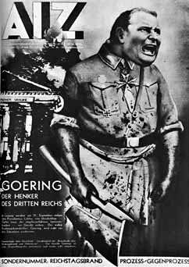

[A Communist poster produced just after the fire.]

What was the purpose of Source B? [8]

[Use details from Source B and your own knowledge and understanding of the historical context to answer the question.]

------------------------------------------------------------------------------------------------------------------------------------------------------------------------------------------------------------------------------------------------------------------------------------------------------------------------------------------------------------------------------------------------------------------------------------------------------------------------------------------------------------------------------------------------------------------------------------------------------------------------------------------------------------------------------------------------------------------------------------------------------------------------------------------------------------------------------------------------------------------------------------------------------------------------------------------------------------------------------------------------------------------------------------------------------------------------------------------------------------------------------------------------------------------------------------------------------------------------------------------------------------------------------------------------------------------------------------------------------------------------------------------------------------------------------------------------------------------------------------------------------------------------------------------------------------------------------------------------------------------------------------------------------------------------------------------------------------------------------------------------------------------------------------------------------------------------------------------------------------------------------------------------------------------------------------------------------------------------------------------------------------------------------------------------------------------------------------------------------------------------------------------------------------------------------------------------------------------------------------------------------------------------------------------------------------------------------------------------------------------------------------------------------------------------------------------------------------------------------------------------------------------------------------------------------------------------------------------------------------------------------------------------------------------------------------------------------------------------------------------------------------------------------------------------------------------------------------------------------------------------------------------------------------------------------------------------------------------------------------------------------------------------------------------------------------------------------------------------------------------------------------------------------------------------------------------------------------------------------------------------------------------------------------------------------------------------------------------------

QUESTION 4
Study the sources below and then answer the question that follows.
Source C
In the circumstances I had to make but one decision. If disaster was to be prevented at all, action had to be taken with lightning speed. Only a ruthless and bloody intervention might still perhaps stifle the spread of revolt. If anyone reproaches me and asks why I did not resort to the regular courts of justice for conviction of the offenders, then alI can say is – ‘In this hour I was responsible for the fate of the German people and therefore I became the supreme judge of the German people.’

[From Hitler’s speech to the Reichstag on 13 July 1934, justifying his actions concerning the SA]
Source D
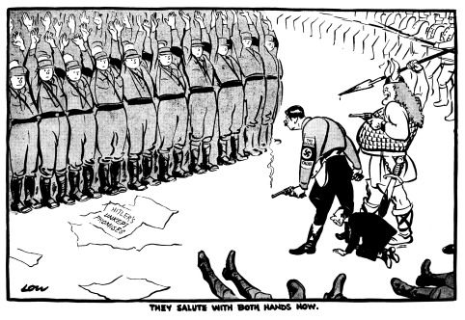

[A cartoon by David low which appeared in the London Evening Standard 3 July 1934. The caption read ‘They salute with both hands now.’]
Which of the sources is more useful to an historian studying the Night of the Long knives
[12]

[You should refer to both sources in your answer and use your knowledge and understanding of the historical context.
------------------------------------------------------------------------------------------------------------------------------------------------------------------------------------------------------------------------------------------------------------------------------------------------------------------------------------------------------------------------------------------------------------------------------------------------------------------------------------------------------------------------------------------------------------------------------------------------------------------------------------------------------------------------------------------------------------------------------------------------------------------------------------------------------------------------------------------------------------------------------------------------------------------------------------------------------------------------------------------------------------------------------------------------------------------------------------------------------------------------------------------------------------------------------------------------------------------------------------------------------------------------------------------------------------------------------------------------------------------------------------------------------------------------------------------------------------------------------------------------------------------------------------------------------------------------------------------------------------------------------------------------------------------------------------------------------------------------------------------------------------------------------------------------------------------------------------------------------------------------------------------------------------------------------------------------------------------------------------------------------------------------------------------------------------------------------------------------------------------------------------------------------------------------------------------------------------------------------------------------------------------------------------------------------------------------------------------------------------------------------------------------------------------------------------------------------------------------------------------------------------------------------------------------------------------------------------------------------------------------------------------------------------------------------------------------------------------------------------------------------------------------------------------------------------------------------------------------------------------------------------------------------------------------------------------------------------------------------------------------------------------------------------------------------------------------------------------------------------------------------------------------------------------------------------------------------------------------------------------------------------------------------------------------------------------------------------------------

--------------------------------------------------------------------------------------------------------------------------------------------------------------------------------------------------------------------------------------------------------------------------------------------------------------------------------------------------------------------------------------------------------------------------------------------------------------------------------------------------------------------------------------------------------------------------------------------------------------------------------------------------------------------------------------------------------------------------------------------------------------------------------------------------------------------------------------------------------------------------------------------------------------------------------------------------------------------------------------------------------------------------------------------------------------------------------------------------------------------------------------------------------------------------------------------------------------------------------------------------------------------------------------------------------------------------------------------------------------------------------------------

Exam question 5
Was the Reichstag fire the most significant event in Hitler’s consolidation of power? [16]
Use your own knowledge and understanding of the issue to support your answer. Marks for spelling, punctuation and the accurate use of grammar and specialist language are allocated to this question. [3]
- You need to develop a two-sided answer which has balance and good support
- You should start by discussing the factor mentioned in the question, using your factual knowledge to explain why the Reichstag fire helped to consolidate Hitler’s power
- You then need to consider the counter argument by using your knowledge to examine other relevant factors. Discuss the Enabling Act, Night of the Long Knives and the death of Hindenburg
- Aim to link each paragraph by using words such as ‘other factors include’, ‘also important’, ‘in addition to’, ‘however’.
- Conclude your answer with a link back to the question, making a judgement about the importance of the Reichstag fire
- Aim to write between one and two sides of A4
