BOOK 3

NAME:
TEACHER:

GERMANY IN TRANSITION, 1919-39
Nazi economic, social and racial policy

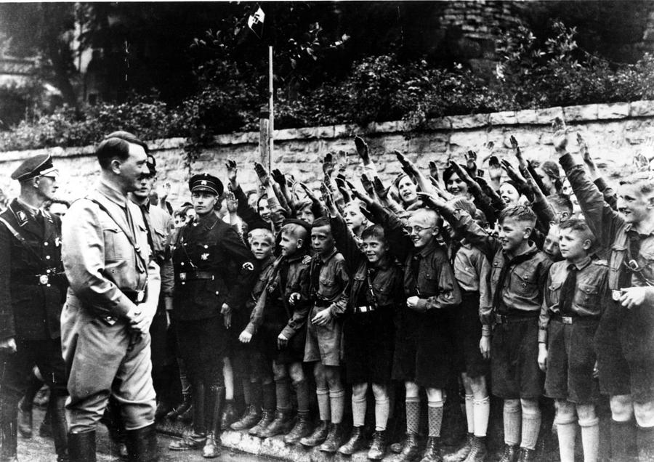

Date marked | Comment

Put syllabus from specification on this page

Key Question 5 – Nazi economic, social and racial policy
How did Nazi economic, social and racial policy affect life in Germany?
Topics covered: | Topic covered  Tick once you have understood each topic
Reducing unemployment
Nazi policy towards workers
Women and the Three K’s
Controlling education
The role of the Hitler youth Movement
Attitudes to religion
The treatment of Jews 1933-1939

Page
How did Hitler reduce Unemployment?

Exam question 1
Source A

Use Source A and your own knowledge to describe what happened to unemployment under Nazi rule. [6]

-------------------------------------------------------------------------------------------------------------------------------------------------------------------------------------------------------------------------------------------------------------------------------------------------------------------------------------------------------------------------------------------------------------------------------------------------------------------------------------------------------------------------------------------------------------------------------------------------------------------------------------------------------------------------------------------------------------------------------------------------------------------------------------------------------------------------------------------------------------------------------------------------------------------------------------------------------------------------------------------------------------------------------------------------------------------------------------------------------------

Fill in the following table illustrating how Hitler reduced unemployment

Measure introduced | Notes
National Labour Service (RAD)
Job creation schemes
Invisible unemployment
Rearmament

Exam question 4
Which of the sources is more useful to an historian studying the how Hitler reduced unemployment? [12]
[You should refer to both sources in your answer and use your knowledge and understanding of the historical context.]

Source B

Under the Nazis there was much ‘invisible’ unemployment. The number of unemployed Jews was great but they were not counted as being unemployed. Another source of ‘invisible’ unemployment was the sacking of women from their jobs. None of these people were included among the unemployed in the official statistics. Part time workers were counted as fully employed.

[From a GCSE History textbook Germany 1918-45 written in 1989 ]

Source C

My mother and father went to hear Adolf Hitler give a speech at a rally in town. The next morning they told us children how he wanted to be on the side of the unemployed. My mother wept for joy as we would no longer be poor because Hitler knew how to get jobs for us.

[From an interview with a German woman reflecting on her experiences in Nazi Germany for a BBC television programme in 1979.]

.........................................................................................................……………………….................................................................................................................................................................................................................................................................................................................................................................................................................
.........................................................................................................………………………..................................................................................................................................................................................................................................................................................................................................................................................................................................................................................................................................................................................................................................……………………….................................................................................................................................................................................................................................................................................................................................................................................................................................................
.........................................................................................................……………………….................................................................................................................................................................................................................................................................................................................................................................................................................
.........................................................................................................……………………….................................................................................................................................................................................................................................................................................................................................................................................................................
.........................................................................................................………………………..................................................................................................................................................................................................................................................................................................................................................................................................................................................................................................................................................................................................................................……………………….................................................................................................................................................................................................................................................................................................................................................................................................................................................

How did Hitler control the workforce?

Fill in the table below:
Measure introduced | Notes
The German Labour Front (DAF)
Strength Through Joy
(KdF)
Volkswagen scheme

The role of women

Read page

Annotate the following Nazi poster illustrating the role of women in Nazi Germany

The Role of Women in Weimar and Nazi Germany
Card Sort Exercise
Colour in pre1933 attitudes to women in one colour and post 1933 in another.
Pre 1933
Post 1933
The Honour Cross of the German Mother was awarded according to how many children you had

Women were told that the ideal husband would be
an Aryan

Married women were encouraged to have children
Married and unmarried women were encouraged
to have children

There were 3000 female doctors
Female doctors and civil servants were sacked
Women were free to smoke and wear make-up

Women sat in the Reichstag

Loans were offered to brides who agreed not to take a job

Exam question 1
Source A
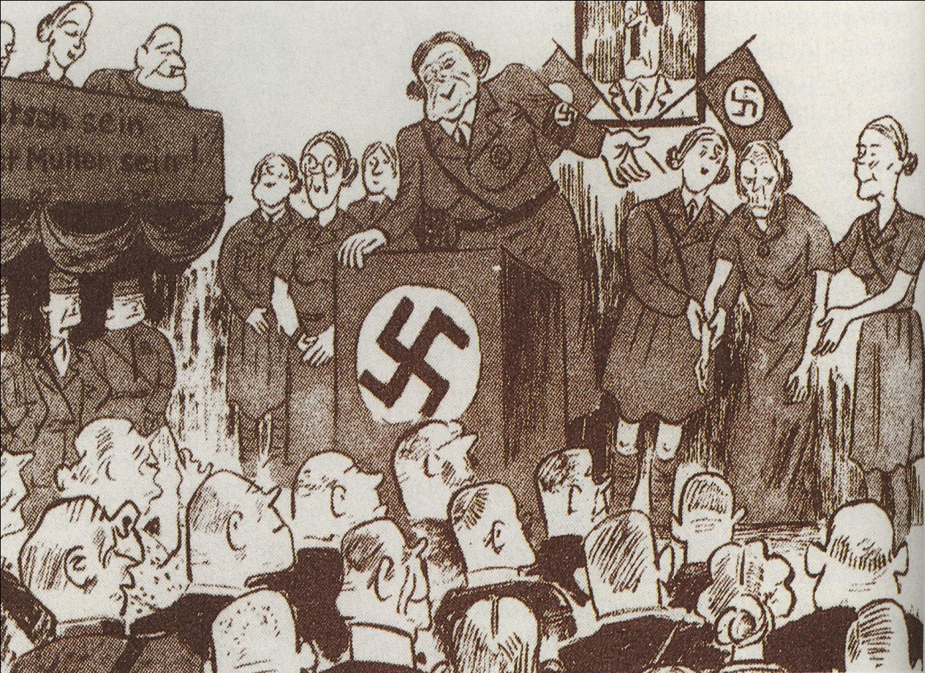

[A German cartoon from the 1930s with the caption ‘Introducing Frau Mueller who up to now has brought 12 children into the world’.]

Use Source A and your own knowledge to describe the role of women in Nazi Germany. [6]

-----------------------------------------------------------------------------------------------------------------------------------------------------------------------------------------------------------------------------------------------------------------------------------------------------------------------------------------------------------------------------------------------------------------------------------------------------------------------------------------------------------------------------------------------------------------------------------------------------------------------------------------------------------------------------------------------------------------------------------------------------------------------------------------------------------------------------------------------------------------------------------------------------------------------------------------------------------------------------------------------------------------------------------------------------------------------------------------------------

Exam question 3
Study the source below and then answer the question which follows.
Source B
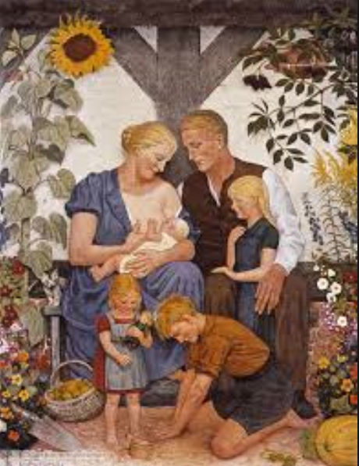

[A Nazi propaganda poster produced in the early 1930s]

What was the purpose of Source B? [8]
[Use details from Source B and your own knowledge and understanding of the historical context to answer the question.]
------------------------------------------------------------------------------------------------------------------------------------------------------------------------------------------------------------------------------------------------------------------------------------------------------------------------------------------------------------------------------------------------------------------------------------------------------------------------------------------------------------------------------------------------------------------------------------------------------------------------------------------------------------------------------------------------------------------------------------------------------------------------------------------------------------------------------------------------------------------------------------------------------------------------------------------------------------------------------------------------------------------------------------------------------------------------------------------------------------------------------------------------------------------------------------------------------------------------------------------------------------------------------------------------------------------------------------------------------------------------------------------------------------------------------------------------------------------------------------------------------------------------------------------------------------------------------------------------------------------------------------------------------------------------------------------------------------------------------------------------------------------------------------------------------------------------------------------------------------------------------------------------------------------------------------------------------------------------------------------------------------------------------------------------------------------------------------------------------------------------------------------------------------------------------------------------------------------------------------------------------------------------------------------------------------------------------------------------------------------------------------------------------------------------------------------------------------------------------------------------------------------------------------------------------------------------------------------------------------------------------------------------------------------------------------------------------------------------------------------------------------------------------------------------------------------------------------------------------------------------------------------------------------------------------------------------------------------------------------------------------------------------------------------------------------------------------------------------------------------------------------------------------------------------------------------------------------------------------------------------------------------------------------------------------------------------------------------------

Exam question 4
Source B
The mission of women is to be beautiful and to bring children into the world. This is not at all as.........un-modern as it sounds. The female bird preens herself for her mate and hatches eggs for him. In exchange, the male takes care of gathering food, and stands guard and wards off the enemy.’

[Joseph Goebbels, the Minister for Propaganda and Enlightenment]

Source C
In 1900 there had been over two million live births per year but this had dropped to under one million in 1933…in 1936 there were over 30% more births than there had been in 1933.

[Germany 1918-1945, Greg Lacey and Keith Sheppard, 1998]

Which of the sources is more useful to an historian studying the role of women in Nazi Germany?
[12]
[You should refer to both sources in your answer and use your knowledge and understanding of the historical context.]

-------------------------------------------------------------------------------------------------------------------------------------------------------------------------------------------------------------------------------------------------------------------------------------------------------------------------------------------------------------------------------------------------------------------------------------------------------------------------------------------------------------------------------------------------------------------------------------------------------------------------------------------------------------------------------------------------------------------------------------------------------------------------------------------------------------------------------------------------------------------------------------------------------------------------------------------------------------------------------------------------------------------------------------------------------------------------------------------------------------------------------------------------------------------------------------------------------------------------------------------------------------------------------------------------------------------------------------------------------------------------------------------------------------------------------------------------------------------------------------------------------------------------------------------------------------------------------------------------------------------------------------------------------------------------------------------------------------------------------------------------------------------------------------------------------------------------------------------------------------------------------------------------------------------------------------------------------------------------------------------------------------------------------------------------------------------------------------------------------------------------------------------------------------------------------------------------------------------------------------------------------------------------------------------------------------------------------------------------------------------------------------------------------------------------------------------------------------------------------------------------------------------------------------------------------------------------------------------------------------------------------------------------------------------------------------------------------------------------------------------------------------------------------------------------------------------------------------------------------------------------------------------------------------------------------------------------------------------------------------------------------------------------------------------------------------------------------------------------------------------------------------------------------------------------------------------------------------------------------------------------------------------------------------------------------------------------------------------------------------------------------------------------------------------------------------------------------------------------------------------------------------------------------------------------------------------------------------------------------------------------------------------------------------------------------------------------------------------------------------------------------------------------------------------------------------------------------------------------------------------------------------------------------------------------------------------------------------------------------------------------------------------------------------------------------------------------------------------------------------------------------------------------------------------------------------------------------------------------------------------------------------------------------------------------------------------------------------------------------------------------------------------------------------------------------------------------------------------------------------------------------------------------------------------------------------------------------------------------------------------------------------------------------------------------------------------------------------------------------------------

The treatment young people
Read page

Controlling Education
Anti Semitism – A hatred of the Jews
Aryan – Someone who is supposed to have pure blood – or is of pure Germanic stock
Curriculum – A course of study that is set down for pupils to follow
Eugenics – The study of how to create fine offspring
Hitler Youth – A youth organisation set up by the Nazis for young people in Germany aged 14 - 18.
Indoctrination - A set of beliefs constantly repeated to implant ideas in the mind.
Propaganda – Information that is often repeated and used to support one set of ideas
Regimented – Having strict rules and discipline

- Hitler was in control of the education in Germany and the curriculum was changed to prepare students for their future roles in life. Boys being trained for the military and girls being prepared to fulfil their roles and duties as mothers and housewives.

- Hitler saw the young as the future of the Third Reich so they had to be converted to Nazi ideals and understand Nazi policies. This was achieved through controlling education.

- Education was an effective method of indoctrinating (brain washing) young people and promoting Nazi ideals to the next generation.

- It was important to Hitler and the Nazi policy to have strong, healthy and fit men and women so fifteen percent of time in school was devoted to physical education with an emphasis on preparation for the military for boys.

- The curriculum was changed to fit in with the Nazi ideal role of women in society so girls had lessons to prepare them for work at home such as needlework, home crafts and in particular cookery to become good mothers able to look after their families.

- New subjects were introduced to the curriculum under the control of the Nazis such as race studies to teach the youth about the Nazi policies and beliefs about race and population control studies. Children were taught the Nazi racial theory that Aryans were superior and should not marry inferior races such as Jews.
- Lessons would begin and end with the student saluting and saying ‘Heil Hitler’ and Nazi themes were presented through every aspect of the curriculum for example in Maths problems dealt with social issues.

- The Nazis laid down strict rules about what was to be taught in all German schools. All subjects had to be taught according to the Nazi point of view all the textbooks were rewritten to reflect this, Mein Kampf also became a standard textbook. Non Nazi teachers were sacked and all teachers had to belong to the Nazi Teachers League.

1c exam question

Study the sources below and then answer the question which follows.

Source A

Explain why the Nazis wanted to control education?
----------------------------------------------------------------------------------------------------------------------------------------------------------------------------------------------------------------------------------------------------------------------------------------------------------------------------------------------------------------------------------------------------------------------------------------------------------------------------------------------------------------------------------------------------------------------------------------------------------------------------------------------------------------------------------------------------------------------------------------------------------------------------------------------------------------------------------
Describe how the school curriculum changed under the Nazis
------------------------------------------------------------------------------------------------------------------------------------------------------------------------------------------------------------------------------------------------------------------------------------------------------------------------------------------------------------------------------------------------------------------------------------------------------------------------------------------------------------------------------------------------------------------------------------------------------------------------------------------------------------------------------------------------------------------------------------------------------------------------------------------------------------------------------------------------------------------------------------------------------------------------------------------------------------------------------------------------------------------------------------------------------------------------------------------------------------------------------------------------------------------------------------------------------------------------------------------------------------------------------------------------------------------------------------------------------------------------------------------------------------------------------------------------------------------------------------------------------------------------------------------------------------------------------------------------------------------------------------------------------------------

Exam question 1
Source A
Girls usually had a different curriculum from boys. They also studied domestic science and eugenics (how to produce perfect offspring by selecting ideal qualities in the parents).

[Germany 1918-1945 (GCSE textbook) by Greg Lacey and Keith Shepherd.]
Use Source A and your own knowledge to describe the education girls received under the Nazis. [6]

--------------------------------------------------------------------------------------------------------------------------------------------------------------------------------------------------------------------------------------------------------------------------------------------------------------------------------------------------------------------------------------------------------------------------------------------------------------------------------------------------------------------------------------------------------------------------------------------------------------------------------------------------------------------------------------------------------------------------------------------------------------------------------------------------------------------------------------------------------------------------------------------------------------------------------------------------------------------------------------------------------------------------------------------------------------------------------------------------------------

Exam question 3
Study the source below and then answer the question which follows.
Source B
The Jews are aliens in Germany. In 1933 there were 66,060,000 inhabitants of the German reich of whom 499,862 were jews. What is the percentage of alins in germnay

[A question from a maths textbook, 1933]

What was the purpose of Source B? [8]
[Use details from Source B and your own knowledge and understanding of the historical context to answer the question.]
------------------------------------------------------------------------------------------------------------------------------------------------------------------------------------------------------------------------------------------------------------------------------------------------------------------------------------------------------------------------------------------------------------------------------------------------------------------------------------------------------------------------------------------------------------------------------------------------------------------------------------------------------------------------------------------------------------------------------------------------------------------------------------------------------------------------------------------------------------------------------------------------------------------------------------------------------------------------------------------------------------------------------------------------------------------------------------------------------------------------------------------------------------------------------------------------------------------------------------------------------------------------------------------------------------------------------------------------------------------------------------------------------------------------------------------------------------------------------------------------------------------------------------------------------------------------------------------------------------------------------------------------------------------------------------------------------------------------------------------------------------------------------------------------------------------------------------------------------------------------------------------------------------------------------------------------------------------------------------------------------------------------------------------------------------------------------------------------------------------------------------------------------------------------------------------------------------------------------------------------------------------------------------------------------------------------------------------------------------------------------------------------------------------------------------------------------------------------------------------------------------------------------------------------------------------------------------------------------------------------------------------------------------------------------------------------------------------------------------------------------------------------------------------------------------------------------------------------------------------------------------------------------------------------------------------------------------------------------------------------------------------------------------------------------------------------------------------------------------------------------------------------------------------------------------------------------------------------------------------------------------------------------------------------------------------------------------------------

The Hitler Youth Movement
Hitler wanted to turn the young into loyal Nazis. The three greatest influences on young people were their families, schools and what they did in their free time. The Nazis tried to control all of these influences. Youth movements had been popular in Germany for a long time. They usually involved hiking, singing folk songs, camping and sport. Churches or political groups ran most of these movements. It was important to control the Youth in their spare time so the Hitler Youth was established and all other youth organizations were banned, from 1939 all membership was compulsory and by 1939 there were 7 million members.
The aims of the Hitler Youth (HJ), were:
- To indoctrinate children with Nazi ideology
- To make them feel part of a mass movement
- To prepare them for their roles in life; the military or motherhood.
The Hitler Youth Movement was not popular with all its members and some young people challenged Nazi ideas and rejected attempts to convert them to the Nazi ideas through education and youth movements. Some teenagers resented the Nazis attempting to control all aspects of their lives. The opposition to Nazi rule by any German civilians were dealt with and punished by the Nazi state.

Boys
6-10 joined the ‘Pimpf’ (Little Fellows) for camping activities, wearing miniature SA uniforms and swastika armbands.
10-14 joined the Deutsche Jungvolk (German Young People), to learn about Nazi ideology and military matters.
14-18 joined the Hitler Jugend (Hitler Youth) with a strong emphasis on military training.

Girls
6-14 joined the Jungmadel (Young Maidens) for camping activities, and education about health and motherhood.
14-21 joined the Bund Deutsche Madel (BDM) (League of German Maidens), with a strong emphasis on motherhood and household issues.

Look at the statements below and decide which speech bubble to put them in.
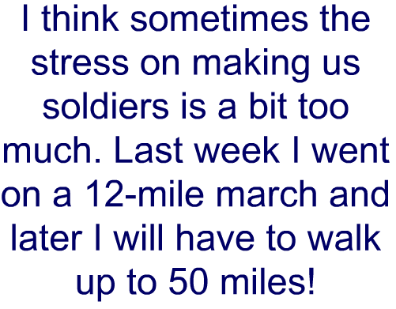
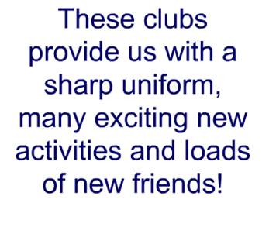
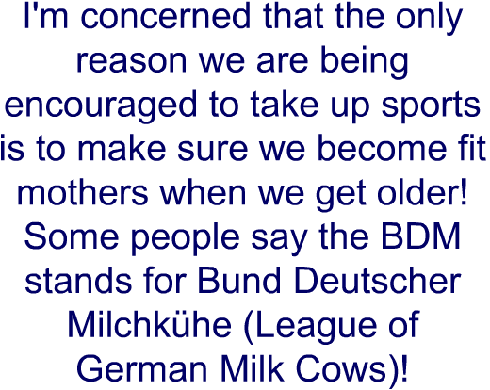

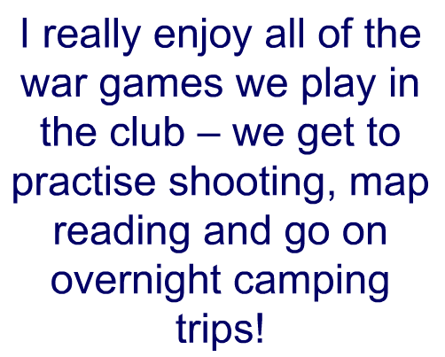
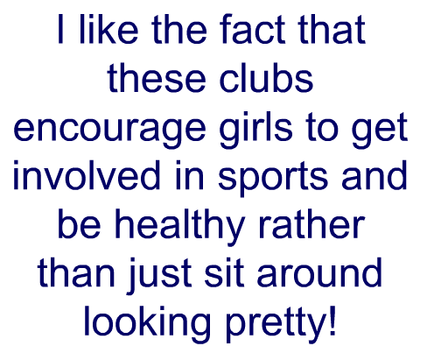


I really like being part of the Hitler Youth because....

Some things do concern me though, such as .........

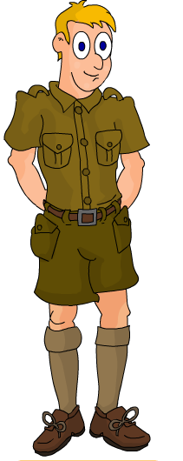

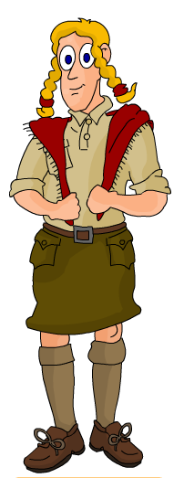
I really like being part of the Hitler Youth because....

Some things do concern me though, such as ....

Exam question 3
Study the source below and then answer the question which follows.

Source A

[A contemporary poster by Ludwig Hohlwin, advertising the ‘League of German Maidens, in the Hitler Youth’.]

What was the purpose of Source B? [8]

[Use details from Source B and your own knowledge and understanding of the historical context to answer the question.]

------------------------------------------------------------------------------------------------------------------------------------------------------------------------------------------------------------------------------------------------------------------------------------------------------------------------------------------------------------------------------------------------------------------------------------------------------------------------------------------------------------------------------------------------------------------------------------------------------------------------------------------------------------------------------------------------------------------------------------------------------------------------------------------------------------------------------------------------------------------------------------------------------------------------------------------------------------------------------------------------------------------------------------------------------------------------------------------------------------------------------------------------------------------------------------------------------------------------------------------------------------------------------------------------------------------------------------------------------------------------------------------------------------------------------------------------------------------------------------------------------------------------------------------------------------------------------------------------------------------------------------------------------------------------------------------------------------------------------------------------------------------------------------------------------------------------------------------------------------------------------------------------------------------------------------------------------------------------------------------------------------------------------------------------------------------------------------------------------------------------------------------------------------------------------------------------------------------------------------------------------------------------------------------------------------------------------------------------------------------------------------------------------------------------------------------------------------------------------------------------------------------------------------------------------------------------------------------------------------------------------------------------------------------------------------------------------------------------------------------------------------------------------------------------------------------------------------------------------------------------------------------------------------------------------------------------------------------------------------------------------------------------------------------------------------------------------------------------------------------------------------------------------------------------------------------------------------------------------------------------------------------------------------------------------------------------------------------------

[
.........................................................................................................………………………..................................................................................................................................................................................................................................................................................................................................................................................................................................................................................................................................................................................................................................………………………............................
.........................................................................................................……………………….................................................................................................................................................................................................................................................................................................................................................................................................................

The treatment of religion
Page

Annotate this image illustrating reasons why the Church might have supported the Nazi party at first!
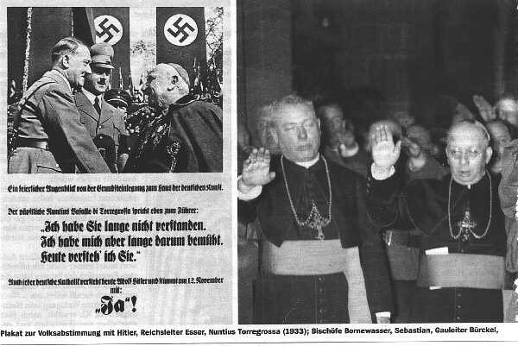

Fill in the following table
 | Catholic Church | Protestant Church
Numbers in Germany
Reason for initial cooperation
Reasons for eventual opposition to the Nazi regime

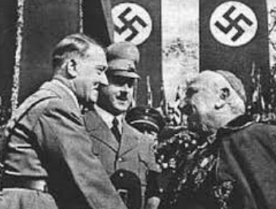
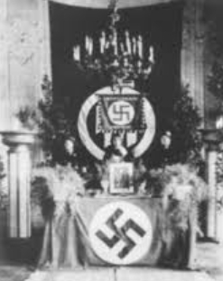
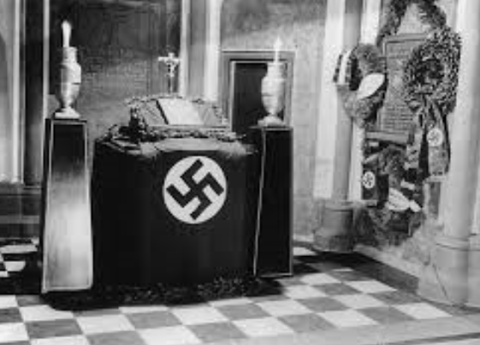

The National Reich Church – Supported the Nazi’s
Leader
When established?
Objects on alter?

The Confessional Church – Against the Nazi’s
Leader
When established?
What happened to it’s leader?

Explain why Hitler wanted to control the church in Germany

_____________________________________________________________________________________________________________________________________________________________________________________________________________________________________________________________________________________________________________________________________________________________________________________________________________________________________________________________________________________________________________________________________________________________________________________________________________________________________________________________________________________________________________________________________

The treatment of the Jews

Page 168-172

Annotate these pictures illustrating the persecution Jews suffered in Nazi Germany

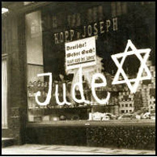
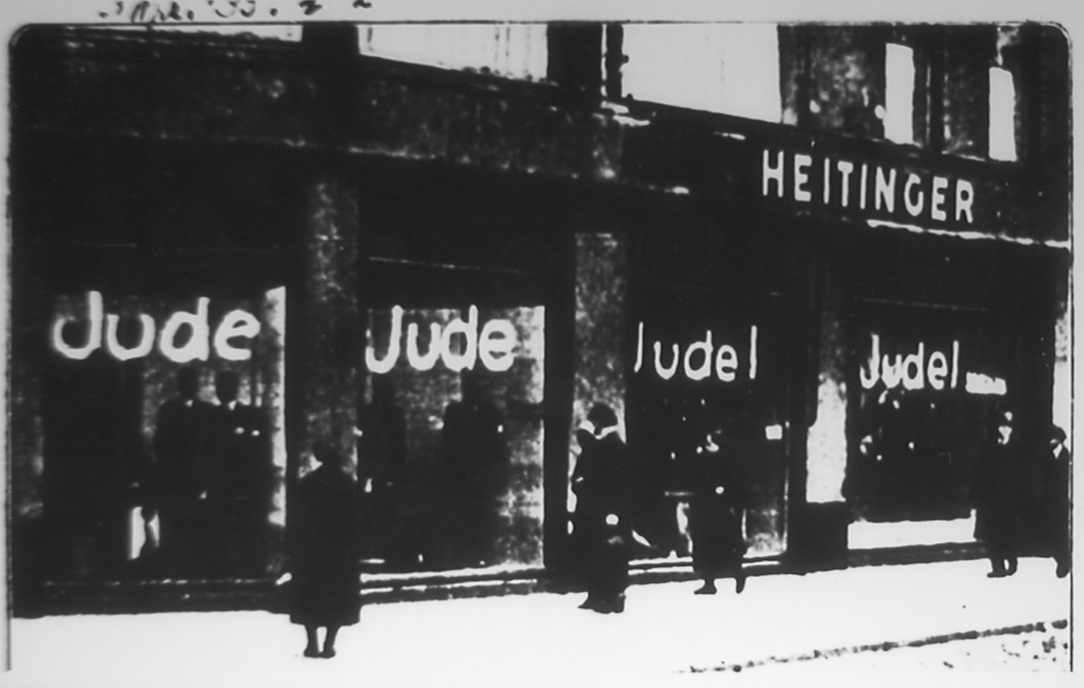

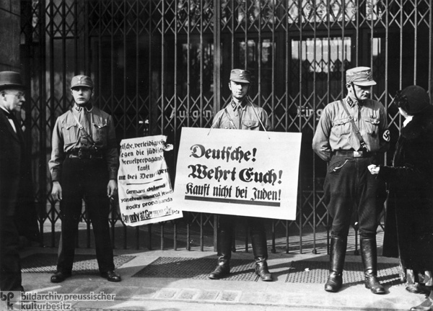

Read the relevant pages in your text book and complete the table below illustrating how the Nazis removed Jews’ political, social and economic rights.

Political rights
Economic rights
Social rights
Exam question 3
Study the source below and then answer the question which follows.
Source A
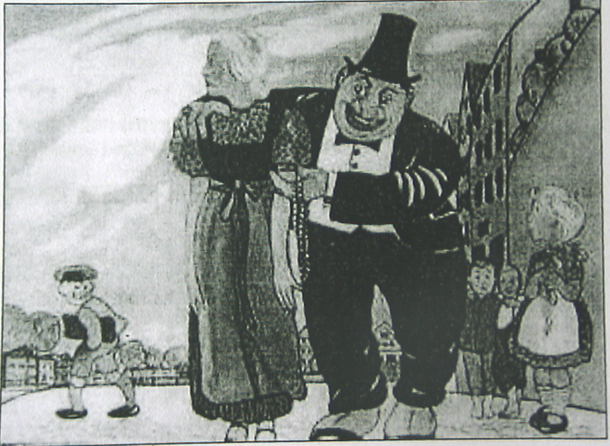

[An image showing a Jew and a German girl, printed in a Nazi school textbook (1937)]

What was the purpose of Source B? [8]

[Use details from Source B and your own knowledge and understanding of the historical context to answer the question.]

------------------------------------------------------------------------------------------------------------------------------------------------------------------------------------------------------------------------------------------------------------------------------------------------------------------------------------------------------------------------------------------------------------------------------------------------------------------------------------------------------------------------------------------------------------------------------------------------------------------------------------------------------------------------------------------------------------------------------------------------------------------------------------------------------------------------------------------------------------------------------------------------------------------------------------------------------------------------------------------------------------------------------------------------------------------------------------------------------------------------------------------------------------------------------------------------------------------------------------------------------------------------------------------------------------------------------------------------------------------------------------------------------------------------------------------------------------------------------------------------------------------------------------------------------------------------------------------------------------------------------------------------------------------------------------------------------------------------------------------------------------------------------------------------------------------------------------------------------------------------------------------------------------------------------------------------------------------------------------------------------------------------------------------------------------------------------------------------------------------------------------------------------------------------------------------------------------------------------------------------------------------------------------------------------------------------------------------------------------------------------------------------------------------------------------------------------------------------------------------------------------------------------------------------------------------------------------------------------------------------------------------------------------------------------------------------------------------------------------------------------------------------------------------------------------------------------------------------------------------------------------------------------------------------------------------------------------------------------------------------------------------------------------------------------------------------------------------------------------------------------------------------------------------------------------------------------------------------------------------------------------------------------------------------------------------------------------------------

Exam question 4
Study the sources below and then answer the question that follows.
Source B
Mob law ruled in Berlin throughout the afternoon and evening as hordes of hooligans took part in an orgy of destruction. I have never seen an anti-Jewish outbreak as sickening as this. I saw fashionably dressed women clapping their hands and screaming with glee while respectable mothers held up their babies to see the ‘fun’. No attempt was made by the police to stop the rioters.

[An account of Kristallnacht published in the Daily Telegraph, a British newspaper, on 12 November 1938]
Source C
The death of a loyal party member by the Jewish murderer has aroused spontaneous anti-Jewish demonstrations through the Reich. In many places Jewish shops have been smashed. The synagogues, from which the teachings hostile to the state and people are spread have been set on fire. Well done to those Germans who have ensured revenge for the murder of an innocent German

[An account of Kristallnacht published in Der Sturmer, an anti-Semitic German newspaper, on 10th November 1938]

Which of the sources is more useful to an historian studying Kristallnacht [12]
[You should refer to both sources in your answer and use your knowledge and understanding of the historical context.]

------------------------------------------------------------------------------------------------------------------------------------------------------------------------------------------------------------------------------------------------------------------------------------------------------------------------------------------------------------------------------------------------------------------------------------------------------------------------------------------------------------------------------------------------------------------------------------------------------------------------------------------------------------------------------------------------------------------------------------------------------------------------------------------------------------------------------------------------------------------------------------------------------------------------------------------------------------------------------------------------------------------------------------------------------------------------------------------------------------------------------------------------------------------------------------------------------------------------------------------------------------------------------------------------------------------------------------------------------------------------------------------------------------------------------------------------------------------------------------------------------------------------------------------------------------------------------------------------------------------------------------------------------------------------------------------------------------------------------------------------------------------------------------------------------------------------------------------------------------------------------------------------------------------------------------------------------------------------------------------------------------------------------------------------------------------------------------------------------------------------------------------------------------------------------------------------------------------------------------------------------------------------------------------------------------------------------------------------------------------------------------------------------------------------------------------------------------------------------------------------------------------------------------------------------------------------------------------------------------------------------------------------------------------------------------------------------------------------------------------------------------------------------------------------------------------------------------------------------------------------------------------------------------------------------------------------------------------------------------------------------------------------------------------------------------------------------------------------------------------------------------------------------------------------------------------------------------------------------------------------------------------------------------------------------------------------------------------------

--------------------------------------------------------------------------------------------------------------------------------------------------------------------------------------------------------------------------------------------------------------------------------------------------------------------------------------------------------------------------------------------------------------------------------------------------------------------------------------------------------------------------------------------------------------------------------------------------------------------------------------------------------------------------------------------------------------------------------------------------------------------------------------------------------------------------------------------------------------------------------------------------------------------------------------------------------------------------------------------------------------------------------------------------------------------------------------------------------------------------------------------------------------------------------------------------------------------------------------------------------------------------------------------------------------------------------------------------------------------------------------------

Exam Question 5
Did the lives of all Germans improve in Nazi Germany in the 1930s? [16]
Use your own knowledge and understanding of the issue to support your answer. Marks for spelling, punctuation and the accurate use of grammar and specialist language are allocated to this question. [3]

Preparing your answer
- Read the information in this pack about each of the following members of German society:
- Workers
- Women
- Youth
- Farmers
- Jews
- Industrialists

For each group fill in a table, like the one below, illustrating positive and negative aspects of Nazi rule. I have done the table for workers as an example for you:
WORKERS (Aryans)
POSITIVE ASPECTS OF NAZI RULE
- Had jobs, steady income
- Subsidized leisure activities through Kdf
- Many were happy that they now had secure and relatively safe jobs.
- There were benefits of being a member of the Nazi party
- Strong government leadership

NEGATIVE ASPECTS OF NAZI RULE
- Lost their trades unions and the right to strike
- There was a loss of personal freedom
- Many lived with the constant threat of the SS and Gestapo
- Many young men forced to join RAD
- People who refused to work were imprisoned.

WOMEN
POSITIVE ASPECTS OF NAZI RULE

NEGATIVE ASPECTS OF NAZI RULE

YOUTH
POSITIVE ASPECTS OF NAZI RULE

NEGATIVE ASPECTS OF NAZI RULE

FARMERS

NEGATIVE ASPECTS OF NAZI RULE

JEWS
POSITIVE ASPECTS OF NAZI RULE

NEGATIVE ASPECTS OF NAZI RULE

INDUSTRIALISTS
POSITIVE ASPECTS OF NAZI RULE

NEGATIVE ASPECTS OF NAZI RULE

Notes to help answer question 3

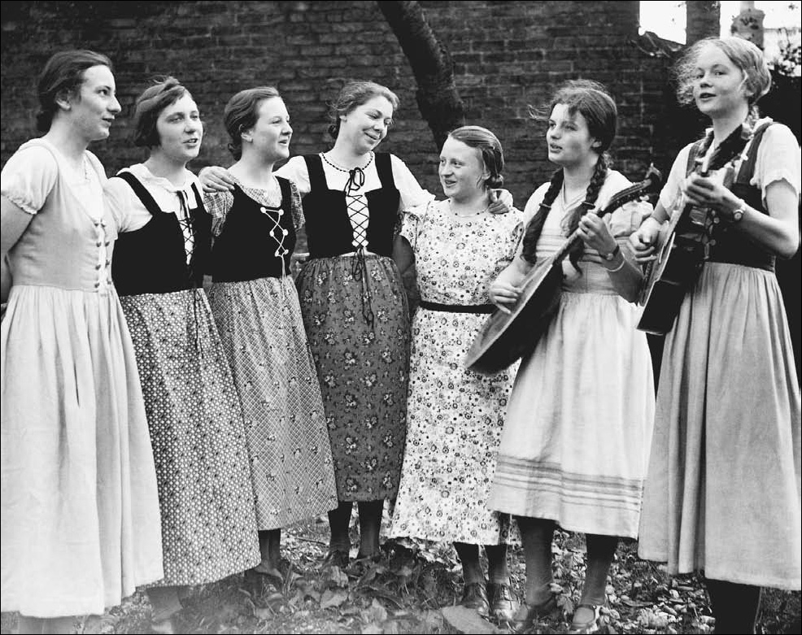
Women

When Hitler came to power in 1933, he introduced a ‘Law for the Encouragement of Marriage’.
The law said that the government would give all newly married couples a loan of 1000 marks, they could keep 250 marks for each child they had.

The phrase the Nazis used to put across what was expected for women was:
Kinder, Kirche und Küche. This meant, ‘children, church and cooking’ - what the Nazis believed women should be limited to. Women in Nazi Germany found themselves being forced to stay at home. Within months of Hitler coming to power, many intelligent women doctors, civil servants were sacked. Soon women lawyers and teachers were dismissed. By 1939 few women had professional jobs.

The Nazi party attempted to stop women following fashions. Make-up and wearing trousers was frowned upon, and hair was ‘expected’ to be in certain styles..
Slimming was discouraged because being slim was not thought to be good for childbearing. The only thing women were actively encouraged to do was to have children. Every 12th August, the birthday of Hitler’s mother, the Motherhood
Cross was awarded to the women who had the most children.

The Nazi government even set up homes for unmarried mothers. These were called Lebensborn - Spring of Life – and recognised by a white flag with a red dot in the middle. These maternity homes were also brothels. An unmarried woman could go there with the aim of becoming pregnant and would be introduced to ‘racially pure’ SS men.

In the education of girls in the German state the emphasis must be placed primarily on physical education; only after that should the spiritual and mental values be considered. The one goal always to be kept in mind when educating girls is that some day they aim to be mothers.

Farmers

Hit
- The Nazis told farmers they were one of the most important groups in Germany.

- Some farm debts were written off and all farmers benefited from an increase in food process

- By the 1933 Farm Law, farmers were assured of sales and given subsidies.
The government kept food prices at the 1928 level.

- But farmers resented government meddling

- Farmers were organised into the Reich Food Estate and strictly controlled (e.g., one rule stated that hens must lay 65 eggs a year).

- Farmers also suffered from a shortage of labour as workers left to go to better paid jobs in the towns

Youth

Education
- Hitler was in control of the education in Germany and the curriculum was changed to prepare students for their future roles in life. Boys being trained for the military and girls being prepared to fulfil their roles and duties as mothers and housewives.
- Hitler saw the young as the future of the Third Reich so they had to be converted to Nazi ideals and understand Nazi policies. This was achieved through controlling education.
- Education was an effective method of indoctrinating (brain washing) young people and promoting Nazi ideals to the next generation.
- It was important to Hitler and the Nazi policy to have strong, healthy and fit men and women so fifteen percent of time in school was devoted to physical education with an emphasis on preparation for the military for boys
- The curriculum was changed to fit in with the Nazi ideal role of women in society so girls had lessons to prepare them for work at home such as needlework, home crafts and in particular cookery to become good mothers able to look after their families.
- New subjects were introduced to the curriculum under the control of the Nazis such as race studies to teach the youth about the Nazi policies and beliefs about race and population control studies. Children were taught the Nazi racial theory that Aryans were superior and should not marry inferior races such as Jews.
- Lessons would begin and end with the student saluting and saying ‘Heil Hitler’ and Nazi themes were presented through every aspect of the curriculum for example in Maths problems dealt with social issues.
- The Nazis laid down strict rules about what was to be taught in all German schools. All subjects had to be taught according to the Nazi point of view all the textbooks were rewritten to reflect this, Mein Kampf also became a standard textbook. Non Nazi teachers were sacked and all teachers had to belong to the Nazi Teachers League.

Hitler Youth
Hitler wanted to turn the young into loyal Nazis. The three greatest influences on young people were their families, schools and what they did in their free time. The Nazis tried to control all of these influences. Youth movements had been popular in Germany for a long time. They usually involved hiking, singing folk songs, camping and sport. Churches or political groups ran most of these movements. It was important to control the Youth in their spare time so the Hitler Youth was established and all other youth organizations were banned, from 1939 all membership was compulsory and by 1939 there were 7 million members.
The aims of the Hitler Youth (HJ), were:
- To indoctrinate children with Nazi ideology
- To make them feel part of a mass movement
- To prepare them for their roles in life; the military or motherhood.

The Hitler Youth Movement was not popular with all its members and some young people challenged Nazi ideas and rejected attempts to convert them to the Nazi ideas through education and youth movements. Some teenagers resented the Nazis attempting to control all aspects of their lives. The opposition to Nazi rule by any German civilians were dealt with and punished by the Nazi state.

German Workers

- The depression had resulted in 6 million unemployed. They were immediately put to work on government programmes.
- For many this was a lifeline, it allowed them to feed and clothe their families
- BUT trade unions were banned and all workers had to join the German Labour Front. They lost their right to strike for better pay and conditions.
- Wages actually fell.
- People who refused to work were imprisoned.
- Wages and conditions on the RAD schemes were very poor and sometimes lower than the rate of unemployment benefit.
- They had no option, if they did not accept the work they would not receive unemployment benefit

Strength through Joy (KdF) Movement
- Workers were offered cut-price holidays, theatre trips and concerts. In Berlin, 1933–38, the KdF sponsored 134,000 events for 32 million people (2 million went on cruises & weekend trips, and 11 million on theatre trips).
- The KdF designed the Volkswagen (or ‘People’s Car’) ‘Beetle’, which it was planned to be able to buy for 5 marks a week. – no one got one!
- The government made sure that everybody could get a cheap radio.

Once in power, Hitler used his position to launch a campaign against the Jews that ended in the Holocaust.
German Jew

- After January 1933, the Jews became the "Untermenschen" - the sub-humans. Nazi thugs stopped Germans from shopping in Jewish shops.
- By 1934, all Jewish shops were marked with the yellow Star of David or had the word "Juden" written on the window. SA men stood outside the shops to deter anyone from entering, this was an attempt to economically bankrupt them and destroy what they had spent years building up.
- On buses, trains and park benches, Jews had to sit on seats marked for them. Children at schools were taught specifically anti-Semitic ideas. Jewish school children were openly ridiculed by teachers and the bullying of Jews in the playground by other pupils went unpunished.
- In 1935, the Nuremberg Laws were passed. The Jews lost their right to be German citizens and marriage between Jews and non-Jews was forbidden. It was after this law that the violence against the Jew really openly started. Those that could pay a fine were allowed to leave the country. Many could not and many shops refused to sell food to those who remained. Medicines were also difficult to get hold of as chemists would not sell to Jews.
- The campaign against the Jews stopped for a short duration during the Berlin Olympics - but once the overseas press had gone, it started up again. It reached a pre-war peak in 1938 with Krystalnacht - The Night of the Broken Glass.
- In November 1938, a Nazi 'diplomat' was shot dead by a Jew in Paris. Hitler ordered a seven day campaign of terror against the Jews in Germany to be organised by Himmler and the SS. On the 10th November, the campaign started. 10,000 shops owned by Jews were destroyed and their contents stolen. Homes and synagogues were set on fire and left to burn. The fire brigades showed their loyalty to Hitler by assuming that the buildings would burn down anyway, so why try to prevent it? A huge amount of damage was done to Jewish property but the Jewish community was ordered to pay a one billion mark fine to pay for the eventual clear-up. Jews were forced to scrub the streets clean
German Industrialist

- The New Plan of 1934 stopped imports, and subsidised industry. This is called 'Autarky' - the belief that Germany should be self-sufficient

- Large firms benefited from massive rearmaments programme and the destruction of tree union.

- The value of German industry rose and big profits were made

- The average salary of managers rose by nearly 70% between 1934-38

- Production rose, especially of oil, steel, coal and explosives.

- In 1936, Goering was put in charge. His Four Year Plan proposed to get the army and industry ready for war in four years.

- Employers were happy when workers were well disciplined.

- BUT businesses were strictly controlled; they could be told to make something different/ were not allowed to raise wages/ workers could be sent to other factories.

- Goering said: ‘Iron makes an empire strong; butter only makes people fat’.

- Economists know now that these policies cause massive economic problems

Exam question 5
Did the lives of all Germans improve in Nazi Germany in the 1930s? [16]

- Use your own knowledge and understanding of the issue to support your answer. Marks for spelling, punctuation and the accurate use of grammar and specialist language are allocated to this question.
- You need to develop a two-sided answer which has balance and good support
- You should start by discussing the ways in which the lives of German people improved under the Nazis
- You then need to consider the counter argument by considering how the lives of German people became worse under the Nazis.
- Aim to link each paragraph by using words such as ‘other factors include’, ‘also important’, ‘in addition to’, ‘however’.
- Conclude your answer with a link back to the question, making a judgement about the extent of recovery.
- Aim to write between one and two sides of A4













