BOOK 4

NAME:
TEACHER:

GERMANY IN TRANSITION, 1919-39
Terror and persuasion
Hitler’s foreign policy

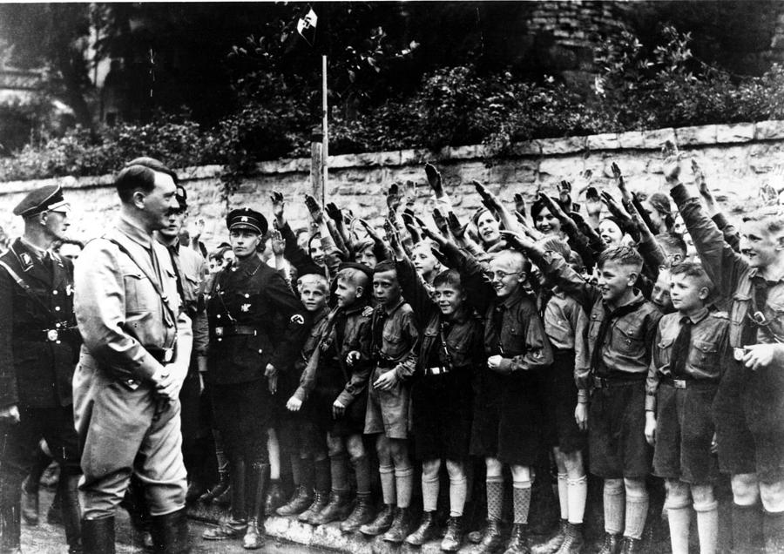

Date marked | Comment

Put syllabus from specification on this page

Key Question 6 – Terror and persuasion
What methods did the Nazis use to control Germany?
Topics covered: | Topic covered  Tick once you have understood each topic
Use of SS and Gestapo
Control of the legal system
Goebbels and propaganda
Use of rallies, radio and cinema
Censorship of newspapers and the arts

Page
Use of SS and Gestapo

The Terror State
A key element in maintaining a Nazi dictatorship was to create a climate of fear, to make people too frightened to actively oppose the Nazi state. This was achieved through the establishment of a police state including a secret police, the Gestapo, the SS, Nazi control of the law courts and the setting up of concentration camps.
Key words:
Gestapo - the German state secret police, known for its brutal methods.
SS Schutzsaffel - Military Unit. Hitler’s body guards & special police force.
SD Sicherheitsdienst – The intelligence body of the Nazi Party

- The Nazi police force operated through the use of force and terror.
- The Nazis used their own organisations to instil fear into the German people.
- The SS and Gestapo were the main organisations, in 1936 they were brought under the control of Heinrich Himmler.
- The SS were formed to act as a body guard unit to Hitler and they had a clear visible identity. Members wore black and were expected to be fine examples of the Aryan race and marry racially pure wives.
- The Gestapo was set up in 1933 be Hermann Goering. In 1936 it became under the control of the SS. The Gestapo was the most important police section of the Nazi state.
- Suspects would most likely end up in a concentration camp.
- The Nazis controlled the Reichstag and could make laws but Hitler still wanted to ensure that all laws were interpreted in a Nazi fashion. Some judges were removed and all had to become members of the National Socialist League for the Maintenance of Law.
- Nazi views were to be upheld in court. In 1934 a new People’s Court was established, the judges were loyal Nazis but Hitler himself could alter sentences if he felt they were too soft.
- By the end of 1934 Hitler controlled the Reichstag, the army and the legal system.
- It was now impossible for anyone to escape the power and grip of the Nazis.

Make notes about the police state

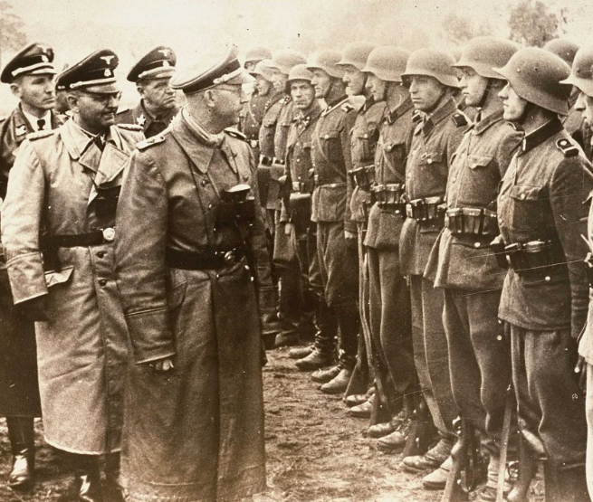
The role of the SS ( Schutzstaffel)

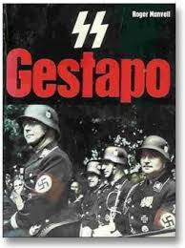
The role of the Gestapo)

What was the police state?

Concentration camps
The role of the Legal System
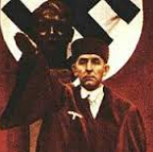

Exam question 1
This question is about Terror and persuasion
Study the source below and then answer the question which follows.
Source A
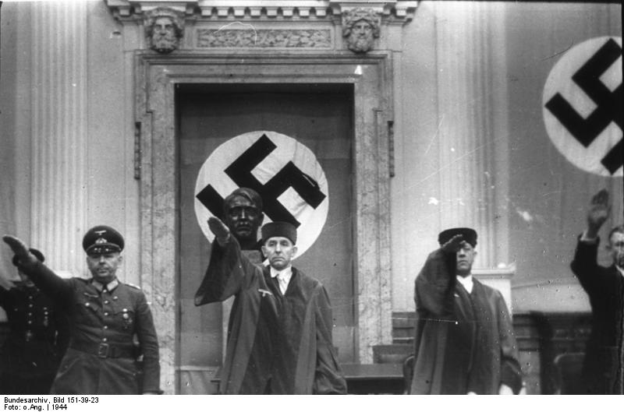

[Judge Roland Freisler, State Secretary of the Reich Ministry of Justice. Here, he is presiding over a People’s Court.]

Use Source A and your own knowledge to describe the how the legal system was controlled under the Nazis. [6]
------------------------------------------------------------------------------------------------------------------------------------------------------------------------------------------------------------------------------------------------------------------------------------------------------------------------------------------------------------------------------------------------------------------------------------------------------------------------------------------------------------------------------------------------------------------------------------------------------------------------------------------------------------------------------------------------------------------------------------------------------------------------------------------------------------------------------------------------------------------------------------------------------------------------------------------------------------------------------------------------------------------------------------------------------------------------------------------------------------------------------------------------------------------------------------------------------------------------------------------------------

Exam question 4
This question is about Terror and persuasion
Study the sources below and then answer the question that follows.
Source A
Finally, I alone created, on my own initiative, the State Secret Police Department. This is the instrument which is so much feared by the enemies of the Sate, and which is chiefly responsible for the fact that in Germany and Prussia today there is no question of a Marxist or communist danger.

[Herman Goering explains about his role in setting up the Gestapo in his book Germany Reborn, written in 1934]
Source B
In a cafe, a 64 year old women remarked to her companion at the table: ‘Mussolini (leader of Italy) has more political sense in one of his boots than Hitler has in his brain.’ The remark was overheard and five minutes later the woman was arrested by the Gestapo who had been alerted by telephone.

[An incident reported in the Rhineland, July 1938]

Which of the sources is more useful to an historian studying the role of the Gestapo in Nazi Germany? [12]
[You should refer to both sources in your answer and use your knowledge and understanding of the historical context.]
--------------------------------------------------------------------------------------------------------------------------------------------------------------------------------------------------------------------------------------------------------------------------------------------------------------------------------------------------------------------------------------------------------------------------------------------------------------------------------------------------------------------------------------------------------------------------------------------------------------------------------------------------------------------------------------------------------------------------------------------------------------------------------------------------------------------------------------------------------------------------------------------------------------------------------------------------------------------------------------------------------------------------------------------------------------------------------------------------------------------------------------------------------------------------------------------------------------------------------------------------------------------------------------------------------------------------------------------------------------------------------------------------------------------------------------------------------------------------------------------------------------------------------------------------------------------------------------------------------------------------------------------------------------------------------------------------------------------------------------------------------------------------------------------------------------------------------------------------------------------------------------------------------------------------------------------------------------------------------------------------------------------------------------------------------------------------------------------------------------------------------------------------------------------------------------------------------------------------------------------------------------------------------------------------------------------------------------------------------------------------------------------------------------------------------------------------------------------------------------------------------------------------------------------------------------------------------------------------------------------------------------------------------------------------------------------------------------------------------------------------------------------------------------------------------------------------------------------------------------------------------------------------------------------------------------------------------------------------------------------------------------------------------------------------------------------------------------------------------------------------------------------------------------------------------------------------------------------------------------------------------------------------------------------------------------------------------------------------------------------------------------------------------------------------------------------------------------------------------------------------------------------------------------------------------------------------------------------------------------------------------------------------------------------------------------------------------------------------------------------------------------------------------------------------------------------------------------------------------------------------------------------------------------------------------------------------------------------------------------------------------------------------------------------------------------------------------------------------------------------------------------------------------------------------------------------------------------------------------------------------------------------------------------------------------------------------------------------------------------------------------------------------------------------------------------------------------------

Goebbels and propaganda

Make notes illustrating the different methods of propaganda used by the Nazi’s

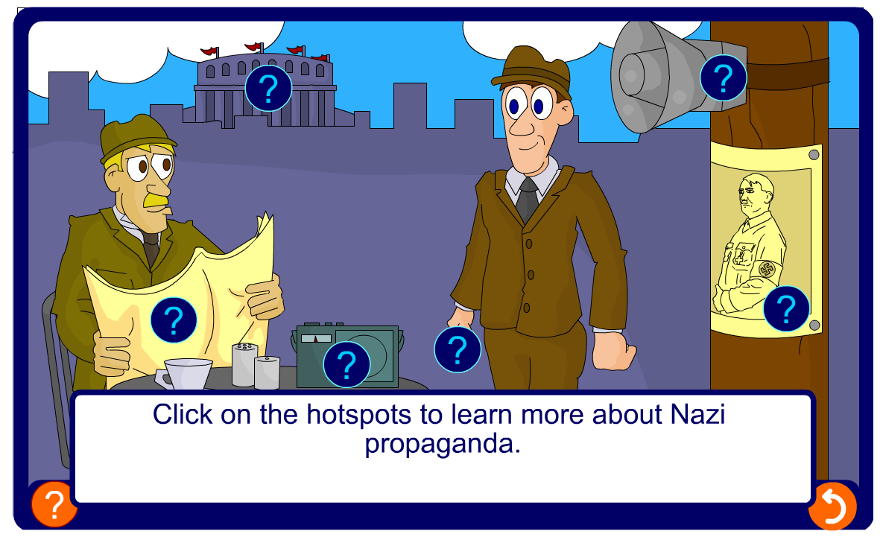

Consider how effective each method of propaganda or censorship would have been by filling in the table below. The first one has been done for you.

 | How was it used? | How effective?
Radio | All radio stations were placed under Nazi control. Everyone could assess cheap radios. Radio sets were also put in cafes, factories and loudspeakers were placed in streets. | Very effective because it was made widely available so almost all Germans could listen to Nazi propaganda. They could not listen to foreign broadcasts and so only had access to Nazi viewpoints.
Cinema
Posters
Books
Rallies

Exam question 3
This question is about Terror and persuasion
Study the source below and then answer the question which follows.
Source A
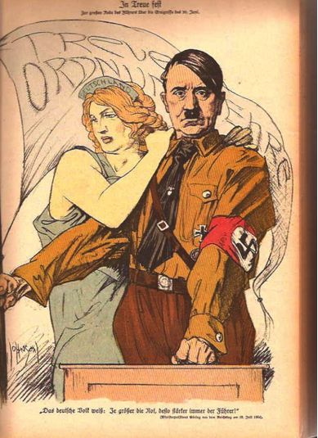

[A propaganda poster of 1934 which says ‘Loyalty, Honour and order’]

What was the purpose of Source B? [8]

[Use details from Source B and your own knowledge and understanding of the historical context to answer the question.]

Censorship of newspapers and the arts

Fill in the following mind map illustrating how Hitler and the Nazis used censorship to control newspapers and the arts
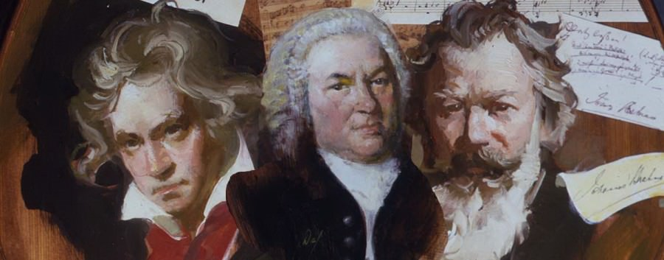
Music
Newspapers
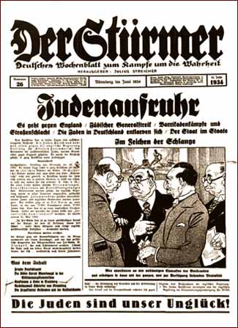

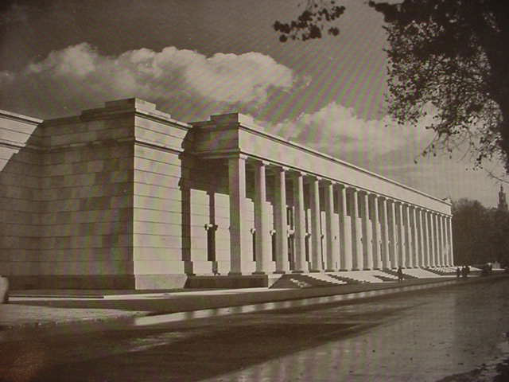
Architecture

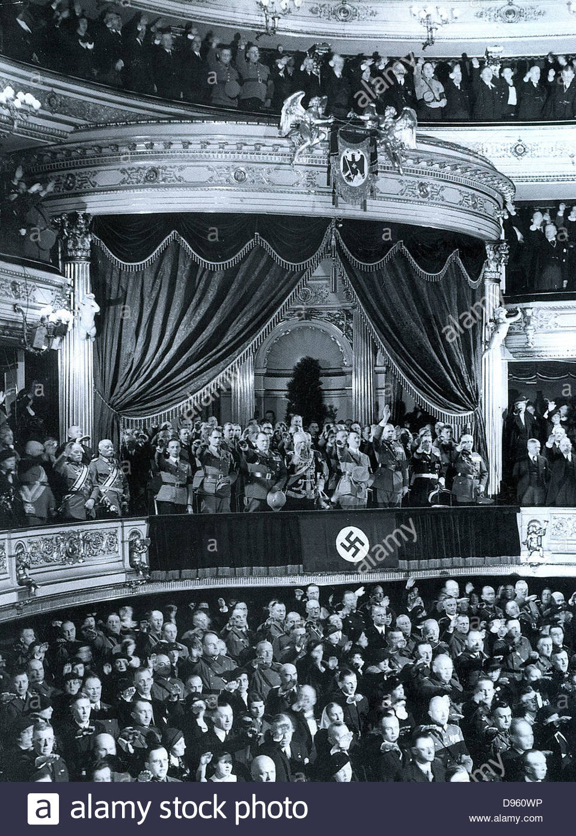
Theatre
Censorship of newspapers and the arts

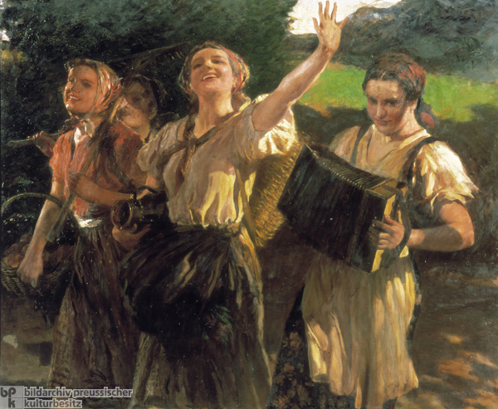
Art

Exam question 3
This question is about terror and persuasion
Study the source below and then answer the question which follows.
Source A

[A Nazi painting by Leopold Schmutzler which was exhibited in the "Great German Art Exhibition" of 1940 in Munich]

What was the purpose of Source B?

[Use details from Source B and your own knowledge and understanding of the historical context to answer the question.]

----------------------------------------------------------------------------------------------------------------------------------------------------------------------------------------------------------------------------------------------------------------------------------------------------------------------------------------------------------------------------------------------------------------------------------------------------------------------------------------------------------------------------------------------------------------------------------------------------------------------------------------------------------------------------------------------------------------------------------------------------------------------------------------------------------------------------------------------------------------------------------------------------------------------------------------------------------------------------------------------------------------------------------------------------------------------------------------------------------------------------------------------------------------------------------------------------------------------------------------------------------------------------------------------------------------------------------------------------------------------------------------------------------------------------------------------------------------------------------------------------------------------------------------------------------------------------------------------------------------------------------------------------------------------------------------------------------------------------------------------------------------------------------------------------------------------------------------------------------------------------------------------------------------------------------------------------------------------------------------------------------------------------------------------------------------------------------------------------------------------------------------------------------------------------------------------------------------------------------------------------------------------------------------------------------------------------------------------------------------------------------------------------------------------------------------------------------------------------------------------------------------------------------------------------------------------------------------------------------------------------------------------------------------------------------------------------------------------------------------------------------------------------------------------------------------------------------------------------------------------------------------------------------------------------------------------------------------------------------------------------------------------------------------------------------------------------------------------------------------------------------------------------------------------------------------------------------------------------------------------------------------------------------------------------------------------------------------------

Exam question 5
Was the use of terror the only way the Nazis attempted to control the people of Germany? [16]

- Use your own knowledge and understanding of the issue to support your answer. Marks for spelling, punctuation and the accurate use of grammar and specialist language are allocated to this question.
- You need to develop a two-sided answer which has balance and good support
- You should start by discussing the Nazis use of terror
- You then need to consider the counter argument by considering how the Nazi’s also made use of persuasion
- Aim to link each paragraph by using words such as ‘other factors include’, ‘also important’, ‘in addition to’, ‘however’.
- Conclude your answer with a link back to the question, making a judgement about the extent of recovery.
- Aim to write between one and two sides of A4

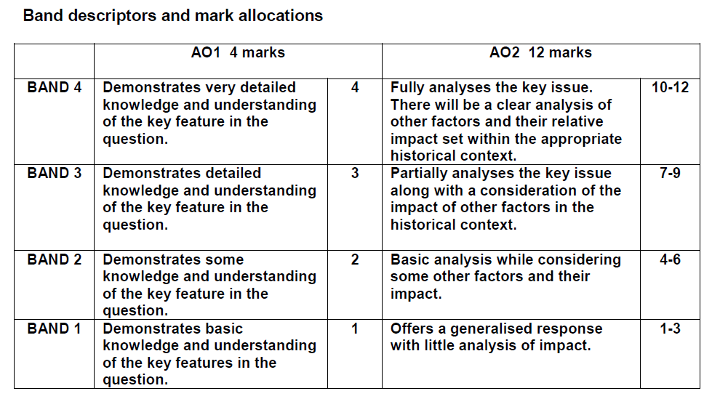

.......................................................................................................………………………..................................................................................................................................................................................................................................................................................................................................................................................................................................................................................................................................................................................................................................……………………….................................................................................................................................................................................................................................................................................................................................................................................................................................................
.........................................................................................................……………………….........................................................................................................................................................................................................................................................................................................................................................................................................................................................................................………………………..........................................................................................................................................................................................................................................................................................................................................................................................................................................................................................................................................................……………………….........................................................................................................................................................................................................................................................................................................................................................................................................................................................................................................................………………………..........................................................................................................................................................................................................................................................................................................................................................................................................................................................................................................................………………………....................................................................................................................................................................................................................................................................................................................................................................................………………………........................................................................................................................................................................................................................................................................................................................................................................................................

Key Question 7 – Hitler’s foreign policy
What factors led to the outbreak of war in 1939?
Topics covered: | Topic covered  Tick once you have understood each topic
Hitler’s foreign policy aims
Rearmament and conscription
The Rhineland 1936
The Anschluss 1938
The Sudetenland 1938
The Nazi-Soviet Pact 1939

Hitler’s foreign policy aims

Fill in the table below illustrating Hitler’s foreign policy aims:
Reverse the Treaty of Versailles
Unite all German speaking people
Lebensraum
Anschluss
Destroy communism

This question is about Hitler’s foreign policy
Study the source below and then answer the question which follows.
Source A
We turn our eyes towards the lands of the east…. When we speak of new territory in Europe today, we must principally think of Russia and the border states subject to her. Destiny itself seems to wish to point out the way for us here. Colonisation of eastern frontiers is of extreme importance. It will be the duty of Germany’s foreign policy to provide large living spaces for nourishment and settlement of the growing population of Germany.

[From Hitler’s Mein Kampf, 1924.]

Use Source A and your own knowledge to describe Hitler’s foreign policy aims

..............................................................................................................................................................................................................................................................................
.........................................................................................................………………………...............................................................................................................................................................................................................................................................................................................................................................................................................................................................................................................................................................................................................................................................………………………........................................................................................................................................................................................................................................................................

Rearmament and conscription

Why was the league of nations considered weak?
…...............................................................................................................................................................................................................................................................................................................................................................................................................................................................................................................................................................................................................................................................……………………...…..........................................................................................................................................................................................................................................................................
Why did the Disarmament Conference of 1932-34 fail?
…...............................................................................................................................................................................................................................................................................................................................................................................................................................................................................................................................................................................................................................................................……………………...….........................................................................................................................................................................................................................................................................…..........................................................................................................................................................................................................................................................................
Describe the non –aggression pact with Poland in January 1934
…...............................................................................................................................................................................................................................................................................................................................................................................................................................................................................................................................................................................................................................................................……………………...…..........................................................................................................................................................................................................................................................................…...............................................................................................................................................................................................................................................................................................................................................................................................................................................................................................................................................................................................................................................................……………………...…..........................................................................................................................................................................................................................................................................

Rearmament and conscription

Draw a time line of Hitler’s actions from 1933 to 1935 by using the table below.
One has been done for you:

Date | Details | Result
The Disarmament Conference 19323-34
Non-aggression Pact with Poland January 1934
Attempted Anschluss Austria 1934
Renouncing Treaty of Versailles March 1935 | Hitler announced that he was renouncing the terms of the Treaty of Versailles which dealt with disarmament | Conscription was reintroduced and the army, navy and air force were all built up openly. Hitler made Hitler popular with the German people.

The Rhineland 1936

Exam question 1
Study the source below and then answer the question which follows.
Source A
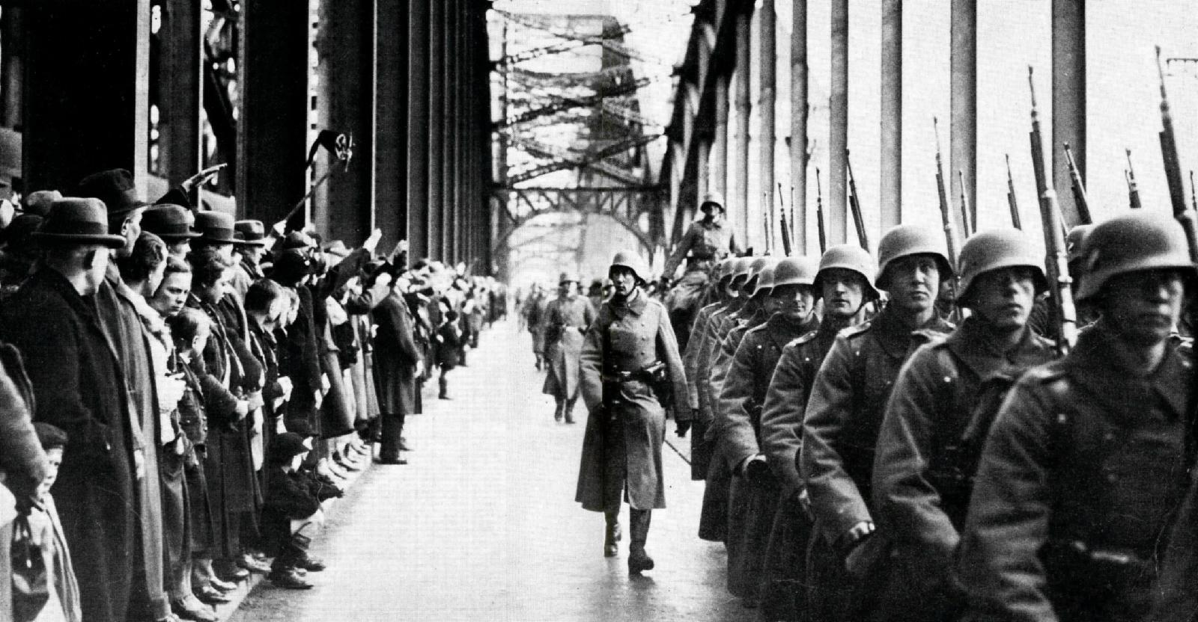

[German troops entering Cologne, in the Rhineland, in March 1936.]

Use Source A and your own knowledge to describe German re-occupation of the Rhineland.
…...............................................................................................................................................................................................................................................................................................................................................................................................................................................................................................................................................................................................................................................................……………………...…..........................................................................................................................................................................................................................................................................…...................................................................................................................................
Exam question 4
Study the sources below and then answer the question that follows.
Source A
More than once, during the war, I heard Hitler say: ‘The 48 hours after the march into the Rhineland were the most nerve-racking of my life.’ He always added: If the French had then marched into the Rhineland, we would have had to withdraw with our tails between our legs, for the military resources at our disposal would have been wholly inadequate for even a moderate resistance.

[From an account written by Hitler’s interpreter in 1951]

Source B
Hitler has got away with it. France has done nothing. No wonder the faces of Hitler and Goering were all smiles this noon. Oh the stupidity of the French! I learned today that the German troops who marched into the Rhineland yesterday were under strict orders to beat a hasty retreat if the French army opposed them in any way.

[A question from a Nazi math’s textbook, 1933]

[An entry from Berlin Diary 1934-41, by William Shirer, an American journalist living in Berlin in the 1930s, dated 8th March 1936]

Which of the sources is more useful to an historian studying the German re occupation of the Rhineland in March 1936?

…...............................................................................................................................................................................................................................................................................................................................................................................................................................................................................................................................................................................................................................................................……………………...…..........................................................................................................................................................................................................................................................................…...................................................................................................................................
…...............................................................................................................................................................................................................................................................................................................................................................................................................................................................................................................................................................................................................................................................……………………...…..........................................................................................................................................................................................................................................................................…...................................................................................................................................…...............................................................................................................................................................................................................................................................................................................................................................................................................................................................................................................................................................................................................................................................……………………...…..........................................................................................................................................................................................................................................................................…...................................................................................................................................…...............................................................................................................................................................................................................................................................................................................................................................................................................................................................................................................................................................................................................................................................……………………...…...................................................................................................................................

The Anschluss 1938

What was the Hossbach memorandum?
…...............................................................................................................................................................................................................................................................................................................................................................................................................................................................................................................................................................................................................................................................……………………...…..........................................................................................................................................................................................................................................................................
According to the source below what reasons are suggested for the Anschluss with Austria?
Don’t think for one moment that anyone on earth is going to thwart my decisions. Italy? I see eye to eye with Mussolini. England?.....and France? France could have stopped Germany in the Rhineland and then we would have had to retreat. But now it is too late for France.

[Hitler in conversation with Schuschnigg, the Chancellor of the Federal State of Austria, March 1938]
…...............................................................................................................................................................................................................................................................................................................................................................................................................................................................................................................................................................................................................................................................……………………...…..........................................................................................................................................................................................................................................................................
1936-37
January 1938
12th February 1938
8th March 1938
12th March 1938
13th March 1938
April 1938
Fill in the events of the Anschluss

Exam question 1
Study the source below and then answer the question which follows.
Source A
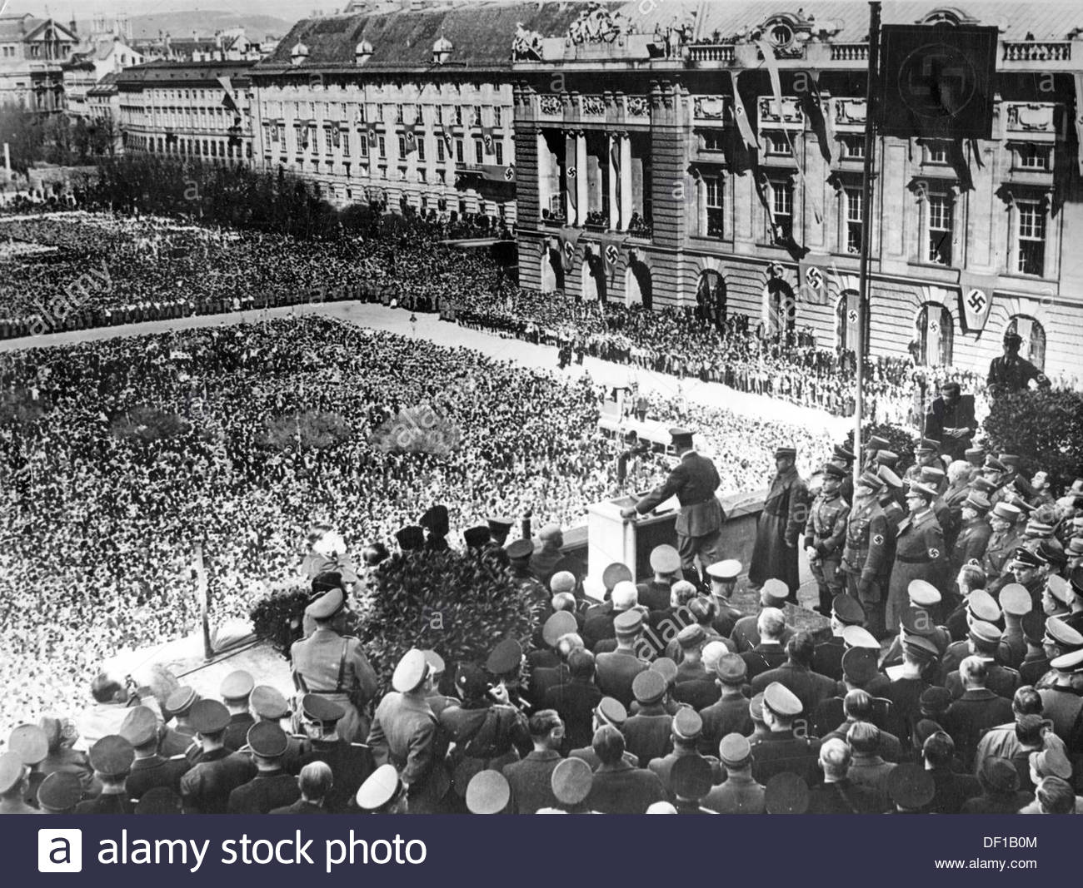

[Nazi propaganda showing Hitler on the balcony of the Hofburg, Vienna, announcing the annexation of Austria to the German Reich to a crowd of people on the 15th March 1938]

Use Source A and your own knowledge to describe the Anschluss of 1938.
…...............................................................................................................................................................................................................................................................................................................................................................................................................................................................................................................................................................................................................................................................……………………...…..........................................................................................................................................................................................................................................................................

…...............................................................................................................................................................................................................................................................................................................................................................................................................................................................................................................................................................................................................................................................……………………...…........................................................................................................................................................................................................................................................................
Exam question 4
Study the sources below and then answer the question that follows.
Source A
Herr Hitler returned here yesterday, a conquering hero. His triumphant welcome was shared by the army he sent to Austria. Flowers were strewn in the path of the armoured cars. If any Austrian was against him on Friday, they either hid their faces or were completely converted yesterday and today.

[A report from Germany published in the Times on Monday 14th March 1938, after German troops entered Austria]

Source B
I imagine that the event which is in our minds today, the Anschluss, will be the cause of regret, of sorrow, perhaps indignation. The event cannot be regarded by His majesty’s government with indifference….The immediate result must be to intensify the sense of uncertainty and insecurity in Europe. This is not a moment for hasty decisions or for careless words. As regards our defence programmes…we have decided to make a fresh review, and in due course we shall announce what further steps we may think it necessary to take.

[A question from a Nazi math’s textbook, 1933]

[From a speech by Neville chamberlain, British Prime Minister, to the House of Commons, 14th March 1938]
Which of the sources is more useful to an historian studying the Anschluss of 1938?

…...............................................................................................................................................................................................................................................................................................................................................................................................................................................................................................................................................................................................................................................................……………………...…........................................................................................................................................................................................................................................................................…...............................................................................................................................................................................................................................................................................................................................................................................................................................................................................................................................................................................................................................................................……………………...….......................................................................................................................................................................................................................................................................…...............................................................................................................................................................................................................................................................................................................................................................................................................................................................................................................................................................................................................................................................……………………...…........................................................................................................................................................................................................................................................................…...............................................................................................................................................................................................................................................................................................................................................................................................................................................................................................................................................................................................................................................................……………………...…........................................................................................................................................................................................................................................................................…...............................................................................................................................................................................................................................................................................................................................................................................................................................................................................................................................................................................................................................................................……………………...…........................................................................................................................................................................................................................................................................

The Sudetenland 1938

Read the relevant pages in your textbook and answer the questions that follow:
Why did Hitler want to control Czechoslovakia?
.......................................................................................................……………………...…........................................................................................................................................................................................................................................................................…...............................................................................................................................................................................................................................................................................................................................................................................................................................................................................................................................................................................................................................................................……………………...…........................................................................................................................................................................................................................................................................

Summarise the key features of the Sudetenland crisis using the following flow chart.
From April 1938

15th September 1938

22nd September 1938

29th September 1938

Exam question 3
Study the source below and then answer the question which follows.
Source A
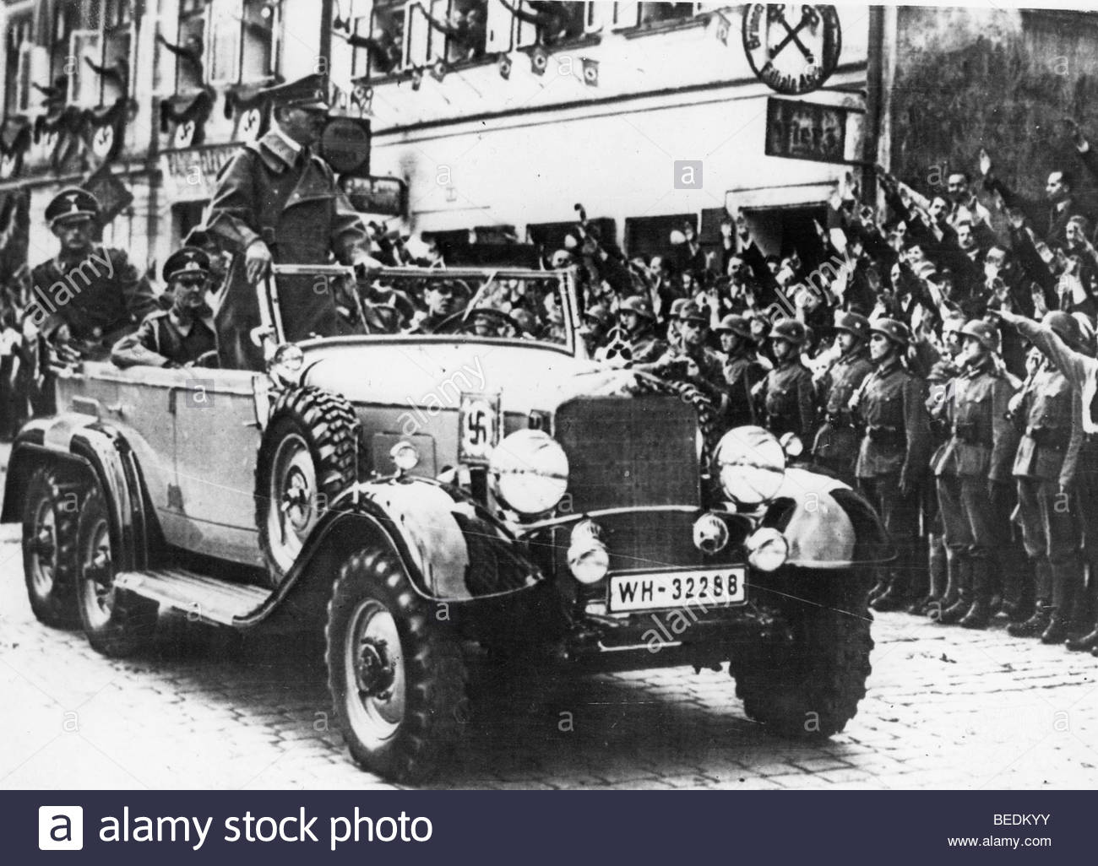

[Official Nazi photograph of Hitler visiting the Sudetenland, October 1938. The Nazi caption read – The Fuhrer in the liberated town of Asch. Today, the Fuhrer arrived in Asch among indescribable exultation of the liberated Sudeten German population]

What was the purpose of Source B?

[Use details from Source B and your own knowledge and understanding of the historical context to answer the question.]

.......................................................................................................……………………...…........................................................................................................................................................................................................................................................................…...............................................................................................................................................................................................................................................................................................................................................................................................................................................................................................................................................................................................................................................................……………………...…...............................................................................................................................................................................................................................................................................................................................................................................……………………...…........................................................................................................................................................................................................................................................................…...............................................................................................................................................................................................................................................................................................................................................................................................................................................................................................................................................................................................................................................................……………………...…........................................................................................................................................................................................................................................................................

The Nazi-Soviet Pact 1939

Exam question 2
Describe the Nazi-Soviet pact of 1939. [8]
---------------------------------------------------------------------------------------------------------------------------------------------------------------------------------------------------------------------------------------------------------------------------------------------------------------------------------------------------------------------------------------------------------------------------------------------------------------------------------------------------------------------------------------------------------------------------------------------------------------------------------------------------------------------------------------------------------------------------------------------------------------------------------------------------------------------------------------------------------------------------------------------------------------------------------------------------------------------------------------------------------------------------------------------------------------------------------------------------------------------------------------------------------------------------------------------------------------------------------------------------------------------------------------------------------------------------------------------------------------------------------------------------------------------------------------------------------------------------------------------------------------------------------------------------------------------------------------------------------------------------------------------------------------------------------------------------------------------------------------------------------------------------------------------------------------------------------------------------------------------------------------------------------------------------------------------------------------------------------------------------------------------------------------------------------------------------------------------------------------------------------------------------------------------------------------------------------------------------------------------------------------------------------------------------------------------------------------------------------------------------------------------------------------------------------------------------------------------------------------------------------------------------------------------------------------------------------------------------------------------------------------------------------------------------------------------------------------------------------------------------------------------------------------

Study the source below and then answer the question, which follows.
Source A
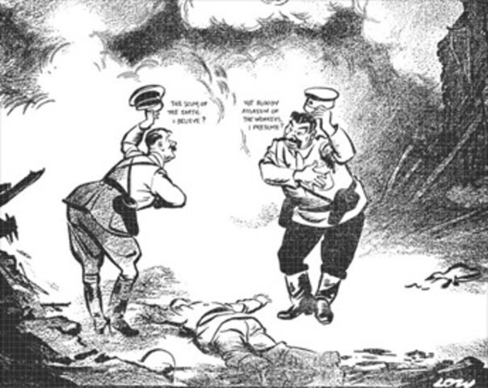

What can you learn about the Nazi-Soviet Pact from this cartoon?
----------------------------------------------------------------------------------------------------------------------------------------------------------------------------------------------------------------------------------------------------------------------------------------------------------------------------------------------------------------------------------------------------------------------------------------------------------------------------------------------------------------------------------------------------------------------------------------------------------------------------------------------------------------------------------------------------------------------------------------------------------------------------------------------------------------------------------------------------------------------------------------------------------------------------------------------------------------------------------------------------------------------------------------------------------------------------------------------------------------------------------------------------------------------------------------------------------------------------------------------------------------------------------------------------------------------------------------------------------------------------------------------------------------------------------------------------------------------------------------------------------------------------------

Exam question 5
Hitler’s main aim in foreign policy was to unite all German-speaking people in a single country.
To what extent do you agree with this interpretation?
[16]
Use your own knowledge and understanding of the issue to support your answer. Marks for spelling, punctuation and the accurate use of grammar and specialist language are allocated to this question. [3]

------------------------------------------------------------------------------------------------------------------------------------------------------------------------------------------------------------------------------------------------------------------------------------------------------------------------------------------------------------------------------------------------------------------------------------------------------------------------------------------------------------------------------------------------------------------------------------------------------------------------------------------------------------------------------------------------------------------------------------------------------------------------------------------------------------------------------------------------------------------------------------------------------------------------------------------------------------------------------------------------------------------------------------------------------------------------------------------------------------------------------------------------------------------------------------------------------------------------------------------------------------------------------------------------------------------------------------------------------------------------------------------------------------------------------------------------------------------------------------------------------------------------------------------------------------------------------------------------------------------------------------------------------------------------------------------------------------------------------------------------------------------------------------------------------------------------------------------------------------------------------------------------------------------------------------------------------------------------------------------------------------------------------------------------------------------------------------------------------------------------------------------------------------------------------------------------------------------------------------------------------------------------------------------------------------------------------------------------------------------------------------------------------------------------------------------------------------------------------------------------------------------------------------------------------------------------------------------------------------------------------------------------------------------------------------------------------------------------------------------------------------------------------------------------------------------------------------------------------------------------------------------------------------------------------------------------------------------------------------------------------------------------------------------------------------------------------------------------------------------------------------------------------------------------------------------------------------------------------------------------------------------------------------------------------------------------------------------------------------------------------------------------------------------------------------------------------------------------------------------------------------------------------------------------------------------------------------------------------------------------------------------------------------------------------------------------------------------------------------------------------------------------------------------------------------------------------------------------------------------------------------------------------------------------------------------------------------------------------------------------------------------------------------------------------------------------------------------------------------------------------------------------------------------------------------------------------------------------------------------------------------------------------------------------------------------------------------------------------------------------------------------------------------------------------------------------------------------------------------------------------------------------------------------------------------------------------------------------------------------------------------------------------------------------------------------------------------------------------------------------------------------------------------------------------------------------------------------------------------------------------------------------------------------------------------------------------------------------------------------------------------------------------------------------------------------------------------------------------------------------------------------------------------------------------------------------------------------------------------------------------------------------------------------------------------------------------------------------------------------------------------------------------------------------------------------------------------------------------------------------------------------------------------------------------------------------------------------------------------------------------------------------------------------------------------------------------------------------------------------------------------------------------------------------------------------------------------------------------------------------------------------------------------------------------------------------------------------------------------------------------------------------------------------------------------------------------------------------------------------------------------------------------------------------------------------------------------------------------------------------------------------------------------------------------------------------------------------------------------------------------------------------------------------------------------------------------------------------------------------------------------------------------------------------------------------------------------------------------------------------------------------------------------------------------------------------

