**UNIT 3 - Relationships**

These terms are the **key concepts** - terms which you must learn and know their meaning for the exam!

**Commitment** - making and keeping promises.

E.g -

**Responsibility** - Duties or tasks that you should carry out.

E.g -

**Divorce** - When the marriage comes to an end. E.g

**Roles:** Status, position of a person in society. E.g

**Responsibilities -** Duties you should carry out. Things you have to do. What you are expected to take care of. Something you do out of a sense of duty, or because you are expected to do it. E.g

**Adultery** - A sexual relationship outside of the marriage. E.g

**Cohabitation-** Living together before marriage. E.g

**Contraception** – methods which prevent (stop) a female from getting pregnant.E.g

**Gender equality** – All genders having the same rights/opportunities in their lives. Treated the same.

E.g

**ISSUES OF RELATIONSHIPS**

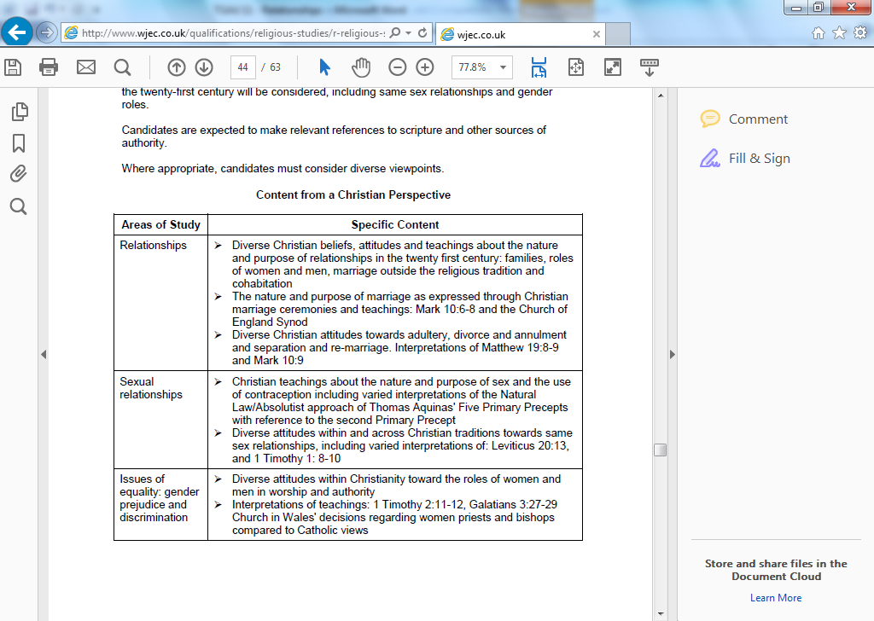

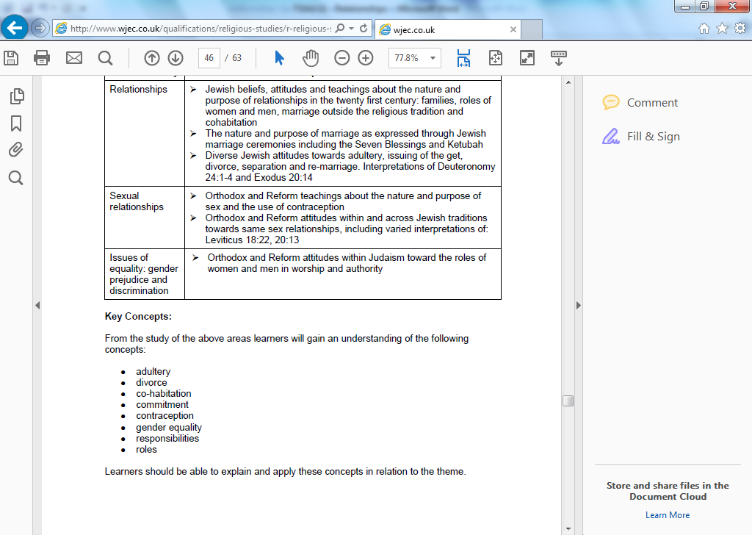

**SEXUAL RELATIONSHIPS**

**Purpose of sex**

* Gift from God – part of God’s creation.
* Continuation of the human race.
* Strengthens the love between the couple.
* To have children – procreation.
* Pleasure.
* To show each other commitment.
* To strengthen the agreement between them.

**Discussion:**

**Watch the clip from Friends – “The One with Free Porn”**

* What is Joey and Chandler’s attitudes towards sex in the clip?
* What is the purpose of sex?
* What are the dangers of sex in this day and age?
* What are the attitudes of people towards sex?

**Chastity – (refuse sex until marriage)**

http://tbn2.google.com/images?q=tbn:eMbG0z1tYfrjgM:http://www.staffspasttrack.org.uk/exhibit/ilm/Image/Logo/CHRIST~1.gifhttp://tbn0.google.com/images?q=tbn:MFmUb-xiFxFeRM:http://www.staffspasttrack.org.uk/exhibit/ilm/Image/Logo/Jewish.gifChristians and Jews teach that people who are not married should live a life of Chastity (refuse sex until marriage). This is the safest way, and the only way of making sure that children aren’t produced outside of marriage.



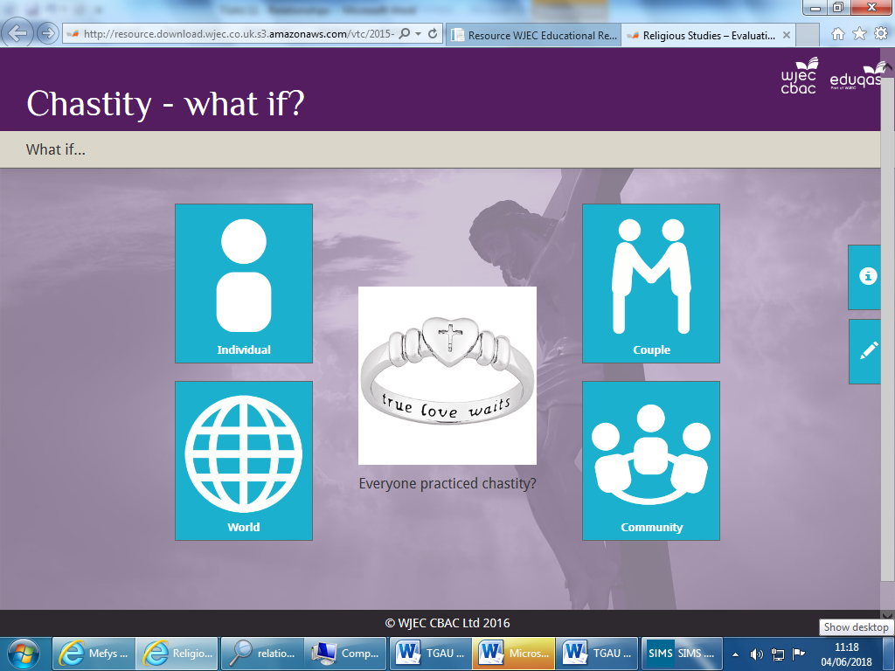

**Discuss the What if question from each perspective. Consider what impact this decision would have upon the person group or thing being considered. How the impact might be positive. How the impact might be negative.** http://adnoddau.cbac.co.uk/Pages/ResourceSingle.aspx?rIid=1092&langChange=cy-GB

**Celibacy (vow not to marry or have a sexual relationship)**

http://tbn2.google.com/images?q=tbn:eMbG0z1tYfrjgM:http://www.staffspasttrack.org.uk/exhibit/ilm/Image/Logo/CHRIST~1.gifSome Christians choose a celibate lifestyle to dedicate their lives to serving God e.g. Catholic priests and monks. It’s their choice of commitment to dedicate their life to God.

http://tbn0.google.com/images?q=tbn:MFmUb-xiFxFeRM:http://www.staffspasttrack.org.uk/exhibit/ilm/Image/Logo/Jewish.gifUnlike Christianity, the idea of celibacy does not exist within Judaism. It is believed that God wished men and women to serve him by living together as a married couple and producing families. Therefore, Jewish tradition would see it ‘abnormal’ for people to live celibate lives like monks or nuns.

**RELIGIOUS ATTITUDES TO SEX**

**Christianity** http://tbn2.google.com/images?q=tbn:eMbG0z1tYfrjgM:http://www.staffspasttrack.org.uk/exhibit/ilm/Image/Logo/CHRIST~1.gif

Promiscuity (casual sex) is unacceptable. Devalue sex and individuals. Paul – ‘…Those who live like this will not inherit the kingdom of God.’ (Galatians 5).

Strengthen the love and develop the relationship.

Between husband and wife within a marriage.

To have children.

Sex is a gift from God and is something special, which should be respected.

God said; “Be fruitful and multiply.” (Genesis 1:28)

**Catholics**

The main purpose of sex is to have children because God said; “Be fruitful and multiply.” (Genesis 1:28) Sex is also a way of showing love to each other. Sex before marriage is a sin.

**Protestants**

Sex is acceptable if they love each other and are in a steady relationship. Sex shows commitment. They accept sex before marriage for the above reasons.

‘Whoever sins sexually, sins against their own body.’ Paul (1 Cor 6:18).

‘Marriage should be honoured, and the marriage bed should be kept pure, for God will judge all the sexually immoral.’ (Hebrews 13.4)

[](http://images.google.co.uk/imgres?imgurl=http://atschool.eduweb.co.uk/carolrb/Christianity/images/cross2.gif&imgrefurl=http://atschool.eduweb.co.uk/carolrb/Christianity/christian_symbols.html&usg=__qyQwb7owXIsQdeDDWpXcia5Sknk=&h=214&w=150&sz=1&hl=en&start=27&tbnid=EYgZbgPhztjE3M:&tbnh=106&tbnw=74&prev=/images?q%3Dchristianity%2Bsymbols%26gbv%3D2%26ndsp%3D20%26hl%3Den%26sa%3DN%26start%3D20)[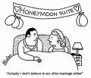](http://images.google.co.uk/imgres?imgurl=http://www.benettontalk.com/premarital-sex-usa.jpg&imgrefurl=http://enlightenedcatholicism-colkoch.blogspot.com/2009/01/jewish-thoughts-on-sex-in-marriage.html&usg=__ay811U5ItTUT9Ik1X6AIFR407oE=&h=301&w=350&sz=33&hl=en&start=7&tbnid=XRxPdSr_84rKHM:&tbnh=103&tbnw=120&prev=/images?q%3Dchristianity%2Bsex%2Band%2Bmaariage%26imgsz%3Dsmall|medium|large|xlarge%26gbv%3D2%26ndsp%3D20%26hl%3Den%26sa%3DN)[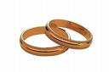](http://images.google.co.uk/imgres?imgurl=http://www.sjcclerk.net/Clerks/Recording/marriage.jpeg&imgrefurl=http://www.sjcclerk.net/Marriage%20Licenses1.aspx&usg=__orXfLN1cH0fdD6-aq-U47SjrA90=&h=307&w=460&sz=38&hl=en&start=4&tbnid=1jRmr19l8-UdGM:&tbnh=85&tbnw=128&prev=/images?q%3Dmarriage%26imgsz%3Dsmall|medium|large|xlarge%26gbv%3D2%26hl%3Den%26sa%3DX)[](http://images.google.co.uk/imgres?imgurl=http://atschool.eduweb.co.uk/carolrb/Christianity/images/cross2.gif&imgrefurl=http://atschool.eduweb.co.uk/carolrb/Christianity/christian_symbols.html&usg=__qyQwb7owXIsQdeDDWpXcia5Sknk=&h=214&w=150&sz=1&hl=en&start=27&tbnid=EYgZbgPhztjE3M:&tbnh=106&tbnw=74&prev=/images?q%3Dchristianity%2Bsymbols%26gbv%3D2%26ndsp%3D20%26hl%3Den%26sa%3DN%26start%3D20)

**JUDASIM** [Jewish](http://images.google.co.uk/imgres?imgurl=http://www.staffspasttrack.org.uk/exhibit/ilm/Image/Logo/Jewish.gif&imgrefurl=http://www.staffspasttrack.org.uk/exhibit/ilm/&usg=__VGNdYDpexA6KD9Ew1-zx23U1Fbc=&h=39&w=50&sz=1&hl=en&start=1&tbnid=MFmUb-xiFxFeRM:&tbnh=39&tbnw=50&prev=/images?q%3Djewish%2Bsymbol%26imgsz%3Dicon%26gbv%3D2%26hl%3Den)

Sex is a gift from God and is something special, which should be respected. Sex is for pleasure as well as procreation.

In the Torah God said; “Be fruitful and multiply.” (Genesis 1:28). Keeping to the Mitzvot.

**Orthodox Jews**

The main purpose of sex is to have children because God said in the Torah; “Be fruitful and multiply.” (Genesis 1:28) It is important to keep to this Mitzvot as it secures the survival of their religion. Sex also displays their love for one another. Sex before marriage is a sin because children should be born within marriage. If people slept around a child might not be raised within a Jewish family.

Between husband and wife within a marriage. It’s one of the 3 stages of marriage:

* promise to marry
* the wedding
* sex

**Reform Jews**

Sex is preferred within marriage to have children within marriage. However, sex is acceptable if both love each other, are in a stable relationship and if they don’t hurt anyone in the process. Sex shows commitment. They accept sex before marriage for the above reasons only.

To have children - survival of the religion.

Strengthen the love and develop the relationship.

[](http://images.google.co.uk/imgres?imgurl=http://www.tpub.com/content/religion/14229/img/14229_72_1.jpg&imgrefurl=http://www.tpub.com/content/religion/14229/css/14229_72.htm&usg=__Hqyw1_ETjZHfmhRaIAwl02hNXAU=&h=317&w=284&sz=8&hl=en&start=2&tbnid=eEVTJsRLe92V9M:&tbnh=118&tbnw=106&prev=/images?q%3DJUDAISM%26imgsz%3Dsmall|medium|large|xlarge%26gbv%3D2%26hl%3Den)[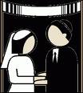](http://images.google.co.uk/imgres?imgurl=http://lawblog.legalmatch.com/wp-content/uploads/2008/12/jewish-marriage-268x300.gif&imgrefurl=http://lawblog.legalmatch.com/2008/12/18/for-better-or-worse-the-%E2%80%9Cjewish-marriage-clause%E2%80%9D-debate-marches-on/&usg=__B6MM3M1XkTdR1nvEsYVRTnqTAfI=&h=300&w=268&sz=16&hl=en&start=20&tbnid=s23nyIawjhFdBM:&tbnh=116&tbnw=104&prev=/images?q%3DJEWISH%2BAND%2BMARRIAGE%26imgsz%3Dsmall|medium|large|xlarge%26gbv%3D2%26hl%3Den)[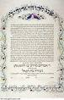](http://images.google.co.uk/imgres?imgurl=http://bp1.blogger.com/_VByoe7_6L0Y/SJgp1LMv9gI/AAAAAAAAAK8/D7-dqgQm4YQ/s320/Ketubah.jpg&imgrefurl=http://yackety-yak-israel.blogspot.com/2008/08/who-needs-get-jewish-rabbinical-divorce.html&usg=__8gLLfellgeNAnk9Wl7q0aJwet-o=&h=320&w=206&sz=27&hl=en&start=39&tbnid=5R6iNoib6fsnSM:&tbnh=118&tbnw=76&prev=/images?q%3DJEWISH%2BAND%2BMARRIAGE%26imgsz%3Dsmall|medium|large|xlarge%26gbv%3D2%26ndsp%3D20%26hl%3Den%26sa%3DN%26start%3D20)[](http://images.google.co.uk/imgres?imgurl=http://www.tpub.com/content/religion/14229/img/14229_72_1.jpg&imgrefurl=http://www.tpub.com/content/religion/14229/css/14229_72.htm&usg=__Hqyw1_ETjZHfmhRaIAwl02hNXAU=&h=317&w=284&sz=8&hl=en&start=2&tbnid=eEVTJsRLe92V9M:&tbnh=118&tbnw=106&prev=/images?q%3DJUDAISM%26imgsz%3Dsmall|medium|large|xlarge%26gbv%3D2%26hl%3Den)

**DISCUSS:**

* Listen to the song Right Girl by Daniel Beddingfield. What is the artists’ attitude towards sex?
* What is your opinion about the religious attitudes to sex?
* Are these attitudes relevant in this day and age?

**CONTRACEPTION -** Methods which prevent (stop) a female from getting pregnant. For example:

[](http://images.google.co.uk/imgres?imgurl=http://www.pulsetoday.co.uk/pictures/466xAny/a/d/f/contraceptive_pills.jpg&imgrefurl=http://home2rome.wordpress.com/2008/06/18/the-contraception-question/&usg=__E9PvwXcgpqFXgWpuJVRpvuaAziM=&h=373&w=466&sz=144&hl=en&start=12&tbnid=1vTG06E2pTQVJM:&tbnh=102&tbnw=128&prev=/images?q%3Dcontraception%26imgsz%3Dsmall|medium|large|xlarge%26gbv%3D2%26hl%3Den)The pill [](http://images.google.co.uk/imgres?imgurl=http://www.avert.org/photo_library/images/normal_photo_no_240.gif&imgrefurl=http://pandagon.blogsome.com/2008/02/11/6720/&usg=__M77gWbS88AvuUXslPdfNHwlGQ_A=&h=299&w=399&sz=37&hl=en&start=35&tbnid=UP3LOUkfvTdu7M:&tbnh=93&tbnw=124&prev=/images?q%3Dcontraception%26imgsz%3Dsmall|medium|large|xlarge%26gbv%3D2%26ndsp%3D20%26hl%3Den%26sa%3DN%26start%3D20) Condom

**TASKS AND DISCUSSION**

1. **Try to think of points that show the advantages and disadvantages of birth-control methods in this day and age.**

|  |  |
| --- | --- |
| **Advantages** | **Disadvantages** |
|  |  |

1. **Whose decision is it concerning the use of contraception?**

**JEWISH ATTITUDES** [Jewish](http://images.google.co.uk/imgres?imgurl=http://www.staffspasttrack.org.uk/exhibit/ilm/Image/Logo/Jewish.gif&imgrefurl=http://www.staffspasttrack.org.uk/exhibit/ilm/&usg=__VGNdYDpexA6KD9Ew1-zx23U1Fbc=&h=39&w=50&sz=1&hl=en&start=1&tbnid=MFmUb-xiFxFeRM:&tbnh=39&tbnw=50&prev=/images?q%3Djewish%2Bsymbol%26imgsz%3Dicon%26gbv%3D2%26hl%3Den)

In general, Jews do not allow the use of contraception because the purpose of sex is to have children. Orthodox and Reform emphasise how precious children are, especially in the light of the many Jewish lives lost during the Holocaust. However, both Orthodox and Reform allow birth-control if pregnancy would pose a threat to the mother’s life or health.

According to **Orthodox** **Jews**, wasting seed (sperm) is a sin therefore contraception like the condom are not allowed. The purpose of the seed is to create new life. Orthodox does not allow contraception for social or economic reasons (e.g. because a couple cannot afford another child). One Mitzvot in the Torah is ‘Be fruitful and multiply.’ (Genesis 1:28) Having children is God’s will. Children secure the survival of the religion.

The **Torah** forbids the ‘withdrawal’ as a method of contraception based on a man called Onan doing this: *‘Now what he did was evil in the eyes of the Lord.’ (Genesis 38:10)*

**Reform Jews** allow the use of contraception for social or economic reasons and allow the individuals to choose which method to use. They believe that it is acceptable to use contraception if the couple love each other, want to show commitment to each other and are in a steady relationship, and agreed between the husband and wife. They also accept any method to limit family size.

|  |  |  |  |  |  |  |  |  |
| --- | --- | --- | --- | --- | --- | --- | --- | --- |
| **CHRISTIAN ATTITUDES** [CHRIST~1](http://images.google.co.uk/imgres?imgurl=http://www.staffspasttrack.org.uk/exhibit/ilm/Image/Logo/CHRIST~1.gif&imgrefurl=http://www.staffspasttrack.org.uk/exhibit/ilm/Mourining%20and%20Remembrance/Types%20of%20funerals/Christian%20Funerals.htm&usg=__rf4RNx0px9ZxQznik9ex98Rrd3k=&h=46&w=50&sz=1&hl=en&start=8&tbnid=eMbG0z1tYfrjgM:&tbnh=46&tbnw=50&prev=/images?q%3Dchristian%2Bsymbol%26imgsz%3Dicon%26gbv%3D2%26hl%3Den)  **Many Catholics** are **against** using contraception because the purpose of sex is to have children, and contraception prevents this from happening. It is a sin to use these methods because it goes against God’s word when he said, “Be fruitful and multiply.” (Genesis 1:28) The only methods that are acceptable to use are the “pull out” method or the “rhythm” method.  **Protestants and some Catholics allow** theuse of contraception if the couple are not ready to have children, as sex is a way of showing love and commitment. It is acceptable if the couple are in a steady relationship, both content, and both agree which methods to use. Other reasonable reasons are the fact that contraception helps to control the overpopulation of the planet as well as stopping sexual transmitted diseases. God gave people free will and they should use their conscience to decide if they should use contraception or not.  **Natural Law Theory**  This is a theory by Aquinas which tries to help people how to live and make moral decisions. It’s an absolutist view, and many Catholics would follow this theory. Aquinas believed people should live their lives based on rules given by God. There are **five primary precepts**:   1. Protect the innocent. 2. Reproduction 3. Educate children 4. Live in an ordered society 5. Worship God.   Aquinas set out secondary precepts as well to help keep the primary precepts. E.g   |  |  | | --- | --- | | **PRIMARY PRECEPT** | **SECONDARY PRECEPT** | | Reproduce | Not to use contraception | |  |  | |  |  |   Some Catholics agree with the above, therefore, contraception should not be used because it goes against Natural Law. |

|  |
| --- |
|  |

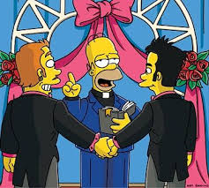**SAME-SEX RELATIONSHIPS**

A sexual relation between two people of the same sex. Homosexuals are often called gay or lesbians in the case of two females. Homosexuality – <https://www.bbc.com/education/clips/z3ky34j>

Strengthen the love and develop the relationship.

Between husband and wife within a marriage.

To have children.

Sex is a gift from God and is something special and holy, which should be respected.

God said; “Be fruitful and multiply.” (Genesis 1:28)

**Catholics**

The main purpose of sex is to have children because God said; “Be fruitful and multiply.” (Genesis 1:28) Sex is also a way of showing love to each other. Sex before marriage is a sin.

**Protestants**

Sex is acceptable if the two love each other and are in a steady relationship. Sex shows commitment. They accept sex before marriage for the above reasons.

**Christian attitudes**http://tbn2.google.com/images?q=tbn:eMbG0z1tYfrjgM:http://www.staffspasttrack.org.uk/exhibit/ilm/Image/Logo/CHRIST~1.gif

* **Catholics** are against same-sex relationship as it goes against God’s will. God said in the Old Testament ‘You shall not lie with a male as with a woman; it is an abomination.’ (Leviticus 18:22). They are also against same-sex relationships as it is unnatural because the purpose of sex is to have children so they go against the word of God when he said ‘be fruitful and multiply.’
* **Protestants** are also against same-sex relationships, but are willing to accept it if both is in a steady relationship, and love each other. Some churches will bless same-sex couples although there is no actual official ceremony.
* **Quakers** have welcomed same-sex relationships for over twenty years.
* **Anglicans** do not believe that same-sex marriages should take place in a church.
* Many Christians are against same-sex marriage based on the following quotes:
* ‘A man lies with a male as with a woman, both of them have committed an abomination; they shall be put to death; their blood is upon them.’ Lev 20:13
* ‘Now we know that the law is good, if one uses it legitimately. This means understanding that the law is laid down not for the innocent but for the lawless and disobedient, for the godless and sinful, for the unholy and profane, for those who kill their father or mother, for murderers, slave traders, liars, perjurers, and whatever else is contrary to the sound teaching.’ (1 Timothy 1:8-10)
* Other Christians believe that there are many things condemned in the Bible, but would be seen as acceptable in today’s society.
* Some Churches will allow same-sex marriages to take place in their churches.

**Jewish attitudes** [Jewish](http://images.google.co.uk/imgres?imgurl=http://www.staffspasttrack.org.uk/exhibit/ilm/Image/Logo/Jewish.gif&imgrefurl=http://www.staffspasttrack.org.uk/exhibit/ilm/&usg=__VGNdYDpexA6KD9Ew1-zx23U1Fbc=&h=39&w=50&sz=1&hl=en&start=1&tbnid=MFmUb-xiFxFeRM:&tbnh=39&tbnw=50&prev=/images?q%3Djewish%2Bsymbol%26imgsz%3Dicon%26gbv%3D2%26hl%3Den)

* Jewish opinion varies from one group to another but generally speaking, all Jews are against same-sex relationships, as God’s plan was for a man and woman to be together (Adam & Eve). God said: **“You shall not lie with a male as with a woman, it is an abomination”.**
* Jews believe that same-sex relationships goes against the commandment to **‘be fruitful and multiply’** as same-sex couples cannot conceive children themselves, therefore putting the future of the religion in danger.
* There is no mention of a relationship between two females in the Torah, but the Talmud says that such a relationship should not exist. It is believed that same-sex relationships are learnt or brought about by circumstances, and that people can be helped out of it. Recently, a number of gay groups have criticised this attitude saying that it is not the fault of the individual that they are gay. Some reform Jews have accepted their arguments, but not orthodox Jews.
* However, Jews do not allow anyone to be prejudice against homosexuals or to persecute them as they suffered side by side with Jews during the Holocaust at the hands of Hitler.

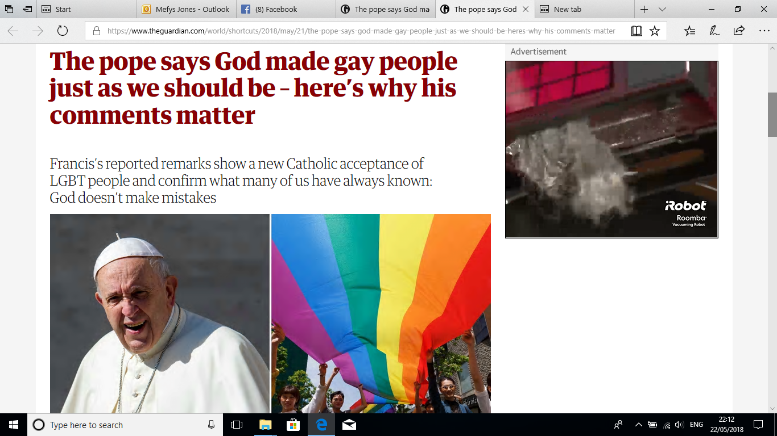

**I**t is powerful to hear that Pope Francis, the leader of the Roman Catholic Church, [reportedly told Juan Carlos Cruz](https://www.theguardian.com/world/2018/may/20/pope-juan-carlos-cruz), a gay man: “God made you like this and loves you like this.”

Cruz is a survivor of abuse who spoke with the pope a few weeks ago. His abuser was found guilty of abuse by the Vatican in 2011.

As a practising Catholic, I find it deeply moving to have [Pope Francis](https://www.theguardian.com/world/pope-francis) appear to confirm what many Catholics already know to be true: God made us just as we should be, there are no mistakes.

Lesbian, gay, bi and trans people exist in every community, from every ethnic background and in every religion. However, religion can often be the area of life that people find the most difficult to reconcile with their identity. Some people will say that LGBT people can’t exist in faith communities; that faith communities don’t accept same-sex relationships or those whose gender doesn’t match the one that they were assigned at birth.

I have never felt excluded from the church and have always been made to feel welcome. But I have met many people who have had different experiences; people who have been damaged by being told to deny their sexuality or who feel rejected by God.

Religions teach that God is love.

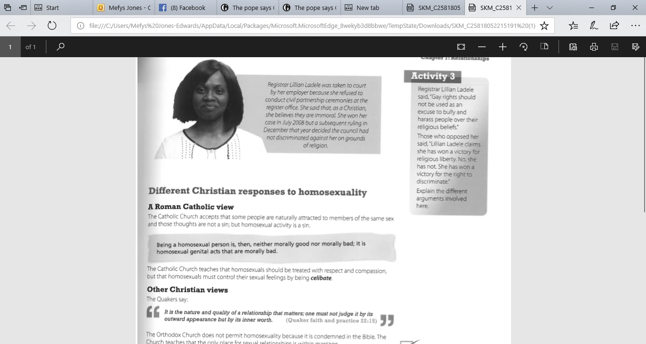

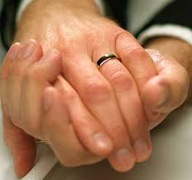 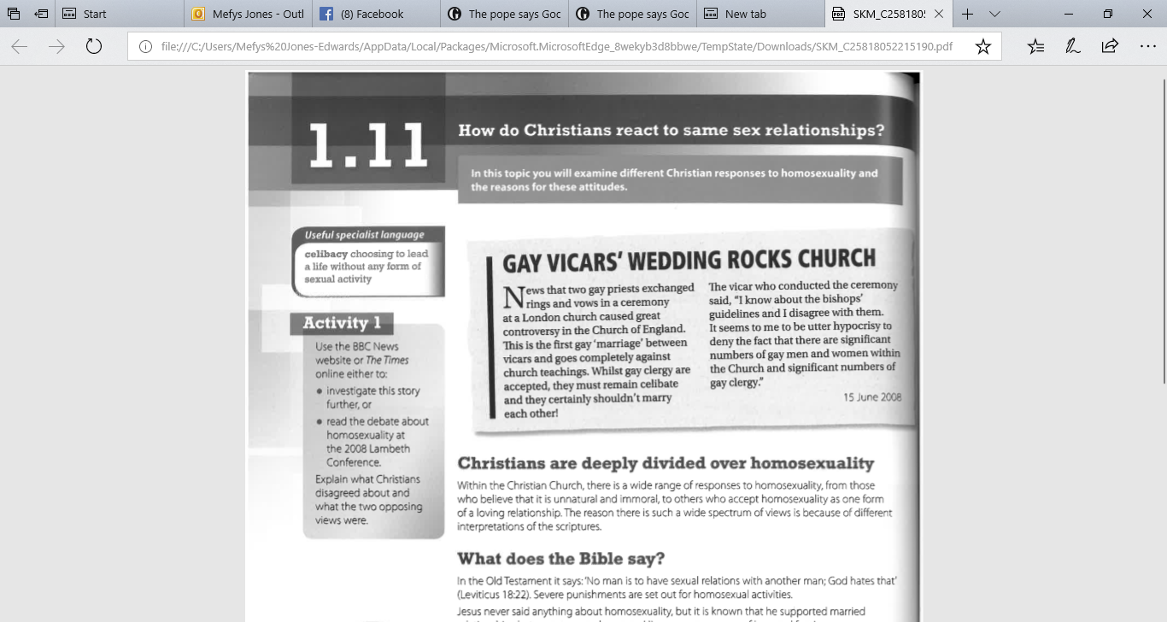

**DISCUSSION AND HOMEWORK**

**After reading the information and sources, answer the following questions.**

1. **How have things changed in regards to the response to same sex relations in the media, law and religion?**
2. **Should same-sex couples have the same rights to get married in a place of worship?** Complete the table below.

|  |  |
| --- | --- |
| Yes | No |
| 1. Everyone deserves happiness. | 1. It says in the Torah and the Old Testament “*You*  *shall not lie with a male as with a woman; it is an*  *abomination.”* (Leviticus 18:22). |

**HOMEWORK - REVISION**

Summarise the religious attitudes in the table.

|  |  |  |  |  |
| --- | --- | --- | --- | --- |
|  | **CATHOLICS** | **PROTESTANTS** | **ORTHODOX JEWS** | **REFORM JEWS** |
| **Purpose of sex** |  |  |  |  |
| **Sex** |  |  |  |  |
| **Birth-control methods** |  |  |  |  |
| **Same sex relationships** |  |  |  |  |

**Tasks**

**(c) Explain Christian and Jewish attitudes to same-sex relationships. [8]**

Success criteria for question c?

....................................................................................................................................................................................................................................................................................................

...................................................................................................................................................................................................................................................................................................

....................................................................................................................................................................................................................................................................................................

....................................................................................................................................................................................................................................................................................................

....................................................................................................................................................................................................................................................................................................

...................................................................................................................................................................................................................................................................................................

......................................................................................................................................................................................................................................................................................................................................................................................................................................................

...................................................................................................................................................................................................................................................................................................

......................................................................................................................................................................................................................................................................................................................................................................................................................................................

|  |  |  |  |
| --- | --- | --- | --- |
| **Marked by** | **Mark/level** | **(+)** | **(-)** |
| **Peer/self** |  |  |  |
| **Teacher** |  |  |  |

**‘Sex before marriage is wrong. If you truly love a person, you should wait until you are married before you have sex’.** Discuss this statement showing that you have considered more than one point of view. (You must refer to religion and belief in your answer). [15]

**Success criteria for question d?**

.......................................................................................................................................................................................................................................................................

........................................................................................................................................................................................................................................................................

........................................................................................................................................................................................................................................................................

........................................................................................................................................................................................................................................................................

........................................................................................................................................................................................................................................................................

........................................................................................................................................................................................................................................................................

...................................................................................................................................

........................................................................................................................................................................................................................................................................

........................................................................................................................................................................................................................................................................

.......................................................................................................................................................................................................................................................................

....................................................................................................................................

........................................................................................................................................................................................................................................................................

........................................................................................................................................................................................................................................................................

........................................................................................................................................................................................................................................................................

........................................................................................................................................................................................................................................................................

........................................................................................................................................................................................................................................................................

........................................................................................................................................................................................................................................................................

.......................................................................................................................................................................................................................................................................

....................................................................................................................................

........................................................................................................................................................................................................................................................................

........................................................................................................................................................................................................................................................................

........................................................................................................................................................................................................................................................................

........................................................................................................................................................................................................................................................................

........................................................................................................................................................................................................................................................................

....................................................................................................................................

|  |  |  |  |
| --- | --- | --- | --- |
| **Marked by** | **Mark/level** | **(+)** | **(-)** |
| **Peer/self** |  |  |  |
| **Teacher** |  |  |  |