Question 1

Using source material and knowledge to describe an aspect of history.

Use Source A and your own knowledge to ...............

AA1 (4 marks) Knowledge and understanding of the historical context.
AA3 (2 marks) Analysing source material correctly.

Exemplar questions

Key Question
IMMIGRATION:
Why did immigration become such a major issue in American society?

Source A

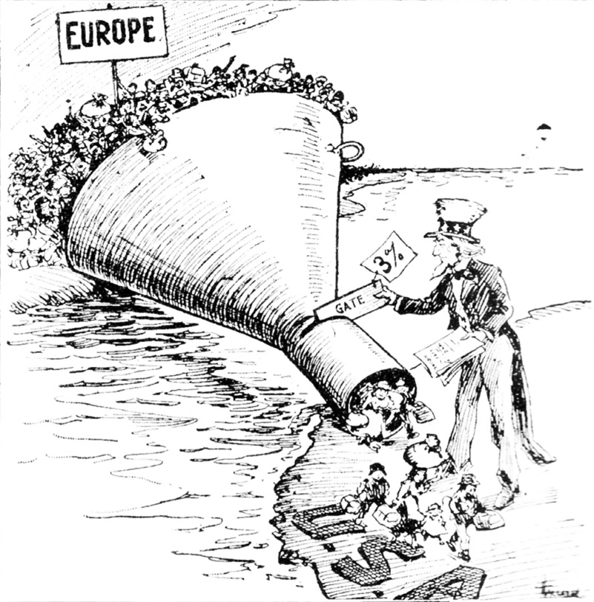

[A cartoon from an American newspaper supporting the reduction of immigration].

Use Source A and your own knowledge to describe government legislation on immigration.
[6]

Source A
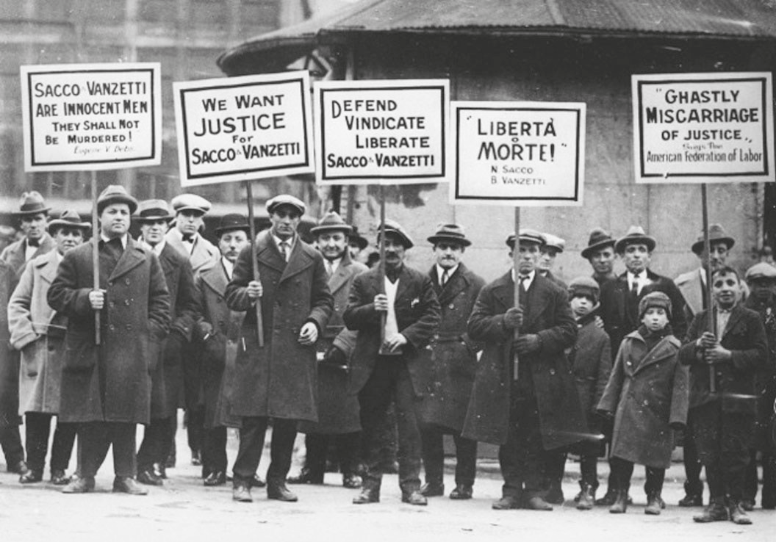
[A photograph of people protesting during the Sacco and Vanzetti case]

Use Source A and your own knowledge to describe the Sacco and Vanzetti case.
[6]

Key Question
RELIGION AND RACE:
Was America a country of religious and racial intolerance during this period?

Source A

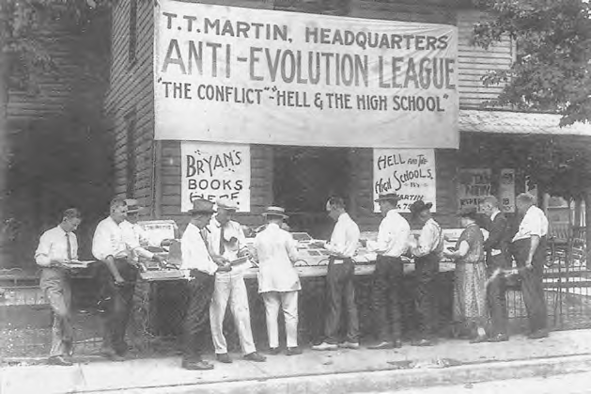
[A photograph of anti-evolution books on sale during the Monkey Trial in 1925]

Use Source A and your own knowledge to describe the Monkey Trial.
[6]

Source A

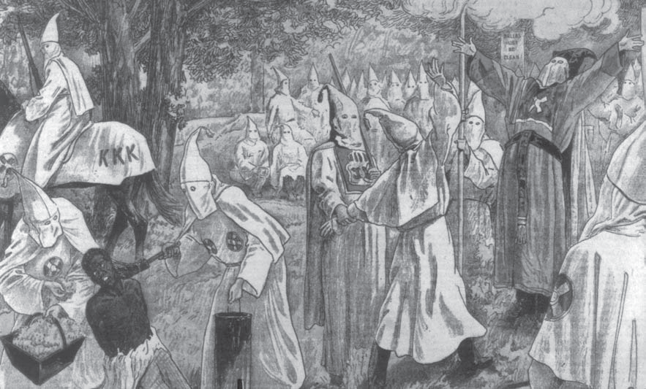
[Image showing the KKK accession ceremony held in 1923]

Use Source A and your own knowledge to describe the KKK.
[6]

Source A

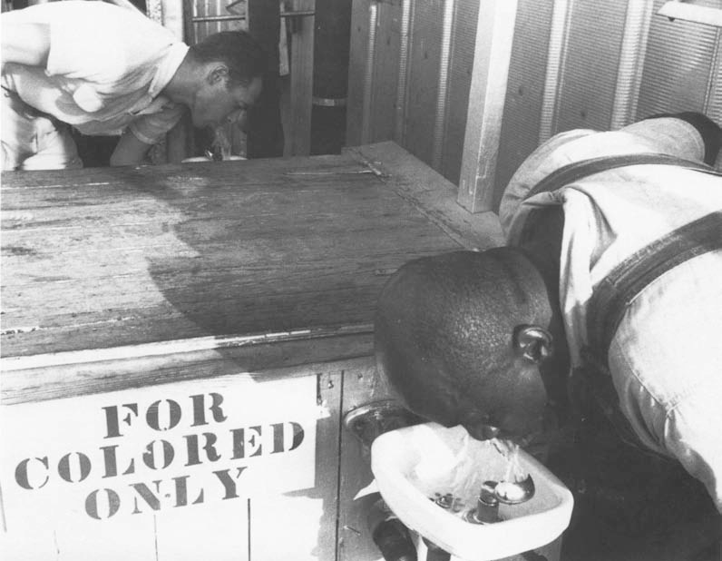
[A photograph showing a black worker and a white worker drinking from different water fountains]

Use Source A and your own knowledge to describe Jim Crow laws.
[6]

Key Question
CRIME AND CORRUPTION:
Was the 1920s a decade of organised crime and corruption?

Source A
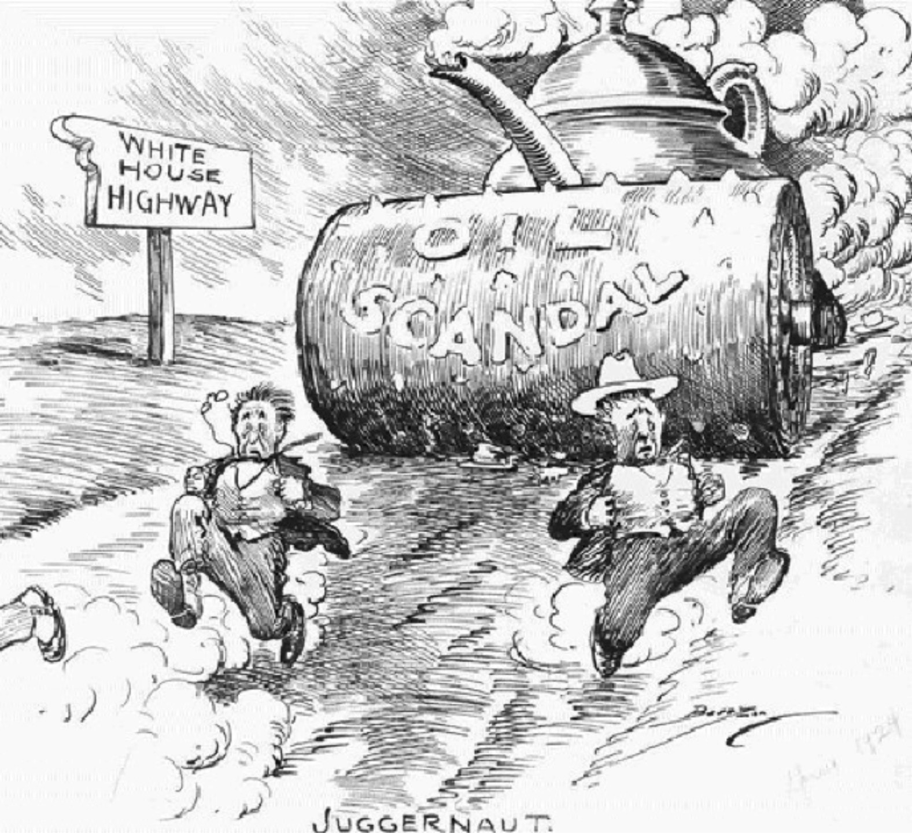

[Cartoon published in an American newspaper in 1924].
Two politicians are running away from a political scandal].

Use Source A and your own knowledge to describe the Tea Pot Dome scandal/political corruption in the 1920s.
[6]

Source A

Daddy's in the Saloon...
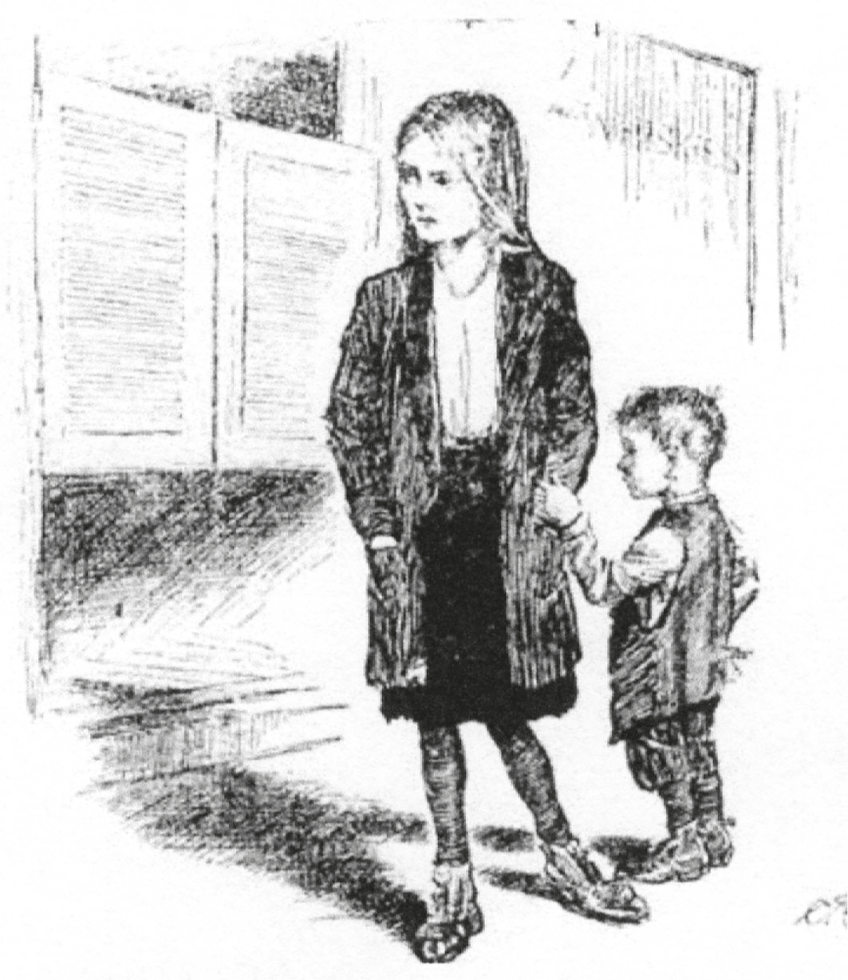
...and he spends all of his money
on beer, instead of buying shoes and
stockings and clothes and food for us.
[A poster about prohibition, 1917]

Use Source A and your own knowledge to outline the reasons why prohibition was introduced.
[6]

Source A

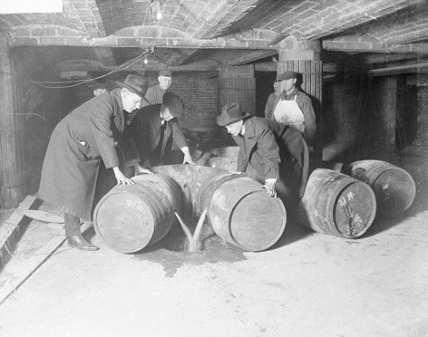

[A photograph showing anti-prohibition officers emptying barrels filled with alcohol in 1927].

Use Source A and your own knowledge to describe crime during the period of the prohibition.
[6]

Key Question
ECONOMIC PROSPERITY:
What were the causes of the economic prosperity of the 1920s?

Source A
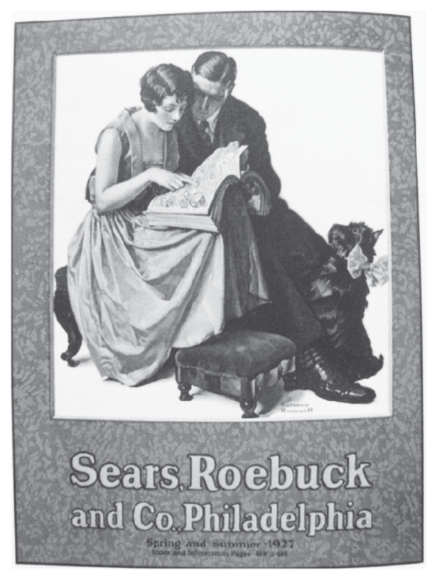

[Poster advertising a mail order catalogue in 1927.]

Use Source A and your own knowledge to describe the economic prosperity of the 1920s.
[6]

Source A
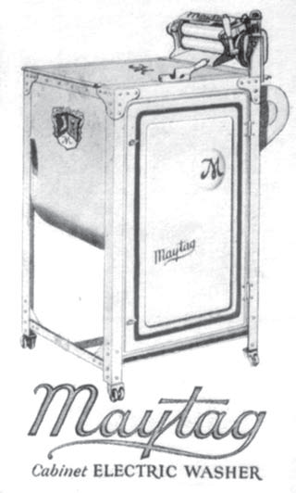

[Advertisement for a Maytag electric washing machine,
which appeared in an American magazine in 1926.]

Use Source A and your own knowledge to describe the impact of electrification.
[6]

Key Question
END OF PROSPERITY:
What factors led to the end of the prosperity in 1929?

Source A

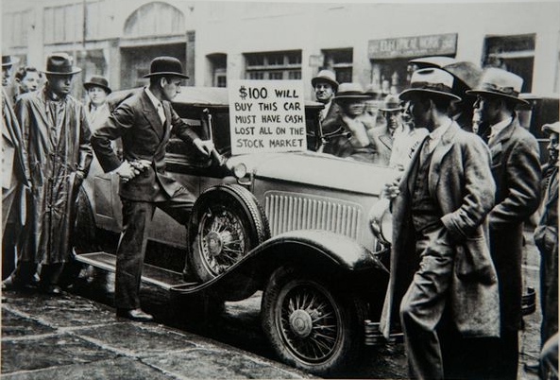

[A photograph showing a car for sale in New York at the end of 1929].

Use Source A and your own knowledge to describe the Wall Street Crash.
[6]

Key Question
POPULAR ENTERTAINMENT:
How did popular entertainment develop during this period?

Source A

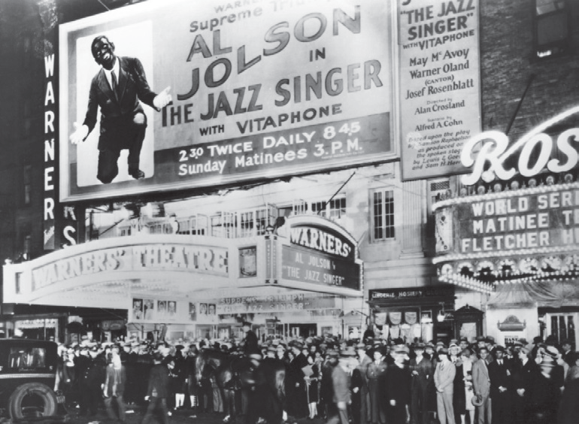

[A photograph showing the opening night of the film, The Jazz Singer, 1927]

Use Source A and your own knowledge to describe the popularity of the cinema.
[6]

Source A
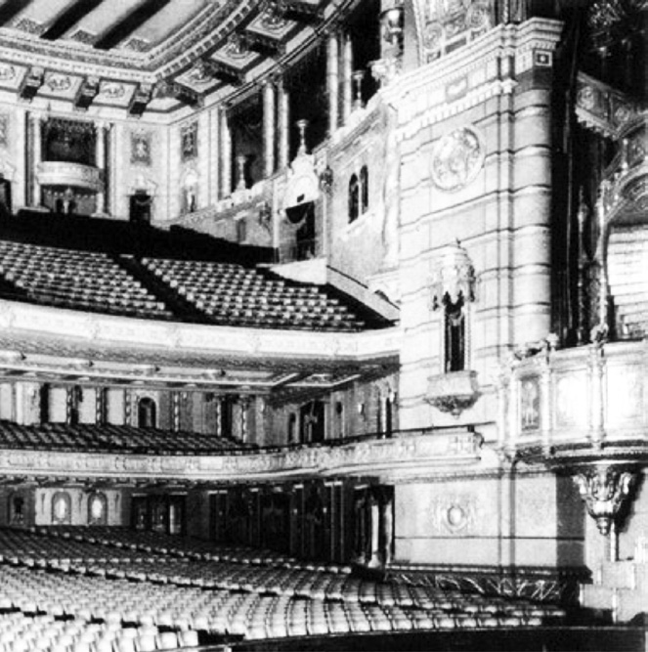

[The new Roxy cinema in New York, which opened in 1927].

Use Source A and your own knowledge to describe the popularity of the cinema.
[6]

Source A

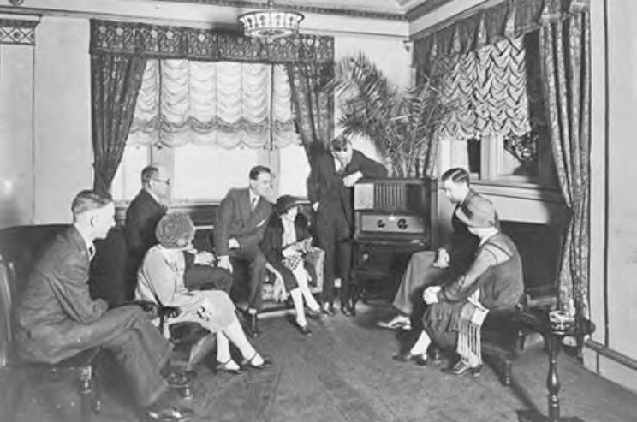
[A photograph of Americans listening to the radio in the late 1920s].

Use Source A and your own knowledge to describe the impact of the radio on Americans].
[6]

Key Question
ROLE OF WOMEN:
How did the lifestyle and status of women change during this period?

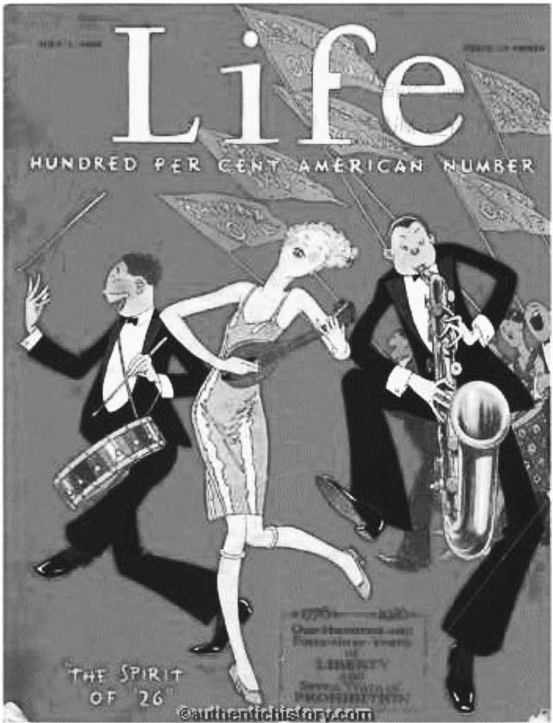

[Cover of Life magazine, which was popular with young people, in 1926].

Use Source A and your own knowledge to describe the influence of Jazz culture on women.
[6]

