[](https://www.google.co.uk/url?sa=i&rct=j&q=&esrc=s&source=images&cd=&cad=rja&uact=8&ved=2ahUKEwi4jurdjr_bAhXJuBQKHT3QDkkQjRx6BAgBEAU&url=https://www.dreamstime.com/vector-silhouette-big-man-small-woman-standing-gender-symbols-men-women-concept-inequality-discrimination-image114795052&psig=AOvVaw0Or_4odj4jeoj-HGxDvNGy&ust=1528377133631945)

**R.E**

**Unit 2 Year 11**

**Relationships**

**TGAU**

[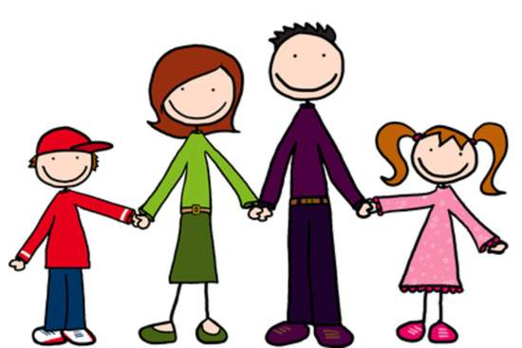](https://www.google.co.uk/url?sa=i&rct=j&q=&esrc=s&source=images&cd=&cad=rja&uact=8&ved=2ahUKEwie8LzL3MfcAhUlxIUKHYAUD3sQjRx6BAgBEAU&url=http://worldartsme.com/family-clipart.html&psig=AOvVaw0YM2mZN5KBJqBLlDA5kIg8&ust=1533070916844535)[](https://www.google.co.uk/url?sa=i&rct=j&q=&esrc=s&source=images&cd=&cad=rja&uact=8&ved=2ahUKEwiU3Zve3cfcAhVEUhoKHTYzC7sQjRx6BAgBEAU&url=https://dumielauxepices.net/broken-heart-clipart/broken-heart-clipart-divorced&psig=AOvVaw0AHhJiMyX32K4HYUIPRy43&ust=1533071137770594)[](https://www.google.co.uk/url?sa=i&rct=j&q=&esrc=s&source=images&cd=&cad=rja&uact=8&ved=2ahUKEwj_qt2o3cfcAhUPCxoKHRprCHwQjRx6BAgBEAU&url=http://www.divorcerecoveryaustin.com/&psig=AOvVaw0AHhJiMyX32K4HYUIPRy43&ust=1533071137770594)

[](https://www.google.co.uk/url?sa=i&rct=j&q=&esrc=s&source=images&cd=&cad=rja&uact=8&ved=2ahUKEwi3_ayMkr_bAhWGbhQKHXKVCsUQjRx6BAgBEAU&url=https://en.wikipedia.org/wiki/Gender_equality&psig=AOvVaw0zjj4x5fCoy-1ih2Z2uRjD&ust=1528378046350018)

[](https://www.google.co.uk/url?sa=i&rct=j&q=&esrc=s&source=images&cd=&cad=rja&uact=8&ved=2ahUKEwjdxs6a3sfcAhWxxYUKHUimCG4QjRx6BAgBEAU&url=http://priests.org.uk/clipart-gay-marriage.html&psig=AOvVaw0ay78yD-lsxWbjI6N4qcK8&ust=1533071351030502)

**Enw:**

**UNIT 3 - Relationships**

These terms are the **key concepts** - terms, which you must learn and know their meaning for the exam!

**Commitment** - making and keeping promises.

E.g -

**Responsibility** - Duties or tasks that you should carry out.

E.g -

**Divorce** - When the marriage ends. E.g

**Roles:** Status, position of a person in society. E.g

**Responsibilities -** Duties you should carry out. Things you have to do. What you are expected to take care of. Something you do out of a sense of duty, or because you are expected to do it. E.g

**Adultery** - A sexual relationship outside of the marriage. E.g

**Cohabitation-** Living together before marriage. E.g

**Contraception** – methods which prevent (stop) a female from getting pregnant. E.g

**Gender equality** – All genders having the same rights/opportunities in their lives. Treated the same.

E.g

**ISSUES OF RELATIONSHIPS**

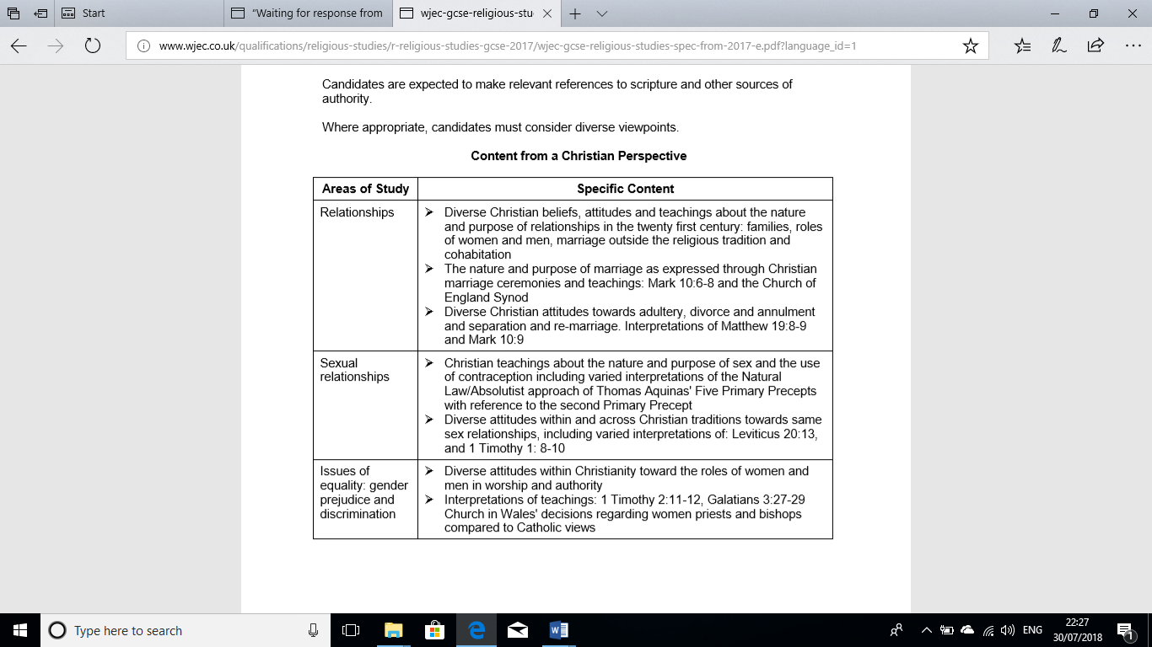

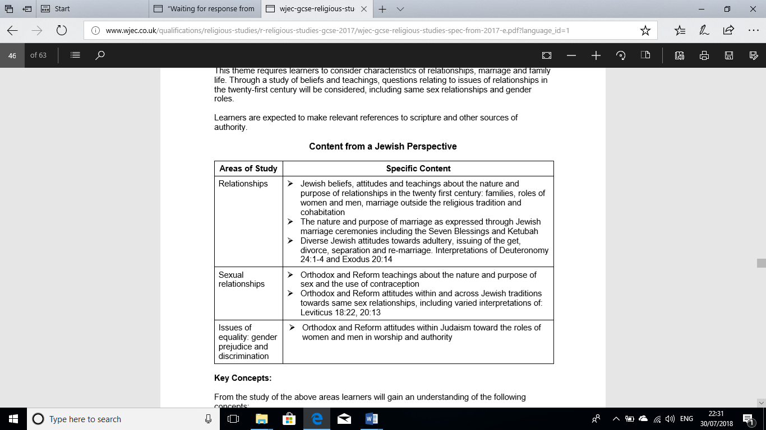

**The Family**

[](https://www.google.co.uk/imgres?imgurl=http://www.brainboxx.co.uk/a3_aspects/images2/TALKthinkpairshare2.gif&imgrefurl=http://www.brainboxx.co.uk/a3_aspects/pages/TALKthinkpair.htm&docid=9sjegRdv0OTuwM&tbnid=aCi8WDuSleV7BM:&vet=1&w=556&h=556&safe=active&bih=521&biw=1093&ved=0ahUKEwjGzq_Mh8XcAhWkJsAKHbHxB5kQMwjFASg7MDs&iact=c&ictx=1)

**Think, pair, share …. The different types of families that exist.**

**Watch the clip Charlie and the Choloclate Factory. Why is the family unit important? Can you include more points?**

** Discuss with your partner why the family unit is important for religious believers.**

**Include those points above.**

**THE FAMILY**

**Christianity**1



The family should be based on the marriage of a man and a woman and include children. Children have the right to be brought up by two parents in a loving environment. Parents should be role models for their children. They should teach, by example, how to be a good parent, a good husband or wife, a good citizen and a good Christian. Paul, in the Bible, sets out the relationship between parents and children: *‘Honour your father and mother’*. Children have a duty to obey their parents. Parents should be patient with their children and raise them up as Christians. They can do this by praying with their children, teaching them stories from the Bible, sending them to Sunday school and encouraging them to be baptised or confirmed.

*“Children, obey your parents in the Lord, for this is right. “****Honor your father and mother,****” which is the first commandment accompanied by a promise, namely, “****that it will******go******well with you and that you will live******a***

***long time on the earth****.” Fathers, do not provoke your children to anger, but raise them up in the*

*discipline and instruction of the Lord”. Ephesians 6:1-4*

[](http://www.google.com/url?sa=i&rct=j&q=&esrc=s&source=images&cd=&cad=rja&uact=8&ved=2ahUKEwjN3NeLsMvbAhWE6xQKHXKQBDUQjRx6BAgBEAU&url=http://www.westword.com/event/opera-on-tap-colorado-monthly-themed-show-boys-vs-girls-9202320&psig=AOvVaw1mD2LOfmTfaykl8GCkMf4j&ust=1528798414019708)**Judaism**



All family members have a role in raising children: parents, grandparents, aunts, uncles and so on. It’s important that children are born to a married couple, so they can have contact with relatives on both sides of their family. The family is the environment in which children learn about the teachings and traditions of Judaism. This learning is reinforced in religious occasions that involve the whole family: rites of passage, Shabbat, festivals. Jewish children learn about Jewish food laws (kashrut), clothing, prayer and worship in the family. Judaism places great emphasis on the importance of education and many Jewish parents prioritise their children’s schooling over other commitments.

**Roles of Women and Men** - **Discuss and note how the roles of men and women within the family have developed over time.**

**COMPARISON ALLEY**

**SIMILARITIES**

**PAST**

**TODAY**

**Christianity**



All people, as God’s creations, are equal: “*you are all one in Christ Jesus.” (Galatians 3.28).* Some Christians believe that, although men and women are equal, they are different and have different roles.

The traditionalist view is that, because Adam was created before Eve (who was made to be his companion) and because women, according to Paul, are subject to the authority of men, men should be leaders in their own homes and women subordinate. For Christians, the man is the head of the household and the woman is responsible for housekeeping and childcare.

Some Christians recognise that, as times change, so the dynamics of social interaction change. They would say that gender inequality in the Bible reflect a society of the past. Today, women (should) have equal opportunities in all areas of life and this includes the home.

**Judaism**Traditionally, men and women are seen to be equal but different. There are two accounts of the Ten Commandments in the Bible; one says, *‘Honour your father and your mother’* and the other, reversing the order, says, *‘Respect your mother and father’*, indicating that both parents in a family have equal status. The role of the woman in the family is to be a good wife and mother. Men must be good husbands; they should not mistreat their wives. Sex between married couples is regarded as the right of the wife in Judaism, not the husband.



While the woman is the principal housekeeper in a home, she is also spiritual head of the family. Thus, Jewishness runs through the maternal line of a family: a person is Jewish if and only if their mother is Jewish. This means that it is the mother’s role to pass on Jewish values to her children. The woman of the house light candles to mark the beginning of Shabbat, the home’s sacred time. A woman’s role as mother and homemaker is thought to be so important that she is exempt from performing certain mitzvot in order to perform household /maternal duties.

Reform Jews have broken down barriers between the separate roles of men and women in Jewish religious life, for example, by enabling women to become rabbis. Although Reform Jews do not feel bound by the mitzvoth, in practice most families still respect the role of the mother as their spiritual head and would still expect her to welcome in Shabbat, for example. Parents should:

* Take their children to a place of worship
* Teach how to read and understand sacred texts
* When and how to pray
* Encourage children to take part in celebrations and festivals
* Understand the importance of rites of passage

**Tick whether each statement is true or false.**

|  |  |  |
| --- | --- | --- |
| **Statement** | **True** | **False** |
| **Role of the Jewish man to pass on Jewish values to the children** |  |  |
| **Traditional Christians believe the man is the head of the household** |  |  |
| **Only men can become rabbis in the reform denomination** |  |  |
| **Modern Christians believe that gender inequality is in the past** |  |  |
| ***‘Honour your father not your mother’* is one of the Ten Commandments** |  |  |
| **Paul said that women are subject to the authority of men** |  |  |
| **The woman is the spiritual head of the family in Judaism** |  |  |

**Marriage**

**Rank what you believe makes a perfect partner from essential to makes little difference. E.g. affectionate.**

**Essential**

**Makes little difference**

Marriage is seen as the union of two people who wish to join and commit to one another. People can get married in a place of worship, in a registry office or also these days anywhere that has the legal right to conduct weddings by a registrar (e.g. in a hotel, on the beach or even under water!)

|  |  |
| --- | --- |
| **Why marry in a religious building?** | **Why marry elsewhere?** |
| 1. 1. God’s blessing on the marriage. 2. 2. Tradition. 3. 3. Religious building – holy place. 4. 4. Covenant with God. 5. 5. Vows in God’s presence. | 1. Not religious.  2. Choose a place that is important to them. |

**CHRISTIAN MARRIAGE**



**Purpose of marriage for Christians? Why marry?**

* + Companionship
  + Sex
  + Children
  + Marriage created by God.
  + God’s blessing on the relationship.
  + To show their love and commitment publicly.
  + Marriage is a sacrament.
  + The couple will help each other on the journey of life.
  + Because the Bible suggests that two people should marry:

‘A man will leave his mother and father and will join together with his wife, and the two shall become one flesh.’ Jesus – (Mathew 19:5.)

Then the Lord God said ‘It is not good that the man should be alone…’ (Genesis 2:18).

**Christian Marriage Service**



|  |
| --- |
| 1. The vicar explains the purpose and importance of marriage 2. The vows – the couple promise each other things and to God – to have, to hold, tolove, to cherish. Commitment for life – promise to stay faithful to each other and keep the vows that were made in front of God. 3. Bless and exchange the rings. Never ending love. The marriage will last forever.  1. Announce that both are married – ‘What God has joined together, let no man separate.’ Jesus 2. The vicar will tie a scarf around the couple’s right hands to show that God has united them. 3. Readings and prayers.  1. Signing the register – to make the marriage legal. |

[](https://www.google.com/url?sa=i&rct=j&q=&esrc=s&source=images&cd=&cad=rja&uact=8&ved=2ahUKEwi4wtaou8vbAhWIRhQKHfUpDrEQjRx6BAgBEAU&url=https://www.pinterest.com/meiskesherly/weddings-cartoon/&psig=AOvVaw0525JsGlGUPn2S63T4XtE1&ust=1528801427314995)**The significance/meaning of marriage**

* Some Christians regard marriage as a gift given to humanity by God – a sacrament. In the Christian wedding service, the phrase ‘ordained by God’ is used, giving marriage a very special significance for all Christians. The vows exchanged between a bride and a groom in a Christian wedding ceremony shows this.
* Jesus uses powerful language to convey the meaning that marriage is the complete joining of two people in a very special way. It shows that the relationship becomes the most important human relationship for the couple who are married.
* *“But at the beginning of creation God ‘made them male and female’. ‘For this reason a man will leave his father and mother and be united to his wife, and the two will become one flesh’. So they are no longer two, but one flesh”. Jesus* ***(Mark 10.6–8)***
* Christians believe that marriage is a gift from God.
* Traditionally, Christian marriage ceremonies have taken place in a chapel or church to show this belief.
* In 2002, the **Synod (council) of the Church of England** set out the Church’s teaching on marriage.In this statement, the Church confirms that:
* marriage should last until the death of the first partner
* it should endure through all circumstances
* it should be between a man and woman only
* they should be faithful to each other
* marriage should produce children
* it should dignify the sexual act
* the couple should provide support for each other
* It’s a sacrament
* God’s blessing on the marriage
* Covenant between the couple and God

**JEWISH MARRIAGE**



**Purpose of marriage?** Companionship, sex, a strong foundation for starting a family, to have children … make sure the Jewish religion survives,to show love and commitment publicly,help each other on the journey of life, marriage is a sacred duty and **s**ecures a relationship both physical and spiritual satisfaction.

**JEWISH MARRIAGE SERVICE -**The Jewish marriage service is made up of 2 parts.

**The Kiddushin**: engagement, ceremony of commitment **Nisuin** – End of the marriage, the 7 blessings.

**The Kiddushin**

[http://tbn0.google.com/images?q=tbn:MFmUb-xiFxFeRM:http://www.staffspasttrack.org.uk/exhibit/ilm/Image/Logo/Jewish.gif](http://images.google.co.uk/imgres?imgurl=http://www.staffspasttrack.org.uk/exhibit/ilm/Image/Logo/Jewish.gif&imgrefurl=http://www.staffspasttrack.org.uk/exhibit/ilm/&usg=__VGNdYDpexA6KD9Ew1-zx23U1Fbc=&h=39&w=50&sz=1&hl=en&start=1&tbnid=MFmUb-xiFxFeRM:&tbnh=39&tbnw=50&prev=/images?q%3Djewish%2Bsymbol%26imgsz%3Dicon%26gbv%3D2%26hl%3Den)The rabbi will highlight the importance of marriage.

[http://tbn0.google.com/images?q=tbn:MFmUb-xiFxFeRM:http://www.staffspasttrack.org.uk/exhibit/ilm/Image/Logo/Jewish.gif](http://images.google.co.uk/imgres?imgurl=http://www.staffspasttrack.org.uk/exhibit/ilm/Image/Logo/Jewish.gif&imgrefurl=http://www.staffspasttrack.org.uk/exhibit/ilm/&usg=__VGNdYDpexA6KD9Ew1-zx23U1Fbc=&h=39&w=50&sz=1&hl=en&start=1&tbnid=MFmUb-xiFxFeRM:&tbnh=39&tbnw=50&prev=/images?q%3Djewish%2Bsymbol%26imgsz%3Dicon%26gbv%3D2%26hl%3Den)The couple will be taken by both sets of parents to stand underneath the **Chuppah.** It’s a symbol of harmony and living together under one roof; the couple’s new home. There are no sides to the chuppah to show they’re part of a community.

[http://tbn0.google.com/images?q=tbn:MFmUb-xiFxFeRM:http://www.staffspasttrack.org.uk/exhibit/ilm/Image/Logo/Jewish.gif](http://images.google.co.uk/imgres?imgurl=http://www.staffspasttrack.org.uk/exhibit/ilm/Image/Logo/Jewish.gif&imgrefurl=http://www.staffspasttrack.org.uk/exhibit/ilm/&usg=__VGNdYDpexA6KD9Ew1-zx23U1Fbc=&h=39&w=50&sz=1&hl=en&start=1&tbnid=MFmUb-xiFxFeRM:&tbnh=39&tbnw=50&prev=/images?q%3Djewish%2Bsymbol%26imgsz%3Dicon%26gbv%3D2%26hl%3Den)The rabbi will say 2 blessings over the wine.

[http://tbn0.google.com/images?q=tbn:MFmUb-xiFxFeRM:http://www.staffspasttrack.org.uk/exhibit/ilm/Image/Logo/Jewish.gif](http://images.google.co.uk/imgres?imgurl=http://www.staffspasttrack.org.uk/exhibit/ilm/Image/Logo/Jewish.gif&imgrefurl=http://www.staffspasttrack.org.uk/exhibit/ilm/&usg=__VGNdYDpexA6KD9Ew1-zx23U1Fbc=&h=39&w=50&sz=1&hl=en&start=1&tbnid=MFmUb-xiFxFeRM:&tbnh=39&tbnw=50&prev=/images?q%3Djewish%2Bsymbol%26imgsz%3Dicon%26gbv%3D2%26hl%3Den)The couple will drink from the same cup symbolising unity between the couple. Sharing everything from now on.

[http://tbn0.google.com/images?q=tbn:MFmUb-xiFxFeRM:http://www.staffspasttrack.org.uk/exhibit/ilm/Image/Logo/Jewish.gif](http://images.google.co.uk/imgres?imgurl=http://www.staffspasttrack.org.uk/exhibit/ilm/Image/Logo/Jewish.gif&imgrefurl=http://www.staffspasttrack.org.uk/exhibit/ilm/&usg=__VGNdYDpexA6KD9Ew1-zx23U1Fbc=&h=39&w=50&sz=1&hl=en&start=1&tbnid=MFmUb-xiFxFeRM:&tbnh=39&tbnw=50&prev=/images?q%3Djewish%2Bsymbol%26imgsz%3Dicon%26gbv%3D2%26hl%3Den)Giving / exchanging rings, by saying, “with this ring you are sanctified to me according to the law of Moses and Israel.” Ring - circle - no beginning, no end to their love. Everlasting love.

[http://tbn0.google.com/images?q=tbn:MFmUb-xiFxFeRM:http://www.staffspasttrack.org.uk/exhibit/ilm/Image/Logo/Jewish.gif](http://images.google.co.uk/imgres?imgurl=http://www.staffspasttrack.org.uk/exhibit/ilm/Image/Logo/Jewish.gif&imgrefurl=http://www.staffspasttrack.org.uk/exhibit/ilm/&usg=__VGNdYDpexA6KD9Ew1-zx23U1Fbc=&h=39&w=50&sz=1&hl=en&start=1&tbnid=MFmUb-xiFxFeRM:&tbnh=39&tbnw=50&prev=/images?q%3Djewish%2Bsymbol%26imgsz%3Dicon%26gbv%3D2%26hl%3Den)The rabbi will read out the **Ketubah** and it is then signed by the groom, bride and the 2 witnesses. Marriage contract - protects the female, if the marriage ends in divorce or the man dies, she will be financially secure, will have a home for her and the children.

The groom will break the glass under his foot. This acknowledges that there will be problems within the marriage but must work through them; remember the temple being destroyed.



**The Nisuin**

[http://tbn0.google.com/images?q=tbn:MFmUb-xiFxFeRM:http://www.staffspasttrack.org.uk/exhibit/ilm/Image/Logo/Jewish.gif](http://images.google.co.uk/imgres?imgurl=http://www.staffspasttrack.org.uk/exhibit/ilm/Image/Logo/Jewish.gif&imgrefurl=http://www.staffspasttrack.org.uk/exhibit/ilm/&usg=__VGNdYDpexA6KD9Ew1-zx23U1Fbc=&h=39&w=50&sz=1&hl=en&start=1&tbnid=MFmUb-xiFxFeRM:&tbnh=39&tbnw=50&prev=/images?q%3Djewish%2Bsymbol%26imgsz%3Dicon%26gbv%3D2%26hl%3Den)In the second part of the ceremony, seven blessings are said praising God for creating the human race and bringing happiness to the couple. They are:

**1** Blessed are you, God, who brings forth fruit from the vine

**2** Blessed are you, God, who shapes the universe. All things created speak of your glory.

**3** Blessed are you, Holy One, who fashions each person.

**4** We bless you, God, for forming each person in your image. You have planted within us a vision of you and given us the means that we may flourish through time. Blessed are you, Creator of humanity.

**5** May Israel, now delight as they gather in joy. Blessed are you who lets Zion rejoice with her children.

**6.** Let these loving friends taste of the bliss you gave to the first man and woman in the Garden of Eden in the days of old. Blessed are you, the Presence who dwells with bride and groom in delight.

**7** Blessed are you, who lights the world with happiness and contentment, love and companionship, peace and friendship, bridegroom and bride. Let the mountains of Israel dance! Let the gates of Jerusalem ring with the sounds of joy, song and delight — the voice of the groom and the voice of the bride, the happy shouts of their friends and companions. We bless you, God, who brings bride and groom together to rejoice in each other.

**Significance and meaning of marriage?**

**J**ews regard marriage as being a blessing from God and it is an important spiritual ceremony. Both partners must enter marriage with the right intentions and are expected to respect and be faithful to each other. Marriage is seen as the basis of family life. Weddings can take place in a synagogue, or any suitable place. The home is a spiritual centre for the family, and to raise children; Marriage is a sacred duty - it makes a relationship **Kiddushin** (holy); Marriage means that Jews can fulfil the Mitzvot (rules) to ‘be fruitful and multiply’ - to have children … make sure the Jewish religion survives.

**Marriage outside the religious tradition**

**TASK - Note the problems that could arise if a religious person would marry out of the religion.**

**Christianity**



Christians may marry non-Christians, but Catholics and Evangelical Christians, in particular, urge couples to think about tensions that different religious views may put on their marriage. There may also be an issue about where an inter-faith wedding ceremony can take place. Examples of issues raised by inter-faith marriages are:

* In the Orthodox Christian traditions, a marriage in church can only take place if an Orthodox Christian is marrying a baptised Christian.
* In the Catholic tradition, a partner who is not Catholic must agree to any children of the marriage being taught to follow the Catholic faith.
* Where there is an issue about people of different religious beliefs marrying in a place of worship, it may be possible to have a civil ceremony followed by a religious blessing.

**Judaism** [http://tbn0.google.com/images?q=tbn:MFmUb-xiFxFeRM:http://www.staffspasttrack.org.uk/exhibit/ilm/Image/Logo/Jewish.gif](http://images.google.co.uk/imgres?imgurl=http://www.staffspasttrack.org.uk/exhibit/ilm/Image/Logo/Jewish.gif&imgrefurl=http://www.staffspasttrack.org.uk/exhibit/ilm/&usg=__VGNdYDpexA6KD9Ew1-zx23U1Fbc=&h=39&w=50&sz=1&hl=en&start=1&tbnid=MFmUb-xiFxFeRM:&tbnh=39&tbnw=50&prev=/images?q%3Djewish%2Bsymbol%26imgsz%3Dicon%26gbv%3D2%26hl%3Den)

If a Jewish man marries a woman who is not Jewish, then their children will not be Jewish, since Jewishness follows the female family line. Jews hold that children are less likely to follow their faith if only one parent follows it, so many discourage ‘marrying out’ – marrying a person from a different religious community or none. In the Jewish Orthodox tradition, only Jews may marry each other in a synagogue.

**Cohabitation**

[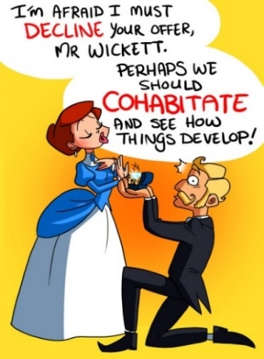](https://www.google.com/url?sa=i&rct=j&q=&esrc=s&source=images&cd=&cad=rja&uact=8&ved=2ahUKEwi7jrrvucvbAhXDXRQKHWIsBAgQjRx6BAgBEAU&url=https://the-ez.deviantart.com/art/Marriage-versus-Cohabitation-257378596&psig=AOvVaw01FmxJW6XXfp1mwCEtMbrs&ust=1528801029483961)**Christianity**Although Christians have traditionally prohibited cohabitation, there’s been a more tolerant view taken in some denominations towards couples who cohabit. Anglicans, for example, accept cohabitation if it’s a committed relationship, although they still believe that marriage would be the ideal. Other denominations disagree with cohabitation as they believe it devalues the special and sacred nature of sex, which should only take place within marriage. The Catholic Church and some Anglicans do not accept cohabitation and expect a couple not to have sex before marriage. Some Baptist Churches may refuse to marry a couple who are cohabiting.



**Judaism** [http://tbn0.google.com/images?q=tbn:MFmUb-xiFxFeRM:http://www.staffspasttrack.org.uk/exhibit/ilm/Image/Logo/Jewish.gif](http://images.google.co.uk/imgres?imgurl=http://www.staffspasttrack.org.uk/exhibit/ilm/Image/Logo/Jewish.gif&imgrefurl=http://www.staffspasttrack.org.uk/exhibit/ilm/&usg=__VGNdYDpexA6KD9Ew1-zx23U1Fbc=&h=39&w=50&sz=1&hl=en&start=1&tbnid=MFmUb-xiFxFeRM:&tbnh=39&tbnw=50&prev=/images?q%3Djewish%2Bsymbol%26imgsz%3Dicon%26gbv%3D2%26hl%3Den)

For many Jews it is important that couples get married rather than cohabit. In the Torah, for two people to live as husband and wife, they require the blessings of God. This may only take place when they declare marriage vows. In practice though, some Jewish people do choose to cohabit. Some Reform Jews take the view that a couple living together as a husband and wife would, and are, married.

|  |  |
| --- | --- |
| **COHABIT** | **MARRIAGE** |
| 1. Living together gives the couple a chance to get to know each other better. 2. It is cheaper to live together – do not have to pay for a wedding, which is very expensive. 3. Protestants and Reform Jews would allow cohabitation (live together) if the couple really love each other, are in a stable relationship, and plan to get married in the future. | 1. Shows the couple’s commitment. 2. Shows the couple’s love publicly. 3. Sex should only happen within a marriage for **Jews** and the main purpose is to keep the Mitzvot and ‘be fruitful and multiply.’ 4. To be an example to others on how to live according to God’s will according to **Jews.** 5. Marriage is a sacred duty for **Jews** – it makes a relationship Kiddushin (holy). 6. Catholics and Orthodox Jews agrees with marriage. |

**PROBLEMS WITHIN A MARRIAGE - DIVORCE**

Unfortunately, not every marriage is a happy one, and not all marriages are successful. Because of this, **conflict** (disagreeing and arguing) happens between the couple, within the marriage and the family. If there is conflict, it is important to reconcile (make good, make up) to get along especially if the relationship is going to work. Today, 1 in 4 marriages fail. Why?

**Adultery**

Extra-marital sex or adultery is when a married person has a sexual relationship with someone other than their husband or wife. Christianity considers adultery a great sin.

**Christianity** Christians are against adultery because:



* Against the Ten Commandments – ‘Thou shall not commit adultery.’
* Jesus said in the Sermon on the Mount that adultery is a sin and a good enough reason to divorce.
* A woman went up to Jesus and told him that she had committed adultery. He told her– I forgive you this time, but don’t sin again. (John 7:53-8:11).
* Sex should be within marriage only.
* The relationship will not be as strong as it used to be- destroy marriage.
* Not fair on the children.
* God is a part of the marriage – sacrament.
* Break the covenant.
* Break their promises they made in front of God.
* Will not trust each other again.
* Committing adultery can harm the family unit and cause the partner to feel cheated and betrayed.

**Judaism** [http://tbn0.google.com/images?q=tbn:MFmUb-xiFxFeRM:http://www.staffspasttrack.org.uk/exhibit/ilm/Image/Logo/Jewish.gif](http://images.google.co.uk/imgres?imgurl=http://www.staffspasttrack.org.uk/exhibit/ilm/Image/Logo/Jewish.gif&imgrefurl=http://www.staffspasttrack.org.uk/exhibit/ilm/&usg=__VGNdYDpexA6KD9Ew1-zx23U1Fbc=&h=39&w=50&sz=1&hl=en&start=1&tbnid=MFmUb-xiFxFeRM:&tbnh=39&tbnw=50&prev=/images?q%3Djewish%2Bsymbol%26imgsz%3Dicon%26gbv%3D2%26hl%3Den)

Judaism teaches that adultery is wrong for the following reasons:

* + The Ten Commandments forbid adultery *– ‘You shall not commit adultery.’* ***(Exodus 20.14)*.**
  + Sex is only acceptable within a marriage.
* Adultery destroys marriage - the relationship will not be as strong.
* Not fair on the children.
* Break the covenant.
* Will not trust each other again.
  + Halakhah (Jewish law) emphasises that a husband should be sexually considerate towards his wife and not be sexually disloyal.
  + Men and women are most fulfilled through marriage, which is referred to as ‘**kiddushin**’ (sanctified).

[](https://www.google.com/url?sa=i&rct=j&q=&esrc=s&source=images&cd=&cad=rja&uact=8&ved=2ahUKEwi3x--DwcvbAhWMQBQKHWJNDS4QjRx6BAgBEAU&url=https://ianmaiguapictures.deviantart.com/art/Happy-Man-Cartoon-Portrait-Commission-527263356&psig=AOvVaw2C7KgP2CXSc12JBKjkWsdt&ust=1528802966009801)**This is Harry. Harry is 42 years old, married to Lindsay and they have three children together. Harry has been having a sexual relationship with Lindsay’s best friend Sarah for the last three months. Lindsay knows nothing about this.**

**How would a Christian respond to this?**

**How would a Jew respond to this?**

**SEPARATION**

Some couples will decide to separate in order to work through their problems. This could avoid divorce in the long term.

**Christianity** [http://tbn2.google.com/images?q=tbn:eMbG0z1tYfrjgM:http://www.staffspasttrack.org.uk/exhibit/ilm/Image/Logo/CHRIST~1.gif](http://images.google.co.uk/imgres?imgurl=http://www.staffspasttrack.org.uk/exhibit/ilm/Image/Logo/CHRIST~1.gif&imgrefurl=http://www.staffspasttrack.org.uk/exhibit/ilm/Mourining%20and%20Remembrance/Types%20of%20funerals/Christian%20Funerals.htm&usg=__rf4RNx0px9ZxQznik9ex98Rrd3k=&h=46&w=50&sz=1&hl=en&start=8&tbnid=eMbG0z1tYfrjgM:&tbnh=46&tbnw=50&prev=/images?q%3Dchristian%2Bsymbol%26imgsz%3Dicon%26gbv%3D2%26hl%3Den)

Better to separate than divorce - allow the couple to think about the relationship and reconcile. Catholics allows separation in some cases but **not** divorce if one wants a child and the other does not, if one is mentally ill or if they were forced into marriage.

**Judaism** [http://tbn0.google.com/images?q=tbn:MFmUb-xiFxFeRM:http://www.staffspasttrack.org.uk/exhibit/ilm/Image/Logo/Jewish.gif](http://images.google.co.uk/imgres?imgurl=http://www.staffspasttrack.org.uk/exhibit/ilm/Image/Logo/Jewish.gif&imgrefurl=http://www.staffspasttrack.org.uk/exhibit/ilm/&usg=__VGNdYDpexA6KD9Ew1-zx23U1Fbc=&h=39&w=50&sz=1&hl=en&start=1&tbnid=MFmUb-xiFxFeRM:&tbnh=39&tbnw=50&prev=/images?q%3Djewish%2Bsymbol%26imgsz%3Dicon%26gbv%3D2%26hl%3Den)

Some Jews decide to separate; others choose not to. Some rabbis suggest a trial separation, where others might urge a divorce if the relationship / marriage is no longer sacred.

**DIVORCE**

[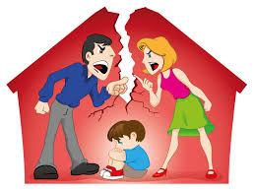](https://www.google.com/url?sa=i&rct=j&q=&esrc=s&source=images&cd=&cad=rja&uact=8&ved=2ahUKEwif88HpwcvbAhUFWRQKHSdBBEQQjRx6BAgBEAU&url=https://cdrli.com/sedacca/&psig=AOvVaw2Qw190bfxUJlrbWc0pgxVJ&ust=1528803169746618)**Christianity and divorce** [http://tbn2.google.com/images?q=tbn:eMbG0z1tYfrjgM:http://www.staffspasttrack.org.uk/exhibit/ilm/Image/Logo/CHRIST~1.gif](http://images.google.co.uk/imgres?imgurl=http://www.staffspasttrack.org.uk/exhibit/ilm/Image/Logo/CHRIST~1.gif&imgrefurl=http://www.staffspasttrack.org.uk/exhibit/ilm/Mourining%20and%20Remembrance/Types%20of%20funerals/Christian%20Funerals.htm&usg=__rf4RNx0px9ZxQznik9ex98Rrd3k=&h=46&w=50&sz=1&hl=en&start=8&tbnid=eMbG0z1tYfrjgM:&tbnh=46&tbnw=50&prev=/images?q%3Dchristian%2Bsymbol%26imgsz%3Dicon%26gbv%3D2%26hl%3Den)

Every Christian believes divorce is wrong because:

* God is a part of the marriage (marriage is a sacrament), therefore divorce is going against God’s will.
* Breaking the vows and the covenant made during the ceremony ‘until death do us part.’
* Jesus said – ‘What God has joined together, let no man separate.’
* God said – ‘I hate divorce.’ (Old Testament).

There are differences between Christian denominations when it comes to attitudes towards divorce.

**Catholics [CHRIST~1](http://images.google.co.uk/imgres?imgurl=http://www.staffspasttrack.org.uk/exhibit/ilm/Image/Logo/CHRIST~1.gif&imgrefurl=http://www.staffspasttrack.org.uk/exhibit/ilm/Mourining%20and%20Remembrance/Types%20of%20funerals/Christian%20Funerals.htm&usg=__rf4RNx0px9ZxQznik9ex98Rrd3k=&h=46&w=50&sz=1&hl=en&start=8&tbnid=eMbG0z1tYfrjgM:&tbnh=46&tbnw=50&prev=/images?q%3Dchristian%2Bsymbol%26imgsz%3Dicon%26gbv%3D2%26hl%3Den)**

The Catholic Church regards marriage as a lifelong commitment and does not recognise divorce. In a situation where a marriage breaks down and there is no chance of a reconciliation, the two options for a Catholic are either an annulment or separation. Catholics base this belief on teachings of the Bible, for example:

*Jesus replied, ‘Moses permitted you to divorce your wives because your hearts were hard. But it was not this way from the beginning. I tell you that anyone who divorces his wife, except for sexual immorality, and marries another woman commits adultery.’* ***(Matthew 19.8–9)***

*Therefore, what God has joined together, let no one separate****. (Mark 10.9)***

Catholics who are separated are expected not to cohabit with anyone else and, if they do this, they are not allowed to receive Holy Communion. Of course, some Catholics do get divorced; however, the Catholic Church would not recognise their divorce. The couple may no longer be married in law, but they are still married in the eyes of the Church. In other Christian traditions, there is a diversity of viewpoints. Catholics will allow an annulment in some situations. An annulment is when a court or the Church says your marriage or domestic partnership is not valid. The Catholic Church teaches that annulment is the only acceptable way a marriage can be dissolved. An annulment may be granted if a married couple have not had sex, or where it is proved the marriage should not have taken place, for example, because one or both partners were too young, or one or both were forced into marriage, one is mentally ill.

**Protestants** [http://tbn2.google.com/images?q=tbn:eMbG0z1tYfrjgM:http://www.staffspasttrack.org.uk/exhibit/ilm/Image/Logo/CHRIST~1.gif](http://images.google.co.uk/imgres?imgurl=http://www.staffspasttrack.org.uk/exhibit/ilm/Image/Logo/CHRIST~1.gif&imgrefurl=http://www.staffspasttrack.org.uk/exhibit/ilm/Mourining%20and%20Remembrance/Types%20of%20funerals/Christian%20Funerals.htm&usg=__rf4RNx0px9ZxQznik9ex98Rrd3k=&h=46&w=50&sz=1&hl=en&start=8&tbnid=eMbG0z1tYfrjgM:&tbnh=46&tbnw=50&prev=/images?q%3Dchristian%2Bsymbol%26imgsz%3Dicon%26gbv%3D2%26hl%3Den)

Divorce is wrong and a sad time. However, they do accept that divorce happens as a last resort and they have tried to reconcile first e.g. if one has committed adultery, violence and abuse in the relationship or falling out of love.

**Judaism and divorce** [http://tbn0.google.com/images?q=tbn:MFmUb-xiFxFeRM:http://www.staffspasttrack.org.uk/exhibit/ilm/Image/Logo/Jewish.gif](http://images.google.co.uk/imgres?imgurl=http://www.staffspasttrack.org.uk/exhibit/ilm/Image/Logo/Jewish.gif&imgrefurl=http://www.staffspasttrack.org.uk/exhibit/ilm/&usg=__VGNdYDpexA6KD9Ew1-zx23U1Fbc=&h=39&w=50&sz=1&hl=en&start=1&tbnid=MFmUb-xiFxFeRM:&tbnh=39&tbnw=50&prev=/images?q%3Djewish%2Bsymbol%26imgsz%3Dicon%26gbv%3D2%26hl%3Den)

“If a man divorced his wife, even the altar sheds tears.” - Talmud

[http://tbn0.google.com/images?q=tbn:MFmUb-xiFxFeRM:http://www.staffspasttrack.org.uk/exhibit/ilm/Image/Logo/Jewish.gif](http://images.google.co.uk/imgres?imgurl=http://www.staffspasttrack.org.uk/exhibit/ilm/Image/Logo/Jewish.gif&imgrefurl=http://www.staffspasttrack.org.uk/exhibit/ilm/&usg=__VGNdYDpexA6KD9Ew1-zx23U1Fbc=&h=39&w=50&sz=1&hl=en&start=1&tbnid=MFmUb-xiFxFeRM:&tbnh=39&tbnw=50&prev=/images?q%3Djewish%2Bsymbol%26imgsz%3Dicon%26gbv%3D2%26hl%3Den)Divorce is painful for all involved, but it is the right choice in an unhealthy relationship. This would cause more suffering and heartache to everyone.

[http://tbn0.google.com/images?q=tbn:MFmUb-xiFxFeRM:http://www.staffspasttrack.org.uk/exhibit/ilm/Image/Logo/Jewish.gif](http://images.google.co.uk/imgres?imgurl=http://www.staffspasttrack.org.uk/exhibit/ilm/Image/Logo/Jewish.gif&imgrefurl=http://www.staffspasttrack.org.uk/exhibit/ilm/&usg=__VGNdYDpexA6KD9Ew1-zx23U1Fbc=&h=39&w=50&sz=1&hl=en&start=1&tbnid=MFmUb-xiFxFeRM:&tbnh=39&tbnw=50&prev=/images?q%3Djewish%2Bsymbol%26imgsz%3Dicon%26gbv%3D2%26hl%3Den)Divorce is only considered after counselling and sincere efforts to change prove fruitless (has not worked). Divorce is the last resort.

[http://tbn0.google.com/images?q=tbn:MFmUb-xiFxFeRM:http://www.staffspasttrack.org.uk/exhibit/ilm/Image/Logo/Jewish.gif](http://images.google.co.uk/imgres?imgurl=http://www.staffspasttrack.org.uk/exhibit/ilm/Image/Logo/Jewish.gif&imgrefurl=http://www.staffspasttrack.org.uk/exhibit/ilm/&usg=__VGNdYDpexA6KD9Ew1-zx23U1Fbc=&h=39&w=50&sz=1&hl=en&start=1&tbnid=MFmUb-xiFxFeRM:&tbnh=39&tbnw=50&prev=/images?q%3Djewish%2Bsymbol%26imgsz%3Dicon%26gbv%3D2%26hl%3Den)Jews do not try to put blame on one or the other.

[http://tbn0.google.com/images?q=tbn:MFmUb-xiFxFeRM:http://www.staffspasttrack.org.uk/exhibit/ilm/Image/Logo/Jewish.gif](http://images.google.co.uk/imgres?imgurl=http://www.staffspasttrack.org.uk/exhibit/ilm/Image/Logo/Jewish.gif&imgrefurl=http://www.staffspasttrack.org.uk/exhibit/ilm/&usg=__VGNdYDpexA6KD9Ew1-zx23U1Fbc=&h=39&w=50&sz=1&hl=en&start=1&tbnid=MFmUb-xiFxFeRM:&tbnh=39&tbnw=50&prev=/images?q%3Djewish%2Bsymbol%26imgsz%3Dicon%26gbv%3D2%26hl%3Den)Divorce may sometimes lead to happiness, and true love. However, avoiding divorce would be the best thing.

[http://tbn0.google.com/images?q=tbn:MFmUb-xiFxFeRM:http://www.staffspasttrack.org.uk/exhibit/ilm/Image/Logo/Jewish.gif](http://images.google.co.uk/imgres?imgurl=http://www.staffspasttrack.org.uk/exhibit/ilm/Image/Logo/Jewish.gif&imgrefurl=http://www.staffspasttrack.org.uk/exhibit/ilm/&usg=__VGNdYDpexA6KD9Ew1-zx23U1Fbc=&h=39&w=50&sz=1&hl=en&start=1&tbnid=MFmUb-xiFxFeRM:&tbnh=39&tbnw=50&prev=/images?q%3Djewish%2Bsymbol%26imgsz%3Dicon%26gbv%3D2%26hl%3Den)For Jews who live in countries outside Israel, they must get a legal document (civil divorce) and the Jewish law certificate (GET) to say that they are divorced. It is a Mitzvot for a husband to give his wife a get if they get divorced.

[http://tbn0.google.com/images?q=tbn:MFmUb-xiFxFeRM:http://www.staffspasttrack.org.uk/exhibit/ilm/Image/Logo/Jewish.gif](http://images.google.co.uk/imgres?imgurl=http://www.staffspasttrack.org.uk/exhibit/ilm/Image/Logo/Jewish.gif&imgrefurl=http://www.staffspasttrack.org.uk/exhibit/ilm/&usg=__VGNdYDpexA6KD9Ew1-zx23U1Fbc=&h=39&w=50&sz=1&hl=en&start=1&tbnid=MFmUb-xiFxFeRM:&tbnh=39&tbnw=50&prev=/images?q%3Djewish%2Bsymbol%26imgsz%3Dicon%26gbv%3D2%26hl%3Den)The couple will go to the Beth Din (House of Law) who will issue the GET, which must be signed by 2 witnesses.

[http://tbn0.google.com/images?q=tbn:MFmUb-xiFxFeRM:http://www.staffspasttrack.org.uk/exhibit/ilm/Image/Logo/Jewish.gif](http://images.google.co.uk/imgres?imgurl=http://www.staffspasttrack.org.uk/exhibit/ilm/Image/Logo/Jewish.gif&imgrefurl=http://www.staffspasttrack.org.uk/exhibit/ilm/&usg=__VGNdYDpexA6KD9Ew1-zx23U1Fbc=&h=39&w=50&sz=1&hl=en&start=1&tbnid=MFmUb-xiFxFeRM:&tbnh=39&tbnw=50&prev=/images?q%3Djewish%2Bsymbol%26imgsz%3Dicon%26gbv%3D2%26hl%3Den)The GET will then be handed over by the husband to his wife. They are now divorced. If the husband does not give his wife the GET, she may not re-marry in a synagogue. This is because the GET says, ‘You are permitted to every man’, meaning that the man gives the woman her freedom to re-marry.

Sometimes problems are caused where a husband has refused to give the woman a divorce, or where he cannot be traced: women in this situation are called *agunot* (chained). Jews believe that marriage is always a last resort.



The community will give support and try to keep the couple together. *‘When a man takes a wife and marries her, if then she finds no favour in his eyes because he has**found some indecency in her, and he writes her a bill of divorce, and puts it in her hand ...'* **(*Deuteronomy* 24:1–4)**



**How could religious believers help a married couple who face problems?**

* Listen to their problems
* Pray with the couple
* Older members could advise
* Arrange for them to attend advice sessions
* Remind what the Bible/Torah says.

**RE-MARRIAGE**

**Christianity and re-marriage** [http://tbn2.google.com/images?q=tbn:eMbG0z1tYfrjgM:http://www.staffspasttrack.org.uk/exhibit/ilm/Image/Logo/CHRIST~1.gif](http://images.google.co.uk/imgres?imgurl=http://www.staffspasttrack.org.uk/exhibit/ilm/Image/Logo/CHRIST~1.gif&imgrefurl=http://www.staffspasttrack.org.uk/exhibit/ilm/Mourining%20and%20Remembrance/Types%20of%20funerals/Christian%20Funerals.htm&usg=__rf4RNx0px9ZxQznik9ex98Rrd3k=&h=46&w=50&sz=1&hl=en&start=8&tbnid=eMbG0z1tYfrjgM:&tbnh=46&tbnw=50&prev=/images?q%3Dchristian%2Bsymbol%26imgsz%3Dicon%26gbv%3D2%26hl%3Den)

* Forgiveness, second chance and happiness is important.
* Children want a stable life.
* The Church should move with the times.
* Some churches allow re-marriage e.g. Protestants, and offer a blessing services after a couple have married in a registry office.
* The only condition that Catholics accept re-marriage is if one partner has died. Catholics are against re-marriage - first marriage should last forever - marriage is a sacrament.
* Divorced Catholics may choose to remarry in a different place of worship or in a civil ceremony.
* In the Anglican tradition, a minister may exercise personal judgement in deciding to remarry a divorcee, depending on the circumstances of a divorce. Some Anglican ministers will not marry a divorced person, but may perform a church blessing ceremony after a register office wedding.

**Judaism and re-marriage** [http://tbn0.google.com/images?q=tbn:MFmUb-xiFxFeRM:http://www.staffspasttrack.org.uk/exhibit/ilm/Image/Logo/Jewish.gif](http://images.google.co.uk/imgres?imgurl=http://www.staffspasttrack.org.uk/exhibit/ilm/Image/Logo/Jewish.gif&imgrefurl=http://www.staffspasttrack.org.uk/exhibit/ilm/&usg=__VGNdYDpexA6KD9Ew1-zx23U1Fbc=&h=39&w=50&sz=1&hl=en&start=1&tbnid=MFmUb-xiFxFeRM:&tbnh=39&tbnw=50&prev=/images?q%3Djewish%2Bsymbol%26imgsz%3Dicon%26gbv%3D2%26hl%3Den)

Humans have been given free will by God; we can make mistakes. If a marriage ends in divorce, they believe that we all deserve a second chance at finding happiness. BUT:-

* A woman may not re-marry in a synagogue if she has not received the GET from her husband (especially orthodox).
* The woman must wait 92 days before re-marrying to prevent doubts over the paternity of any newly conceived child.

**SEXUAL RELATIONSHIPS**

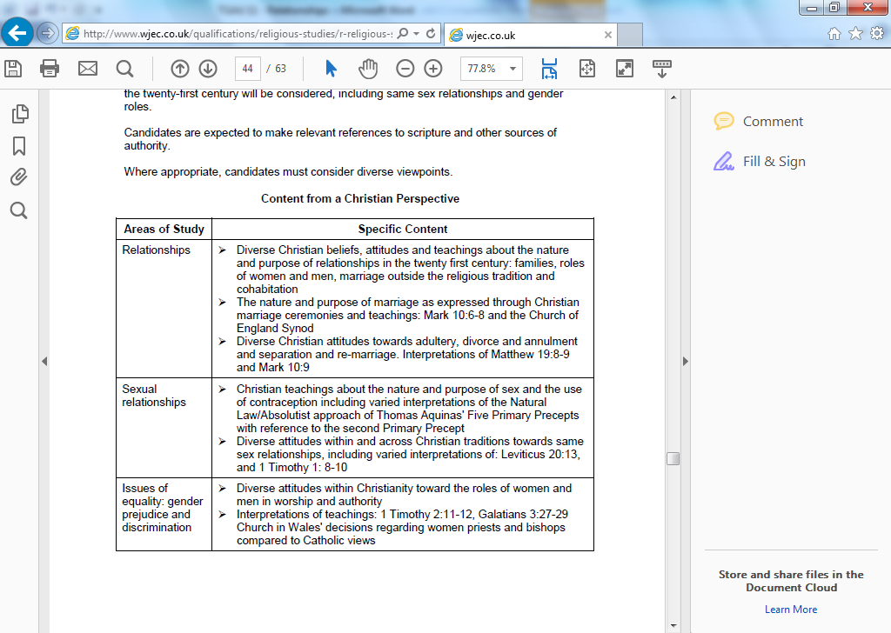

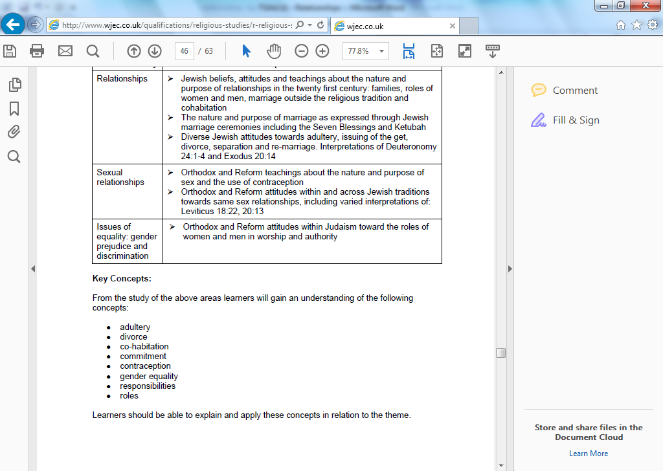

**Purpose of sex**

* Gift from God – part of God’s creation.
* Continuation of the human race.
* Strengthens the love between the couple.
* To have children – procreation.
* Pleasure.
* To show each other commitment.
* To strengthen the agreement between them.

**Discussion: Watch the clip from Friends – “The One with Free Porn”**

* What is Joey and Chandler’s attitudes towards sex in the clip?
* What is the purpose of sex?
* What are the dangers of sex in this day and age?
* What are the attitudes of people towards sex?



**Chastity – (refuse sex until marriage)**

http://tbn2.google.com/images?q=tbn:eMbG0z1tYfrjgM:http://www.staffspasttrack.org.uk/exhibit/ilm/Image/Logo/CHRIST~1.gifhttp://tbn0.google.com/images?q=tbn:MFmUb-xiFxFeRM:http://www.staffspasttrack.org.uk/exhibit/ilm/Image/Logo/Jewish.gifChristians and Jews teach that people who are not married should live a life of Chastity (refuse sex until marriage). This is the safest way, and the only way of making sure that children are not produced outside of marriage.



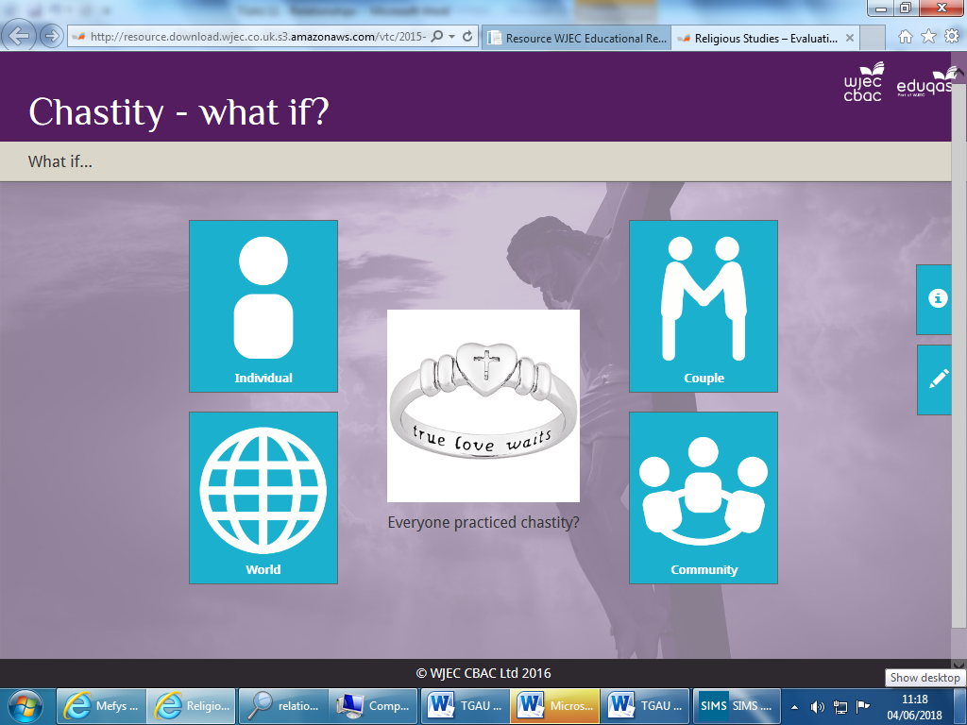

**Discuss: What if question from each perspective. Consider what impact this decision would have upon the person, group or thing being considered. How the impact might be positive. How the impact might be negative.** http://adnoddau.cbac.co.uk/Pages/ResourceSingle.aspx?rIid=1092&langChange=cy-GB

**Celibacy (vow not to marry or have a sexual relationship)**

http://tbn2.google.com/images?q=tbn:eMbG0z1tYfrjgM:http://www.staffspasttrack.org.uk/exhibit/ilm/Image/Logo/CHRIST~1.gifSome Christians choose a celibate lifestyle to dedicate their lives to serving God e.g. Catholic priests and monks. It is their choice of commitment to dedicate their life to God.

http://tbn0.google.com/images?q=tbn:MFmUb-xiFxFeRM:http://www.staffspasttrack.org.uk/exhibit/ilm/Image/Logo/Jewish.gifUnlike Christianity, the idea of celibacy does not exist within Judaism. It’s believed that God wished men and women to serve him by living together as a married couple and producing families. Therefore, Jewish tradition would see it ‘abnormal’ for people to live celibate lives like monks or nuns.

**RELIGIOUS ATTITUDES TO SEX**

**Christianity** http://tbn2.google.com/images?q=tbn:eMbG0z1tYfrjgM:http://www.staffspasttrack.org.uk/exhibit/ilm/Image/Logo/CHRIST~1.gif

Promiscuity (casual sex) is unacceptable. Devalue sex and individuals. Paul – ‘…Those who live like this will not inherit the kingdom of God.’ (Galatians 5).

Strengthen the love and develop the relationship.

Between husband and wife within a marriage.

To have children.

Sex is a gift from God and is something special, which should be respected.

God said; “Be fruitful and multiply.” (Genesis 1:28)

**Catholics**

The main purpose of sex is to have children because God said; “Be fruitful and multiply.” (Genesis 1:28) Sex is also a way of showing love to each other. Sex before marriage is a sin.

**Protestants**

Sex is acceptable if they love each other and are in a steady relationship. Sex shows commitment. They accept sex before marriage for the above reasons.

‘Whoever sins sexually, sins against their own body.’ Paul (1 Cor 6:18).

‘Marriage should be honoured, and the marriage bed should be kept pure, for God will judge all the sexually immoral.’ (Hebrews 13.4)

[](http://images.google.co.uk/imgres?imgurl=http://atschool.eduweb.co.uk/carolrb/Christianity/images/cross2.gif&imgrefurl=http://atschool.eduweb.co.uk/carolrb/Christianity/christian_symbols.html&usg=__qyQwb7owXIsQdeDDWpXcia5Sknk=&h=214&w=150&sz=1&hl=en&start=27&tbnid=EYgZbgPhztjE3M:&tbnh=106&tbnw=74&prev=/images?q%3Dchristianity%2Bsymbols%26gbv%3D2%26ndsp%3D20%26hl%3Den%26sa%3DN%26start%3D20)[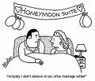](http://images.google.co.uk/imgres?imgurl=http://www.benettontalk.com/premarital-sex-usa.jpg&imgrefurl=http://enlightenedcatholicism-colkoch.blogspot.com/2009/01/jewish-thoughts-on-sex-in-marriage.html&usg=__ay811U5ItTUT9Ik1X6AIFR407oE=&h=301&w=350&sz=33&hl=en&start=7&tbnid=XRxPdSr_84rKHM:&tbnh=103&tbnw=120&prev=/images?q%3Dchristianity%2Bsex%2Band%2Bmaariage%26imgsz%3Dsmall|medium|large|xlarge%26gbv%3D2%26ndsp%3D20%26hl%3Den%26sa%3DN)[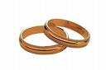](http://images.google.co.uk/imgres?imgurl=http://www.sjcclerk.net/Clerks/Recording/marriage.jpeg&imgrefurl=http://www.sjcclerk.net/Marriage%20Licenses1.aspx&usg=__orXfLN1cH0fdD6-aq-U47SjrA90=&h=307&w=460&sz=38&hl=en&start=4&tbnid=1jRmr19l8-UdGM:&tbnh=85&tbnw=128&prev=/images?q%3Dmarriage%26imgsz%3Dsmall|medium|large|xlarge%26gbv%3D2%26hl%3Den%26sa%3DX)[](http://images.google.co.uk/imgres?imgurl=http://atschool.eduweb.co.uk/carolrb/Christianity/images/cross2.gif&imgrefurl=http://atschool.eduweb.co.uk/carolrb/Christianity/christian_symbols.html&usg=__qyQwb7owXIsQdeDDWpXcia5Sknk=&h=214&w=150&sz=1&hl=en&start=27&tbnid=EYgZbgPhztjE3M:&tbnh=106&tbnw=74&prev=/images?q%3Dchristianity%2Bsymbols%26gbv%3D2%26ndsp%3D20%26hl%3Den%26sa%3DN%26start%3D20)

**JUDASIM** [Jewish](http://images.google.co.uk/imgres?imgurl=http://www.staffspasttrack.org.uk/exhibit/ilm/Image/Logo/Jewish.gif&imgrefurl=http://www.staffspasttrack.org.uk/exhibit/ilm/&usg=__VGNdYDpexA6KD9Ew1-zx23U1Fbc=&h=39&w=50&sz=1&hl=en&start=1&tbnid=MFmUb-xiFxFeRM:&tbnh=39&tbnw=50&prev=/images?q%3Djewish%2Bsymbol%26imgsz%3Dicon%26gbv%3D2%26hl%3Den)

Sex is a gift from God and is something special, which should be respected. Sex is for pleasure as well as procreation.

In the Torah God said; “Be fruitful and multiply.” (Genesis 1:28). Keeping to the Mitzvot.

**Orthodox Jews**

The main purpose of sex is to have children because God said in the Torah; “Be fruitful and multiply.” (Genesis 1:28) It is important to keep to this Mitzvot as it secures the survival of their religion. Sex also displays their love for one another. Sex before marriage is a sin because children should be born within marriage. If people slept around a child might not be raised within a Jewish family.

Between husband and wife within a marriage. It’s one of the 3 stages of marriage:

* promise to marry
* the wedding
* sex

**Reform Jews**

Sex is preferred within marriage to have children within marriage. However, sex is acceptable if both love each other, are in a stable relationship and if they don’t hurt anyone in the process. Sex shows commitment. They accept sex before marriage for the above reasons only.

To have children - survival of the religion.

Strengthen the love and develop the relationship.

[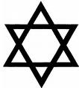](http://images.google.co.uk/imgres?imgurl=http://www.tpub.com/content/religion/14229/img/14229_72_1.jpg&imgrefurl=http://www.tpub.com/content/religion/14229/css/14229_72.htm&usg=__Hqyw1_ETjZHfmhRaIAwl02hNXAU=&h=317&w=284&sz=8&hl=en&start=2&tbnid=eEVTJsRLe92V9M:&tbnh=118&tbnw=106&prev=/images?q%3DJUDAISM%26imgsz%3Dsmall|medium|large|xlarge%26gbv%3D2%26hl%3Den)[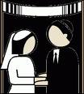](http://images.google.co.uk/imgres?imgurl=http://lawblog.legalmatch.com/wp-content/uploads/2008/12/jewish-marriage-268x300.gif&imgrefurl=http://lawblog.legalmatch.com/2008/12/18/for-better-or-worse-the-%E2%80%9Cjewish-marriage-clause%E2%80%9D-debate-marches-on/&usg=__B6MM3M1XkTdR1nvEsYVRTnqTAfI=&h=300&w=268&sz=16&hl=en&start=20&tbnid=s23nyIawjhFdBM:&tbnh=116&tbnw=104&prev=/images?q%3DJEWISH%2BAND%2BMARRIAGE%26imgsz%3Dsmall|medium|large|xlarge%26gbv%3D2%26hl%3Den)[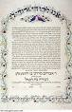](http://images.google.co.uk/imgres?imgurl=http://bp1.blogger.com/_VByoe7_6L0Y/SJgp1LMv9gI/AAAAAAAAAK8/D7-dqgQm4YQ/s320/Ketubah.jpg&imgrefurl=http://yackety-yak-israel.blogspot.com/2008/08/who-needs-get-jewish-rabbinical-divorce.html&usg=__8gLLfellgeNAnk9Wl7q0aJwet-o=&h=320&w=206&sz=27&hl=en&start=39&tbnid=5R6iNoib6fsnSM:&tbnh=118&tbnw=76&prev=/images?q%3DJEWISH%2BAND%2BMARRIAGE%26imgsz%3Dsmall|medium|large|xlarge%26gbv%3D2%26ndsp%3D20%26hl%3Den%26sa%3DN%26start%3D20)[](http://images.google.co.uk/imgres?imgurl=http://www.tpub.com/content/religion/14229/img/14229_72_1.jpg&imgrefurl=http://www.tpub.com/content/religion/14229/css/14229_72.htm&usg=__Hqyw1_ETjZHfmhRaIAwl02hNXAU=&h=317&w=284&sz=8&hl=en&start=2&tbnid=eEVTJsRLe92V9M:&tbnh=118&tbnw=106&prev=/images?q%3DJUDAISM%26imgsz%3Dsmall|medium|large|xlarge%26gbv%3D2%26hl%3Den)

**DISCUSS:**

* Listen to the song Right Girl by Daniel Beddingfield. What is the artists’ attitude towards sex?
* What is your opinion about the religious attitudes to sex?
* Are these attitudes relevant in this day and age?

**CONTRACEPTION -** Methods which prevent (stop) a female from getting pregnant. For example:

[](http://images.google.co.uk/imgres?imgurl=http://www.pulsetoday.co.uk/pictures/466xAny/a/d/f/contraceptive_pills.jpg&imgrefurl=http://home2rome.wordpress.com/2008/06/18/the-contraception-question/&usg=__E9PvwXcgpqFXgWpuJVRpvuaAziM=&h=373&w=466&sz=144&hl=en&start=12&tbnid=1vTG06E2pTQVJM:&tbnh=102&tbnw=128&prev=/images?q%3Dcontraception%26imgsz%3Dsmall|medium|large|xlarge%26gbv%3D2%26hl%3Den)The pill [](http://images.google.co.uk/imgres?imgurl=http://www.avert.org/photo_library/images/normal_photo_no_240.gif&imgrefurl=http://pandagon.blogsome.com/2008/02/11/6720/&usg=__M77gWbS88AvuUXslPdfNHwlGQ_A=&h=299&w=399&sz=37&hl=en&start=35&tbnid=UP3LOUkfvTdu7M:&tbnh=93&tbnw=124&prev=/images?q%3Dcontraception%26imgsz%3Dsmall|medium|large|xlarge%26gbv%3D2%26ndsp%3D20%26hl%3Den%26sa%3DN%26start%3D20) Condom

**TASKS AND DISCUSSION**

1. **Try to think of points that show the advantages and disadvantages of birth-control methods in this day and age.**

|  |  |
| --- | --- |
| **Advantages** | **Disadvantages** |
|  |  |

1. **Whose decision is it concerning the use of contraception?**

**JEWISH ATTITUDES** [Jewish](http://images.google.co.uk/imgres?imgurl=http://www.staffspasttrack.org.uk/exhibit/ilm/Image/Logo/Jewish.gif&imgrefurl=http://www.staffspasttrack.org.uk/exhibit/ilm/&usg=__VGNdYDpexA6KD9Ew1-zx23U1Fbc=&h=39&w=50&sz=1&hl=en&start=1&tbnid=MFmUb-xiFxFeRM:&tbnh=39&tbnw=50&prev=/images?q%3Djewish%2Bsymbol%26imgsz%3Dicon%26gbv%3D2%26hl%3Den)

In general, Jews do not allow the use of contraception because the purpose of sex is to have children. Orthodox and Reform emphasise how precious children are, especially in the light of the many Jewish lives lost during the Holocaust. However, both **Orthodox and Reform** allow birth-control if pregnancy would pose a threat to the mother’s life or health.

According to **Orthodox** **Jews**, wasting seed (sperm) is a sin therefore contraception like the condom are not allowed. The purpose of the seed is to create new life. **Orthodox** does not allow contraception for social or economic reasons (e.g. because a couple cannot afford another child). One Mitzvot in the Torah is ‘Be fruitful and multiply.’ (Genesis 1:28) Having children is God’s will. Children secure the survival of the religion.

The **Torah** forbids the ‘withdrawal’ as a method of contraception based on a man called Onan doing this: *‘Now what he did was evil in the eyes of the Lord.’ (Genesis 38:10)*

**Reform Jews** allow the use of birth control for social or economic reasons and allow the individuals to choose which method to use. They believe that it is acceptable to use contraception if the couple love each other, want to show commitment to each other and are in a steady relationship, and agreed between the husband and wife. They also accept any method to limit family size.

|  |  |  |  |  |  |  |  |  |
| --- | --- | --- | --- | --- | --- | --- | --- | --- |
| **CHRISTIAN ATTITUDES** [CHRIST~1](http://images.google.co.uk/imgres?imgurl=http://www.staffspasttrack.org.uk/exhibit/ilm/Image/Logo/CHRIST~1.gif&imgrefurl=http://www.staffspasttrack.org.uk/exhibit/ilm/Mourining%20and%20Remembrance/Types%20of%20funerals/Christian%20Funerals.htm&usg=__rf4RNx0px9ZxQznik9ex98Rrd3k=&h=46&w=50&sz=1&hl=en&start=8&tbnid=eMbG0z1tYfrjgM:&tbnh=46&tbnw=50&prev=/images?q%3Dchristian%2Bsymbol%26imgsz%3Dicon%26gbv%3D2%26hl%3Den)  **Many Catholics** are **against** using contraception because the purpose of sex is to have children, and contraception prevents this from happening. It is a sin to use these methods because it goes against God’s word when he said, “Be fruitful and multiply.” (Genesis 1:28) The only methods that are acceptable to use are the “pull out” method or the “rhythm” method.  **Protestants and some Catholics allow** theuse of contraception if the couple are not ready to have children, as sex is a way of showing love and commitment. It is acceptable if the couple are in a steady relationship, both content, and both agree which methods to use. Other reasonable reasons are the fact that contraception helps to control the overpopulation of the planet as well as stopping sexual transmitted diseases. God gave people free will and they should use their conscience to decide if they should use contraception or not.  **Natural Law Theory**  This is a theory by Aquinas which tries to help people how to live and make moral decisions. It’s an absolutist view, and many Catholics would follow this theory. Aquinas believed people should live their lives based on rules given by God. There are **five primary precepts**:   1. Protect the innocent. 2. Reproduction 3. Educate children 4. Live in an ordered society 5. Worship God.   Aquinas set out secondary precepts as well to help keep the primary precepts. E.g   |  |  | | --- | --- | | **PRIMARY PRECEPT** | **SECONDARY PRECEPT** | | Reproduce | Not to use contraception | |  |  | |  |  |   Some Catholics agree with the above, therefore, contraception should not be used because it goes against Natural Law. |

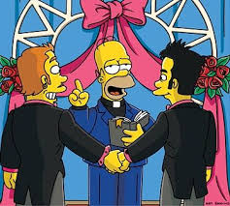**SAME-SEX RELATIONSHIPS**

A sexual relation between two people of the same sex. Homosexuals are often called gay or lesbians in the case of two females. Homosexuality – <https://www.bbc.com/education/clips/z3ky34j>

Strengthen the love and develop the relationship.

Between husband and wife within a marriage.

To have children.

Sex is a gift from God and is something special and holy, which should be respected.

God said; “Be fruitful and multiply.” (Genesis 1:28)

**Catholics**

The main purpose of sex is to have children because God said; “Be fruitful and multiply.” (Genesis 1:28) Sex is also a way of showing love to each other. Sex before marriage is a sin.

**Protestants**

Sex is acceptable if the two love each other and are in a steady relationship. Sex shows commitment. They accept sex before marriage for the above reasons.

**Christian attitudes**http://tbn2.google.com/images?q=tbn:eMbG0z1tYfrjgM:http://www.staffspasttrack.org.uk/exhibit/ilm/Image/Logo/CHRIST~1.gif

* **Catholics** are against same-sex relationship as it goes against God’s will. God said in the Old Testament ‘You shall not lie with a male as with a woman; it is an abomination.’ (Leviticus 18:22). They are also against same-sex relationships as it is unnatural because the purpose of sex is to have children so they go against the word of God when he said ‘be fruitful and multiply.’
* **Protestants** are also against same-sex relationships, but are willing to accept it if both is in a steady relationship, and love each other. Some churches will bless same-sex couples although there is no actual official ceremony.
* **Quakers** have welcomed same-sex relationships for over twenty years.
* **Anglicans** do not believe that same-sex marriages should take place in a church.
* Many Christians are against same-sex marriage based on the following quotes:
* ‘A man lies with a male as with a woman, both of them have committed an abomination; they shall be put to death; their blood is upon them.’ Lev 20:13
* ‘Now we know that the law is good, if one uses it legitimately. This means understanding that the law is laid down not for the innocent but for the lawless and disobedient, for the godless and sinful, for the unholy and profane, for those who kill their father or mother, for murderers, slave traders, liars, perjurers, and whatever else is contrary to the sound teaching.’ (1 Timothy 1:8-10)
* Other Christians believe that there are many things condemned in the Bible, but would be seen as acceptable in today’s society.
* Some Churches will allow same-sex marriages to take place in their churches.

**Jewish attitudes** [Jewish](http://images.google.co.uk/imgres?imgurl=http://www.staffspasttrack.org.uk/exhibit/ilm/Image/Logo/Jewish.gif&imgrefurl=http://www.staffspasttrack.org.uk/exhibit/ilm/&usg=__VGNdYDpexA6KD9Ew1-zx23U1Fbc=&h=39&w=50&sz=1&hl=en&start=1&tbnid=MFmUb-xiFxFeRM:&tbnh=39&tbnw=50&prev=/images?q%3Djewish%2Bsymbol%26imgsz%3Dicon%26gbv%3D2%26hl%3Den)

* Jewish opinion varies from one group to another but, all Jews are against same-sex relationships, as God’s plan was for a man and woman to be together (Adam & Eve). God said: **“You shall not lie with a male as with a woman, it is an abomination”.**
* Jews believe that same-sex relationships goes against the commandment to **‘be fruitful and multiply’** as same-sex couples cannot conceive children themselves, therefore putting the future of the religion in danger.
* There is no mention of a relationship between two females in the Torah, but the Talmud says that such a relationship should not exist. It is believed that same-sex relationships are learnt or brought about by circumstances, and that people can be helped out of it. Recently, a number of gay groups have criticised this attitude saying that it is not the fault of the individual that they are gay. Some reform Jews have accepted their arguments, but not orthodox Jews.
* However, Jews do not allow anyone to be prejudice against homosexuals or to persecute them as they suffered side by side with Jews during the Holocaust at the hands of Hitler.



**I**t is powerful to hear that Pope Francis, the leader of the Roman Catholic Church, [reportedly told Juan Carlos Cruz](https://www.theguardian.com/world/2018/may/20/pope-juan-carlos-cruz), a gay man: “God made you like this and loves you like this.”

Cruz is a survivor of abuse who spoke with the pope a few weeks ago. His abuser was found guilty of abuse by the Vatican in 2011.

As a practising Catholic, I find it deeply moving to have [Pope Francis](https://www.theguardian.com/world/pope-francis) appear to confirm what many Catholics already know to be true: God made us just as we should be, there are no mistakes.

Lesbian, gay, bi and trans people exist in every community, from every ethnic background and in every religion. However, religion can often be the area of life that people find the most difficult to reconcile with their identity. Some people will say that LGBT people can’t exist in faith communities; that faith communities don’t accept same-sex relationships or those whose gender doesn’t match the one that they were assigned at birth.

I have never felt excluded from the church and have always been made to feel welcome. But I have met many people who have had different experiences; people who have been damaged by being told to deny their sexuality or who feel rejected by God.

Religions teach that God is love.

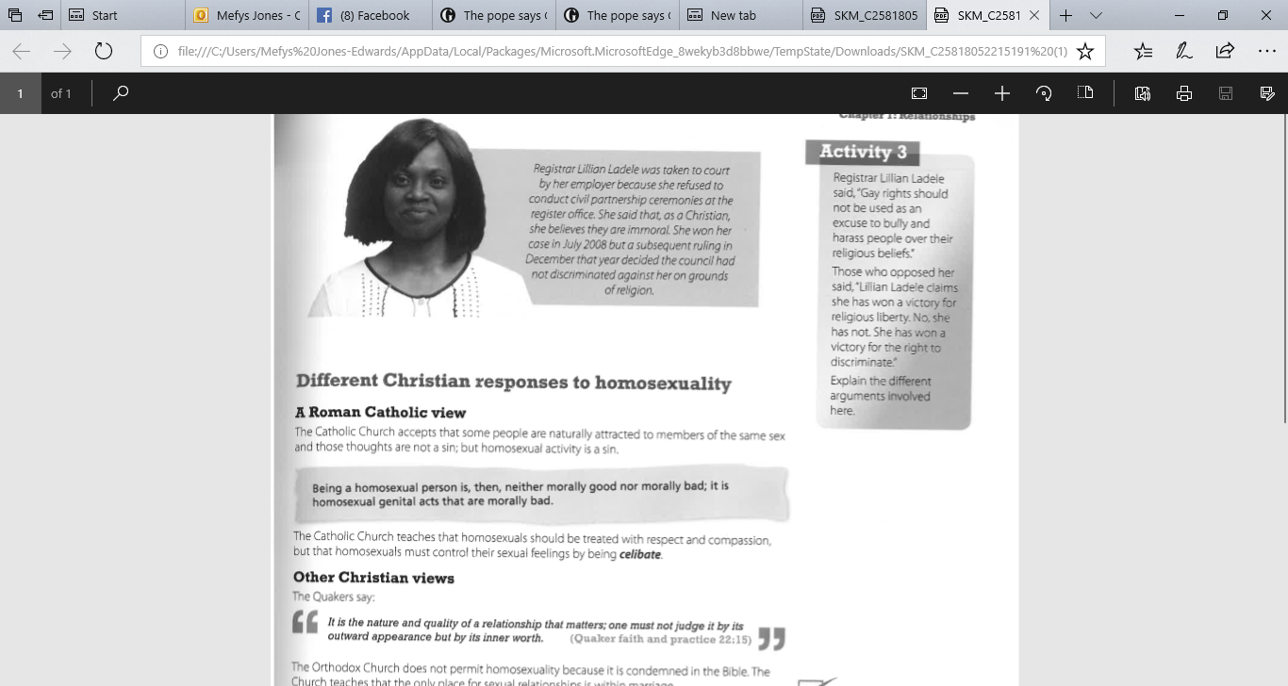

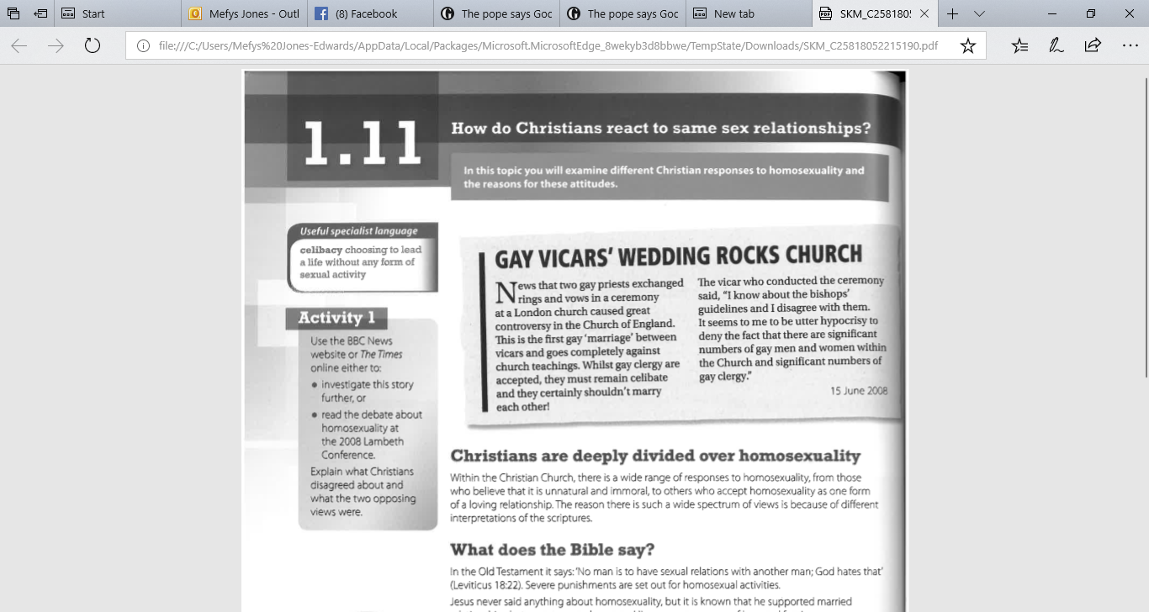

[](https://www.google.co.uk/imgres?imgurl=https://media.wired.com/photos/593376947965e75f5f3c81f2/master/pass/facebook_doma.jpg&imgrefurl=https://www.wired.com/2013/02/apple-google-facebook-supreme-court-same-sex-marriage/&docid=qdmwlg36xCTRkM&tbnid=OdJHR938QF7iNM:&vet=10ahUKEwjqwI2s3ujdAhUMD8AKHdPQAtkQMwhYKCYwJg..i&w=695&h=404&safe=strict&bih=521&biw=1093&q=gay%20marriage&ved=0ahUKEwjqwI2s3ujdAhUMD8AKHdPQAtkQMwhYKCYwJg&iact=mrc&uact=8)

**DISCUSSION AND HOMEWORK**

**After reading the information and sources, answer the following questions.**

1. **How have things changed in regards to the response to same sex relations in the media, law and religion?**
2. **Should same-sex couples have the same rights to get married in a place of worship?** Complete the table below.

|  |  |
| --- | --- |
| Yes | No |
| 1. Everyone deserves happiness. | 1. It says in the Torah and the Old Testament “*You*  *shall not lie with a male as with a woman; it is an*  *abomination.”* (Leviticus 18:22). |

**HOMEWORK - REVISION**

Summarise the religious attitudes in the table.

|  |  |  |  |  |
| --- | --- | --- | --- | --- |
|  | **CATHOLICS** | **PROTESTANTS** | **ORTHODOX JEWS** | **REFORM JEWS** |
| **Purpose of sex** |  |  |  |  |
| **Sex** |  |  |  |  |
| **Birth-control methods** |  |  |  |  |
| **Same sex relationships** |  |  |  |  |

**ISSUES OF EQUALITY, GENDER PREJUDICE AND DISCRIMINATION**





**Recall… What is meant by …**

* **Equality -**
* **Prejudice -**
* **Gender prejudice –**
* **Discrimination –**

One of the most important changes in society in recent times is the changing relationships between women and men around the issues of equality across the world. Gender equality aims to stop gender discrimination. In UK law, men and women have equal rights in employment and discrimination based on gender is illegal. The 2010 Equality Act protects people from discrimination, including sex. Traditionally, men and women have different roles in religions, especially their role in authority (leadership) and worship. These roles have been debated because the role of women has changed to become more equal.

**Watch the clip The Arrival – The Vicar of Dibley. Summarise the various attitudes towards the vicar.**



**Christians teaching about prejudice based on gender**



God has created people in His image, which includes male and females, therefore people should respect others, and treat them as equals.



Jesus showed respect towards women e.g. He mixed with woman; He had women as disciples; women were present during important events in his life e.g. crucifiction and resurrection; He believed women were equal and should be treated with respect.



Christians believe all humans are created in the image of Gods, so, each human life is equal. Paul said in Galatians 3:28 that men and women are equal- **‘…*There is neither … male******and female for you are all one in Christ Jesus.’*** This indicates that gender is not important as long as you have faith in Jesus. Salvation / heaven is available for all – men and women.



However, in other places, Paul says that women should be quiet in the church, there is no place for women in the church, and that men are the head of the family and that wives should be subject to their husbands. ***‘A woman should learn in quietness and full submission. I do not permit a woman to teach or to assume authority over a man: she must be quiet****.*’ (Paul- 1 Tim 2:11-12). This indicates that women are different from men and that women should not have authority over men. Although women should be quiet in church, women could teach other women in private and teach their children at home in the absence of their husbands.



Catholics will not allow women to become priests. However, other churches will allow women to become a vicar.



In many churches today, women are ordained as priests or ministers.



Traditionally, women are expected to:



* Raise a family
* Maintain a Christian home
* Obey her husband
* Not to lead worship in Church

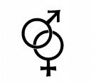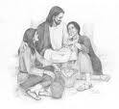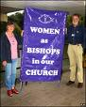

**The Catholic Church**

Within the **Catholic** and **Orthodox** Churches, women can take an active role in worship and authority. They can become a nun, and devout their lives to God, they can support the church in several ways e.g member of committee, help lead a service, admin work.

Women are always **lay people** in these Churches – they cannot be ordained, therefore cannot become priests. One reason for this is that every priest is a successer of Jesus’ apostles and Jesus had 12 male disciples.

Another reason is men and women have different strengths and contributions to make in society. Men take more religious leadership roles, while women have an important role to play in their families and communities. Pope Francis has praised the role of women in the Church and hope that they can play a bigger part in Church life in the future as well as supporting their families.

The Pope confirmed that the women could never be priests in the Catholic Church:

***‘I declare that the Church has no authority whatsoever to the ordination of women …’***

**The Protestant Church**

Accept that men and women are equal and have allowed women to be priests for years. They allow this because the Bible says that men and women are created in ‘God’s image’ and based on Paul’s words ‘there’s no difference between male and female, (Galatians 3:28). Jesus also respected men and women, and treated women with dignity.

[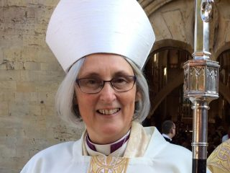](http://www.google.co.uk/url?sa=i&rct=j&q=&esrc=s&source=images&cd=&cad=rja&uact=8&ved=2ahUKEwik4PuZ0cHbAhUHwBQKHZSoCvMQjRx6BAgBEAU&url=http://www.100welshwomen.wales/100-women/laura_ashley/&psig=AOvVaw1_z4tR5EYvQNIIaADtXTC5&ust=1528463688366809)**The Church in Wales**

Allow women to become priests since 1996 but on January 11th, 1997 the first woman was ordained for the first time. The first female bishop was in November 2016.

Further information – see the following articles

[**Church in Wales' first woman bishop consecrated - BBC News**](https://www.bbc.co.uk/news/uk-wales-38685268)

[**First woman bishop Joanna Penberthy 'faced prejudice' - BBC News**](https://www.bbc.co.uk/news/av/uk-wales-37864828/first-woman-bishop-joanna-penberthy-faced-prejudice)

**Jewish teaching on prejudice based on gender**



God has created everyone in His image, including men and women, therefore every person must be treated the same.



Women are important within the Jewish religion - they have an important role in the home.



Jewish women have been important within the religion e.g. Esther.



If the mother is Jewish, the child is Jewish, which means that it is the mother who decides the religion of the child.



In Biblical times, men had authority over women, but in society today, there’s more equality.



Jewish holy texts e.g. the Talmud, describe equal, but different roles for men and women.



Some religious duties such as welcoming Shabbat are done by women.



Some of the mitzvoth (rules) are not relevant for women e.g women don’t have to wear tallith and tefillin.



[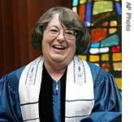](http://www.google.co.uk/url?sa=i&rct=j&q=&esrc=s&source=images&cd=&cad=rja&uact=8&ved=2ahUKEwij9rPV6dDbAhUTeMAKHSOpC1YQjRx6BAgBEAU&url=http://www.unsv.com/voanews/specialenglish/scripts/2006/07/31/0045/&psig=AOvVaw32NMyp0HZYYC10I7Nhd3tW&ust=1528985679135897)**Jewish attitudes to the roles of women and men in worship and authority**

**Reform and Liberal Judaism**

Women can be ordained as rabbis and lead worship. The first female Reform rabbi was ordained in 1972. In Reform worship, men and women sit together in the synagogue. Also, women are part of the minyan – 10 people in order to conduct a service in the synagogue.

**Orthodox Judaism**

[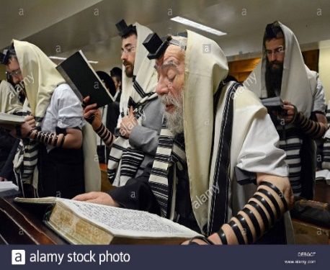](https://www.google.co.uk/url?sa=i&rct=j&q=&esrc=s&source=images&cd=&cad=rja&uact=8&ved=2ahUKEwixmYab6dDbAhWLLcAKHd3lCmUQjRx6BAgBEAU&url=https://www.alamy.com/stock-photo-88-year-old-man-orthodox-jewish-man-leads-morning-prayer-services-60490664.html&psig=AOvVaw15KaQZGU-jBibzmlkF5Lls&ust=1528985469902801)Worship has always led by men although there’s a campaign for women to be able to be rabbis. A woman’s main role is to care for the family, and men to lead worship. During worship in the synagogue, women sit in the gallery apart from the men. Women are not allowed to be a part of the minyan. Some Orthodox Jews are campaigning for women to have more equality to be able to take part in worship in the same way as men.

**HOMEWORK**

**Gwaith Cartref**

**Key Concepts**

**Match the key concept to the correct definition.**

**Legally end a marriage**

**Adultery**

**Actions/duties you are expected to/feel obligated to carry out**

**Divorce**

**Methods used to prevent a woman from becoming pregnant**

**Cohabitation**

**Having sexual intercourse outside of marriage**

**Commitment**

**Live together in a sexual relationship without being married**

**Contraception**

**Position, status or function of a person in society**

**Gender equality**

**Sense of dedication and obligation to someone or something**

**Responsibilities**

**People of all genders enjoying the same rights and opportunities**

**Roles**

Success criteria for question a:

1. **What is meant by adultery? (2)**

**________________________________________________________________________________________________________________________________________________________________________________________________________________________________________________________________________________________________**

**(b) Describe religious attitudes to the family. [5]**

Success criteria for question b?

**_______________________________________________________________________________________________________________________________________________________________________________________________________________________________________________________________________________________________________________________________________________________________________________________________________________________________________________________________________________________________________________________________________________________________________________________________________________________________________________________________________________________________________________________________________________________________________________________________________________________________________________________________________________________________________________________________________________________________________________________________________________**

|  |  |  |  |
| --- | --- | --- | --- |
| **Marked by** | **Mark/level** | **(*)** | **(?)** |
| **Peer/self** |  |  |  |
| **Teacher** |  |  |  |

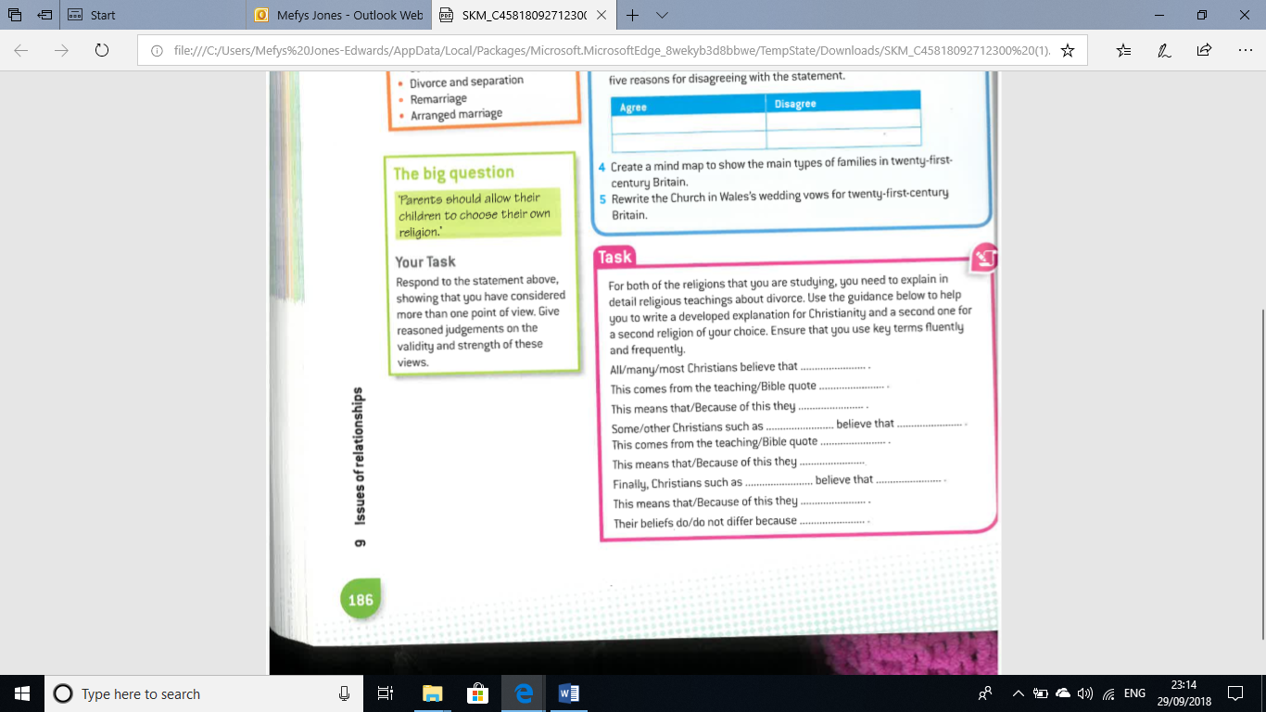

Success criteria for question c?

**_____________________________________________________________________________________________________________________________________________________________________________________________________________________________________________________________________________________________________________________________________________________________________________________________________________________________________________________________________________________________________________________________________________________________________________________________________________________________________________________________________________________________________________________________________________________________________________________________________________________________________________________________________________________________________________________________________________________________________________________________________________________________________________________________________________________________________________________________________________________________________**

**_________________________________________________________________________________________________________________________________________________________________________________________________________________________________**

**‘Sex before marriage is wrong. If you truly love a person, you should wait until you are married before you have sex’.** Discuss the statement showing that you have considered more than one point of view. (You must refer to religion and belief in your answer). [15]

Success criteria for question d?

________________________________________________________________________________________________________________________________________________________________________________________________________________________________________________________________________________________________________________________________________________________________________________________________________________________________________________________________________________________________________________________________________________________________________________________________________________________________________________________________________________________________________________________________________________________________________________________________________________________________________________________________________________________________________________________________________________________________________________________________________________________________________________________________________________________________________________________________________________________________________________________________________________________________________________________________________________________________________________________________________________________________________________________________________________________________________________________________________________________________________________________________________________________________________________________________________________________________________________________________________________________________________________________________________________________________________________________________________________________________________________________________________________________________________________________________________________________________________________________________________________________________________________________________________________________________________________________________________________________________________________________________________________________________________________________________________________________________________________________________________________________________________________________________________________________________________________________________________________________________

__________________________________________________________________________________________________________________________________________________________________________________________________________________________________________________________________________________________________________________________________________________________________________________________________________________________________________________________________________________________________________________________________________________________________________________________________________________________________________________________________________________________________________________________________________________________________________________________________________________________________________________________________________________________________________________________________________________________________________________________________________________________________________________________________________________________________________________________________________________________________________________________________________________________________________________________________________________________________________________________________________________________________________________________________________________________________________________________________________________________________________________________________________________________________________________________________________________________________________________________________________________________________________________

|  |  |  |  |
| --- | --- | --- | --- |
| **Marked by** | **Mark/level** | **(*)** | **(?)** |
| **Peer/self** |  |  |  |
| **Teacher** |  |  |  |

* **Do you know your target?**

**Self-evaluation of the unit ­­- Relationships**

* **Test result for this unit? % Grade:**
* **Are you on track?**
* **If not, why?**
* **Do you have regular homework?**
* **Are you aware of the success criteria to some questions?**
* **Have you had the opportunity to self-assess/peer-assess work during this unit?**

**Standard of your work:**

|  |  |
| --- | --- |
| **Happy with** | **Difficulty with** |
|  |  |

**Teacher’s response:**