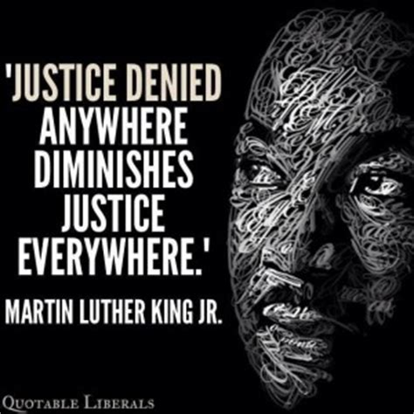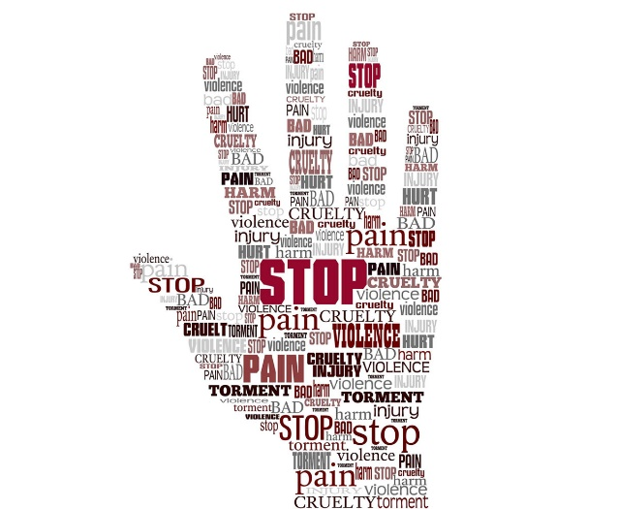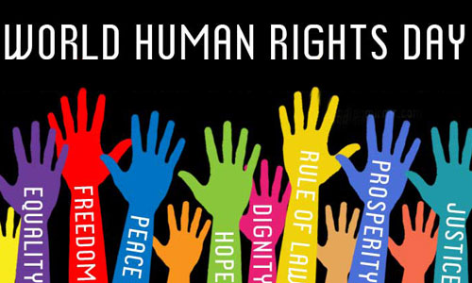

R.E

YEAR 11

ISSUES OF HUMAN RIGHTS

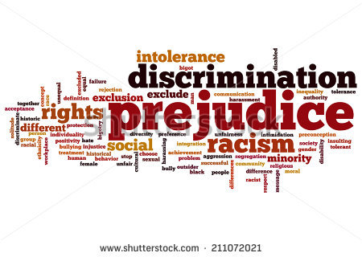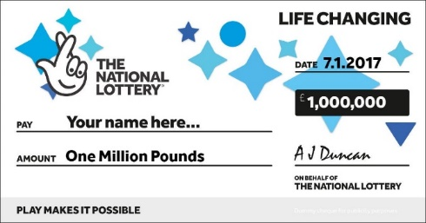

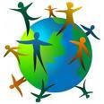

Enw: ___________________________

**ISSUES OF HUMAN RIGHTS**

These terms are the **key concepts** - terms, which you must learn and know their meaning for the exam!

**Censorship:** The control over how information / ideas are spread in society. Denying the right of freedom of expression, freedom of opinion or give any information publically which may cause offence, be prejudice towards others.

**Discrimination:**

An action where you treat someone differently e.g. colour of their skin.

**Prejudice:** Judging someone or something before knowing them or knowing the facts e.g. how they look.

**Human Rights:**

Things that a person expects

to get or do e.g. food and

shelter; what was agreed

that everyone should get;

something that someone

has the right to because

they are human e.g.

religious freedom.

**Personal conviction:**

Something that you feel or know that is right e.g. because of your religious beliefs; personal opinions.

**Social justice:** Making sure that people living in our society or communities are treated **fairly and justly** i.e. that they are valued for what they are rather than the colour of their skin, race, belief or non-belief, or even their sexuality. Everyone should **receive the same rights, opportunities and provision.**

**Extremism:** To believe very strongly in something, to support and act on ideas that are far from correct e.g Terrorism.

**Absolute poverty:** It usually incudes having no access to basic services such as medicine or shelter.

**Relative poverty: A** level of income below the majority of a particular country.

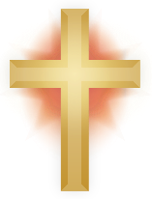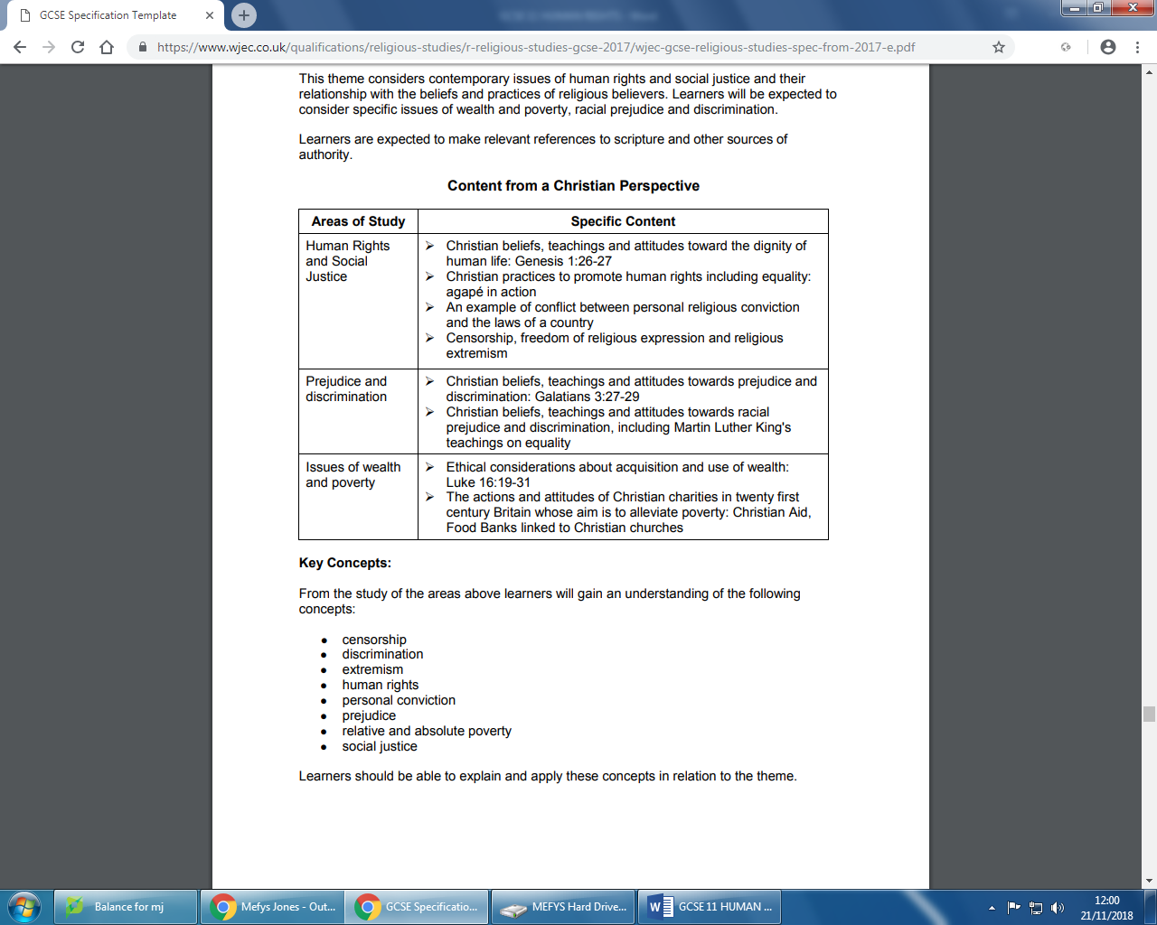

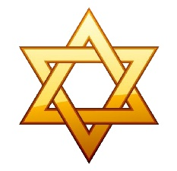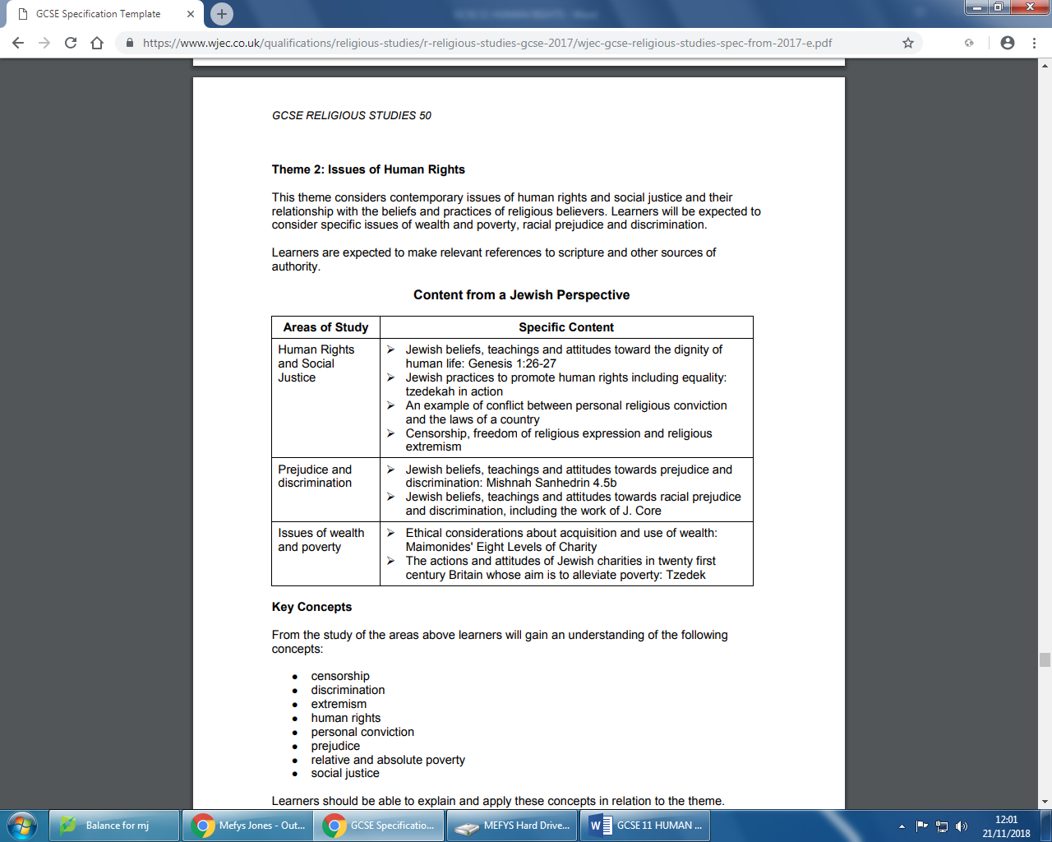

**Human Rights**

Watch the clip from Truetube – Human Rights – The Global Outlook and What do you Think? What is the meaning of human rights?

**What do we mean by human rights?**

Every person living on earth is entitled to live his/her life in peace regardless of his/her situation, race, personal religious belief or non-religious belief, political preferences, age or sexual orientation. The 10th of December is referred to annually as the **International Day of Human Rights**. In 1948, the United Nations announced the Human Rights declaration. These includes 30 articles which states which rights each individual should have e.g. the right to shelter, education, food**.** All are based on the first statement that **"all men are born equal, with a right to be treated fairly and with dignity.”**

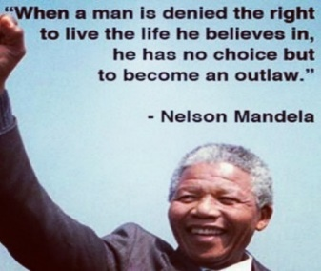

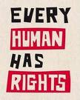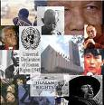

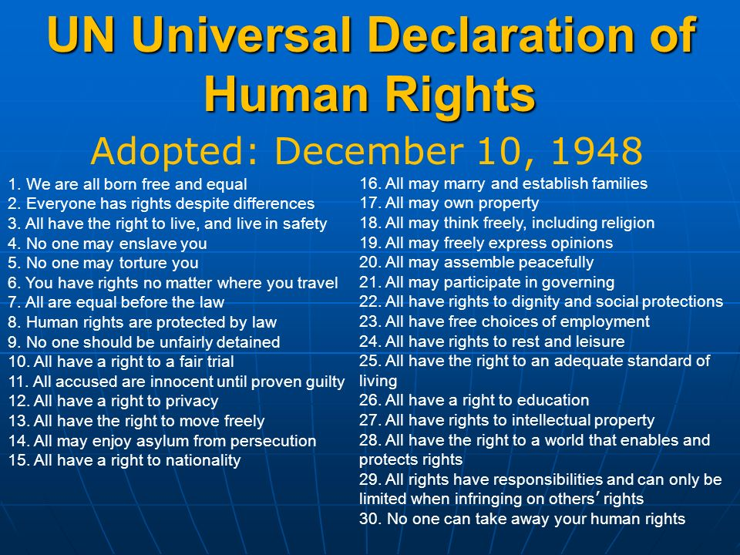

Many countries have agreed to this statement. If any of the articles are violated, then different international agencies have a responsibility to try to persuade the countries to put these back in place.

**Amnesty International** is a group which operates in and helps countries where these rights are absent. The agency logo has two parts.

**- The candle** - symbol of hope for all prisoners and victims who cannot get these basic rights.

- The **barbed wire** show’s that people sometimes have to cut the barbed wire so that they can help others i.e. go against the laws of the country where they live in order to make sure that everyone has the right to live in peace and with dignity.

The members of the agency use non-violent methods such as writing letters to the governments of the world in order to get rid of discrimination and ill-treatement of people. They also try to stop cruelty towards women, protect the rights of those living in poverty, end capital punishment, release prisoners of conscience, defend and protect refugees and migrants and control the arms trade. Although the International Declaration was published in 1948, many people, even today, are unable to secure these rights and are deprived of the respect and dignity owed to them. There are over 7 million members.

**TASK**

**Look at** [**www.youthforhumanrights.org**](http://www.youthforhumanrights.org)**. Note any 6 rights that you think are the most important, ranking them from the most important.**

1.

2.

3.

4.

5.

6.

**SOCIAL JUSTICE** means making sure that people living in our society or communities are treated **fairly and justly** i.e. that they are valued for what they are rather than the colour of their skin, race, belief or non-belief, or even their sexuality. Everyone should **receive the same rights, opportunities and provision.** Social justice is important in order to have a happy and **peaceful co-existence within and between nations**.

**SOCIAL JUSTICE**

Social justice involves governments and agencies working together to try to help developing countries. They try to narrow a divide between rich and poor and that the environments are clean and safe to live in.

Nid ymddangosiad person sydd yn bwysig ond yr hyn ydyw y tu mewn. Y mae gan bob un, boed dlawd neu gyfoethog, ei deimladau a’i emosiynau personol. **Dyn yw dyn ar bob cyfandir, beth bynnag ei gred neu beidio**. Dyna pam y dylid sianelu pob ymdrech tuag at drin pob dyn yn gyfiawn a chyfartal gan osgoi unrhyw annhegwch a diffyg tosturi o unrhyw fath.

**LOGO’R CENHEDLOEDD UNEDIG**

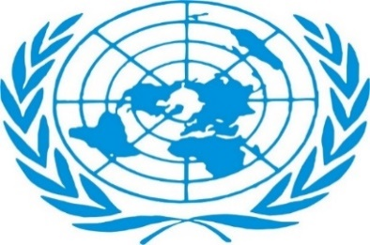

**ATTITUDES TOWARDS HUMAN RIGHTS AND SOCIAL JUSTICE**

**DIGNITY: The state of being worthy of respect – treating someone as you would like to be treated yourself – not to abuse and show a lack of respect.**

This is a belief that is central to any religion or non-religious tradition. It means that life is not only important, but that every human being, no matter what his or her age, gender or ability, is valuable and should always be treated as such.

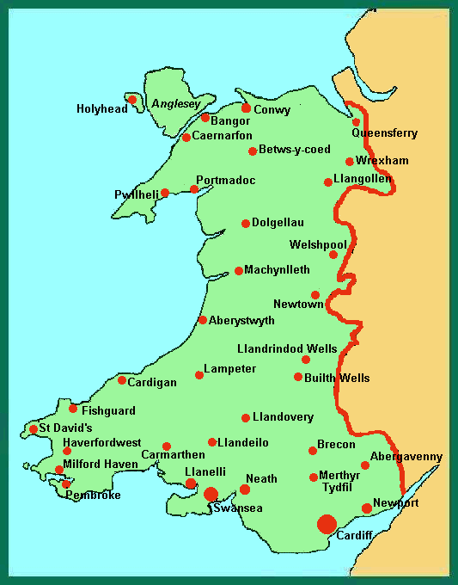

**Social Justice in Wales**



**Gender:**

• Men are more likely to work than women. Between September and November 2016, 70% of women worked compared with 75% of men.

• Almost three-quarters of part-time workers are women. Jobs such as care, personal services and the retail sector are most likely to be part-time.

• Women, on average, receive less pay than men. The gap between them is around 15%.

• Women are less likely than men to start or run their own business. Less than a quarter of small businesses are run by women.

* Mae dynion yn fwy tebygol o weithio na merched. Rhwng mis Medi a Thachwedd 2016, 70% o ferched oedd yn gweithio o gymharu â 75% o ddynion.
* Mae bron i dri chwarter o weithwyr rhan-amser yn ferched. Swyddi fel gofal, gwasanaethau personol a gweithio mewn siopau sydd fwyaf tebygol o fod yn rhan-amser.
* Mae merched, ar gyfartaledd, yn derbyn llai o gyflog llai na dynion. Y bwlch rhyngddynt, gan amlaf, yw tua 15%.
* Mae merched yn llai tebygol o gychwyn neu rededg eu busnes eu hunain na dynion. Mae llai na chwarter busnesau bach yn cael eu rhedeg gan ferched.

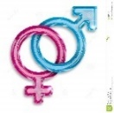

**Poverty:**

• Food – In 2011-12, in Wales, just under 15,000 people were given three days’ worth of emergency food (from food banks). By 2015-16 the number had increased to almost 85,000, an increase of almost 483%!

• Shelter – The number of households classed as homeless fell slightly from 6,515 in 2011-12 to 5,070 in 2014-15.

• Children – Wales has the highest child poverty rate in the UK – 31% the equivalent to approximately 172,000 children.

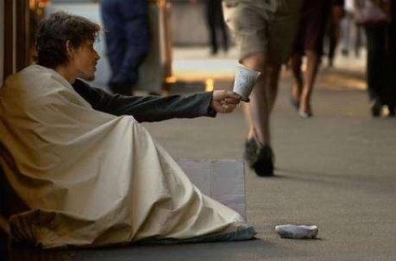

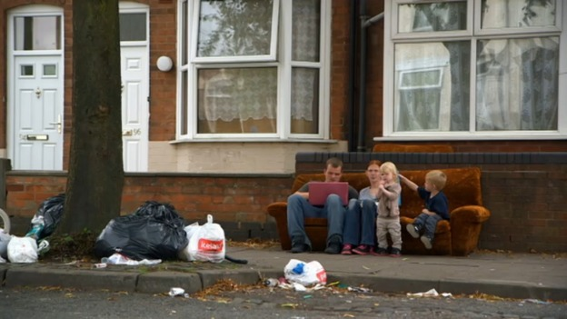

**CHRISTIAN ATTITUDES TO THE DIGNITY OF HUMAN LIFE**

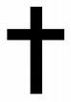

* Paul said “T**here is neither Jew nor Greek; there is neither slave nor free; nor is there male and female, for you are all one in Christ Jesus.”** Galatians 3:28
* The Universal Declaration of Human Rights reflects the main principles of Christianity in respect of treating others = Golden Rule.
* Every man was created in the image of God and therefore, every man is the child of God. That is why everyone should be respected in the same way = The Golden Rule.
* ***“Let Us make man in Our image, according to Our likeness; let them have dominion over the fish of the sea, over the birds of the air, … and every creeping thing that creeps on the earth. So God created man in His own image; in the image of God He created him; male and female He created them”.*** (Genesis 1:26-27)
* There are different Christian opinions about the story of the creation, but all would be happy to say that it shows how important human life is:

- Anglicans: People have similar characteristics to God because it is He who has created them – so they should be treated with respect whoever they are.

- Catholics: Since God has created man, nobody has the right to get rid or destroy human beings, e.g. the death penalty or euthanasia.

* Human life must not be destroyed.
* Life is a gift given by God, and should be valued.
* Pope Francis said that we have a duty as Christians to protect the poor, the elderly and the homeless if we want to follow Jesus’ example: "Love thy neighbour as thy self."
* Jesus teaches in Mathew 25 that caring for the poor and the needy is serving God, e.g. "For I was hungry and you gave me food... "
* Jesus taught in the Parable of the Good Samaritan: “Go and do likewise” when thinking about helping others.
* Every person should be treated with respect and dignity because everyone is equal, and created in the image of God, whatever the colour of skin or religion.
* Jesus expects people to ‘love thy neighbour as yourself’, showing love to people in need.
* Jesus says – Only those who show love for the weak will be allowed into heaven (the parable of the sheep and goats).
* In the Parable of the Good Samaritan, Jesus ordered his followers to follow the Samaritan's example-by helping a person who was in need.

**JEWISH ATTITUDES TO THE DIGNITY OF HUMAN LIFE**



* God has created every human being – it says so in the Torah. ***“Let Us make man in Our image, according to Our likeness; let them have dominion over the fish of the sea, over the birds of the air, … and every creeping thing that creeps on the earth. So God created man in His own image; in the image of God He created him; male and female He created them”.*** (Genesis 1:26-27)
* Human beings are of flesh and blood (the material) as well as the soul (the spiritual).
* The earth provides the material while the spiritual is provided by God.
* Man has been created in the image of God in order to be similar to him in everything achieved in life.
* Human beings are the pinnacle of the creation, not an animal – human beings have a duty to look after the world and God’s creation. That is why they should respect and care for everything that God created. Stewardship.
* Some Jews believe that human beings have a free will to do as they wish but must face the consequences of their actions, i.e. punishment for an offence.
* Some Jews believe that they have a responsibility to treat others with respect and consideration because God created the whole of humanity – that is why no-one is better than anyone else.
* Some Jews believe that when you mistreat or insult another person, you insult or mistreat God as it is He who has created human beings.
* He teaches 3 things about human life in the Talmud:

1. God gave Adam clothes when he was naked in the Garden of Eden. The duty of the Jews is to clothe the needy person, in particular Jews within our society today.
2. God visited Abraham when he was ill. It is the Jew’s duty to do the same today – to visit the sick within our society.
3. God visited Isaac when he was bereaved. It is the duty of the Jews to comfort those who have lost their loved ones in our society today.

**Why do many religious believers consider human rights as important?**

* It is important to protect those who act upon conscience.
* It is important to protect those who are weak and those who are oppressed.
* It is important to act on behalf of justice and make sure there are equal opportunities for everyone.
* Everyone has the right to be treated without discrimination or prejudice.
* Religious teaching regarding caring for others or standing up for others is important.

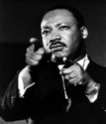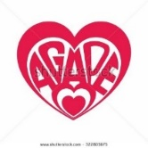

**Christian practices to promote human rights**

**Equality: Agape in action**

**AGAPE**: Unselfish love; love shown in Jesus’ life and work as an example to Christians of how they should live their Christian life; it's a love that gives without expecting anything in return, e.g. a mother's love of her child; Christ's love when crucified is an example of this.

A number of charities and individuals have shown agape love in their day-to-day work, to show God's love at work in the world. Two Christian charities that do this are the **Salvation Army and Christian Aid.**

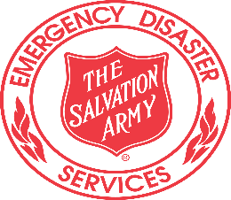

**The Salvation Army**



* A Church that does a lot of social work to show Jesus' words, "love thy neighbour like thy self."
* 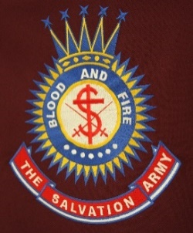Gives out sandwiches and soup to the homeless late at night.
* Runs hostels for the homeless.
* Street Work – walk the streets of our cities ready to speak and help those who are in need.
* Detox – runs programmes to help people with drug / alcohol addiction.
* Run lunch clubs and social clubs for the elderly.
* Helps the police to trace missing people

**Can you give more examples of their work?**

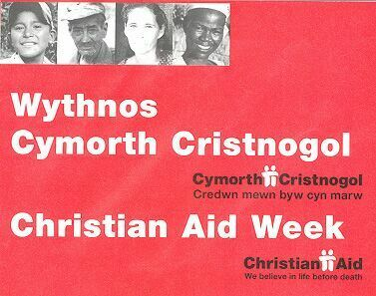 **Christian Aid – "We believe in life before death”**



* A Christian Charity helping people in poor countries.
* Run long-term projects to help a community for a number of years e.g. to give a water pump to a village in Africa, open new schools, sending boys to an agricultural college.
* Try to educate British people about the reasons for worldwide poverty e.g. preparing resources for schools.
* Educate people to be able to be independent and capable of standing on their own feet.

**Can you give more examples of their work?**

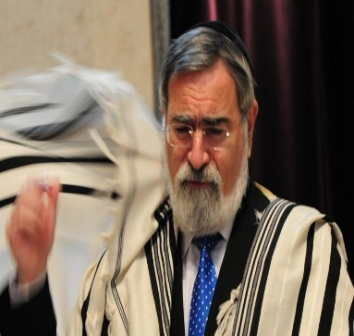 **JUDAISM**



**Tzedekah – JUSTICE, CHARITY**

1. A charity established in 1990 to help the developing world.

2. They try to educate Jews about the reasons for poverty.

3. They provide water pumps in poor/dry countries.

4. They work for a fair life in many countries of the world, e.g. in Bangladesh – they have a family project that cares for women who have been rejected by their family

**JONATHAN SACKS =**

**Former chief RABBI of the Commonwealth**

**He said, "Social justice is at the heart of Judaism..."**

and of orphaned children. They pay a teacher's wage to teach the girls how to make

crafts so that they can sell them for money to be independent.

5.It may involve giving money to either those in need on a one off or annual basis,

or supporting those in need by campaigning for social justice or human rights,

e.g. protests, marches.

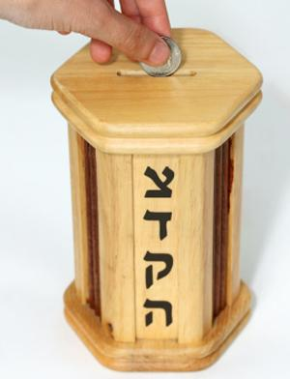

**TZEDEKAH** = religious duty to give to charity

**SIMCHA** = the joy of giving to the needy

**CHESED** = loving, kind acts

**TIKKUN OLAM** = heal the world; improving the world from the problems of the world.

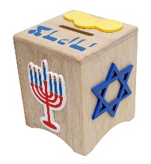

**Why?**

1. They believe that God wants all Jews to work for justice in the world.

2. They believe that giving charity and helping others is one of the most important commandments of the Torah.

3. The Torah states that God expects Jews to care for the weak – e.g. widows, orphans and strangers.

4. Judaism teaches us that a person can best be helped by helping them to stand on their own feet and become independent once again.

5. Give because you can, not because you have to do it, i.e. give from the heart, not because it’s an order. The act of giving Tzedakah is a mitzvah, and many Jews believe this to be one of the most important rule/duty.

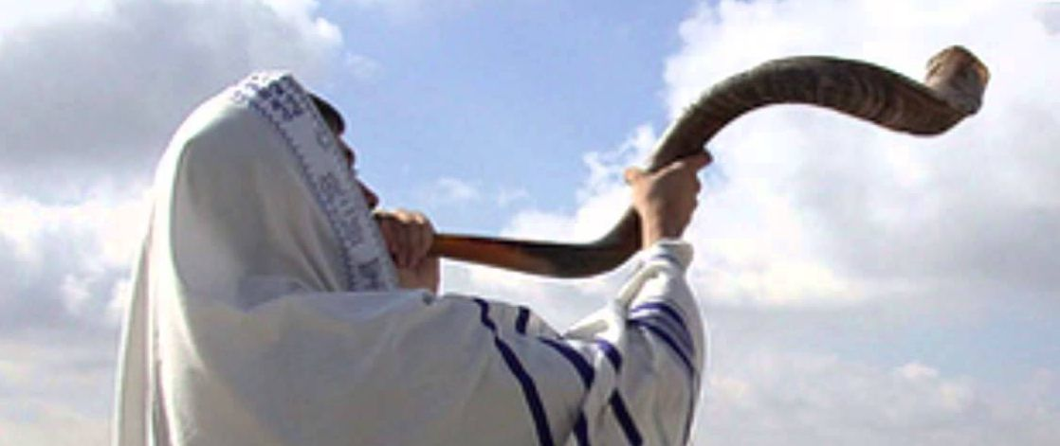

**The Year of the Jubilee**

In the period of the Bible, the Jubilee Festival took place every seven years. It celebrated God's care over agricultural land. The land had been fallowed and no one owned the land for a whole year. There were three ways in which this would impact people:

1. Everything belongs to God. Everything is borrowed from God. Humanity owns nothing.
2. The land was replenished for that year. The purpose was to show God's love to humans by the Jews.
3. All produce would be available to everyone for the whole year during this period to show that the poor and rich were equal before God. There was no difference between them in God's eyes because He created them in His own image.

**Every 7**

**Years!**

**Celebrate**

**God’s**

**Care**

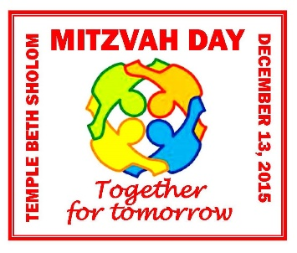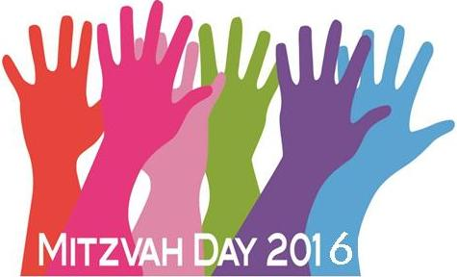

**MITZVAH DAY**

The Talmud teaches Jews about Mitzvah day. This is a day that puts Tzedakah into practice. It is a day of social action led by different Jews. On this day, many people across the world take part in a range of activities to raise the spirits of those who are less fortunate than themselves. They support charities to build stronger communities. The words of the Talmud are: "Tzedakah and acts of kindness towards others are the equivalent to all of the mitzvot in the Torah." According to the UK Mitzvah Day, the importance of this day is: "Reducing hardship and poverty, helping our environment and bringing a little joy – practical – not fundraising..."

Although the original meaning of the word mitzvah is “commandment” it can also mean a kind act by:

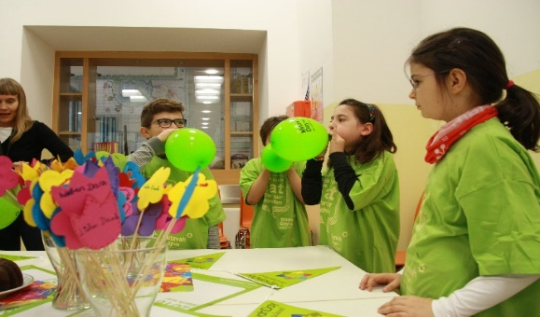1. Reaching out to refugees

2. Visiting the elderly

3. Making a meal for poor families

4. Serve patients

5. Children being taken for walks

"A good act means that God is at work in our lives"

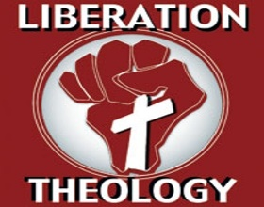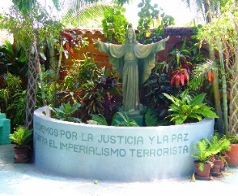

**Liberation Theology**

**Theology**

A good example of social action is liberation theology, i.e. God liberates people from their problems and suffering. It is a Christian organisation founded on what Jesus taught and what he did during his life, e.g. giving sight to the blind, feeding the needy such as feeding the 5,000. During his life, Jesus helped people and freed them from political and economic injustice. Jesus hated to see people being mistreated – he fought for the rights and freedom of the individual. Liberation Theology acts on the Christian idea that God has the ability to transform unjust situations in the world – God is all-powerful and omnipresent and reduce poverty or end a war.

Some Christians believe that the meaning of liberation theology is to stand up and oppose governments in the world that **OPPRESS** (being treated with injustice/cruelty by the government of a country)their people and abuse their freedom. People like **Martin Luther King and Oscar Romero** come to mind with their non-violent and peaceful protests to get their message across. Their **PERSONAL CONVICTIONS** are important. This means that conflicts sometimes occur between government and personal beliefs.

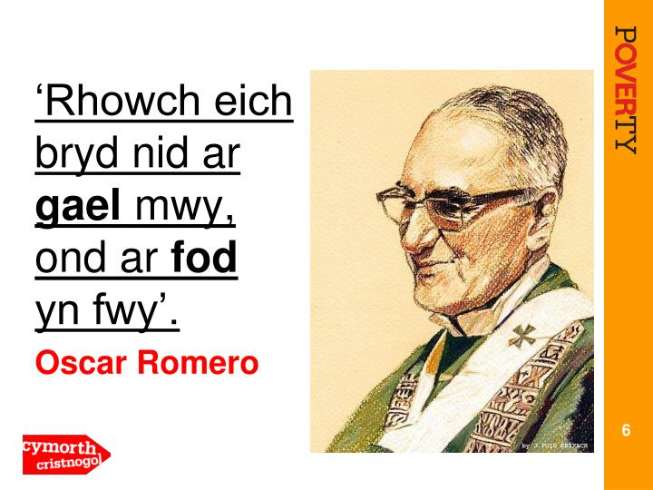

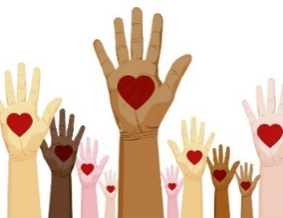

**Does religion and politics go hand in hand?**

|  |  |
| --- | --- |
| **Religion and politics go hand in hand** | **Religion and politics does not go hand in hand** |
| * Paul said ‘Everyone should obey to the authorities who govern…because they have been established by God.’ * The Pope said that Christians should obey the Leaders of the Land. | * Jesus judged the money lenders in the Temple – was against the authorities. * Oscar Romero said if you believe God has created everyone equal, then you must protest when the government kills people who try to get justice. * Jesus said ‘Blessed are those who hunger and thirst for righteousness.’ Christian Aid fought the government in their protest ‘Stop the Debt’. By doing this, many countries now have more money. The Archbishop Tutu went to prison for protesting against apartheid in South Africa. He said ‘When people say that religion and politics should not mix, I do not understand which Bible they are reading!’ * Religion and politics should be kept apart to avoid conflict/fighting between different religions. |

**EXAMPLE OF A CONFLICT BETWEEN PERSONAL**

**RELIGIOUS CONVICTION AND THE LAW**

|  |  |
| --- | --- |
| **Personal Conviction** | What you feel or know is right e.g. because of your religious belief; or personal opinions; some would go so far as to be prepared to die for them. |

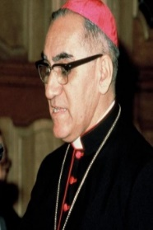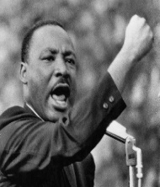

The law of the land is a gift from God. Every Christian must obey the law to the best of his/her ability. However, at times, conflict occurs. Every man should bend to the laws of God rather than to the law of man when that is the case. Some were not afraid to show what they believed in or to whom they belonged! Their personal conviction created a hope of getting rid of social injustice and putting an end to prejudice and discrimination. Martin Luther King and Oscar Romero lost their lives in their campaigns to improve human rights and social justice.

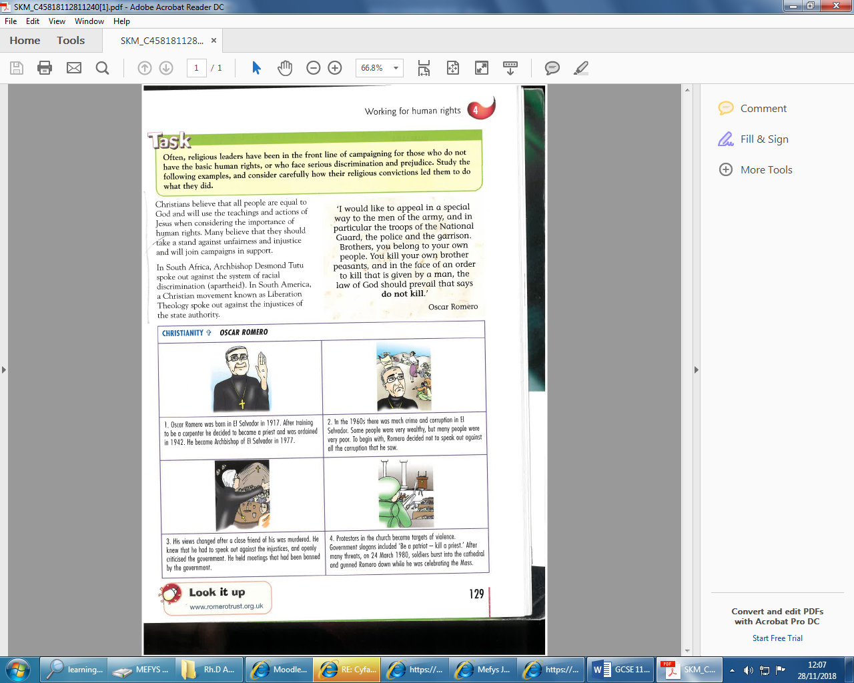

-

**MARTIN LUTHER KING – CHRISTIAN**



• The main purpose of MLK's life was to improve the condition of black peoples' lives and to create a better future for his children. He used non-violent methods such as ' Sit-ins ', marches, speeches and conferences. (Remember the story of Rosa Parks and the bus boycott).

• He got rid of the Jim Crow rules which separated black and white people in restaurants, education etc.

• He was a leading member of the Civil Rights movement – putting his life at risk because of his personal conviction that God had created every man in his own image and that everyone had the right to live as they wanted.

• He believed in what Paul taught- “There **is neither Jew nor Greek; there is neither slave nor free; nor is there male and female, for you are all one in Christ Jesus**” (Galatians 3:28)

• Discrimination was reduced and there became greater equality between the black and white people of America in terms of jobs, homes, and general rights such as voting.

• He made speeches which have become famous, e.g. I have a dream... "I have a dream that my four little children will be called to account, not for the colour of their skin, but for the content of their character."

• He won the Nobel Peace Prize in 1964 for his work.

• He was killed by a white man named James Earl Ray in 1968.

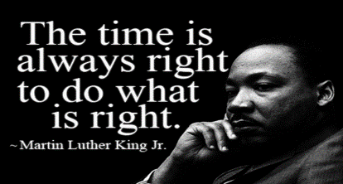

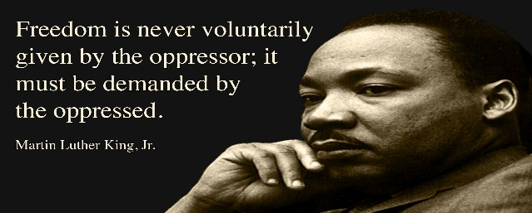

Free at last

**THE WORDS OF JESUS: “Truly I tell you, whatever you did for one of the least of these brothers and sisters of mine you did for me.” Mathew 25:40**

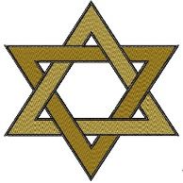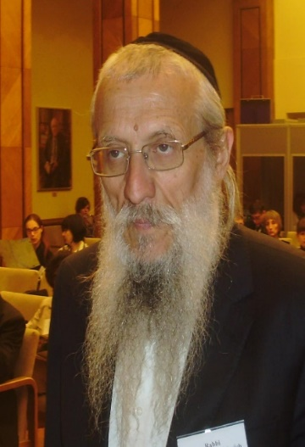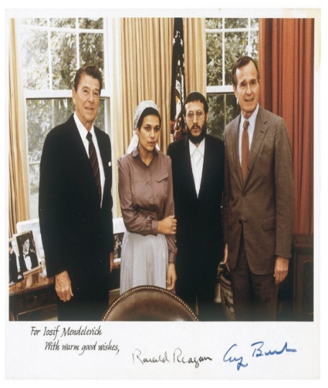

**Yosef Mendelevitch –**

**A Jew who opposed injustice**

* In 1947, the state of Israel was established.
* In that year, Yosef Mendelevitch was born in the former Soviet Union.
* He was a Jew, and the relationship between Israel and the Soviet Union was not good after the Second World War.
* The Communist Party wanted to get rid of religion in the Soviet Union. Free will to express personal opinions on any subject was not allowed although there was a right to do so in private.
* During the period that Mendelevitch was growing up, a ban on meetings was put in place by the authorities. Meeting in the synagogue was illegal. Campaigns were run against Rabbis and the Jewish religion. Hatred existed between the government and the religion.
* In 1966, Mendelevitch began an underground group of Jewish students. The purpose of this was to edit a newspaper that would address Jewish issues from a Jewish perspective.
* Mendelevitch attempted to emigrate to Israel several times. His request was always rejected by the Soviet authorities. The Soviet authorities were prejudiced towards him as a religious Jew.
* In 1970, Mendelevitch led a group of ‘refuseniks’ in an attempt to steal an aircraft and escape or disappear to the West. He was arrested and imprisoned for 11 years. In prison he was also punished for practising Judaism.
* Mendelevitch was released in 1981 and finally emigrated to Israel. During this period, he decided to become an Orthodox Rabbi.
* He did not want to keep silent about the injustice he experienced in the Soviet Union. He tried to change the attitude of the Soviet Union towards Judaism and was active not only within his religion but also politically.

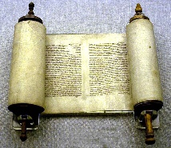

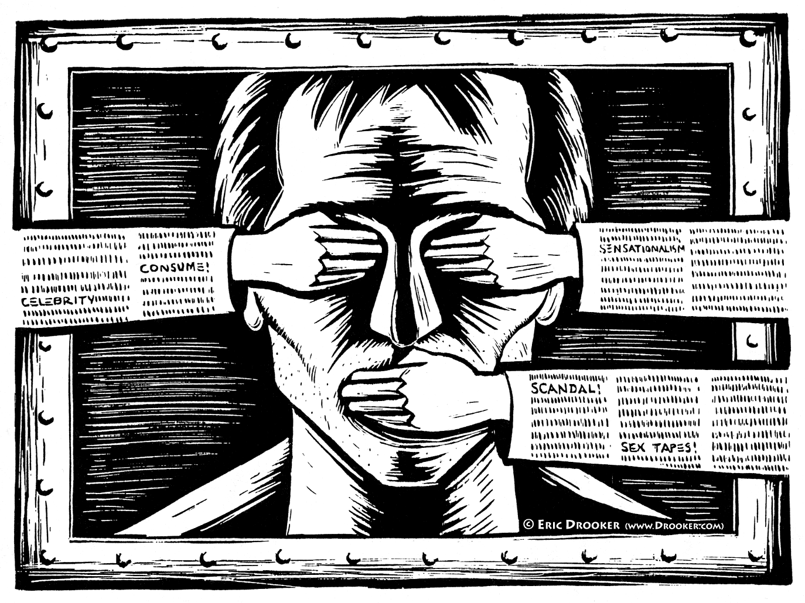Who has the right to say?

Censorship



The control over how information/ideas are spread in society. Denying the right to exercise freedom of expression, freedom of opinion or publicly declaring any information, which may cause offence, be prejudice, sensitive, politically incorrect in the opinion of government, various media, authorities, other groups or organisations. Governments, public institutions, or individuals can play their part in censorship.

The meaning of Censorship

**THE UNITED NATIONS DECLARATION ON HUMAN RIGHTS – ARTICLE 19**

Everyone has the right to freedom of opinion and expression; the right includes freedom to hold opinions without interference and to seek, receive and impart information and ideas through any media regardless of frontiers.

Erthygl 19:



**But what about …….?**

**Ond beth am …….?**

Nobody should publicly state their views if they are going to cause concern to other people. Religious views should only be discussed at home. Nobody else would then hear them.



Rydw i’n credu’n gryf mewn rhyddid barn. Fe ddylai pawb gael yr hawl i ddweud sut y maent yn teimlo heb ofni unrhyw beth. Mae hynny’n golygu safbwyntiau crefyddol ac anghrefyddol fel ei gilydd.

I am a strong believer in freedom of speech. Everyone should have the right to say how they feel without the fear of anything. That means religious and non-religious viewpoints alike.

We should be able to have our say on our religious beliefs in public, but only if they don’t offend anybody else or cause scaremongering and create more hatred between people.

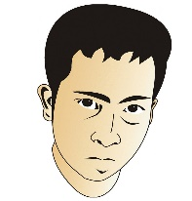

In the UK and Europe, people have the right to express their views on any religion, unless what is said is likely to create unrest or violence. However, many different views exist about censorship if views could create unrest. Censorship would prevent the publication or broadcasting of a specific content. That is why there is much concern about the publication of information about hate crime.

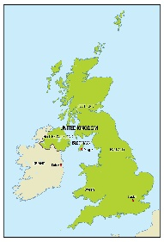

|  |
| --- |
| **HATE CRIMES** |
| This is how the British government defines hate crimes: "A crime which the victim or any other person considers to be motivated by hostility or prejudice based on race, religion or sexual orientation, a disability or any other offence which has been motivated by hostility."  In Wales, these offences rose from 1,877 in 2013-14 to 2,259 in 2015-16. It does not necessarily mean that the number of offences has risen but that many more are now being recorded. The Welsh Government suggests that half the hate crime is not reported or recorded. |

What happens next?

Read the script by Sioned, Twm and Ahmed and then answer the questions:

Ahmed: In class, we've been discussing the Charlie Habdo case. People who worked for a magazine were murdered, just because they had published certain pictures. What next?

Sioned: I agree that murdering the publishers was wrong. There was no reason to do so. But these were pictures of the Prophet Mohammed. These probably upset Muslims in the country. They should not have had the right to publish material that was going to hurt other people.

Twm: But it’s all relevant. Something that worries other people may not worry me. In Denmark, when pictures of the Prophet were published, some countries did let the people see them while other countries censored their release. Do you want to live in a country where nobody is allowed to say anything in public? In some countries, the media have all been censored and only the government itself is allowed to say what is happening there. Do you know that there was a blasphemy act in England up to the year 2008? This meant that everything that went against Christianity had to be censored.

Sioned: That’s not what I mean, but when I look at some websites, I read some Islamophobic statements. I know these have been written with the intent of offending other people... but that can't be right.

Ahmed: In the UK and Europe people enjoy freedom to express their views about any religion unless what they say is going to cause violence or insults their followers.

Sioned: However, it is probably difficult to prove. What is strange is that the offending remarks come from religious believers. Some people still say things about Jews and gay people. That makes me furious.

Ahmed: But their ideas do not represent the majority of Christians. That is an extreme view, and I see those in every religion. Extremism means people expressing extreme political or religious views. Even if people were not entitled to express an opinion that offends others, they would be likely to continue to think in that way.

Twm: For me, it is a personal view that influences the content. I'm not sure if we can achieve a balance between the freedom to express opinions and censorship.

Sioned: It probably depends on the individual. I get sick and tired of people who knock on my door and talk to me about their religion.

Ahmed: Www. This leads us to a really difficult question. To what extent should we be free to express our religion?





**ANTI-SEMITISM:** Hatred / prejudice towards Jews.

**ISLAMOPHOBIA:** Hatred / prejudice towards Muslims, Islam.

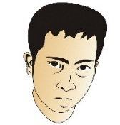**DISCUSS:**



1. Twm, Sioned and Ahmed have different views on religion. Explain which of the three views are the strongest and explain why you think so.
2. What is your personal view of censorship and how free should we be to have our views or ideas publicly shared?





**FREEDOM OF RELIGIOUS EXPRESSION**

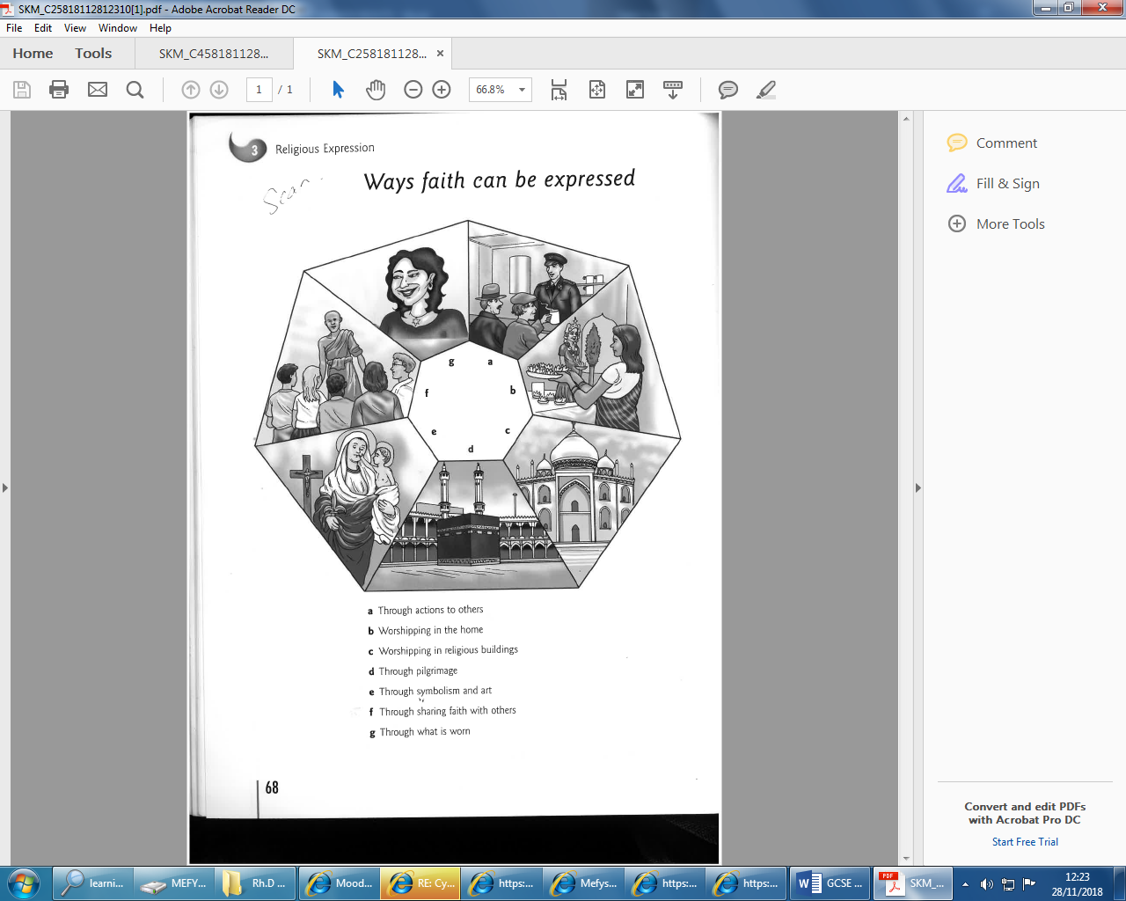





In the media, we hear of different situations where many people have suffered injustice or where conflicts have occurred as a result of what has been seen, heard or done. In some countries, it is illegal to wear religious symbols in public, e.g. in state schools in France.

**Expressing Faith by dress**

**How can faith be expressed through what people wear?**

Sometimes, the clothes people wear show the influence of their culture, and say something important about their religion and religious identity.

**CHRISTIAN SYMBOLS**



|  |  |
| --- | --- |
| **SYMBOL** | **MEANING** |
| **Fish**  [http://files.abovetopsecret.com/files/img/db4f922c42.gif](http://www.google.co.uk/url?sa=i&rct=j&q=Christian+symbol+of+fish&source=images&cd=&cad=rja&docid=dpZBjc3zj3J0mM&tbnid=bj0nuhq_P1BtaM:&ved=0CAUQjRw&url=http://www.abovetopsecret.com/forum/thread830863/pg2&ei=KZ8bUaCFM83J0AWC5ID4Cg&bvm=bv.42261806,d.d2k&psig=AFQjCNE1leHpYGahzRvFgAIhn9JOenPp2Q&ust=1360851054573713) | Ichthus is a Greek word for fish meaning Jesus Christ, the Son of God, Saviour. It’s a symbol of faith. |
| [http://images.sodahead.com/polls/000426267/polls_crucifix_3722_983394_poll_xlarge.jpeg](http://www.google.co.uk/url?sa=i&rct=j&q=Christian+symbol+of+crucifix&source=images&cd=&cad=rja&docid=Iq9ZS7Hgmw1QCM&tbnid=1s2hI6GAIIz34M:&ved=0CAUQjRw&url=http://www.sodahead.com/united-states/why-does-christianity-use-the-crucifix-as-a-symbol-don-t-you-think-that-s-the-last-thing-jesus-is-g/question-426267/&ei=_Z8bUbrtKoaT0QWv3IDIAg&bvm=bv.42261806,d.d2k&psig=AFQjCNEecdN9A5yS0MEOecDvCvmUxhFstw&ust=1360851286015261)**Crucifix**  Image result for christian symbols crucifix | A cross with an image of Jesus is a crucifix. It reminds believers of the crucifixion. It helps at sad times or if a person is worried about something. A symbol of the presence of God. |
| [http://jeffgoins.myadventures.org/blogphotos/myadventures/jeffgoins/christian_symbolism.jpg](http://www.google.co.uk/url?sa=i&rct=j&q=Christian+symbol+of+cross&source=images&cd=&cad=rja&docid=nCVtAn-3055cDM&tbnid=GWAjT_7_GlnfiM:&ved=0CAUQjRw&url=http://jeffgoins.myadventures.org/?filename=christian-symbolism&ei=m6AbUaiWEqKt0QWog4C4Bw&bvm=bv.42261806,d.d2k&psig=AFQjCNGwJaM3IZfoVm2KfiSVz0oI8zPkWA&ust=1360851472141609)**Cross** | A plain cross that reminds believers of Jesus' resurrection and that he has died for the sins of his people. |

Reminding believers of the importance and significance of events in Jesus' life is the purpose of the main symbols of Christianity for the Christian. In wearing them, Christians are evangelising (telling others about the religion) without having to say a word!

**JEWISH SYMBOLS**



|  |  |
| --- | --- |
| **SYMBOL** | **MEANING** |
| [http://0.tqn.com/d/create/1/0/s/C/3/-/TonyKippah.JPG](http://www.google.co.uk/url?sa=i&rct=j&q=Jewish+symbol+of+kippah&source=images&cd=&cad=rja&docid=aWJQb5Wv6B5FvM&tbnid=fYSIYEp77KlSNM:&ved=0CAUQjRw&url=http://forums.wdwmagic.com/threads/has-this-ever-been-done-thought-of.859168/&ei=Z6EbUfz7OZKN0wXe-IEQ&bvm=bv.42261806,d.d2k&psig=AFQjCNHBiBcNXXvTyMtxMJi4GrFtld3-kg&ust=1360851664832553)**Kippah** | Is worn to show respect to God. This is done by covering parts of the body that are close to God. |
| **Tallith**  Image result for tallit clipart | Worn whilst praying. The tassles are a reminder of the 613 mitzvot. The Torah tells Jews to wear them. It reminds Jews of the covenant made between them and God. Men are buried with the tallith. |
| **Tefillin**  Image result for tefillin clipart | Leather boxes which are placed on the forehead and arm during prayer. They contain parts from the Shema. It is a symbol that God is close to the heart and the mind. The Torah states that they must be worn. |

The purpose of the Jewish clothing is to remind Jews of God in their history, and their role as the Chosen nation of God. They also remind Jews of their covenant with God, and to obey His commandments (Mitzvot).

**FREEDOM OF RELIGIOUS EXPRESSION IN ACTION**

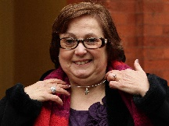

**TASKS**

**Read both stories:**

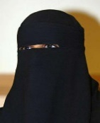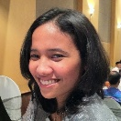

|  |
| --- |
| **Freedom of religious expression in action: Nadia Eweida – was the court correct?** |
| Nadia Eweida was working for British Airways. She was a Christian and liked to wear a small cross on a chain around her neck. Her employers decided to ban the wearing of any jewellery outside clothes and they told her to remove her cross. She was suspended from work for a while. Ms. Eweida's argument was that the cross is a religious symbol just like the hijab and that the company allowed Muslim girls to wear the hijab.  Ms. Eweida's employers changed their uniform policy so that employees are allowed to wear jewellery. But the court refused to make them compensate Ms. Eweida for the salary she lost while she was suspended from work. As there is no duty on Christians to wear a cross, the court stated that she had no good reason to break the company's dress code. The European Court of Human Rights later decided that the airline had breached the European Convention on Human Rights which allows the freedom of religious expression if it does not endanger the health and safety of the individual or the public. |

|  |
| --- |
|  |

|  |
| --- |
| **Aishah Azmi** |
| Aisha Azmi was a classroom assistant at a Christian school in West Yorkshire. She was a Muslim and wore a hijab in her work. Some who had been observing her lessons felt that the children did not hear her properly and that they were unable to see the expression on her face and was asked to remove the hijab. Mrs Azmi agreed to do so when only girls were present. She was not willing to do so when men were present in the classroom.  Mrs Azmi was suspended from working on full pay. She lost her case in an employment tribunal because discrimination had not occurred for religious reasons. The school had based their decision on educational reasons in asking her to remove the hijab. Therefore, the court did not find fault with the school. It was the education of the children that the school had in mind. |

Compare both stories and decide if the courts took the right decision in both cases. Remember to state your views clearly, with reference to religious reasons in your answer.



**Who is right?**

**You decide!**

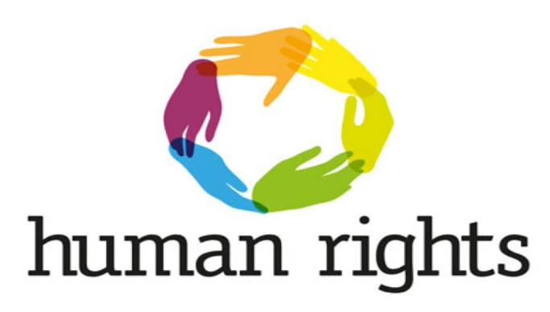

**Place the following sentences in a table under two headings - agree or disagree. The purpose of this exercise is to demonstrate that two clear views exist on the subject.**

Wearing something that represents my faith reminds me how important it is in my everyday life.

I can't see why people need things to remind them of their faith – isn't faith something internal rather than external?

Religious symbols can frighten some people – the girls who wear hijab in Islam make some feel uncomfortable.

It is hard to wear school uniform every day because perhaps this is not the way we want to dress– why should religious believers be treated differently?

I have no problem with religious believers showing what their faith is, as long as they don’t push their beliefs on me.

If religious believers have the right to share their beliefs, then I should also have the right to wear what I believe in order to express my ideas.

I want to share my faith with others so that they understand what I believe in.

An important part of my belief is spreading God's Word – that is why I wish to wear special clothes and symbols in doing so. It shows my identity.

|  |  |
| --- | --- |
| **AGREE** | **DISAGREE** |
|  |  |

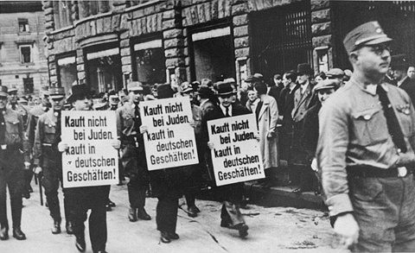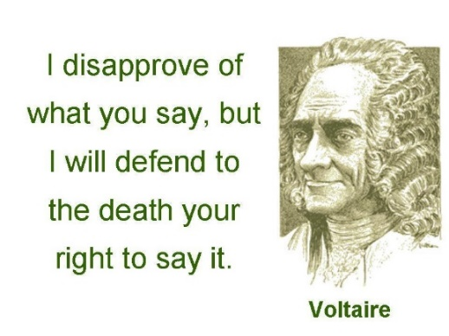

Religious

Extremism

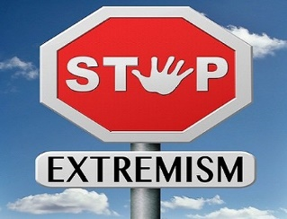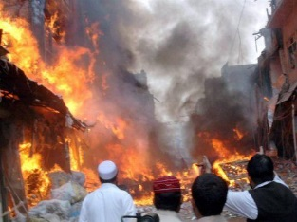

People show the importance of what they believe in different ways. Many feel that it’s important to join with a community of believers who share the same beliefs as them. Several, on the other hand, will try to persuade others to adopt the same belief as them by **evangelising.**

**WATCH - A-Z of Religions – Extremism**

**EXTREMEISM**: To believe very strongly in something, to support and act on ideas that are far from correct or reasonable in the view of the majority of people and to do so in the name of their god or religion.

The purpose of acting in an extreme way is to safeguard and keep beliefs and traditions for the next generation. These acts can cause harm to other people as well as to themselves. These actions can take place because:

• They interpret their sacred scriptures in a way that they believe this to be the only way to behave or respond

• They will receive a reward for their actions in this life or the next life

• They may be influenced by family and friends who behave in a similar way

• They are convinced that they are doing the work of God and for the sake of his kingdom

• They have heard the voice of God talking to them and encouraging them to do this work

• They copy what they have already seen and heard in the media

**What are the different forms of religious extremism?**

* Acting as a result of what they believe to be correct
* They have a personal conviction that is considered right by some
* Believing in a particular set of beliefs
* Embracing extremist religious beliefs is not illegal
* The belief that the Universal Declaration of Human Rights allows them to have the right to freedom of thought and religion

**Violent religious extremism = TERRORISM!**

* Frightening or terrorising people. Intimidating people so that they are unable to follow their regular day-to-day tasks
* Violence against the public which is illegal violence
* Violence with a view to changing law, culture or political systems – or trying to change the mind of people
* It is the leading cause of terrorism worldwide!
* The reason for attacks such as this is that they are credited with fulfilling the teachings of their religion or performing specific commandments

**Does religion promote violence?**

**No according to religious believers because:**

* They believe they have lost their way
* They have misunderstood the religious teachings of their religion
* They are acting in the name of a religion – they're not really religious
* They use religion to make their actions appear justified
* They hide their political ideas under the cloak of faith
* Some of them confuse religious teachings and political teachings
* Such activities may be motivated by religious bodies rather than religious teachings
* Some governments sponsor terrorism. They avoid being punished politically when they say that terrorists perpetrate their evil deeds under the banner of religion

**Worlwide Terrorism**

Although terrorism and terrorist attacks rarely happen in Britain, the British security services regard the possibility as a very high one as a result of international terrorism. Within the last few decades, a large number of religious extremists have committed criminal acts of terrorism across the world. Look at the following headings:

**MUSLIM TERRORISTS ADMIT CONSPIRACY TO BOMB!**

**JAPAN ARRESTS BUDDHIST REFUGEE FOR GAS ATTACK ON TOKYO METRO**

**THE MAN FROM NORWAY WHO IS SUSPECTED OF BOMBING CLAIMS TO BE A CHRISTIAN**

**JEWISH SETTLERS KILL 30 IN HOLY PLACE**

**HINDUS ARRESTED FOR A THEATRE BOMBING**

**JUDGE IN CANADA SAYS SIKH IS GUILTY IN TWO BOMB DEATHS**

**"Religion is a cause of terrorist violence".**

**Do you agree? Give reasons for and against this statement.**

**Who? Where? When? Why? What?**

**Personal research**

Looking at the links, you will see specific examples of religious extremism. Summarise the examples as current evidence for your answers to the questions.

Ctrl + Click to follow the link!

<https://www.youtube.com/watch?v=6IB4Hd0bCmw>

<https://www.youtube.com/watch?v=7O4hhEOtGF8>

<https://www.youtube.com/watch?v=-IchGuL501U>

<https://www.youtube.com/watch?v=R0tGbiFbF6w>

<https://www.youtube.com/watch?v=WVMFnESN1fg>

<https://www.youtube.com/watch?v=9U2M6vsMy48>

<https://www.youtube.com/watch?v=FdceGCc6FvU>

PREJUDICDE AND DISCRIMINATION 



.

**Prejudice**

# Prejudice - Judging someone or something before knowing them or knowing the facts e.g. their appearance. Attitude, opinion that is not based on fact - ‘He won’t be able to do the job well because he is black.’

**Discrimination** - Seeing / treating a person with a difference e.g. colour of skin. **Action**; Treating someone unfairly e.g. - ‘I am not going to give him a job because he is black.’

**List below the types of people who suffer from prejudice/discrimination in our community today, and how.**

|  |  |
| --- | --- |
| **WHO?** | **HOW?** |
| **Merched Iddewig** | **Ddim yn cael bod yn rabbi** |
|  |  |
|  |  |
|  |  |
|  |  |
|  |  |
|  |  |
|  |  |

**Watch the clip from Shrek 4:44-8:52. Write below Shrek and Fiona’s expectations during their visit. Also write down the in-laws response.**

**Why is Shrek negative? Watch the second clip 10:40-17:49. Compare Shrek’s expectations to what actually happened. What should Shrek and the King do to improve the situation?**

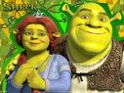

**TASGAU (Gwaith pâr)**

1. **Listen to the songs ‘Ugly’ by Sugababes and ‘Skater Boy’ by Avril Lavigne. What are the main messages?**

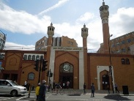In Britain, there are laws to protect people from discrimination. But many would say that discrimination still exists today. For example:

* Some places of worship do not allow everyone to pray in a religious building e.g some mosques in the

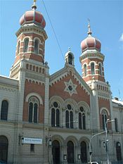country have refused women to worship in the building. They must worship at home.

* Another situation is in an Orthodox synagogue. It is expected for men and women to sit apart.
* Some people discriminate because of gender e.g men have a better chance of getting employed in a

powerful job rather than a woman.

Discrimination takes prejudice to the next level. This is prejudice in action. It happens when an individual or group of people receives less favourable treatment than others. Any form of discrimination - on grounds of race, gender, age – is now illegal in this country.

As a result, there are laws on equality and discrimination in Wales, England and Scotland. There are several laws that have been created to protect certain groups of people that are being discriminated against:

* Sex Discrimination Act (1975)
* Race Relations Act (1976)
* Disability Discrimination Act (1995)
* Equality Act (2010)

The Equality Act 2010 identifies that people should not be discriminated because of their:

* Age
* Being pregnant
* Race
* Religion
* Sex
* Being married

**2. Watch the Harry Potter clip 36:04-39:28. What is Mudblood? Why does Malfoy hate Mudbloods? Watch the second clip 1:01:21-1:08:03. What is the different between prejudice towards Parcelmouths and Mudbloods? Why did people react to Harry in this way?**

**3. Complete the table with specific examples.**

|  |  |
| --- | --- |
| **PREJUDICE**  **(Attitude)** | **DISCRIMINATION** (Action) |
| 1. ‘He won’t be able to do the job well because he is black.’ **2.**  **3.**  **4.**  **5.** | **1.** ‘I am not going to give him a job because he is black.’  **2.**  **3.**  **4.**  **5.** |

**4.What’s the difference between prejudice and discrimination?**

**5. Why treat others differently?**

Fear of people who are different in any way e.g. a gay person.

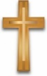**CHRISTIAN BELIEFS, TEACHINGS AND ATTITUDES TO**

**PREJUDICE AND DISCRIMINATION**

Christians teach that prejudice and discrimination are not acceptable. It goes against everything Christianity believes and teaches about God and for the value of all human life.

**TASKS - *Watch the clip:*** [***http://request.org.uk/issues/prejudice-and-christianity/***](http://request.org.uk/issues/prejudice-and-christianity/) to learn about the views of Christians about prejudice and discrimination.

Christians believe that God has created every human equal, whatever their race or gender.



There are several examples of fairness in the Bible. There are examples of Jesus healing and communicating with the outcasts of society. 'The Parable of the Good Samaritan' shows the importance of caring for everyone.



Jesus came across all kinds of prejudice. He dealt with everyone the same and broke several religious and social rules in doing so. Jesus healed everyone, every person deserved the same opportunity.



Many famous Christians like Martin Luther King and Desmond Tutu led many campaigns and non violent protests. The Ten Commandments, gives guidance on how people should live in harmony together.



The creation story (Genesis 1 and 2) shows that God created every person to be equal.



God has created people in His image, therefore people should respect others because we are all God’s children.



The Golden Rule – treat others the way you would like to be treated.



The Ten Commandments gives advice on living in harmony with others.



Jesus said to love your enemies and not to judge other people. We should think about our own faults first.



Jesus said ‘Love your neighbour’ - no matter who your neighbour is.



**The Parable of the Good Samaritan** [**https://www.bbc.com/bitesize/clips/zcyr87h**](https://www.bbc.com/bitesize/clips/zcyr87h)

**What happened? ________________________________________________________________________________**

**_____________________________________________________________________________________________________________________________________________________________________________________________________________________________________________________________________________________________**

**The message of the parable?**

Paul said in Galatians 3:28 ‘There is no difference between a Jew and Greek, slave and free person, men and women…we are all equal in the eyes of the Lord.’



**Meaning?**

**JEWISH BELIEFS, TEACHINGS AND ATTITUDES TO**



**PREJUDICE AND DISCRIMINATION**

God created people in His image; therefore, people should respect others because we are all Gods children.



The Golden Rule – treat others the way you would like to be treated.



The Ten Commandments gives advice on living in harmony with others.



It is a Mitzvot to find justice, show love and being kind towards others.



The Tenakh says that God wants His children to live in harmony with each other.



The creation story states that God created every person to be equal. They are equal in the eyes of God and should be treated so by other humans. Being ‘God’s chosen people’ does not mean that Jews are better than others.



The Jewish scriptures urge Jews to welcome strangers to their hearts. They remind Jews that they were strangers in the land of Israel at one time, and should not try to discriminate against those who ask for help.



Everyone should live in harmony with each other-***“‘When a foreigner resides among you in your land, do not mistreat them. The foreigner residing among you must be treated as your native-born. Love them as yourself, for you were foreigners in Egypt. I am the Lord your God...” Leviticus 19:33-34***



The Mishnah learns that the bond between human beings is so great that if you hurt one person you harm everyone in the world.



***“Therefore, humans were created singly, to teach you that whoever destroys a single soul (of Israel), Scripture accounts it as if (s)he had destroyed a full world; and whoever saves one soul of Israel, Scripture accounts it as if (s)he had saved a full world.”*** (Mishnah Sanhedrin 4.5)

**RACISM**

**Racism** is discriminating against people because of the colour of their skin or their race (religion). Racism is therefore one type of prejudice and discrimination.

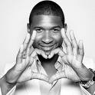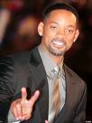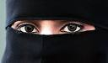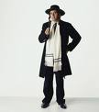

Usher Will Smith Muslim Jew

**Watch the Racism video clip. State your response below:**

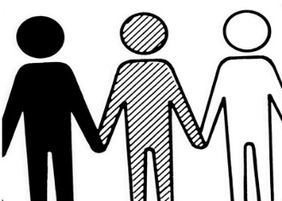

Since 1968, it has been illegal in the UK to discriminate against a person due to the colour of skin in four basic areas-

**Employment** **Education Housing Social Services**

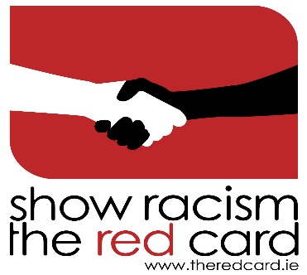

There are several campaigns and charities that have been battling and protesting to prevent prejudice from happening. One charity that is trying to do this is 'Show Racism the Red Card'. This is a campaign to stop racism from happening in football.

**TASK – Describe the work of the charity 'Show Racism the Red Card'.**

<http://www.theredcard.org/> <http://www.theredcard.org/wales>

**CHRISTIAN ATTITUDES TO PREJUDICE AND DISCRIMINATION BASED ON RACE**



**Martin Luther King Jnr**

A Christian who fought for justice and equality for black people is Martin Luther King Jr. **Below, write what he taught about equality.**

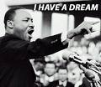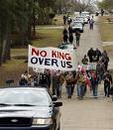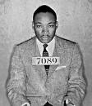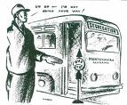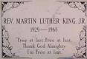

**JEWISH ATTITUDES TO PREJUDICE AND DISCRIMINATION BASED ON RACE**



**J-CORE**

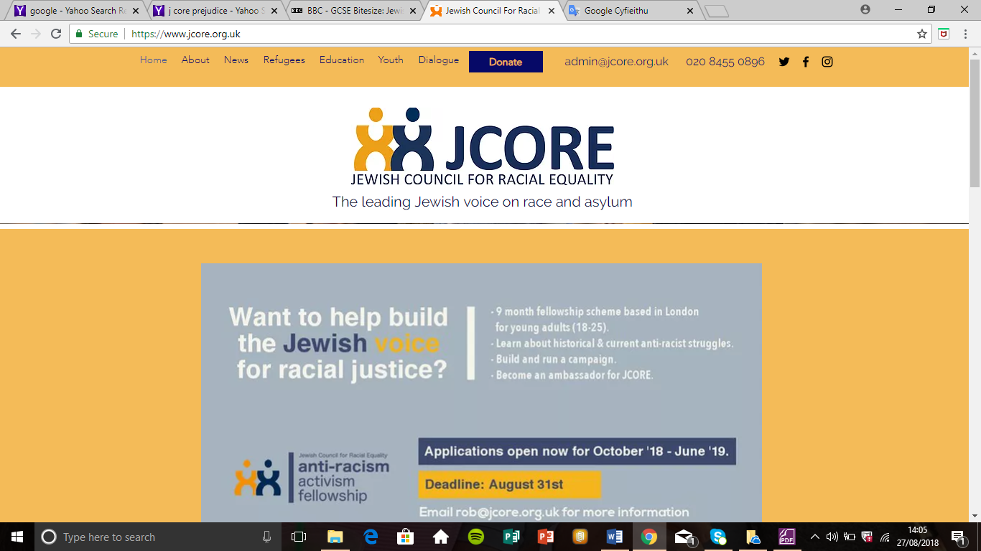

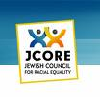

J - Core is the Jewish council for racial equality. This is the kind of work that the organisation does: -

# Produce resources for schools showing that racism is wrong.



Help refugees in Britain.



Teach others that racism is wrong.



Educate and advise doctors and solicitors.



Organise meetings between different people to discuss the problems and issues of racism e.g. Jews and black people.



Protest against racism and inequality.



Working with the government and the press to try to improve the situation of racism and inequality.



**TASK – Further research to the work of J-Core.**

**Use the website :** [**https://www.jcore.org.uk/**](https://www.jcore.org.uk/)

**ISSUES OF WEALTH AND POVERTY**





**ISSUES OF WEALTH**

A-Z of Religions – Wealth

https://www.facebook.com/Upworthy/videos/2338225686218276/UzpfSTU1MDIyNzcwNDpWSzo2ODk5MjE5MDc4NDUwNzA/

* The people of Wales have £400 billion between them.
* 16% of them have half of it.
* The richest 10% have 40% of the nation’s wealth.
* The richest half of the population has 90% of the wealth.
* Nearly a ¼ of Welsh people live in relative poverty, earning less than 60% of average income.
* The poverty rate in Wales is the highest of all the UK countries.

The above statistics show that wealth is not spread out evenly across Wales, (and the UK). Some people are richer that others. People get their wealth by:

* Working for a business and receive income. Some jobs have high salaries e.g sports stars, TV presenters.
* Start their own business.
* Inherit wealth.
* Criminal means e.g burglary, fraud.
* Gambling

Britain is often described as being a materialistic society, which values money and possessions more than spiritual values. Newspaper headlines often describe people queuing to buy the latest mobile phone or shop sales.

According to figures by ‘Charities Aid Foundation’, the UK was Europe’s most generous nation in terms of giving to charity. In 2015, 75% of UK adults donated to charity, compared to a worldwide average of 31.5%. People might give their wealth to help family and friends e.g many parents help their children to buy a home.

|  |  |
| --- | --- |
| **What it means to be rich…** | **What it means to be poor …** |
|  |  |

**TASK -** You have won the lottery; discuss how you would spend the money.

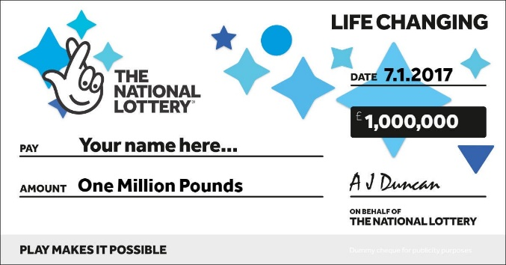

**Discuss- Does money bring happiness?**

**POVERTY**

Poverty is another type of injustice. Religious believers help people who are in need in different ways. How do people suffer from poverty in Wales and developing countries? Complete the table below:

|  |  |
| --- | --- |
| **Poverty in Wales** | **Poverty in developing countries** |
| 1. Drugs  2.  3.  4.  5.  6. | 1. Famine  2.  3.  4.  5.  6. |

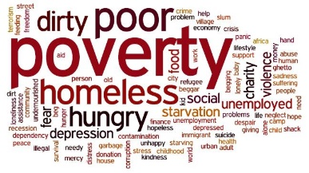

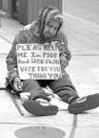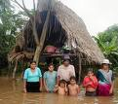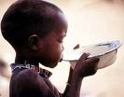

The term poverty is normally to refer to someone who is living in extreme circumstances. This is likely to be because they have little money.

**What does being poor mean to you?**

**What does being poor mean to others?**

There are two levels of poverty:

**ABSOLUTE POVERTY:** It usually incudes having no access to basic services such as medicine or shelter. www.youtube.com/watch?v=igZakJ--3qI

**RELATIVE POVERTY: A** level of income below the majority of one particular country.

https://www.facebook.com/Channel4News/videos/10155073634566939/UzpfSTU5NTEzNjA0MzpWSzoxMzk3NDAzMDMzNjMwODIx/?query=poverty

**Place the ideas on the line and explain why these people should help more than others.**

**Charities**

**Poor people need should help themselves**

**The top 10 richest people in the world**

People

**Me**

**Religious People**

**Whose responsibility is it to help?**

Cyfrifoldeb pwy yw i helpu?

**The Government**

Disagree

Agree

**CHRISTIAN ATTITUDES TO THE USE OF WEALTH**

Jesus taught that wealth does not make people happy and can lead to greed.



In Mathew 6, Jesus warns his disciples that money can take the place of God in their lives and they must stay faithful to him. When a rich ruler wanted to follow Jesus, he was told to sell his possessions and give his money to the poor.



Today, some religious believers take a vow of poverty and give up everything they posses e.g a monk, nun.



Many Christians are against gambling as it encourages love of money and greed. Quakers and Methodists are against gambling as it leads to greed.



Christianity does not state which job is allowed or not allowed, it’s a personal choice but they must assess if it’s harming or helping others. **Important jobs such as …**



Being wealthy is not necessarily bad or wrong, but there are ethical considerations about how Christians gain wealth and how it’s used.



Christianity teaches that a person’s value should be judged by their actions, and not by what they possess or how much money they have **for example ….**



According to the Bible we should not worry about money.



The Bible says that we should share our wealth with others.



Material wealth is not the most important thing in life e.g. car, mobile phone.



It is a duty to give money to **charities e.g?**



Money should not be made unfairly e.g. gambling or being dishonest.



Not to love money or be greedy.



Anghytuno

**CHRISTIAN ATTITUDES TO POVERTY**

Jesus said – share with others.



Paul said ‘Love thy neighbour as yourself.’



Paul said – Love is kind, and should last forever …



God created everyone equal.



According to Christians, everyone has a responsibility to care for others in need.



Jesus mixed with the poor e.g he healed people for example the blind man.



The golden rule – treat people the way you would like to be treated.



Jesus taught that God would punish those who neglect the poor. In the Parable of the Rich Man and Lazarus, the rich man ended up in hell because he did not help a poor person.



The Parable of the Sheep and the Goats teaches that God will judge people, not on how much wealth they have gained but on their treatment of the poor.



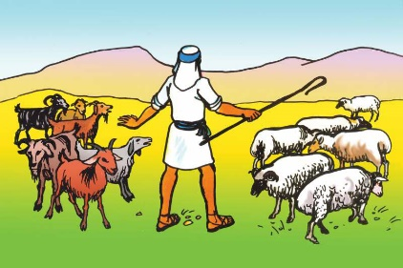

**CHRISTIAN ACTIONS / CHARITIES TO ALLEVIATE POVERTY**



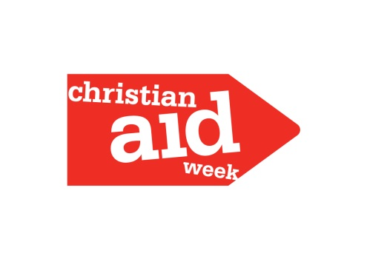**CHRISTIAN AID**

Christian Aid is a charity working in partnership with local organisations in over 60 countries outside the UK to help those in need regardless of religion, ethnicity or nationality. It aims to stop poverty and challenge systems that favour the rich over the poor.

* Belief in God who loves all human life.
* Love: A belief that Christians are called to love and care for their fellow human beings - being compassionate, standing against those who are struggling.
* Dignity and respect: Every human has dignity. All people are equal which is why honesty and respect for others are so important.
* Justice and equality: An understanding where people lack power, poverty remains, so charitable work empowers individuals and communities.
* Cooperation and partnership: Work is rooted in a spirit of cooperation and the value of acting in partnership with others.
* Stewardship: A commitment to being accountable for making the best use of resources, for effective stewardship of the planets resources.

**TASK – Watch** <https://www.youtube.com/watch?v=WH1AjYwJwHA>

**https://www.youtube.com/watch?v=WH1AjYwJwHA&fbclid=IwAR1h58Z1RjyqsxEUvpgaKhI40_Z61sAgFCt_szopN33kaW12kTDQiznCgTg**

1. **Recall information – Note below further examples of the work of Christian Aid to alleviate poverty.**

**FOOD BANKS (CHRISTIAN CHURCHES)**

1. **TASK - Recall information from Year 10 – Note below further examples how christian churches contribute to alleviate poverty.**

**JEWISH ATTITUDES TO THE USE OF WEALTH**

Judaism teaches that humans are in control of wealth for God.



It is not considered wrong to be rich, but what is important is how you earn and use your wealth.



Work is considered an important part of Jewish life but it is also important that Orthodox Jews recognise Shabbat, on which no work is done.



The work permitted for Jews depend on how far they fit with the teachings of the Torah e.g keep Kashrut.



It is important for many Jews that the laws of Kashrut are kept so they would not work in factories where they would have to handle pork products.



It is forbidden to be dishonest or cheat in any business transaction. “When you sell, or buy (property) from your neighbour, do not cheat one another”. (Leviticus 25.14)



Being honest in business dealings is important and is judeged by God.



Jews are against material wealth e.g. car and mobile phone.



Not to be greedy when it comes to money.



To be careful with money and be able to look after and provide for your family.



Wealth can create a distance between a person and God.



To use wealth sensibly and to care for others in the community.



Jews believe that they should give 10% of their wages / wealth to a charity.



**JEWISH ACTIONS – CHARITIES THAT ALLEVIATE POVERTY**



Tzedakah is the Hebrew word for justice.



The belief or giving money to those in need is not only a duty but also a right of the poor to receive.



Rabbis emphasise the need to ensure that the dignity of the poor person is maintained when charity is given.



The guidelines for giving tzedakah vary from each community.



The general guideline is that all Jews should give 1/10 of their income to charity.



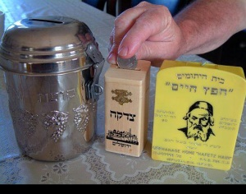The receiving of charity can include synagogue, educational insitiuation or organistation.



At most Jewish festivals, contributions are made to charity.



Most Jewish families have a **pushke** box in which money is donated at Shabbat.



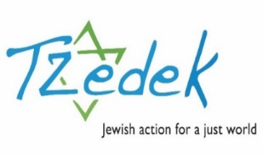

**TZEDEK**

It works to reduce absolute poverty and care for those involved in national disasters.



Tzedek seeks solutions not just by giving charity but by seeking to increase social justice in the world.



***’When a man leaves the world, neither silver nor gold nor precious stones, nor pearls to accompany him, but only the Torah he has learnt and the good works he has carried out.’ (Mishnah)***



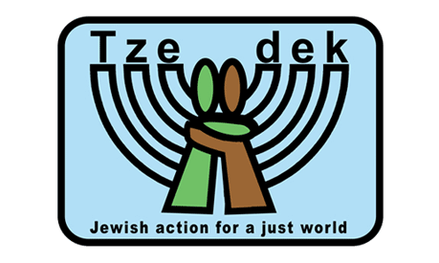

**Many Jewish values are reflected through the work of Tzedek:**

Ahavatah et HaGer (You shall love the stranger) – Jewish traditions teach that the world should be inclusive. The work Tzedek does stretch beyond racial or religious boundraies.



Naaseh v’nishma (We will do and we will understand) - Awareness knowledge and learning lead to deeper commitments and actions. Tzedek raises awareness of social injustices through school and education programmes.



**MAIMONIDES EIGHT LEVELS OF CHARITY**

In the Mishnah Torah, Maimonides identified eight levels of charity. These are still relevant today:

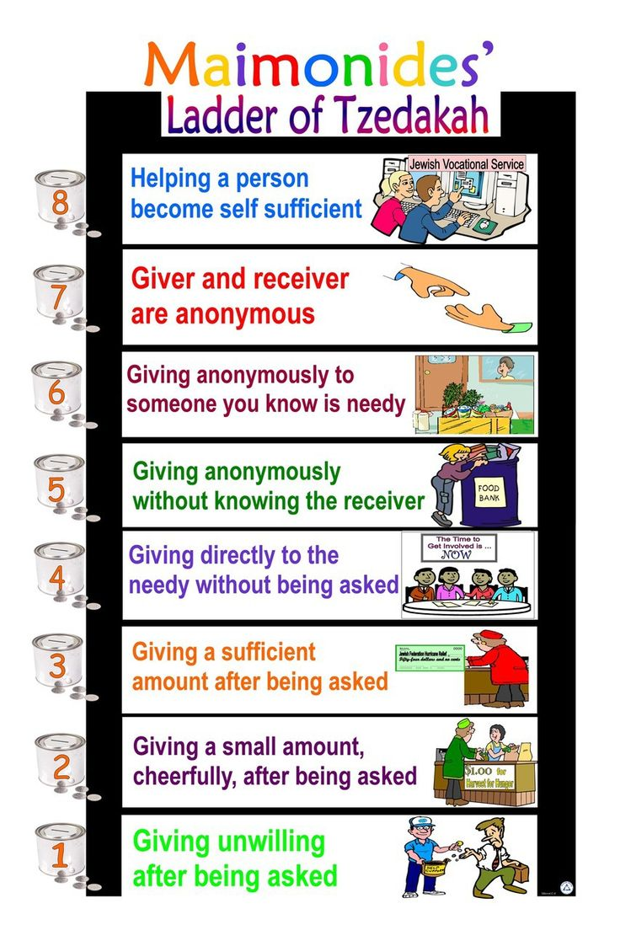**Note next to each level if you believe they are relevant today or not.**

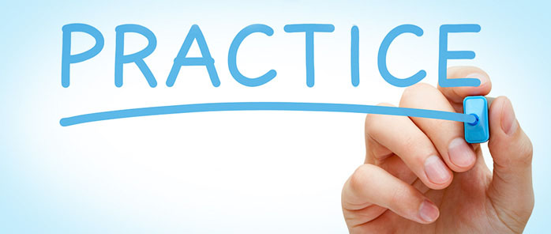

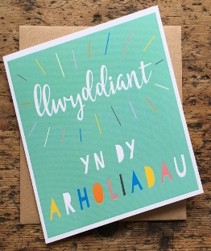

**HOMEWORK**

**Gwaith Cartref**

**Key concepts – Explain the meaning of the key terms in a way that will help you remember them.**

|  |  |  |
| --- | --- | --- |
| **TERM** | **MEANING** | **SYMBOL/COLOUR/LOGO** |
| **DISCRIMINATION** |  |  |
| **EXTREMISM** |  |  |
| **HUMAN RIGHTS** |  |  |
| **PERSONAL CONVICTION** |  |  |
| **PREJUDICE** |  |  |
| **RELATIVE AND ABSOLUTE POVERTY** |  |  |
| **SOCIAL JUSTICE** |  |  |
| **DISCRIMINATION** |  |  |
| **EXTREMISM** |  |  |

**SUCCES CRITERIA FOR QUESTION A:**

**1. What is meant by censorship? (2)** ________________________________________________________________________________________________________________________________________________________________________________________________________________________________

**SUCCES CRITERIA FOR QUESTION B:**

**B) Describe religious teachings about respecting others. (5)**

________________________________________________________________________________________________________________________________________________________________________________________________________________________________________________________________________________________________________________________________________________________________________________________________________________

|  |  |  |
| --- | --- | --- |
| **Mark** | **(*) (?) agiant the success criteria** | **Teacher comments** |
|  |  |  |

**Self-assessment**

**SUCCES CRITERIA FOR QUESTION C:**

**Explain the attitudes and use of wealth in Christianity and Judaism. (8)**

__________________________________________________________________________________________________________________________________________________________________________________________________________________________________________________________________________________________________________________________________________________________________________________________________________________________________________________________________

________________________________________________________________________________________________________________________________________________________________________________________________________

________________________________________________________________________________________________________________________________________________________________________________________________________

________________________________________________________________________________________________________________________________________________________________________________________________________

**“It is important for all people to work for social justice.”** Discuss the statement showing that you have considered more than one point of view. (You must refer to religion and belief in your answer). [15]

**SUCCES CRITERIA FOR QUESTION D:**

.......................................................................................................................................................................................................................................................................

........................................................................................................................................................................................................................................................................

........................................................................................................................................................................................................................................................................

........................................................................................................................................................................................................................................................................

........................................................................................................................................................................................................................................................................

........................................................................................................................................................................................................................................................................

...................................................................................................................................

........................................................................................................................................................................................................................................................................

........................................................................................................................................................................................................................................................................

.......................................................................................................................................................................................................................................................................

....................................................................................................................................

........................................................................................................................................................................................................................................................................

........................................................................................................................................................................................................................................................................

........................................................................................................................................................................................................................................................................

........................................................................................................................................................................................................................................................................

........................................................................................................................................................................................................................................................................

........................................................................................................................................................................................................................................................................

.......................................................................................................................................................................................................................................................................

....................................................................................................................................

........................................................................................................................................................................................................................................................................

........................................................................................................................................................................................................................................................................

........................................................................................................................................................................................................................................................................

........................................................................................................................................................................................................................................................................

........................................................................................................................................................................................................................................................................

....................................................................................................................................

|  |  |  |  |
| --- | --- | --- | --- |
| **MARKED BY** | **MARK/BAND** | **(*)** | **(?)** |
| **PEER/SELF** |  |  |  |
| **TEACHER** |  |  |  |

**Self-evaluation of the unit ­­– Human Rights**

* **Do you know your target?**
* **Test result for this unit? % Grade:**
* **Are you on track?**
* **If not, why?**
* **Do you have regular homework?**
* **Are you aware of the success criteria to some questions?**
* **Have you had the opportunity to self-assess/peer-assess work during this unit?**

**Standard of your work – be specific!**

|  |  |
| --- | --- |
| **Happy with** | **Difficulty with** |
|  |  |

**Teacher’s response:**