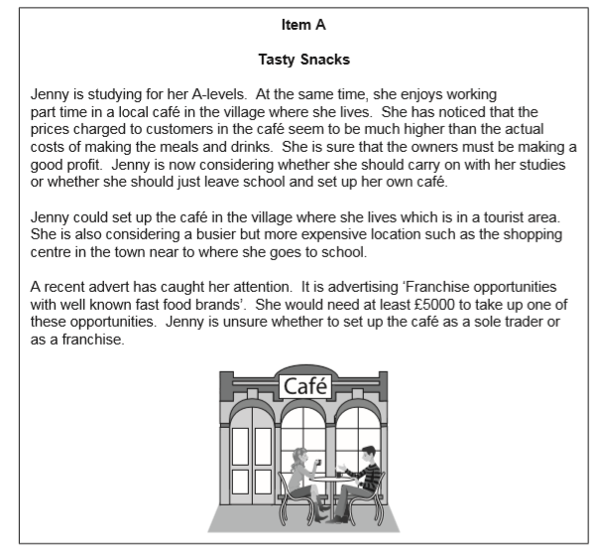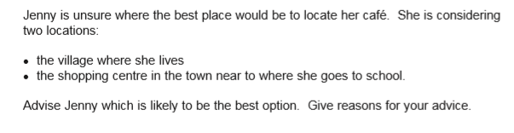

**Developing Literacy Skills - Structure Strips**