TEACHER:
NAME:
The Elizabethan Age
1558-1603

Booklet 1
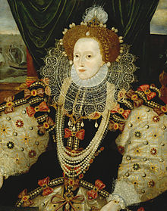

Date marked | Comment
Elizabethan Government
Key Question 1
How successful was the government of Elizabeth 1?

Task 1: Look at the Tudor family tree. Answer the questions.
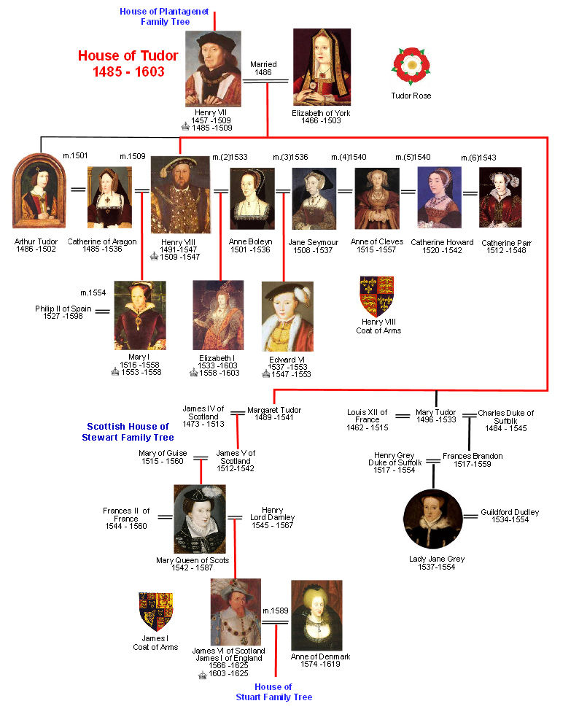

Who was Elizabeth’s mother?

When was Elizbeth born?

How old was Elizabeth when she became queen?

Look at the diagram.
Textbook p10 -11

Some information is missing. Complete the table below

Officers of the Privy Council

Secretary of State
Comptroller of the Household
Lord High Admiral
Lord treasurer

Lord Chamberlain
Chancellor of the Duchy Lancaster
Keeper of the Great Seal
Vice-Chamberlain

Task: Complete the table about the important Privy Councillors in Elizabeth’s reign
Textbook p12 -13

 | Title | Religion | Date when appointed | Position(s) held | Example of work
William Cecil
Robert Dudley
Christopher Hatton
Francis Walsingham
Robert Devereux
Robert Cecil

Task: Outlie the key features of the Justice of the Peace and Parish Constable

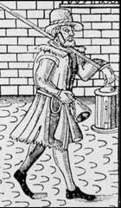

Task: Complete the table about parliament

Parliament | Date of sessions | Reasons for calling parliament
1559
1563-67
1571
1572-82
1584-85
1586-87
1589
1593
1597-98
1601

https://www.bbc.com/education/guides/zppbtv4/test

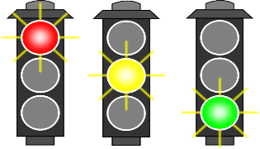

Self assess your progress

Lifestyle of the rich and poor
Key Question 2
How did life differ for the rich and poor in Elizabethan times?

Textbook p23 onwards

Task 1 – Explain the meaning of the following key words/events:
Labouring Poor
........................................................................................................…………………….…..................................................................................................................................................................................................................................................................................................................................................................................................................................................................................................................................................................................................................................………………………............................
Dissolution of the Monasteries
........................................................................................................…………………….…..................................................................................................................................................................................................................................................................................................................................................................................................................................................................................................................................................................................................................................………………………...............................................................................................................................…………………….….........................................................................................................................................
Dowry
.......................................................................................................…………………….….................................................................................................................................................................................................................................................................................................................................................................................................................
Wattle and daub
.............................................................................................................................................................................................................................................…………………….…........................................................................................................................................................................................................................................................................................................................................................................................................................................................................................................................................................
Vagabonds
.............................................................................................................................................................................................................................................…………………….…..........................................................................................................................................................................................................................................................................

Task 2:
Read the following sources and information, fill in the Venn diagram illustrating the structure of society – similarities and differences
Source 1

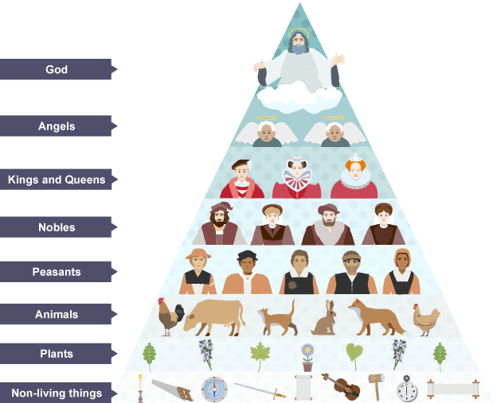

Source 2 from the Road to Wigan Pier, written by George Orwell in 1937
The means test breaks up families. An old age pensioner would usually live with one of his children. Under the means test, he counts as a ‘lodger’ and his children’s dole will be cut.

Source 3 From an account written by the mayor of Jarrow in 1936
A campaign was started by the Labour Party to send a petition. Then it was decided to march with the petition. I opposed the decisions. There were hunger marches going on all over and I didn’t want to embarrass and put down the men. I eventually had to agree, and I marched to Darlington with some of the men. I managed to get time off from Spiller’s’ in Newcastle. Communists wanted to join us on the march, but we wouldn’t let them.

Source 4 From a letter published in the Western Mail in 1936
Today you [King Edward VIII] will be visiting the towns and villages of our valleys, and a valley blighted by the dead hand of poverty. We regret that your tour has been planned in such a way that the terrible effects if this poverty will not be seen.

Life for the bottom 20 to 30 per cent of the population was very hard, with many constantly on the edge of starvation. It was made worse during this period by rising prices, poor harvests and unemployment.

Increase in wealth
Many nobles and merchants increased their wealth during this period.
- Many had bought land during Henry VIII's dissolution of the monasteries.
- The expansion of overseas trade in Europe and beyond.
- Investment in trading companies.
- The granting of monopolies.
- Profits from the sale of wool.
Homes
- The rich were keen to show off their wealth and social status. As a result of this wealth and the fact that times were more peaceful, they began to build and live in grand stately homes. The dissolution of the monasteries had freed up large areas of land for the rich. The money to build these houses often came from rents paid for land.
- It was labelled 'the age of the great rebuild' which was partly fuelled by the Queen's progresses, creating a desire amongst the wealthy to show houses at their best. These stately homes had many rooms and great care was taken over decoration.
- They were distinguished by having many windows (an expensive luxury), ornate woodwork and rich tapestries. Rich people had more leisure time and grand landscaped gardens were designed.
- Some were styled in the shape of the letter ‘E’ or ‘H’, symmetrical in pattern. Famous examples of Elizabethan stately homes are Longleat House, Hardwick Hall and Burghley House.

Clothing and fashion
- Clothes also varied a great deal between rich and poor. Rich Elizabethans would buy expensive clothes made from luxurious materials. Fashion was very important at the Royal Court and courtiers would often spend vast amounts on their clothes.
- For the middle classes, fashion was measured more in the quality of the cloth, rather than in the cut or the colour. The clothes you wore reflected your social status. Sumptuary Laws were passed to make sure that people did not wear clothes above their social rank.

Education
- Children of nobility were often taught by tutors at home. Boys from the lesser gentry from 7 to 14 years old often attended grammar schools, before university in Oxford, Cambridge or London.
Lifestyle of the poor
- Life for the poor was very difficult. The labourers, who made up the majority of the population, still lived in little more than one-roomed, single-storeyed huts. The design of these had changed little since medieval times. They were usually filled with smoke, with open windows and a pot over the fire for cooking.
- These houses would be sparsely furnished, maybe just a bed, table and a few stools. Those who were able to, for example skilled craftsmen or small farmers, might accumulate enough money to build a more permanent house.
- The working day for tenant farmers and labourers would be long – from around 05:00 to 17:00. The relatively few clothes owned by the poor would be practical, as opposed to fashionable. Life expectancy was low and many children did not live beyond the age of five. These people lived in considerable poverty.
- Poverty was one of the major problems Elizabeth faced during her reign. During this period the number of unemployed people grew considerably for a range of reasons. Attitudes towards poverty were also different from today with many believing the unemployed were just too lazy to find work. There was also only a very limited system of welfare to help those in need.

Increase in poverty
- A wide range of factors led to the increase in poverty during this period. Twenty years before Elizabeth’s reign, Henry VIII had dissolved the monasteries.
- This did not help as not only were monks and nuns’ servants dismissed, but the poor had nowhere to go for occasional shelter. From the mid-1500s on the following factors contributed greatly to the problem of poverty.

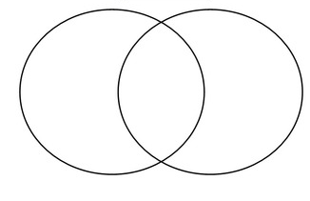
Venn Diagram – Rich and Poor

Task: Complete the table about Government legislation
Year | Act | Key Details | Impact upon vagrancy
1563
1572
1576
1598
1598
1601

Tas: Answer these questions:
Explain the difference between ‘impotent poor’ and ‘able-bodied’ poor
........................................................................................................…………………….…..................................................................................................................................................................................................................................................................................................................................................................................................................................................................................................................................................................................................................................………………………...........................---------------------------------------------------------------------------------------------------------------------------------------------------------------------------------------------------------------------------------.
Explain why most members of the lower classes received little education?
........................................................................................................…………………….…..................................................................................................................................................................................................................................................................................................................................................................................................................................................................................................................................................................................................................................………………………...............................................................................................................................…………………….….............................................................................................................................................................................................................................................................................................................................................................................................................................................................................................................................................................

Explain how the gentry continue to remain rich?
........................................................................................................…………………….…..................................................................................................................................................................................................................................................................................................................................................................................................................................................................................................................................................................................................................................………………………...........................---------------------------------------------------------------------------------------------------------------------------------------------------------------------------------------------------------------------------------.
How did Robert Wynn demonstrate his wealth and status as a member of the Welsh gentry class?
........................................................................................................…………………….…..................................................................................................................................................................................................................................................................................................................................................................................................................................................................................................................................................................................................................................………………………...............................................................................................................................…………………….….............................................................................................................................................................................................................................................................................................................................................................................................................................................................................................................................................................

Popular Entertainment
Key Question 3
What were the most popular types of entertainment I Elizabethan times?

Source A – A woodcut showing bear-baiting in action c1620
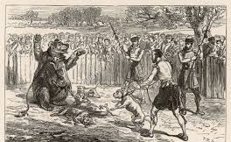

Source B – In 1598, Paul Hentzer. A German visiting England reported seeing a blinded bear being attacked by group of six men for popular entertainment.
The bear cannot escape from the because of the chain’ he defends himself with all his force and skill, throwing down all who come within his reach….and tearing the whips out of their hands and breaking them.

What can be learnt from sources A and B about cruel sports during Elizabethan times?
........................................................................................................…………………….…..................................................................................................................................................................................................................................................................................................................................................................................................................................................................................................................................................................................................................................………………………...............................................................................................................................…………………….….............................................................................................................................................................................................................................................................................................................................................................................................................................................................................................................................................................
Textbook p46-47
Task 2: Under the headings get notes on the following:

Hunting & Hawking | Archery | Music & Singing
Dancing | Ball Games | The Cnapan

Theatre
Textbook p48-53
Task: Read the textbook pages and complete the table below
Arguments supporting the theatre | Arguments against the theatre
The Problem of Religion
Key Question 4
How successfully did Elizabeth deal with the problem of religion?

Source B – Extract from the Act of Uniformity 1559
All and every person and persons inhabiting within this realm…shall diligently and faithfully, having no lawful or reasonable excuse to be absent, endeavour themselves to resort to their parish church or chapel accustomed….upon every Sunday and other [religious days] …upon pain that every person so offending shall forfeit for every such offence twelve pence to e [collected] by the church wardens of the Parish ….

Source A – Extract from the Act of Supremacy
All and every Archbishop, Bishop and all and very other cleric … and all and every judge, justice, mayor, and every other lay or officer and minister and every other person having Your Highness’s fee or wage shall make a[n] oath…
…I…do utterly testify and declare in my conscience that the Queen’s Highness is the only Supreme Governor of this realm and …that no foreign prince, person, bishop …hath or ought to have any jurisdiction, power, superiority, or[authority over religion or state matters within the realm].

What can be learnt from sources A and B about the Religious Settlement of 1559?
........................................................................................................…………………….…..................................................................................................................................................................................................................................................................................................................................................................................................................................................................................................................................................................................................................................………………………...............................................................................................................................…………………….…............................................................................................................................................................................................................................................................................................................................................................................................................................................................................................................................................................
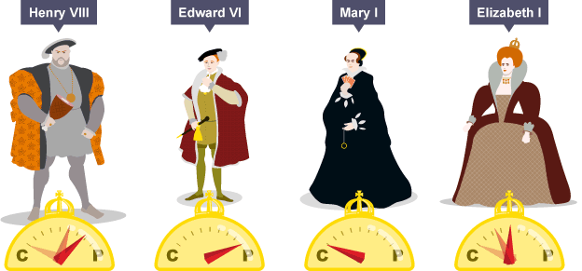

The Act of Supremacy 1559
This required all clergymen and government officers to take an Oath of Supremacy. By this they were to swear that they would accept Elizabeth as Supreme Governor of the Church.
By using the term 'governor' it was hoped that Catholics would be appeased since they could still consider the Pope to be head of the Church. Those who refused to swear the oath could be imprisoned or even executed if they refused three times.

The Act of Uniformity 1559
This laid down the rules about religious services which were to be carried out in churches throughout Wales and England. It said that the newly formed Prayer Book, based on that of Edward’s reign should be used in all churches and that people would be fined one shilling if they did not attend. People who refused to attend Church services were called recusants.

Summarise the Act of Supremacy in one sentence:
--------------------------------------------------------------------------------------------------------------------------------------------------------------------------------------------------------------------------------
Summarise the Act of Uniformity in one sentence:
-------------------------------------------------------------------------------------------------------------------------------------------------------------------------------------------------------------------------------
What Catholics believed | Elizabeth's Religious Settlement | What Protestants believed
Church should be ruled by a strict hierarchy of the Pope, then Cardinals, then Archbishops etc. | Queen would rule as Supreme Governor supported by bishops. | There should be no Pope or bishops.
The most important ceremony is the Mass. | There should be no Mass. | There should be no Mass.
Services and Prayer Book should be in Latin. | Services and Prayer Book would be in English. | Services and Prayer Book should be in the native language.
Churches should be highly decorated and services full of ceremony. | Churches should be decorated and some ceremonies allowed. | Churches and services should be plain.
Priests should wear bright robes and not marry. | All clergy were to wear clerical dress and a white linen gown and not marry. | Plain robes should be worn by churchmen and they should be allowed to marry.
Saints should receive special prayers. | Saints should receive no special prayers. | Saints were unimportant.

Create your own questions about the differences between Catholic and Protestants.

1.

2.

3.

Bishop William Morgan
During the 1570s, a young cleric, William Morgan, began work on translating the Old Testament from Hebrew into Welsh. Most of his work was undertaken whilst he was vicar of Llanrhaeadr-ym-Mochnant and took almost 20 years.

The impact of the translation on Wales and the Welsh language
Salesbury’s translation, whilst important, had been relatively difficult to read. Morgan however, wrote in a more accessible style which was closer to spoken Welsh.
This made his translation extremely important to the Welsh people and to Elizabeth. It helped Elizabeth as many Welsh people now became loyal Protestant subjects of the Queen. Of even greater importance was the translation’s cultural significance.
The translation of the Bible gave great prominence to the Welsh language, to the extent that it served to preserve the Welsh language, culture and tradition. Welsh congregations could understand what was being read to them and this served to reinforce their religious devotion. In all, the translation:
- saved the Welsh language from decline
- enabled Welsh congregations to understand the Scriptures
- secured the Protestant Reformation in Wales and ensured the Welsh were loyal to Elizabeth
- encouraged the development of Welsh literature

Why was the translation of the bible into Welsh significant?
------------------------------------------------------------------------------------------------------------------------------------------------------------------------------------------------------------------------------------------------------------------------------------------------------------------------------------------------------------------------------------------------------------------------------------------------------------------------------------------------------------------------------------------------------------------------------------------------------------------------------------------------------------------------------------------------------------------------------------------------------------------------------------------------------------------------------------------------------------------------------------------------------------------------------------------------------------------------------------------------------------------------------------------------
The Catholic Threat
Key Question 5
Why were the Catholics such a serious threat to Elizabeth?

https://www.bbc.com/education/guides/zpy9fcw/test

Task: Complete the timelines

Task: Mary, queen of Scots
Textbook Page 69 -onwards
Read the textbook page and create a fact file/ information page on Mary Queen of Scots

Catholic Plots

Task: Collect information about the different Catholic plots and complete the table:

Name of plot | Outline | Reasons why failed | What happened to the plotters | How serious was the threat?
Ridolfi
Throckmorton
Babington

Task: Connection the three Catholic Plots together

The Spanish Armada
Key Question 6
How much of a threat was the Spanish Armada?

Textbook Page 82 onwards

Who was Philip II?
........................................................................................................…………………….…..........................................................................................................................................................................................................................................................................
What he is connection to Elizabeth?
........................................................................................................…………………….…...................................................................................................................................
Why is Philip upset with Elizabeth?
…………………………………………………………………………………………………………………………………………………………………………………………………………………………………………………………………………………………………………………………………………………………………………………………………………………………………………………………………………………………………………….
Who is Sir Francis Drake?
……………………………………………………………………………………………………………………………………………………………………………………………………………………………………………………………………………………………………………………………………………………………………………………………………………………………………………………………………………………………………………
Task: Add the captions for the images
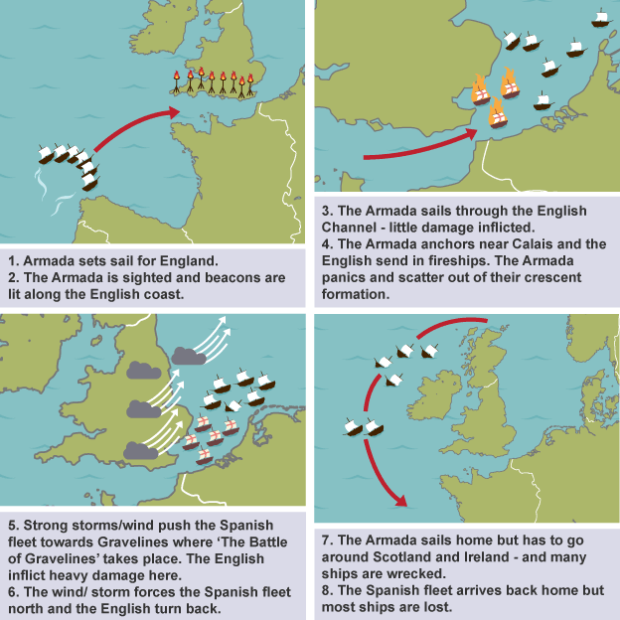

Task: The Spanish Armada Dates

- 28th May 1588

- 21st July 1588

- 7th August 1588

- 8th August 1588

- 9th August 1588

Bullet point the man reasons for the Spanish Armada

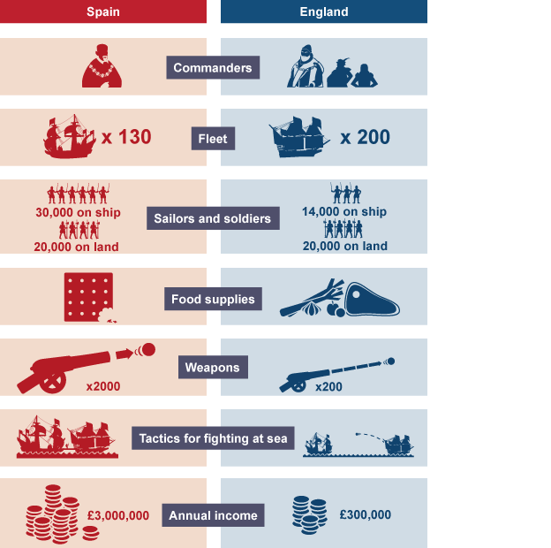

Strengths of the Armada | Weaknesses of the Armada

Annotate the Source
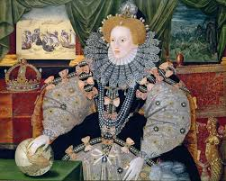

Task: Try to connect these four factors together. Use the worksheet to help you.
Philip II / Duke of Medina Sidonia / The Netherlands / Calais

The Puritan Threat
Key Question 7
Why did the Puritan become an increasing threat during Elizabeth’s reign?

What are:
A Moderate Puritan?
----------------------------------------------------------------------------------------------------------------------------------------------------------------------------------------------------------------------------------------------------------------------------------------------------------------------------------------------------------------------------------------------------------------------------------------------------------------
Presbyterians?
-------------------------------------------------------------------------------------------------------------------------------------------------------------------------------------------------------------------------------------------------------------------------------------------------------------------------------------------------------------------------------------------------------------------------------------------------------------------------------------------------------------------------------------------------------------------------------
Separatists?
------------------------------------------------------------------------------------------------------------------------------------------------------------------------------------------------------------------------------------------------------------------------------------------------------------------------------------------------------------------------------------------------------------------------------------------------------------------

Task: Complete the Table using textbook to help you

Puritan Challenger | Threat it posed to Elizabeth’s authority as supreme governor | Elizabeth’s response
Vestments Controversy

Thomas Cartwright

John Stubbs

Marprelate Tracts

What did John Writgift do?
………………………………………………………………………………………………………………………………………………………………………………………………………………………………………………………………………………………………………

What did Edmund Gridal so?
…………………………………………………………………………………………………………………………………………………………………………………………………………………………………………………………………………………………………………………………………………………………………………………………………………

Summarise Key question 7
How much of a treat were the Puritan movement?
Consider the following:
- Reforms demanded by Puritan MPS
- Writings by Puritan authors
- Presbyterian movement
- Separatist movement

