TEACHER:
NAME:
Radicalism and Protest,
1810 – 1848

Booklet 1
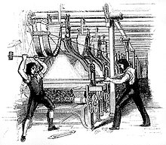

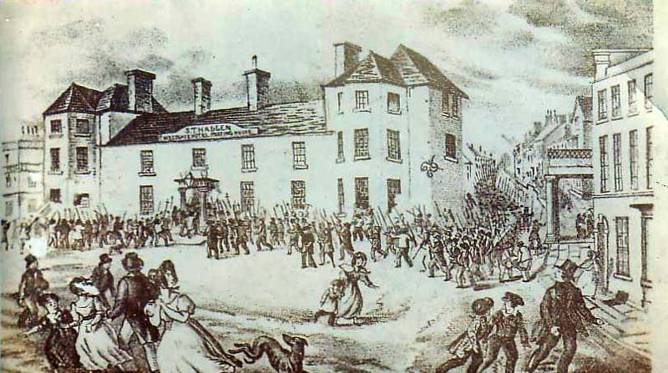

Date marked | Comment
Napoleonic Wars
Key Question 1: What were the main pressures facing the country c.1810?

Task 1: Look at the image. Create a fact file on Thomas Paine.

Name:
Date of Birth:
Place of birth:
Publication:
Beliefs:

WJEC Booklet p1

Read the following pages of the WJEC booklet called Radicalism and Protest and complete the boxes.
French Revolution and its influence

Radical ideas, Key people

London Corresponding Society

Task: Complete the boxes with information
WJEC Booklet page 2

Impact of war on the economy

Demobilised soldiers

The Corn Laws

Task: Mind map around the people about why they could and couldn’t vote

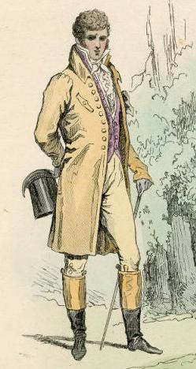

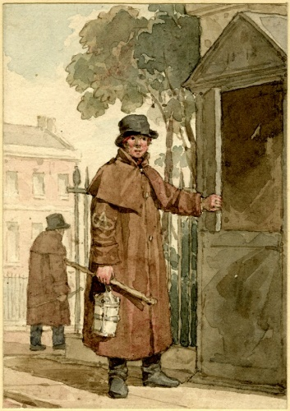

Task: Complete the timeline of events
WJEC Booklet page 4

1750
1830
Manchester
1830
Old Sarum
1830
Liverpool

Task: Next to each man write at least 2 things about them:

Major John Cartwright

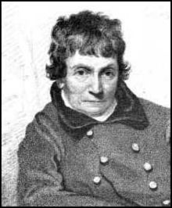

Henry (Orator) Hunt
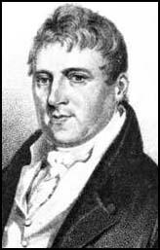

William Cobbett
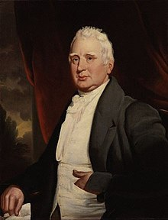

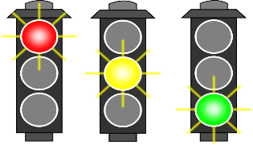

Self assess your progress

Early outbreaks of protest
Key Question 2: What were the most significant protests in the period 1810-1832?

WJEC booklet p 6 onwards

Task 1 – Complete the causes and consequence diagram

Main Causes

Task: Complete the storyboard about the Luddites
Task:
Why was ‘Orator’ Hunt important in the Radical Movement? [12]
........................................................................................................…………………….…..................................................................................................................................................................................................................................................................................................................................................................................................................................................................................................................................................................................................................................………………………...........................---------------------------------------------------------------------------------------------------------------------------------------------------------------------------------------------------------------------------------.
........................................................................................................…………………….…..................................................................................................................................................................................................................................................................................................................................................................................................................................................................................................................................................................................................................................………………………...............................................................................................................................…………………….….............................................................................................................................................................................................................................................................................................................................................................................................................................................................................................................................................................
........................................................................................................…………………….….................................................................................................................................................................................................................................................................................................................................................................................................................
Government Reaction
Key Question 3
How did the government react to popular protest at this time?

WJEC booklet p 11 onwards

Task: Read the information:
Answer these questions:
Explain the impact the French Revolution had on people.
........................................................................................................…………………….…..................................................................................................................................................................................................................................................................................................................................................................................................................................................................................................................................................................................................................................………………………...........................---------------------------------------------------------------------------------------------------------------------------------------------------------------------------------------------------------------------------------.
Who are the Agent Provocateurs?
........................................................................................................…………………….…..................................................................................................................................................................................................................................................................................................................................................................................................................................................................................................................................................................................................................................………………………...............................................................................................................................…………………….…..

Who was the most famous spy?
........................................................................................................…………………….
What was he involved in?
…..................................................................................................................................................................................................................................................................................................................................................................................................................................................................................................................................................................................................................................………………………...........................---------------------------------------------------------------------------------------------------------------------------------------------------------------------------------------------------------------------------------.
What was the Habeas Corpus Act?
........................................................................................................…………………….…..................................................................................................................................................................................................................................................................................................................................................................................................................................................................................................................................................................................................................................………………………...............................................................................................................................…………………….….............................................................................................................................................................................................................................................................................................................................................................................................................................................................................................................................................................

TEACHERS: please note this is not a good exam of this question. It is merely here to get pupils to have a go with this type of question.

Study the source below and then answer the question which follows.
‘A cloud of gloom and mistrust hung over the whole country. The suspension of the habeas corpus act was a measure that…was of a nature to cause anxiety in the most indifferent of us…It seemed as if the sun of freedom were gone down, and a rayless expanse of oppression had finally closed over us.’

[Samuel Bamford, commenting about the importance of suspension]

To what extent does this source accurately explain what people were feeling at the time about the suspension in 1817?

[In your answer you should refer to the strengths and limitations of the source and use your own knowledge and understanding of the historical context.]

The Six Acts;

Act | Key Details | Impact upon people
Training Prevention Act

Seizure of Arms Act

Seditious Meetings Prevention Act

Misdemeanours Act

Blasphemous and Seditious Libels Ac

Newspapers and Stamp Duties Act

Task: Connect these three events together:
Peterloo Massacre 1819 / The Cato Street Conspiracy / 1832 Reform Act

Industrial Protest in Wales
Key Question 4
Why did the Merthyr Rising break out in 1831?

Task: Find Merthyr Tydfil. Add this information to the map of Wales.
- 30,000 people lived
- Merthyr had become an ideal centre for the iron industry
- Penydarren, owned by the Homfrays
- Plymouth, owned by Anthony Bacon
- Richard Hill • Dowlais, owned by Josiah John Guest
- Cyfarthfa, owned by the Crawshays.
- Cyfarthfa became the largest, producing a large percentage of British and indeed world iron

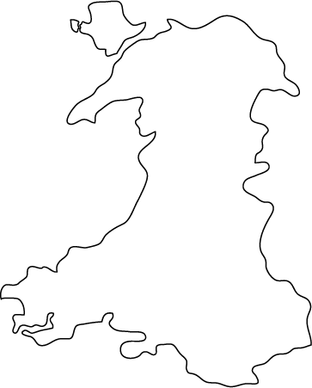

Task: Complete the storyboard about the Merthyr Rising
WJEC booklet p 21 onwards
Annotate the sources:

The Growth of Chartism
Key Question 4
How and Why did Chartism develop?

Source B - Evidence given by the Chartist rioter, William Davies, and used in the trials of the Chartists (December 1839-January 1840
It was agreed that all persons were to gather together armed with guns, pikes and sticks and to meet at the most convenient place in their neighbourhood. Then they had to proceed to be at Risca, outside Newport, at about 12 o’clock. They had to obey the orders of our leaders. It was agreed that they were to seize the people in authority wherever they could be found and stop the mail coaches leaving Newport, so that Chartists in the North of England would know the march had been successful.

Source A –

What can be learnt from sources A and B the Chartist movement?

........................................................................................................…………………….…..................................................................................................................................................................................................................................................................................................................................................................................................................................................................................................................................................................................................................................………………………...............................................................................................................................…………………….…............................................................................................................................................................................................................................................................................................................................................................................................................................................................................................................................................................
Look at the demands from the Charter from May 1838.
Hierarchy – Reorder them in an order you think are the most important
Ext: explain why.
1. A vote for every man at twenty-one years of age.
2. A secret ballot to protect the elector.
3. No property qualifications for MPs so that a constituency could elect a man of their choice, rich or poor.
4. Payment of MPs so that ordinary working men could afford to represent their constituency.
5. Equal constituencies securing the same amount of representation for the same number of electors.
6. Annual parliaments which it was believed would prevent bribery and corruption during the election process as well as making MPs more accountable.

Pages 23- 25

Task: Try to connect these four factors together. Use the worksheet to help you.

1823 Reform Act / Role of Lovett and O’Connor / First Chartist petition / Newport Rising

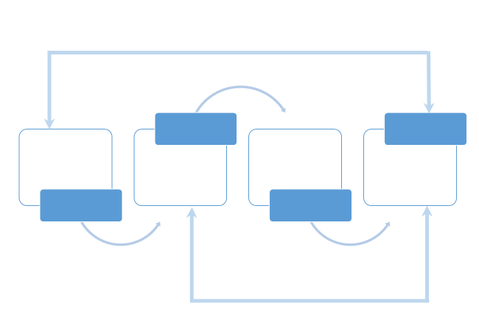

Annotate theses sources:

Rural Protest
Key Question 6
What conditions led to rural protests in this period?

Task: Draft information ere about the Swing Riots.
Then turn your information on the Swing Riots into a leaflet/ newspaper report/ poster.

The Rebecca Riots
Rebecca Riots
In 1839 thousands of farmers from the Welsh countryside went on a march as they were unhappy. They worked long hours and were not getting good money for it. So the farmers had decided to go on a march to show how frustrated they were getting. However, on their way they were stopped at a toll gate, this made some of the farmers even angrier.
Outraged that the protesters would have to pay a penny to cross to continue their march, some of the farmers decided to rebel against the toll gates.
Long white petticoats, colourful long dresses with a matching shoal and bonnet these farmers dressed up as women. They even blacked their faces with soot so they could not be recognisable when attacking the toll gates.
Dressed as women, the farmers would attack the toll gates at night shouting “Rebecca, Rebecca”. Historians are not 100% sure why these men shouted Rebecca, on idea is that the men borrowed the clothes from a women called Rebecca. Other Historians believe that the farmers got the name from the Bible.
The riots continued for years. Farmers did not want to pay the expensive toll to use the road. They had to use the road to transport their livestock and crops for market. With poor harvest in 1837 and 1838, the farmers could not afford to pay the fee.
Eventually the army was brought in to stop the riots. Some of the rioters were caught and sentenced to transportation.

Task 1 - From reading the information about both riots bullet point in your exercise books at least 4 similarities and 4 differences.

Task 2 – Complete the Venn diagram comparing the Merthyr Tydfil Riots and another for the Rebecca Riots.

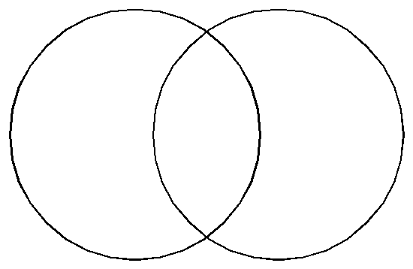
This Photo by Unknown Author is licensed under CC BY-NC-ND

Impact of Industrial and rural Protest
Key Question 7
What were the results of the industrial and rural protests after 1830?

Task: Complete the table. Think about the impact it had.
Event | Impact it had
Rising of Merthyr Rising

Execution of Dic Penderyn

Abolition of the Truck system

Parliamentary representation

Chartist Movement

Poor Law Amendment Act, 1834

Turnpike Act 1844

