TEACHER:
NAME:
Depression, War and Recovery
1930-1951

Booklet 1
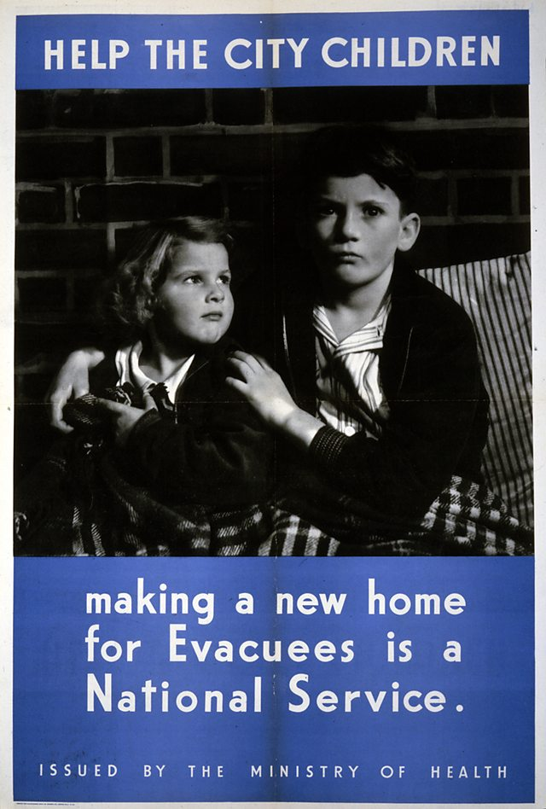
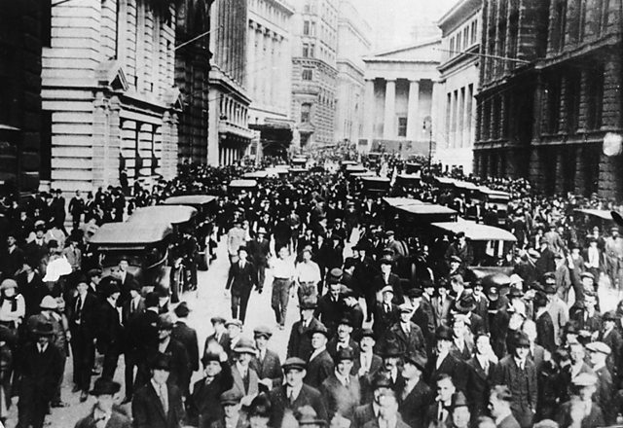

Date marked | Comment
The Coming of the Depression
Key Question 1
What were the main causes of the Depression?

Content
What are the long and short term causes of the Depression?
Textbook Pages 116 - 119

Task 1
Annotate the picture about what it suggests about the Depression in Britain.

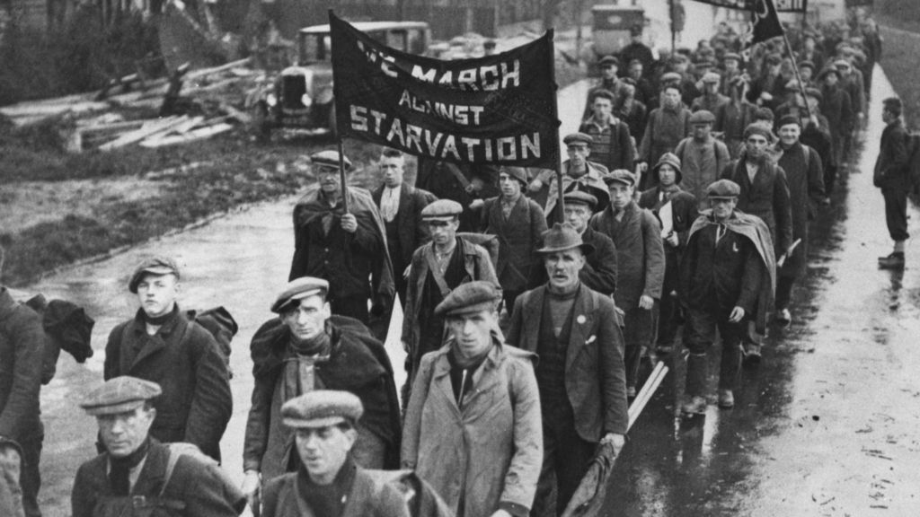

Before the Great War, Britain’s prosperity had depended on the sale of heavy industrial goods such as coal and steel. However, at the end of the war, these older traditional industries entered a period of decline. Rising costs in production, obsolete methods and a failure to invest in new technology and machinery contributed to the decline in these traditional industries. There was a fall in demand for British goods and increased competition from abroad particularly from the USA and Germany. The more expensive British goods could not compete with cheaper imports. To make matters worse, Britain’s traditional prewar export markets (countries that represented the core of the economic strength of the Empire such as Australia, Canada and New Zealand) were no longer prepared to buy British. They bought US steel, German coal and Indian cotton instead. This brought to an end the so-called ‘golden age’ of Welsh and British heavy industry. When the worldwide economic Depression arrived in the early 1930s, Britain’s old industries could not cope.
The massive financial crisis in America, the Wall Street Crash, led to the collapse of the largest, richest and most powerful economy in the world. Britain, Europe and many of the world’s industrial powers had come to depend on US loans and trade. When America’s economy crashed, so did theirs. This was the beginning of a world slump; its effects on Wales and England were devastating. The world slump in production and trade lasted longer and was deeper than many governments had imagined. The slump turned into a depression because it affected both employers and employees. Some businesses crashed while others struggled to survive. Production slumped because orders declined. This in turn led to many companies laying off workers. Unfortunately, these redundancies and dismissals contributed to the Depression because as unemployment rose, the decline in orders fell even more sharply. Clearly, the crisis of 1929 had a significant impact on the British economy, but it may be argued that Britain was already suffering from the effects of economic decline before the crisis of 1929. The collapse of the post-war economic boom in 1921, increased competition from abroad, the disaster of the General Strike of 1926 and the decline in the mining and steel industries crippled the British economy. Therefore, it is probably fair to say that the crisis of 1929 simply made an already bad situation worse.

Use the text and bullet point the long term and short-term causes of the depression.

Long Term | Short term
Quiz from BBC Bitesize  https://www.bbc.com/education/guides/zxy9fcw/test | SCORE = / 10

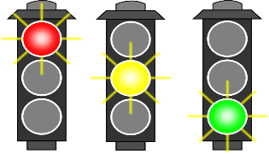

Self assess your progress

Life during the Depression
Key Question 2
How were people able to cope with the challenges of the Depression years?

Textbook p120 – p135

Task 1 - Create an acromion to remember information about the Means Test
M
E
A
N
S

T
E
S
T

Task 2
Read the following sources and information, fill in the mind map illustrating why and what happened during the Jarrow and Rhondda Marches.
Source 1

Source 2 from the Road to Wigan Pier, written by George Orwell in 1937
The means test breaks up families. An old age pensioner would usually live with one of his children. Under the means test, he counts as a ‘lodger’ and his children’s dole will be cut.

Source 3 From an account written by the mayor of Jarrow in 1936
A campaign was started by the Labour Party to send a petition. Then it was decided to march with the petition. I opposed the decisions. There were hunger marches going on all over and I didn’t want to embarrass and put down the men. I eventually had to agree, and I marched to Darlington with some of the men. I managed to get time off from Spiller’s’ in Newcastle. Communists wanted to join us on the march, but we wouldn’t let them.

Source 4 From a letter published in the Western Mail in 1936
Today you [King Edward VIII] will be visiting the towns and villages of our valleys, and a valley blighted by the dead hand of poverty. We regret that your tour has been planned in such a way that the terrible effects if this poverty will not be seen.

The Rhondda Valleys also suffered from a dramatic rise in unemployment. It was an employment black spot, with an unemployment rate that was higher than 40 per cent.

The Jarrow March gained publicity and sympathy from many, but it could be argued that the marchers had little impact on the government.

Hunger marches

Jarrow
In 1936, the people of Jarrow, a town in north-east England, were desperate and organised a meeting with a Cabinet minister to seek help. Unfortunately, they were told to go home and work out their own salvation.
To gain publicity for their cause, the people of Jarrow organised a non-political march to London. 200 men, in their Sunday best, led by the Mayor of Jarrow, the MP Ellen Wilkinson and some town councillors, marched peacefully in step for over 450 km.
They were looked after in parish halls and gained great support along the way. However, there was little support from the government when, after eight months, they reached London and the Prime Minister, Stanley Baldwin, simply ignored the petition.

Rhondda
There were also a number of hunger marches which involved people from the Rhondda Valleys and other areas of south Wales.
- Autumn 1927 - the first hunger march took place. Two years before the Wall Street Crash, the Rhondda was already struggling with high poverty levels. On Sunday 18 September, a meeting named the 'Red Sunday in Rhondda' called for a march to London to raise awareness of the economic difficulties. Due to disagreements between different organisations the march never took place. The planned march highlighted both the poverty in the Rhondda, and the feeling that politicians in London did not understand the area.
- 5 September 1931 - 112 people, including 12 women, took part in a march to Bristol, with a third of the marchers from the Rhondda. Under the slogan 'Struggle or Starve', the march was broken up by the police in Bristol.
- 14 October 1932 – there was a nationwide hunger march to London. 2,500 marchers from all over Britain participated, including 375 from south Wales.

Mind map Task

Jarrow and Rhondda Marches

The Coming of War
Key Question 3
How effectively did Britain prepare for war?

Task 1 – Explain the meaning of the following key words/events:
League of Nations
........................................................................................................…………………….…..................................................................................................................................................................................................................................................................................................................................................................................................................................................................................................................................................................................................................................………………………............................
Treaty of Versailles
........................................................................................................…………………….…..................................................................................................................................................................................................................................................................................................................................................................................................................................................................................................................................................................................................................................………………………...............................................................................................................................…………………….….............................................................................................................................................................................................................................................................................................................................................................................................................................................................................................................................................................

Lebensraum
.......................................................................................................…………………….….................................................................................................................................................................................................................................................................................................................................................................................................................
Plebiscite
.............................................................................................................................................................................................................................................…………………….…........................................................................................................................................................................................................................................................................................................................................................................................................................................................................................................................................................
Appeasement
.............................................................................................................................................................................................................................................…………………….…..........................................................................................................................................................................................................................................................................
Fuhrer
.............................................................................................................................................................................................................................................…………………….….........................................................................................................................................................................................................................................................................

Hitler’s foreign Policy
Textbook pages 138

Read the textbook pages and this information and complete the task:
The majority of historians agree that Germany’s threat began by challenging the terms of the Treaty of Versailles. The treaty had limited the size of Germany’s army to 100,000 men and forbidden that the country rearm or have a navy. The treaty had also forbidden Germany to send its troops into the Rhineland, a demilitarised zone, and to unite with German-speaking Austria.
1934-35: CONSCRIPTION AND REARMAMENT Hitler’s introduction of conscription (calling up men to the army) and his adoption of the policy of rearmament are cited by many historians as the first step to war. This is because Hitler’s build-up of Germany’s armed forces broke the Treaty of Versailles. Britain and France did not respond.
1935: ANGLO-GERMAN NAVAL AGREEMENT Britain signed an agreement allowing Germany to build a navy. This broke the Treaty of Versailles. The agreement set a limit to the size of Germany’s navy to one third the size of Britain’s. The French were angry because they had not been consulted.
1936: RHINELAND Hitler remilitarised the Rhineland when troops were ordered in to occupy this region of Germany. This broke the Treaty of Versailles. It was a bluff – the German army had orders to retreat if they met any resistance. Britain and France did nothing.
1938: AUSTRIA After stirring up trouble in Austria by encouraging the Austrian Nazis to demand union with Germany, Hitler invaded the country. This broke the Treaty of Versailles, but Britain and France did nothing.
1938: SUDETENLAND AND MUNICH Hitler next stirred up trouble in Czechoslovakia by encouraging the Sudeten Germans to demand union with Germany. This time Britain and France did something. Hitler made plans to invade Czechoslovakia but was persuaded to meet with the leaders of Britain and France to discuss the situation. At a conference at Munich in September, Britain and France appeased Hitler by giving him the Sudetenland. The Czechs were ignored. 1939: CZECHOSLOVAKIA In March Hitler’s troops marched into the rest of Czechoslovakia. This broke the agreement signed at Munich six months earlier. The British and French realised that Hitler could not be trusted and they agreed not to give in to him again.
1939: POLAND AND THE NAZI–SOVIET PACT Hitler now demanded the return of a part of Poland known as the Polish Corridor. This region had been taken away from Germany by the Treaty of Versailles. Hitler encouraged the Germans living in the area, and its chief city of Danzig, to demand union with Germany. Britain and France promised Poland that they would support her if Germany attacked. Hitler shocked the world by signing a treaty with his enemy, communist Russia. He thought this would stop Britain and France helping Poland.
On 1 September 1939 Hitler invaded Poland. On 3 September Britain and France declared war on Germany.
Think about how this would have had effected people?
The Prime Minister explained in a radio broadcast to the German people why he had declared war (4 September 1939):
He [Hitler] gave his word that he would respect the Locarno Treaty; he broke it. He gave his word that he neither wished nor intended to annex [take over] Austria; he broke it. He declared that he would not incorporate [include]the Czechs in the Reich [Empire]; he did so. He gave his word after Munich that he had no further territorial demands in Europe; he broke it. He gave his word that he wanted no Polish provinces; he broke it. He has sworn to you for years that he was the mortal enemy of Bolshevism [Communist Russia]; he is now its ally.

Task: How were the significant events in Hitler’s foreign policy?
........................................................................................................…………………….…..................................................................................................................................................................................................................................................................................................................................................................................................................................................................................................................................................................................................................................………………………...............................................................................................................................…………………….…...................................................................................................................................................................................................................................................................................................................................................................................................................................................................................................................................................................................................................................................................................................................................................................................................................................................................................................................................................................................
Task 2: Under the headings get notes on the following:

Preparation for war | Wardens and shelters | Air Raid Shelters
Radar, barrage balloons and anti-aircraft guns | Conscriptions & reserved occupations | How effectively did Britain prepare?

Life During Wartime
Key Question 4
How did people in Britain cope with the experience of war?

Source B – A German Radio Report, 18 September 1940
The legend of British self -control and coolness under fire is being destroyed. All reports from London agree in stating that the people are seized by fear – hair-raising fear. The 7 million Londoners have completely lost their self-control. They run aimlessly about the streets and are victims of bombs and bursting shells

Source A – A market stall open for business in London after a bombing raid
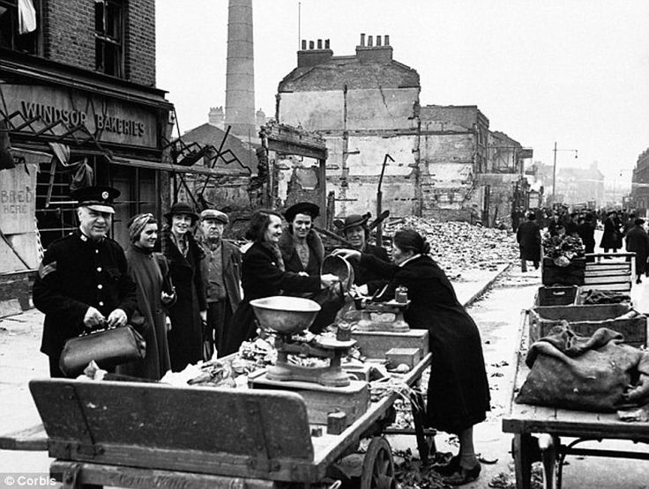

What can be learnt from sources A and B about the impact of the Blitz on London?
........................................................................................................…………………….…..................................................................................................................................................................................................................................................................................................................................................................................................................................................................................................................................................................................................................................………………………...............................................................................................................................…………………….….............................................................................................................................................................................................................................................................................................................................................................................................................................................................................................................................................................

Task: Around the map add information about the bombing of British cities
Textbook pages 149 onwards

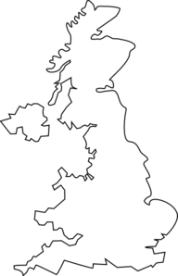

Rationing:
The British government knew that the Germans would follow the same plan that they had used in World War One which was to starve Britain into surrendering. The Germans knew that Britain had to import nearly 40% of its food from abroad, so Hitler built up a large U-boat submarine fleet which he used to sink British merchant ships. For the first three years of the war the U-boats were very successful. In April 1941 alone over 700,000 tons of British shipping was sunk. On the Home Front the people were expected to make sacrifices in order to help beat the U-boat threat. The government set up the Ministry of Food and in January 1940 it introduced food rationing quickly, followed by clothes, petrol and coal rationing. By 1942 even water was being rationed and people were only allowed 13 cm of water in their weekly bath! Ration books were issued to everyone and the ration coupons could only be exchanged for goods like meat, eggs, butter and sugar at shops where people had registered. Some foods such as bread, most vegetables and potatoes were not rationed. But it was almost impossible to get hold of fruits like bananas, oranges and lemons, except on the black market where most rationed items could be bought illegally, but only for a high price.

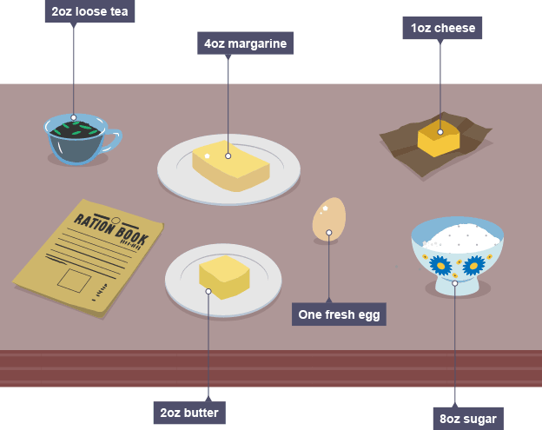

Why was rationing important? ........................................................................................................…………………….…..................................................................................................................................................................................................................................................................................................................................................................................................................................................................................................................................................................................................................................………………………...............................................................................................................................…………………….…..
Evacuation
Textbook Page 153
Task: Complete the table:

Success of Evacuation | Limitations of Evacuation

Women and WW2
Source A – A government poster of 1941
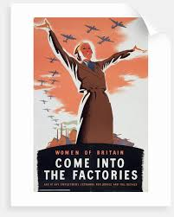

Source B – A statement issued by a government minister during a radio broadcast of May 1941
Today we are calling all women. Every woman in the country is needed to pull her weight to the utmost – to consider carefully where her services would help most and them let nothing stand in the way of giving such services. Like her, many women have made their sacrifices already and are doing their utmost to win the war. But to those thousand who have not yet come forward I would say here and now that every one of us is needed.

What can be learnt from sources A and B about the contribution of women to the war effort?
........................................................................................................…………………….…..................................................................................................................................................................................................................................................................................................................................................................................................................................................................................................................................................................................................................................………………………...............................................................................................................................…………………….….............................................................................................................................................................................................................................................................................................................................................................................................................................................................................................................................................................

Keeping up Morale
Key Question 5
How important was it to maintain people’s morale during the war?

Task: Read the information and complete the worksheet trying to make connections between: Media, Propaganda, Campaigns and appeals and the role of Churchill

The media and propaganda
The government claimed that the censorship laws were there to protect the people from lies, rumours and from German propaganda. William Joyce, nicknamed Lord Haw-Haw because of his posh voice, was a pro-Nazi Irish American. During the war he regularly broadcast to the British people from a radio station in Germany. His aim was to destroy British morale. The government indeed considered censoring his broadcasts until they discovered that most people treated him as a joke. On the other hand, the Daily Worker, a pro-communist newspaper, was banned because it criticised the government and the war effort. Of course, good news like military victories and other successes were not censored, but the truth of them was often exaggerated to make them look more than they were. This was propaganda. Both sides made great use of propaganda and this ‘war of words’ became an important weapon during the war because it helped to keep up people’s morale.
The most effective weapon the British had was the BBC. It broadcast in Britain and abroad so that the people of the occupied countries too would be able to listen to the news. The BBC was so powerful because it was heard in the home via the radio. Radio broadcasts were the single most listened to form of news and entertainment. One of the most popular radio programmes was Tommy Handley’s It’s That Man Again. To ensure that everyone was subjected to government controlled news and propaganda, posters were put up everywhere, ranging from motivational images to simple information exchange. The cinema was subjected to government regulation. The news was controlled as was the film industry which was used by the government to produce patriotic films. Some of the most popular and powerful films about the war were Went the Day Well?; The Day Will Dawn; Tomorrow We Live; and One of Our Aircraft Is Missing. Between them, radio and the cinema did much to mould the attitudes and opinions of the British people. It was an essential tool in the government’s drive to shape and control public opinion.

Campaigns and appeals
If the government employed the media and propaganda to shape the thinking of the British public it used campaigns and appeals to make the people feel as if they were actually doing something for the war effort. The man most responsible for pushing the idea of campaigns and appeals to support the war effort was the AngloCanadian newspaper owner and businessman Lord Beaverbrook. In 1940 he had been drafted into the government by Churchill as Minister of Aircraft Production. One of his most successful campaigns was the Spitfire Fund which captured the imagination of the people through propaganda posters such as that shown. To encourage people to contribute to the Spitfire Fund the Belfast Telegraph published headlines such as ‘A Spitfire A Day Keeps The Nazis Away’. Other regional newspapers also spurred on their readers to give generously to the fund; one such was the South Wales Argus which supported the fund-raising work of Richard Davies the Mayor of Newport, under the headline: ‘A Newport Spitfire will help the cause of humanity’. The people of Newport, like many across the country, were anxious to do their part and in July 1940 the town launched its appeal to raise the £5000 required to build a Spitfire. It has been estimated that of the 30,000 Spitfires built during the war the Fund was responsible for around 1,600.

Churchill’s leadership as a war leader

Winston Churchill was born into a life of wealth and privilege in 1874. His father, Lord Randolph Churchill, was a respected Conservative politician. Winston became a soldier and then a journalist. It was as a war correspondent covering the Boer War 1899-1902, that he earned his reputation for courage and daring. In 1902 he entered politics as a Conservative MP but he later changed sides and joined the Liberals. He became friendly with Lloyd George and together they piloted many social reforms through Parliament. When the Great War broke out, Churchill was put in charge of the Royal Navy as First Lord of the Admiralty. He proved to be an energetic and efficient First Lord, but his plans for an attack on Turkey at Gallipoli ended in disaster. Churchill was blamed and he was forced to resign. Two years later, in 1917, the new prime minister, Lloyd George, brought Churchill back into the government as Minister of Munitions. Again he proved a worthy choice, working hard to speed up the supply of munitions to the front.
When Lloyd George fell from power in 1922, Churchill stayed on in the government once more joining the Conservatives. In Parliament, Churchill was treated with suspicion by many fellow Conservatives because he had once been a Liberal; he was distrusted by the Liberals because he had defected to the Tories; he was positively hated by Labour because of his order to send in the troops to break the miners’ strike at Tonypandy in 1910. As Chancellor of the Exchequer in 1924, he faced the almost impossible task of dealing with the economic depression. His cuts in government spending and his calls for reduction in wages made him unpopular. He remained as Chancellor until 1929; during this time he earned the hatred of the miners and the TUC for his efforts to break the General Strike in 1926. By 1929 he had quarrelled with many members of his own party and had become an outspoken critic of government policy.
He was particularly keen to persuade the government and the people of Britain not to trust Stalin, Mussolini and Hitler. He believed that the policy of appeasement was a mistake that would eventually lead to war. However few listened to his warnings about the dangers of communism, fascism and Nazism. The general public did not care to listen to him: they were afraid of the prospect of another war, so they preferred to believe in the peaceful foreign policy followed by Baldwin and Chamberlain. Churchill’s way of dealing with the likes of Hitler seemed to them aggressive and therefore bound to lead to war.

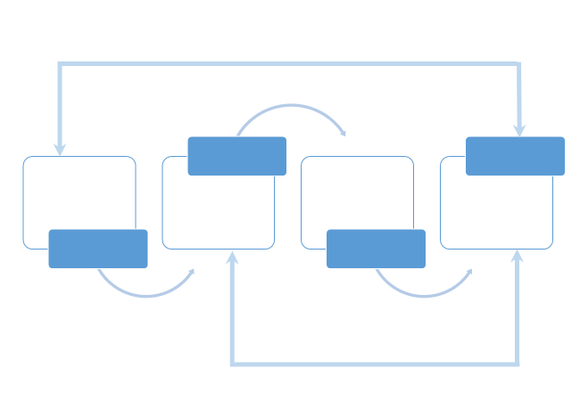

Life after war
Key Question 6
How difficult were conditions in Britain in 1945?

Textbook Page 170 onwards

What was Britain’s economic position in 1945?
........................................................................................................…………………….….........................................................................................................................................................................................................................................................................................................................................................................................................................................................................................................................…………………….….................................................................................................................................................................................................................................................................................................................................................................................................................
What was demobilisation?
........................................................................................................…………………….….........................................................................................................................................................................................................................................................................................................................................................................................................................................................................................................................…………………….….................................................................................................................................................................................................................................................................................................................................................................................................................

Task: Complete the table
Textbook Page 175

 | Conservative Party | Labour Party
Manifesto title
Main Policies
Comments

Task: Using the result data turn this into either a bar chart of pie chart showing the number of seats in Parliament.

Party | Seats | % of seats in Parliament | % of votes cast | % increase/decrease on 1935 election
Labour | 395 | 61.7 | 48.1 | +10.4
Conservative | 215 | 33.6 | 40.1 | -13.9
Liberal | 12 | 1.9 | 9.0 | +0.8
Others | 18 | 3.4 | 2.8

Rebuilding the country after 1945
Key Question 7
How did the Labour government deal with the problem of the time?

Task: Read the information and answer the following questions:
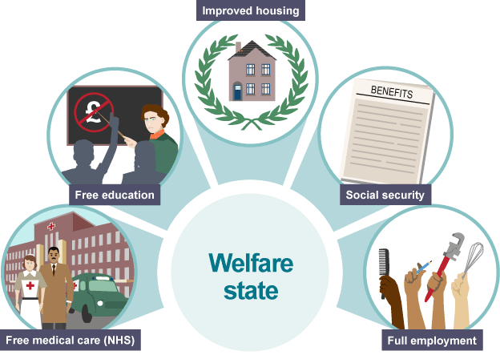

-The Beveridge Report
In 1941, the Liberal politician William Beveridge set out to discover what kind of Britain people wanted to see after the war.
His report, officially entitled Social Insurance and Allied Services, was a key part of the plans to rebuild and improve Britain after the war had ended.
As a result of this research, he declared that there were five giants on the road to reconstruction.

These were:
- want – an adequate income for all
- disease – access to health care
- ignorance – a good education
- squalor – adequate housing
- idleness – gainful employment
To help make a better Britain and to tackle these five ‘evil giants’, he proposed setting up a welfare state.

Why did so many politicians and people want to establish a welfare state?
People had sacrificed so much during World War Two, they believed they had fought for a better future and deserved it for their contribution to the war. Many believed in a fairer society with:
- free medical care
- old age pensions
- affordable housing
The idea was to offer people a safety net from the cradle to the grave. It was a key Labour party policy, as promised in the 1945 election campaign.

Who was responsible for the Beveridge report?
----------------------------------------------------------------------------------------------------------------------------------------------------------------------------------------------------------------------------------------------------------------------------

What are the five things the report said needed to change?
………………………………………………………………………………………………………………………………………………………………………………………………………………………………………………………………………………………………………………………………………………………………………………………………………………………………………………………………………………………

What had people sacrificed during WW2?
……………………………………………………………………………………………………………………………………………………………………………………...

Task: Look at the flow diagram. Now get notes about each change which was introduced.

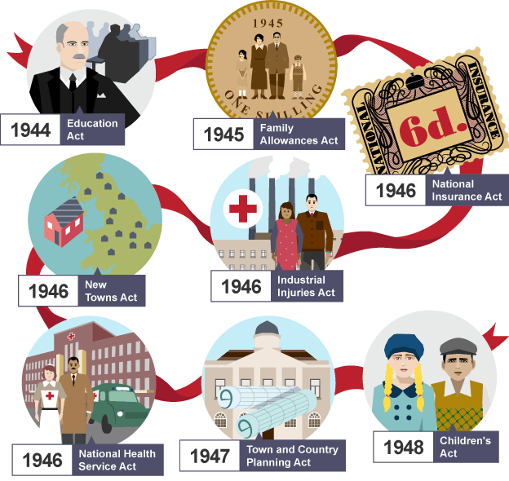

Education Act
--------------------------------------------------------------------------------------------------------------------------------------------------------------------------------------------------------------------------------------------------------------------------------------------------------------------------------------------------------------------------------------------------------------------------------------------------------------------------------------------------------------------------------------------------------
Family Allowance Act
--------------------------------------------------------------------------------------------------------------------------------------------------------------------------------------------------------------------------------------------------------------------------------------------------------------------------------------------------------------------------------------------------------------------------------------------------------------------------------------------------------------------------------------------------------
National Insurance Act
----------------------------------------------------------------------------------------------------------------------------------------------------------------------------------------------------------------------------------------------------------------------------------------------------------------------------------------------------------------------------------------------------------------------------------------------------------------------------------------------------------------------------------------------------------------------------------------------------------------------------------------------------------------------------------------------
Industrial Injuries Act
------------------------------------------------------------------------------------------------------------------------------------------------------------------------------------------------------------------------------------------------------------------------------------------------------------------------------------------------------------------------------------------------------------------
New Towns Act
---------------------------------------------------------------------------------------------------------------------------------------------------------------------------------------------------------------------------------------------------------------------------………………………………………………………………………………………………………………………………………………………………………………………………………………………………………………………………………………………………………………………….

National Health Service Act
--------------------------------------------------------------------------------------------------------------------------------------------------------------------------------------------------------------------------------------------------------------------------------------------------------------------------------------------------------------------------------------------------------------------------------------------------------------------------------------------------------------------------------------------------------
Town and Country Planning Act
------------------------------------------------------------------------------------------------------------------------------------------------------------------------------------------------------------------------------------------------------------------------------------------------------------------------------------------------------------------------------------------------------------------
Children’s Act
----------------------------------------------------------------------------------------------------------------------------------------------------------------------------------------------------------------------------------------------------------------------------------------------------------------------------------------------------------------------------------------------------------------------------------------------------------------------------------------------------------------------------------------------------------------------------------------------------------------------------------------------------------------------------------------------

Task: Select four of these acts. Try to connect the acts together. Use the worksheet to help you.

