Alternative Routes PGCE Wales through The Open University

Invitation for schools to become Strategic Lead Partner Schools in the Development Phase July 2019 – July 2020

Rationale
A strong partnership between the Open University, Regional Consortia and Lead Partner Schools is the principal component of the alternative routes into teaching programmes. Students on both part-time and employment-based routes will identify closely with their allocated Lead Partner School. The school experience will consolidate online studies in a supportive professional context by linking theory and practice and facilitating professional reflection throughout each programme (see appendices for further explanation of the model).
The programmes, plus procedural capacity building will be developed jointly by the OU, Regional Consortia and Lead Partners schools throughout the Development Phase 2019 - 2020. In order to ensure that the developmental preparations reflect the needs of all stakeholders, a number of strategic lead schools must be identified from each region. This document outlines the criteria for schools to apply to become those strategic lead schools for the year 2019 – 2020. We are looking to appoint up to 3 Strategic Lead Partner Schools per region with the addition of further Lead Partner Schools from September 2020.

The role of Strategic Lead Partner schools (development phase) - to have a term of office of 1 year (July 19 to July 20)
Strategic Lead Partner Schools will be highly effective schools that are recognised for high quality provision within their region and will undertake the following roles:
- Membership of the Design Partnership Committee as representatives in their Region to feed into and co-create the development of the programme (materials, teaching, assessment, delivery). This will involve attending a number of Partnership Committee meetings (1 per quarter) and taking a key role in designing a high-quality programme.

- Provide interview space in their region (probably May to July 2020) as required.

- Provide meeting space for staff development in their Region in relation to this programme.

Application to become a Strategic Lead Partner School (further appointment of Lead Partner Schools post September 2020 to follow)

Strategic Lead Partner Schools will be ‘effective schools’ – normally identified as such by Estyn – that are recognised for high quality provision within their Region. Selection will be a joint responsibility of the Regional Consortia and the OU and will be led by the Regional Consortia based on the Criteria. The Strategic Lead Partner Schools will be chosen to cover Primary and Secondary schools, Welsh medium and with a range of denominations, backgrounds and locations.
Please respond to the criteria below (approx. 150 words per criterion) to demonstrate how your school would be an effective Strategic Lead Partner School
CRITERION 1
Your school has the capacity and capability to engage with the Partnership Committee, the development of the programme and the recruitment of students throughout 2019 - 2020.

CRITERION 2
Your school understands the Welsh Education Reform agenda, has begun to make provision for Curriculum for Wales 2022 and is committed to the development of a language continuum for Welsh, working towards Cymraeg 2050.

CRITERION 3
Your school has a proven track record of successfully developing the curriculum, teaching and learning, assessment and coaching at school and practitioner level.

CRITERION 4
Your school has a passion for sharing expertise in ITE throughout the school and will be committed to working in partnership with other schools and the Alternative Routes partnership. This will include supporting the particular needs of students studying towards a PGCE via distance-learning and work-based practice, plus engaging with the materials and teaching of the programme.

CRITERION 5
Your school is committed to becoming a learning organisation¹⁹ with professional learning at all levels, both in school and via relevant partnerships/networks.
(OECD (2016). “What Makes a School a Learning Organisation? A Guide for Policy Makers, School Leadership and Teachers”)

CRITERION 6
Your school has the capacity and capability to provide Practice Tutors to support the programme and the Associate Schools, especially at key named points in the year.

Fees to Lead Partner Schools for participating in the Development Phase (July 19 to July 20) by attending Partnership Committee meetings and contributing to the development of the Alternative Routes programme: £200 per Strategic Lead Partner School per quarter plus travel expenses: £800 for the academic year 2019 – 2020

Please send your application to become a Strategic Lead Partner School to:
pauldavies@gwegogledd.cymru by Friday 5th July.
Appendix 1

The Open University in Wales: part-time and salaried PGCE
The Open University in Wales is embarking on an ambitious programme of Initial Teacher Education leading to the award of Postgraduate Certificate in Education in partnership with the Welsh Government, Regional Consortia and a pan-Wales network of lead partner schools.

This new, blended, programme that draws on the most effective use of new technologies, will offer alternative routes into the teaching profession for those who are currently unable to become teachers because they’re unable to travel to face to face venues or who have other commitments that prevent them from studying at specific times. The alternative routes that we’re developing will offer employment-based and part-time options that will broaden the intake into the teaching profession, increase diversity and help to address teacher shortages in specific areas of curriculum and in geographical locations in Wales.

A flexible, blended approach to initial teacher education is at the forefront of the education reform journey in Wales. Flexible or part-time teacher training opportunities appeal to a broad demographic of potential teachers, who bring with them varied life experiences, backgrounds, attributes and knowledge. Empowering existing talented individuals within Welsh education communities to step up to teaching, helping schools to ‘grow their own teachers’, as well as encouraging new teachers into the profession with experiences from other workplaces and with diverse backgrounds will enrich the teaching workforce and help us to achieve the shared National Mission enabling our staffrooms and teachers to be more reflective of contemporary society.

These approaches will also help to address teacher shortages, not least those that correlate with the Rural Education Action Plan (2018). Rural learners and their communities deserve high quality teachers and, in turn, these teachers need to have the same high-quality training opportunities as those in urban areas.

The Open University in Wales intends to draw on its 20 years of experience in offering high quality part-time distance teacher education across the four nations of the United Kingdom and internationally to develop a world leading, part-time, school-based teacher education programme to support the National Mission in Wales. This is being developed in partnership with school-based teacher educators and Regional Consortia; it will be unique to Wales; will open staff-rooms, schools and students to a wider diversity of teachers; and will revolutionise teacher education in Wales. This collaborative approach to co-creation will bring together the best in high quality distance education, innovative approaches to teacher pedagogy and research with significant experience of local and regional contexts.

The model that we are adopting removes the barriers of specific times and specific location from academic study and offers flexibility in terms of practice-based experiences in schools. It also offers flexibility to Regional Consortia and the Welsh Government through a hybrid blended open learning approach. Our model (See Figure 1) consists of four main elements:
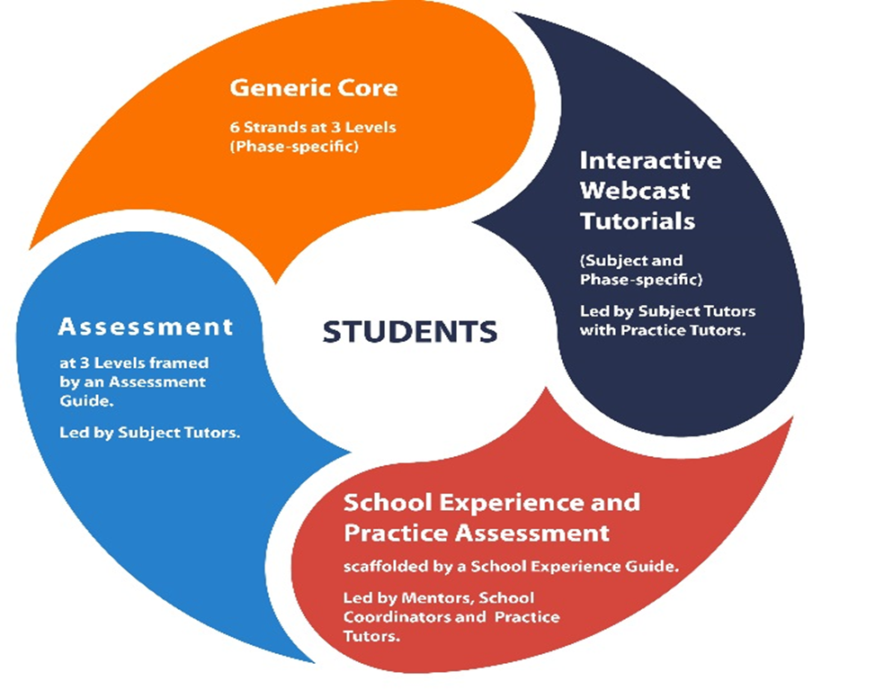
- Generic core study materials (in Welsh and English) covering 6 strands at 3 study levels;
- Interactive webcast tutorials (through the medium of Welsh and English) with a Subject Tutor working alongside selected Practice Tutors/Mentors;
- School experience, with an assessment of practice, scaffolded by a School Experience Guide (which is linked to the tutorials and core study materials) supported by school-based mentors, school coordinators and Practice Tutors;
- Assessment at 3 levels, framed by an Assessment Guide, opening up progression to the next level or, at the end, the award of PGCE and progression into induction.

Figure 1: PGCE University Tuition Strategy

The Regional Consortia, with the Open University in Wales, are currently asking schools to express an interest in participating as strategic lead partner schools in the development and co-creation of the employment-based and part-time routes to PGCE. We believe this is a great opportunity to make a significant
contribution to a pan-Wales project that has the potential to transform schools in Wales.

We very much hope that you’ll be interested in participating and invite you to make an expression of interest.

Dr Steven Hutchinson
Head of School: Education. Childhood, Youth and Sport, The Open University

Steven.Hutchinson@open.ac.uk

Appendix 2
