RELIGIOUS STUDIES – THEME 3
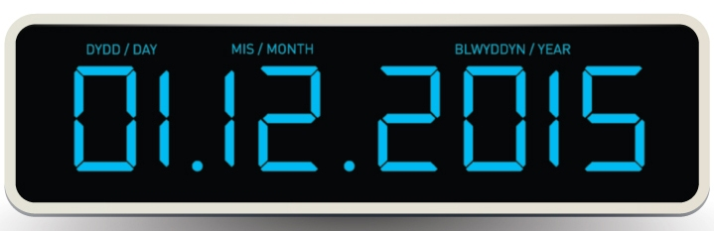
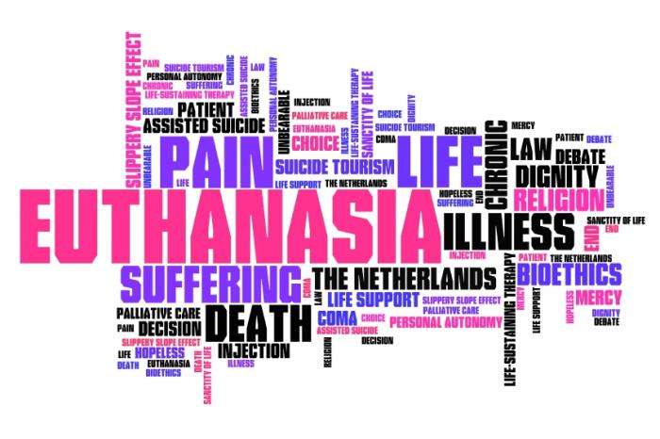
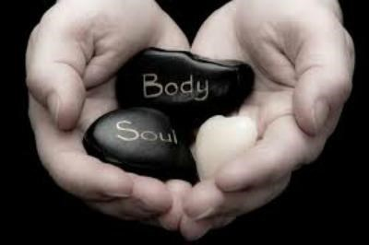
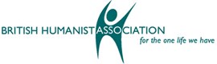
ENW:
LIFE AND DEATH ISSUES

THEME 1 – THE WORLD
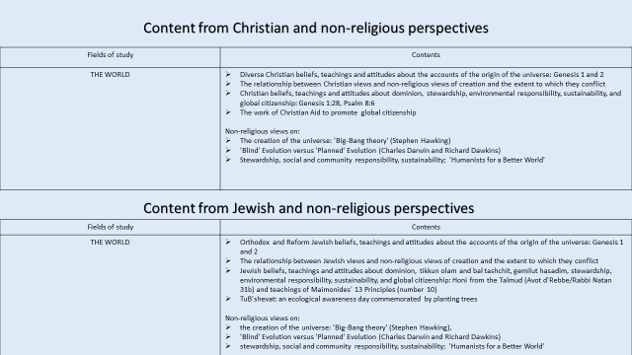
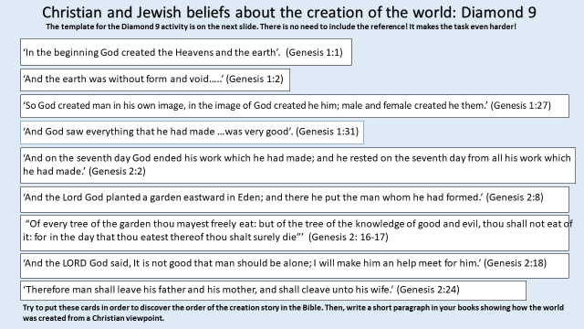
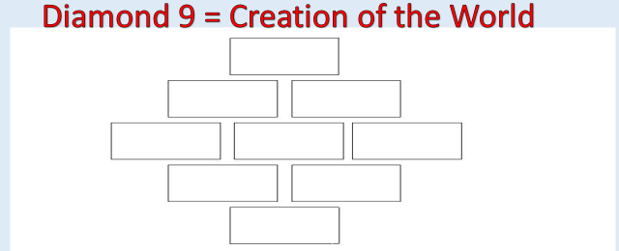
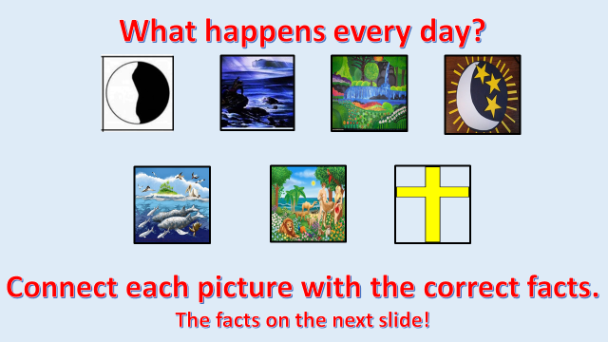

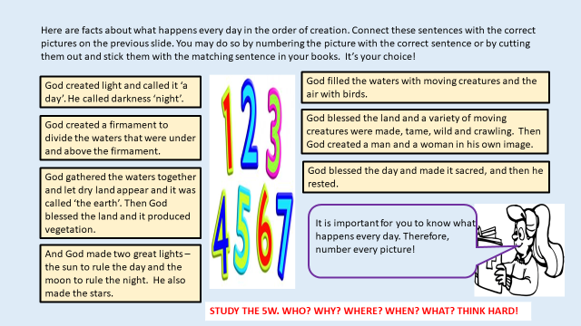
Judaism
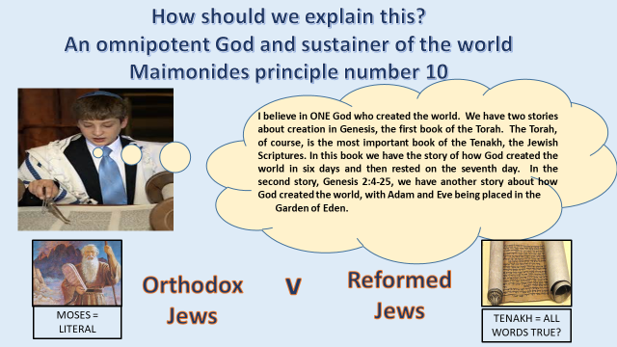

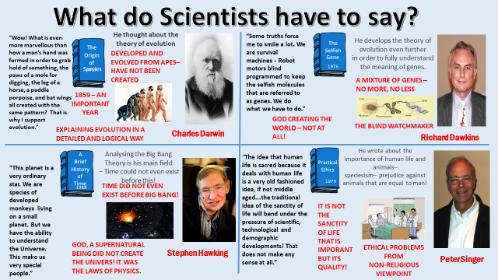

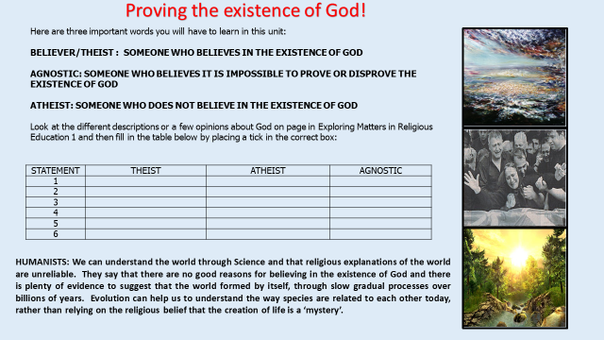

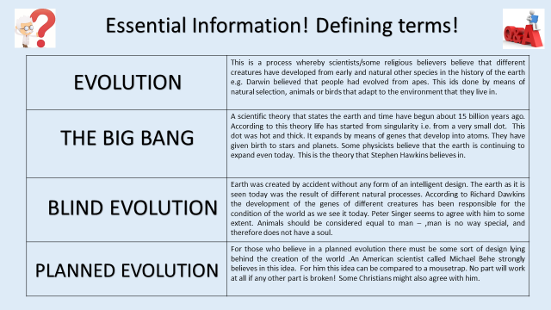

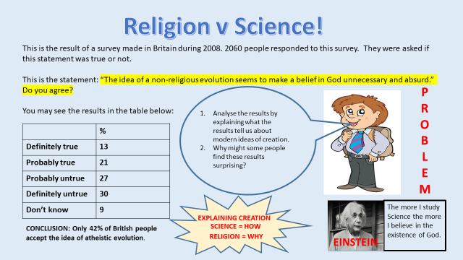

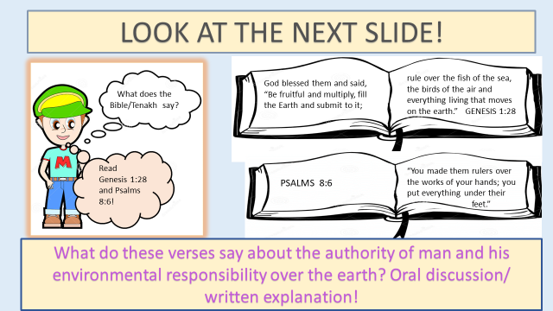

DESTROYING THE WORLD

COMMUNITY RESPONSIBILITY
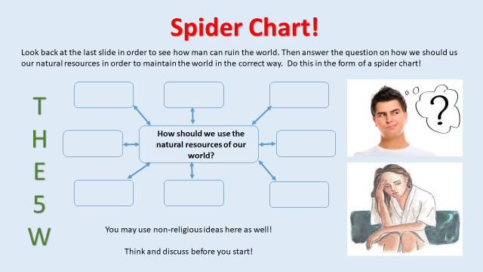
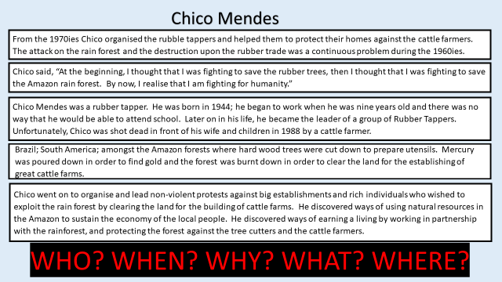

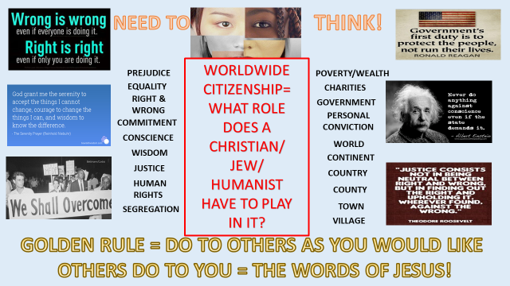

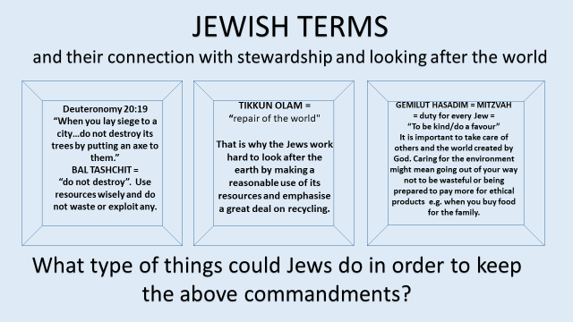

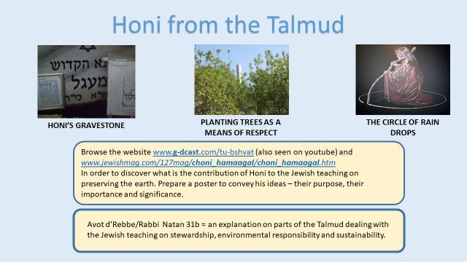

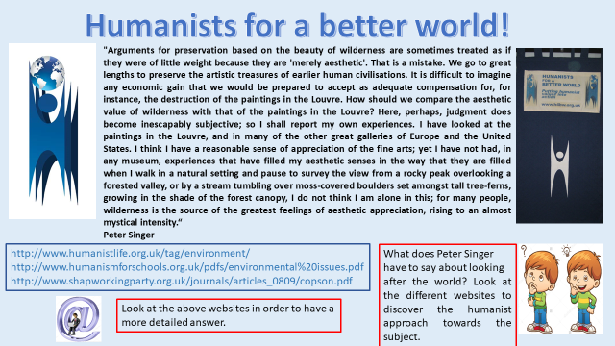

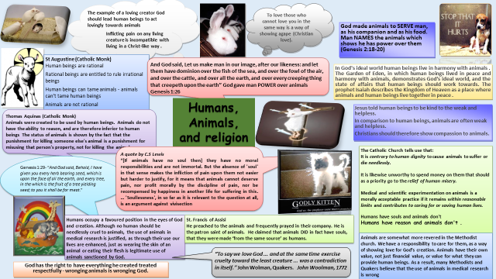

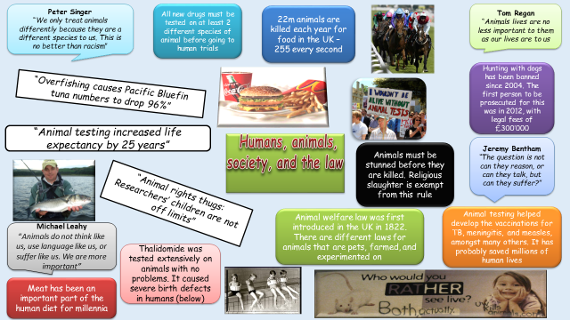
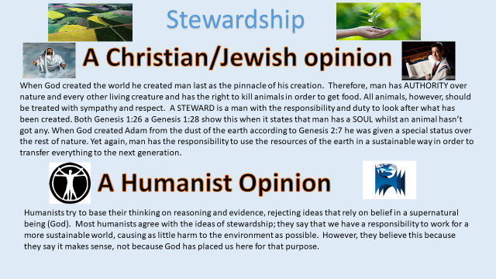

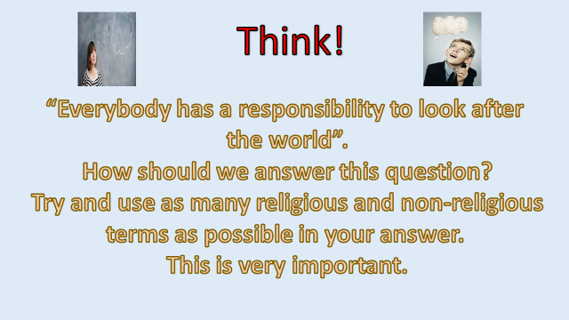

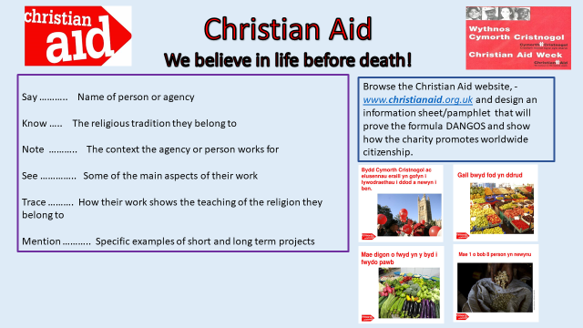

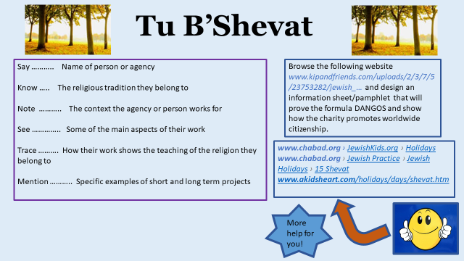

PART B
The origin and value of human life
The specification requirements…

KEY CONCEPTS
- Sanctity Of Life – Life is sacred, special and precious; No one should take life e.g. abortion, euthanasia.
- Euthanasia - Means ‘gentle death’ - Ending someone’s life deliberately for compassionate reasons; death would be the best option. Mercy killing.
- Abortion - terminating / ending a pregnancy before it is born.
- Quality of life -When a person feels of value; contributes to life; life is meaningful and pleasurable e.g. free form pain and stress.

Christianity & Judaism
Sanctity of life - Most people, whether or not they are religious, think that a human life is something special. We only have to see the efforts made by Doctors / Nurses / Fire Fighters etc to see that. For religious believers, the reason why human life is special is because it is a gift from God – God is the creator, and were created in His image. They refer to the term SANCTITY OF LIFE to refer to their belief that human life is precious. Some believe a human life is of greater value than an animal’s because they think God give humans souls. No one should take life or deny it e.g. Abortion / Euthanasia.

Religious Teaching about the Sanctity of Life
The Talmud discusses a number of cases as examples in which Mitzvot can be disregarded for the sake of saving a human life (Yoma 84b 8-9)

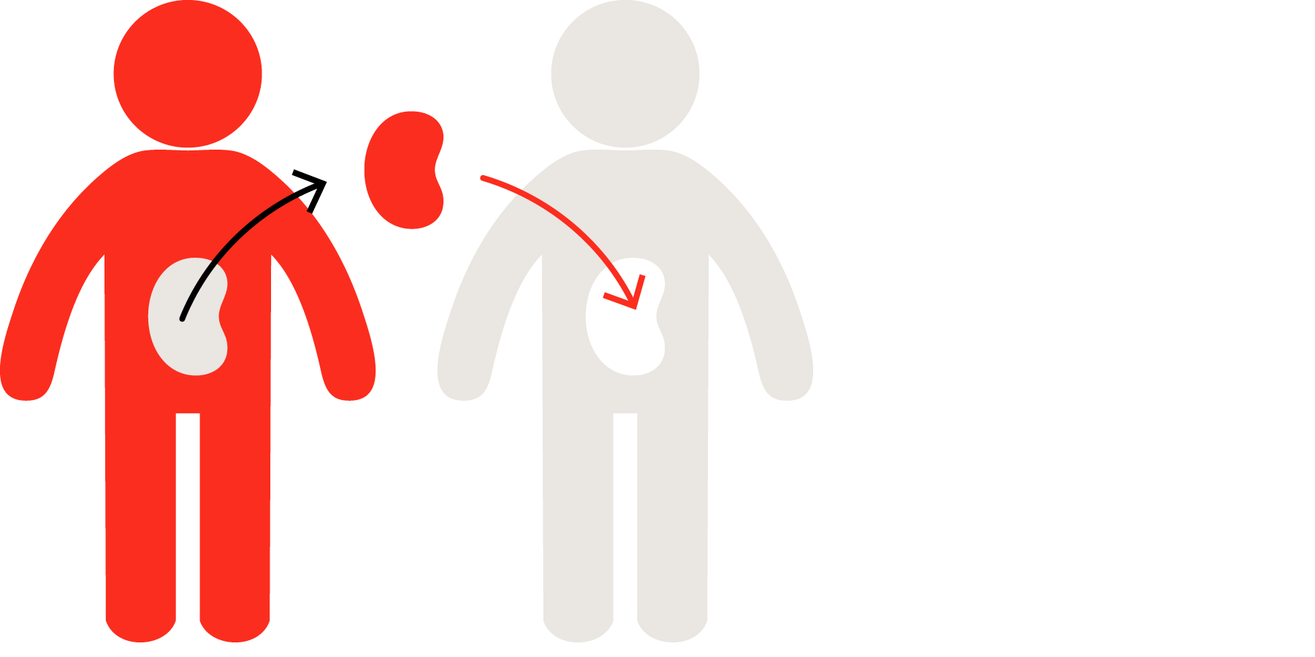
Pikuach Nefesh in Action Today
- On certain festivals like Yom Kippur, Jews must fast. However, a sick person is obliged to break the fast. It is the right thing to do to observe fasting, but when fasting puts a person’s life at risk then it is seen as sinful.
- In terms of health issues, for example, organ donation, pikuach nefesh can be seen in action. Jewish law states that a body should be buried whole. However, if, when the person is dead, their organs can be used for a specific named person (rather than organs being stored) to save their life then this should be done under the pikuach nefesh principle. Also, to give away a kidney for this use would also be acceptable from a living donor.
- Health workers can work on Shabbat and use pagers and telephones to save lives. Abortion is seen as acceptable is the life of the mother was in danger (even though to take a life is against the Commandments). The mother’s life is actual life and so is more important than that of the foetus, which is only the promise of or potential life. Pikuach nefesh again is the overriding idea here.
A humanist View - Most non-believers (atheists or agnostics) also think that human life is unique and special. They do not believe that God created us, and many do not believe that there is life after death nor believe in a soul. BUT, this does not lessen the importance of human life. In fact, some say that human life is SO valuable because this is the only life we have, so ‘let’s make the most of it’ and be happy. Great efforts therefore should be made to protect human life, not destroy it and respect human life.
Think about the following……
The belief in the sanctity of life raises many moral issues:-
- How we treat human beings.
- Attitudes to death and the taking of life – Abortion / Euthanasia
- Attitudes to medical treatments – especially transplants, transfusions, life-support machines.
- If someone believes that human life is precious, it will affect how they treat their own body and how they treat other people’s bodies. This has huge implications for all stages of human life from conception, through life, to the moment of death and possibly care of that body after death.

Peter Singer – Speciesism
- Atheist – refuse the sanctity of life because people were not created in the image of God
- He focused on the quality of life and said if someone’s quality of life is poor then the person should be able to make a decision to end their life and suffering.
- A person’s life should be respected not just because they are alive, but also the quality of life. It is better to allow someone to judge their own quality of life and allow them to decide.
- He argued that it is wrong to give more rights to people not animals. People and animals should be treated the same. He is against experimentation.

Abortion

Human life is sacred because God cherishes us and has a purpose for every moment of our lives. “Before I formed you in the womb I knew you, before you were born I set you apart; I appointed you as a prophet to the nations” (Jeremiah 1:5).

To many people, the issue of abortion, although it is often a matter of conscience, is to do with choice and rights:
- The choices and rights of the mother, and whether she wants and is able to have the baby;
- The rights of the child not yet born, to be alive and grow independently;
- The choice about making decisions in accordance with one’s own conscience;
- The right of religious believers to consider how their beliefs impact on such an issue.

As with many issues, it is not always simply a matter of making up your own mind – there are other people’s views to consider:

It’s my choice. I can’t Hang on a minute – it’s You need to think of the
have a baby now – it partly my child too. I’m long-term effects of an
will ruin my career. sure we can work something abortion, as well as what
out together. seems important now.

I want to stand by my But what about us grandparents? As your religious leader, I
sister; but I really hate We don’t believe it is right to urge you to consider the
the idea of her having take away a life! principles of the sanctity
an abortion. of life before reaching a
decision.

As a neighbour, I think she should just make up her own mind!
She’s the one who’ll have the baby anyway.

What is Legal in Britain?
A woman does not have an automatic right to an abortion in Britain. Two doctors must agree that:-
- The mother is less than 24 weeks pregnant;
- The mothers' physical or mental health is at risk;
- The baby is likely to be born severely physically or mentally handicapped;
- The birth would have a seriously bad effect on other children in the family.

Discussion work/Homework
Does the below situations justify abortion?
- ‘I’m 14, and too young to have a baby.
YES? | NO? | WHY?

(b) ‘I’m scared to have a baby – there’s something wrong with my heart, and the doctor said I could risk my life when giving birth.
YES? | NO? | WHY?

(c)I have enough children as it is! I can’t afford to have another.
YES? | NO? | WHY?

(d) ‘I don’t have a serious partner and I don’t want to raise a child on my own.’
YES? | NO? | WHY?

(e) I wanted a child later on in life – it’s not convenient at the moment- I need to focus on my career first.
YES? | NO? | WHY?

(f) I can’t have this child, my parents will go mad.
YES? | NO? | WHY?

(g) I was raped, and now pregnant.
YES? | NO? | WHY?

(h) ‘It was only a one-night stand! A bit of a laugh. Why should I suffer for the rest of my life because of a drunken night?’
YES? | NO? | WHY?

(i) The tests show that the baby will be disabled. I’m not prepared for such a commitment.’
YES? | NO? | WHY?

Watch the clip on Abortion. Make any relevant points/opinions below:

Some medical facts
- Some very premature babies can now be kept alive, which has altered ideas about when foetuses become human beings with human rights. The law in England and Wales is based on the fact that after 24 weeks the foetus is often viable, in that with medical assistance it can survive outside the womb.
- Many illnesses and disabilities can now be diagnosed long before birth.
- Some very ill or disabled babies who would probably once have died before or shortly after birth can now be kept alive.
- The sex of a foetus can be known well before birth (and some parents would like to be able to choose the sex of their child).
- Abortions can be performed safely, though they can occasionally cause medical or
Psychological problems.

Those for abortion argue that it is the quality of life that matters. If either the mother or the baby is going to suffer a miserable or painful life if the pregnancy continues, then abortion should be allowed.

Those against abortion say that it is wrong to kill unborn babies. They ask what right we have to dispose of a life because it’s inconvenient, or not up to the standard we expected. Human life is special and killing it is murder.

HOMEWORK
Research the following:
‘Pro-life’ -

‘Pro-choice’ –

RELIGIOUS TEACHINGS ON ABORTION
CHRISTIANITY | JUDAISM 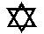
- Generally, Christians are against abortion because life is sacred and special;  The sanctity of life; life is given by God, and people were created in the image of God, All life deserves respect; Life should not be destroyed.  - Different views by Christians.  - Catholics – abortion is wrong under any circumstances – life is sacred and God-given. Abortion is similar to murder.  - Protestants – against abortion carried out for social reasons, but accept in some cases, that it’s the best thing to do for mother or child.  - “Abortion should be avoided at all costs, if possible. However, in an imperfect world, in some situations ending a pregnancy might be the lesser of two evils.”. (Methodist Church)  - One of the 10 Commandments – “Do not kill”  - ‘Children are a gift from the Lord; they are a real blessing’ (Psalm 127)  - From the first moment of his existence, a human being must be recognized as having the rights of a person – among which is the inviolable right of every innocent being to life. (Catholic Church)  - God said, “Be fruitful and multiply”  - Bible makes no mention of abortion. Roman Catholic Church forbids abortion.  - All life is created by God in his own image and is known to him because in the Bible it states “I knew you before I formed you in your mother’s womb” | - Abortion is generally prohibited.  - God is the creator, and he alone can take life.  - Life is God’s greatest gift – it should be preserved/kept.  - Destroying life is a crime.  - Orthodox Judaism abortion is seen as an act that is considered worse than contraception as it not only disobeys God’s will but also destroys potential life. However, every situation is dealt with separately and a Rabbi should be consulted to give advice on such matters.  - Reform Jews accept that abortion isn’t accepted but in some circumstances allow it. In these circumstances they do not use it as a form of birth control and understand that it might have life changing reproductions.  - Abortion can often be regarded as murder, therefore goes against the 8th of the 10 Commandments, ‘Thou shall not kill’.  - The Mishnah states clearly that the woman’s life takes priority over that of the embryo, and that the embryo can and should be terminated.  - Some Jews also accept abortion where the child will be born with any deformities.  - Rabbinic legislation stipulates if less than 41 days gestation an abortion may happen under certain circumstances .e.g. mothers’ life is in danger, mental health of mother or genetic disease.  - The fertilised egg is a potential life and must not be destroyed without reason; it does not however have the same status as a person already born.  - According to the Talmud the zygote is simply water until 40 days after conception.  - According to the Mishnah “whoever destroys one life is as if he destroyed a whole world, and whoever preserves a life is as if he preserved the whole world” (Sanhedrin 4:5).  - Killing a foetus after 41 days breaks God’s command in Genesis 1:28 to go forth and multiply.

Humanist viewpoint
Watch the clip and make notes:

- Humanists seek to live good lives without religious or superstitious beliefs. They use reason, experience and respect for others when thinking about moral issues, not obedience to dogmatic rules.
- Through reasoned consideration of the issues above, humanists conclude that abortion is often a morally acceptable choice to make.
- This choice is personal; the law does not impose abortion on anyone who does not want one or want to perform one.
- Humanists value life and value happiness and personal choice, and many actively campaigned for legalised abortion in the 1960s.
- Although humanists do not think all life is "sacred" they do respect life, and much in this debate hinges on when one thinks human life begins.
- We have seen that humanists tend to think that a foetus does not become a person, with its own feelings and rights, until well after conception.
- They are usually more concerned with the quality of life rather than the right to life. The probable quality of life of the baby, the woman, rights and wishes of the father and the rest of the family, and the doctors and nurses involved, would all have to be given due weight.
- Most humanists would probably put the interests of the woman first, since she would have to complete the pregnancy and likely care for the baby, whose happiness would largely depend on hers. She also exists already with other responsibilities and rights and feelings that can be taken into account - unlike those of the unborn foetus which cannot be so surely ascertained.
- Adoption of the unwanted baby might be the best solution in some cases, or on reflection a woman might decide that she could look after a sick or disabled child. Or she might decide that she cannot offer this child a life worth living and abortion is the better choice. She will need to consider the long-term effects as well as the short term ones.
- As a last resort, most humanists would agree that society should offer safe legal facilities to perform abortion. The alternatives, which would inevitably include illegal abortions, are far worse.
- sex education is crucial in reducing unwanted pregnancies.

Situationist/ relativist approach – action right or wrong depending on personal choice, society or culture.
Absolutist approach – should keep to morals / rules that existi.

Euthanasia

Sometimes, after a terrible accident where people have become paralysed or seriously injured and are in long-term pain, they feel that they no longer want to carry on living. Or perhaps a person has a terminal illness, and is getting progressively worse, and they feel that there might be a time when they will not want to go on living. No quality of life.

Such people feel it is their life, and that they should have a choice whether or not to go on living. They feel that euthanasia should be allowed.

Euthanasia literally means ‘gentle death’, and is sometimes referred to as ‘mercy killing’.
Euthanasia is:-
i) The speeding up of death, through the use of drugs or other medical ways,
ii) Helping a person to die.
Euthanasia is illegal in Britain, and anyone helping a person to die can be arrested.
There are situations other than the two above where some people think that euthanasia should be allowed:
a) When people are on life-support machines for a long time and there is no real hope of them recovering;
b) When a person is in a coma and is not likely to regain consciousness;
c) When a person is completely dependent on others for all basic needs.

There are 3 different kinds of euthanasia:
- Voluntary euthanasia - where a person has asked someone to help them die. This is not suicide, which is taking one’s own life; it is getting help from someone to speed up one’s death.
- Passive euthanasia - this is allowing someone to die and not taking any steps to prevent the death, or not resuscitating the person after a heart attack or other trauma. It also includes giving a person such high doses of painkillers that they die more quickly, often in less pain.
- Non-voluntary euthanasia - This is when the person who dies is not able to make a decision themselves, such as when a life-support machine is switched off.

Watch the clip about euthanasia. Make a note of any points/your opinion about the topic below:

Arguments FOR Euthanasia
- People should have the right to do as they wish with their own lives, including choosing when and how they die;
- If the future is going to be full of pain and suffering + the patient will lose their dignity, death would be the best option for many people;
- Euthanasia prevents the patient becoming a burden on the family;
- If there is no getting better anyway then medical resources can be better spent elsewhere;
- More and more people are living longer, and it may be that in the future the state could not afford to support all those who need it;
- Animals that are terminally ill are ‘put to sleep’. The same should be offered to humans. People should be given the choice.

Arguments AGAINST Euthanasia
- Making euthanasia legal would make doctors go against the Hippocratic Oath that they have made at the beginning of their profession;
- Puts a lot of responsibility and pressure on the doctors;
- Patients would lose confidence and faith in their doctors;
- Human life is sacred and must not be played with;
- Hospices show that people can die in dignity and without too much pain;
- All human beings are precious. It is God who gives life and only God can take life away.
- Religious believers don’t agree with euthanasia, as humans have a soul unlike animals, therefore shouldn’t be ‘put to sleep’.

Religious Viewpoints

CHRISTIANITY | JUDAISM
1. Christians believe in the sanctity of life, so taking any life is wrong.  2. Humans were created in God’s image - God decides when a person’s life is to end.  3. Life is a gift from God, so God can only take it away.  4. Bible – ‘In his hand is the life of every living thing … ‘(Job 12:10).  5. Suffering can have a purpose.  6. Ten Commandments says ‘Do Not Kill’.  7. God will give support and comfort to people during difficult times.  8. Hospices e.g. Tŷ Gobaith offer care and support for the patient and family who are suffering from terminal illness.  9. Some Christians believe that euthanasia is right in some situations:  - God gave free will to make decisions.  - We should show love towards others who are suffering where there is no hope of a recovery.  - ‘Where there’s life, there’s hope’. There have been cases where someone has woken up after being in a coma for 15 years. A miracle might happen.  - Doctors sign a Hippocratic Oath i.e. they promise that they will do everything in their power to extend life. Euthanasia forces doctors to go against their Hippocratic Oath. To assist in euthanasia is to become involved in murder.  - The Bible makes it clear that humans are not meant to choose when they die.  “For everything there is a season, and a time for every matter under heaven; a time to be born and a time to die, a time to plant and a time to pluck what is planted” (Ecclesiastes 3:1-4)  - Most Christians argue that people do not own their lives.  - Birth and death are part of the life processes which God created and so we should respect them.  - No human being has the authority to take the life of any innocent person, even if that person wants to die.  - Euthanasia has been condemned by the Catholic Church since 1943. It states “whatever its motives and means, direct euthanasia consists in putting an end to the lives of handicapped, sick or dying persons it is morally unacceptable.” (2277)  - However the Catholic Church allows the turning off of life support machines.  - The Catholic Church also agree with the use of painkillers to alleviate suffering, even at the risk of hastening death. | 1. Life is a blessing – and should be preserved.  2. Life is a gift from God.  3. Humans were created in God’s image - God decides when a person’s life is to end.  4. A mitzvot (rule) is to practice pikuakh nefesh which means setting aside some rules in order to save life.  5. Life is sacred.  6. Ten Commandments says ‘Do Not Kill’.  7. Jewish faith teaches life is a blessing from God, hastening death is the same as murder.  8. The Talmud states that “he who shoots a man as he falls off a cliff to certain death is guilty of murder” even though he life was only shortened by a few minutes.  9 They believe that life should be preserved at all costs.  10. God is the only one who can decide on the time of death.  11. However, Jews believe that praying to God and asking for death (either personally, or over a loved one) is allowed.  12. Judaism regards active euthanasia as forbidden and what the patient or individual wants does not matter.  13. However, some Reform Jews regard Passive euthanasia as acceptable. E.g. if a patient is certain to die, and is only being kept alive by a ventilator, it is sometimes permissible to switch off the ventilator since it is impeding the natural process of death.  14. Even though euthanasia is generally not accepted within Judaism, there is an example of euthanasia in the Tanakh:-  E.g. book of Samuel (1:1-16) when an injured King Saul ordered a young soldier to kill him during battle. The young man returns to King David and explained what happened. Kind David ordered this young man to be murdered himself. This shows that euthanasia is equivalent to murder and that no one should take another’s life.
The Humanist View
Watch the following clip:

- Humanists think that in a lot of circumstances voluntary euthanasia is the morally right course of action to take.
- Humanists are non-religious people who live by moral principles based on reason and respect for others, not obedience to dogmatic rules.
- They promote happiness and fulfilment in this life because they believe it is the only one we have.
- Humanist concern for quality of life and respect for personal autonomy lead to the view that in many circumstances voluntary euthanasia is the morally right course.
- People should have the right to choose a painless and dignified end, either at the time or beforehand, perhaps in a "living will".
- Individuals should be allowed to decide on such personal matters for themselves; if someone in possession of full information and sound judgement decides that her continued life has no value, her wishes should be respected.
- While humanists generally support voluntary euthanasia, they also uphold the need for certain safeguards. These may include counselling, the prevention of pressure on patients, clear witnessed instructions from the patient, the involvement of several doctors, no reasonable hope of recovery– measures which would prevent involuntary euthanasia.
- There is no rational moral distinction between allowing someone to die and actively assisting them to die in these circumstances: the intention and the outcome (the death of the patient) are the same in both cases, but the more active means is probably the more compassionate one. The BHA supports attempts to reform the current law on voluntary euthanasia.
- Humanists support the legalisation of euthanasia in the UK.
- The ability to die, with dignity is a human right.

EXIT CARD
- EXIT, otherwise known as the Voluntary Euthanasia Society, is an organisation that has campaigned for the right for people to have the choice to decide about their own death, especially when facing extreme pain, disability or a progressive disease that takes away something of the quality of life.
- Part of what they do is provide people with a Medical Emergency Card, which tells doctors what the person’s wishes are about being resuscitated or having their life prolonged when there is no likelihood of real independent life.
- The organisation also recommends that people complete a Living Will while alive and well, so that should they ever be in a critical condition or supported mechanically to be alive, the doctors know their personal wishes.
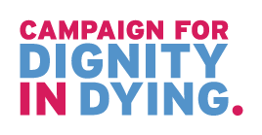
- The Dignitas Clinic in Switzerland also offers the service for terminally ill patients to ‘Live with dignity, to Die with dignity’.

Organ Donating

- On the 1st of December 2015, Wales became the first UK country to introduce a soft opt-out system for organ and tissue donation.
- The new system will make it easier for people in Wales to become organ donors.
- You must be 18+
- If you haven’t registered a decision to opt-in or opt-out of organ donation, you will be treated as having no objection to being an organ donor. This is called deemed consent.
- Which organs can be transplanted? E.g. Kidneys, heart, liver, lungs, pancreas.
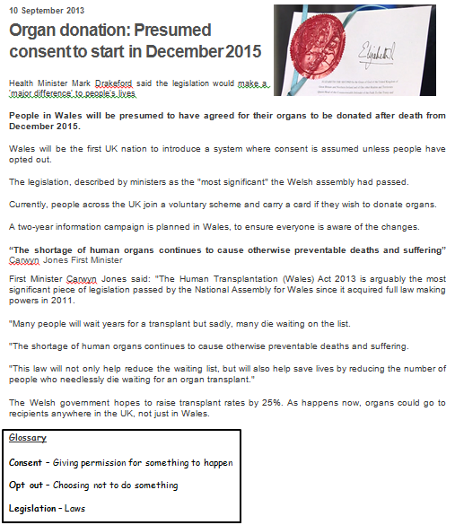
Read the article
What ‘ethical issues’ arise from this article?
Do you agree with the system in Wales?
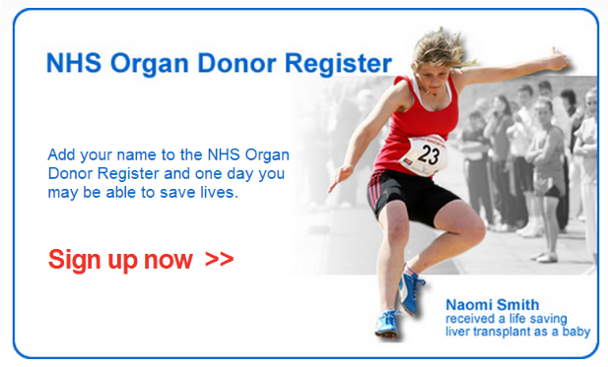

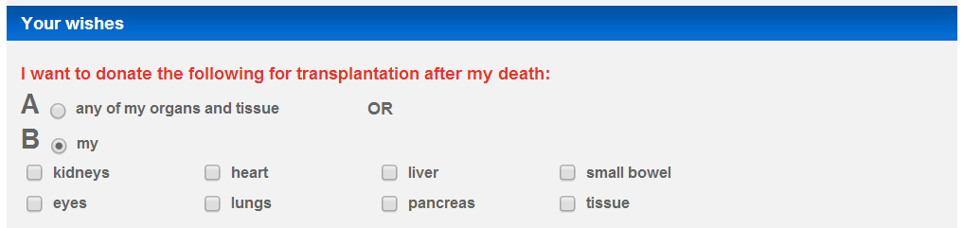

Watch the clips:
https://www.youtube.com/watch?v=dT6Z0ipNVlY
https://www.theguardian.com/society/2015/apr/23/parents-uks-youngest-organ-donor-teddy-houlston-hope-others-inspired

Homework
Making decisions... Who should get the transplant?
Children | Alcoholics/Drugs users
Educated people | People who have already had one transplant
Uneducated people | People who have been on the waiting list the longest
Pensioners | Convicted criminals
People who are willing to pay | British citizens
Immigrants | Tax payers
People under 30 | Parents
People on the organ donor register themselves | People not on the organ donor register themselves
People on benefits | People expected to die the soonest without a transplant

Read the article - http://www.bbc.co.uk/news/uk-wales-38144547
Which ‘ethical issues’ can be found in this article? Do you agree with the system in Wales? Do you agree with the opting out system?

I agree/disagree… because…
It saves lives | You are dead, you do not need your organs anyway | It should be a personal choice
Death of a loved one is sad, agreeing to donate organs brings happiness out of that sadness | We do not know what happens after we die, we may need our body! | There is a shortage of organs, people are dying unnecessarily
Are there religious objections to organ and tissue donation?
No. All the major religions of the UK support the principles of organ donation and transplantation. However, within each religion there are different schools of thought, which mean that views may differ. The NHS have worked with religious leaders across Wales to discuss the new organ donation system.
http://organdonationwales.org/FAQs/Religious-perspectives/?lang=en

Christianity and organ donation
- Christians should be encouraged to help others in need. They look upon organ donation as an act of love, and a way of following Jesus' example.
- A way of showing Agape love.
- Protestant denominations support organ donation, whether they see it as an individual choice motivated by compassion, or encourage it as an act of charity.
- Catholic church strongly supports organ donation.
- “With the advent of organ transplantation, which began with blood transfusion, man has found a way to give of himself, of his blood and of his body, so that others may continue to live”. Pope John Paul II
- Orthodox Christianity, most Pentecostal and evangelical churches also support organ donation.
- “In eternity we will neither have nor need our earthly bodies: former things will pass away, all things will be made new.” Revelation
- Christians believe in eternal life and should not be afraid preparing for death.
http://www.bbc.co.uk/religion/religions/christianity/christianethics/organs.shtml

Judaism and organ donation
- Judaism supports and encourages organ donation in order to save lives (pikuach nefesh).
- As all cases are different, Jewish law requires consultation with a competent Rabbinic authority before consent is granted.
- If an organ is needed for a specific, immediate transplant then it could be considered a great honour for a Jew to donate organs to save another person's life.
- One who saves a single life - it is as if he has saved an entire world. Pirke D’Rav Eliezer

Beliefs about death and the afterlife
Key concepts
Afterlife – A belief that human existence continues after death.

SOUL The spiritual aspect of a being; that which connects someone to God. The soul is often regarded as non-physical and as living on after physical death, in an afterlife.

Christianity
Christian view about the afterlife
Death is not the end – the soul is eternal (last forever). Jesus resurrected / came back to life.
Catholics believe that most people will go to purgatory. Here, the person is purified and is prepared before going to heaven.
Jesus said – the good will go to heaven, the bad will be sent to hell.
Living a life of love towards others helps.
There will be judgement–Jesus will return to earth again and separate people into two groups–those who behaved in a loving way towards others (eternal life), and those who have not (eternal punishment).

Tasks
1. Watch the clip from Gladiator – 1:08:04-1:09:21. Why is the belief in life after death important to Maximus?
2. Watch the second clip from Gladiator - 2:12:25-2:19:09. What does the clip say about life after death?
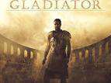

Jewish views about the afterlife (life after death)
Originally Jews believed you could be punished for the sins of your parents or your
grandparents!
Our fathers sinned and are no more, and we bear their punishment.
Lamentations 5:7

However, this view was eventually changed and it was believed that it was how you lived your own life that mattered.
Judaism teaches that death is NOT the end – they believe in eternity.
They should concentrate and worry on this life, not worry about the next life!
Many Jews believe in the resurrection of the dead when the Messiah will come:
Orthodox = resurrection of the Soul and body,
Reform = resurrection of the Soul only.
**(This is why many Jews are against cremation)**
Everyone will be judged by God. Those who have led a good life = will be close to God (heaven). Those
who have done wrong things will require purification in hell:-
Good Jews = straight to heaven and enjoy eternal life.
Bad Jews = Punished and sent to hell (sheol), but they will have a chance to repent and clear their sins.
Jewish belief in life after death gives life meaning and purpose. A Jew knows that if they worship God and follow his laws in their life, then God will reward them.
“I believe with perfect faith that there will be a resurrection of the dead ...”
Maimonides

The Soul
Watch the clip when Bart Simpson sells his soul.

Christianity and Judaism
Christians and Jews believe that only human beings have souls.
And the LORD God formed man from the dust of the ground, and breathed into his nostrils the breath of life; and man became a living soul.
Genesis
SOUL
- Christians and Jews believe that there are more to humans than only body and personality.
- The soul is the part of human nature that is not physical.
- They believe that God has given human beings a SOUL when he created them.
- The spiritual aspect of a human – the ‘real’ you.
- The soul does not die when our body dies. This gives the hope of life after death in heaven for Christians.
- A reflection of the image of God.
- Christians regard the soul as the immortal and God either rewards or punishes the soul (Heaven/hell).
- The conscience is believed by some Christians to be the voice of God in us which warns us to follow the spiritual and not material path.
- Jews do not have any clear teachings about the soul.
- Judaism teaches that God breathed the soul into Adam’s body.
- Many Jews also believe that when they die, they will be judged by God.
- Jews therefore believe that the importance of life is the way in which it is lived on earth.
- Judaism teaches that the body and soul are one; you cannot seperate them. The soul cannot exist without the body. When Adam was created it is said that God ‘breathed life into his nostrils’(Genesis 2:7) Jews see the soul as the thing that makes us alive.

Other ideas on the soul
Humanists deny the existence of a soul.
The belief amongst scientists is that the mind, or consciousness, is the operation of the brain. Some scientists think that the brain is to the mind as computer hardware is to computer software.

Heaven and Hell
Jews and Christians believe that, as humans, we only live one earthly existence, followed by eternal life in the world to come. Many traditional believers hold that after death we will rise from the dead to be judged by God, with those who God deems worthy (good) being raised to eternal life. There is less agreement
Judaism | Christianity
- When the earliest Jewish scriptures were written, it was believed that after death everyone would go to a place called Sheol – where the dead lived as shadows.  - Sheol was believed to be dark and damp, and your soul would stay there for eternity.  - However, Jews later began to believe in an afterlife spent in places called Heaven and Hell – God would judge people after death and send them to the place they deserved.  - If you have lived a good life and performed worthy deeds, you will spend eternity with God in Heaven.  - Those who have failed to lead good lives will go to hell – a place of suffering and punishment.  - Judaism teaches that the body and soul stay together after death, and that Heaven and Hell are open to both Jews and non-Jews.  Orthodox They believe that the physical body will be resurrected, intact, at the end of the Messianic Age. Because of this, the body should not be cut after death (post-mortems are frowned upon) and cremation is forbidden. A Jewish cemetery is called the House of Life (Bet ha-Hayyim) and this also reaffirms the opinion that the body will be resurrected. Liberal Liberal Jews believe that the body is simply a vessel for the soul, and it is the soul that will be judged by God. This is why some liberal Jews are now not so strongly against cremation. Reform Reform Jews are more concerned with the earthly life than with the afterlife. Their attitude is summed up by this phrase from a Reform prayer book: ‘What can we know of death, we who cannot understand life.’ | - Christianity teaches that the soul lives on after death (immortality of the soul). After death, your soul will go to either Heaven or Hell – depending upon how you lived your life on Earth.  - Heaven is often portrayed as a place of great beauty and serenity, a paradise where you will spend eternity with God – as long as you have lived a good life and followed the teachings of Jesus.  - Hell is a place of torment and pain – the final destination of nonbelievers and those who have led bad lives.  - Many Christians see Heaven and Hell as states of mind. In Heaven you will be happy and know God, in Hell, you will be unable to know God’s love.  - Catholics also believe in a place called Purgatory. Here sins are punished before the soul is able to move on to Heaven. This concept isn’t in the Bible, so Protestants reject it.  - Some Christians believe even those who led sinful lives may find salvation thanks to God’s saving power.  Traditionally, Christianity has taught that as human beings, we are born with a sinful nature. This is called original sin. Because Adam and Eve sinned by eating the forbidden fruit in the Garden of Eden, all generations to follow will inherit this sin. For humans to get to heaven we must be reconciled with God; we need to be saved and forgiven. This can only happen through believing that Jesus died on the cross to cleanse us from our sins. Liberal Christians do not accept the concept of ‘original sin’. They argue that we need to take responsibility for our own sin. It is nothing to do with a mythical Adam!

Religious and non religious views
CHRISTIANITY
- Christians believe in resurrection and eternal life; death is not the end.
- Some Christians say that heaven is our true home and our lives here on earth are the testing ground for life in eternity/next life.
- Christians believe that just as Jesus rose again after death, so will we. The Bible teaches that God is the Divine Judge and on Judgement Day he will decide who will be rewarded with eternal life in paradise and who will be punished.
- Those who believe in Jesus and have lived a good life will be taken to heaven. Those who have rejected God’s love and caused harm to others will be sent to hell.
- Other Christians say that at the moment of death, the soul leaves the body. The body decomposes, whilst the soul continues and unites with God in heaven
- Some Christians say we experience resurrection like Jesus, who came back to life in physical form.
- Paul says that, after our deaths, we will be raised as spiritual bodies, not just disembodied souls.
So it will be with the resurrection of the dead. The body that is sown perishable, it is raised imperishable; it is sown in dishonour, it is raised in glory; it is sown in weakness, it is raised in power; it is sown in a natural body, it is raised a spiritual body.
I Corinthians 15:42-44
- Many Christians ask what Paul meant when he talks about a spiritual body. The idea of an angel is the closest we can understand that.
- ²⁴ Martha answered, “I know he will rise again in the resurrection at the last day.”
- ²⁵ Jesus said to her, “I am the resurrection and the life. The one who believes in me will live, even though they die; ²⁶ and whoever lives by believing in me will never die. Do you believe this?”
- ²⁷ “Yes, Lord,” she replied, “I believe that you are the Messiah, the Son of God, who is to come into the world.” (John 11:24-27)

JUDAISM
- Some Jews have come to accept the idea of an afterlife, Olam Ha-Ba.
- Today, Judaism tends to teach that at death there will be a temporary separation of body and soul, but they will be reunited on the Day of Judgement.
- Everyone will be judged by God. Those who have lived a good lifev = can be close to God (heaven). Those who have done bad things = must be purified in hell :-
Good Jews = straight to heaven and enjoy everlasting life.
Bad Jews = Punished and sent to hell (sheol) but will be given the opportunity to repent first (say sorry) and clear their sins. Many Jews believe that judgement and resurrection will take place after the arrival of the Messiah.

Humanist views on life after death
http://understandinghumanism.org.uk/films/?film=5pWEoOXdYIE
Humanism4schools – Afterlife: Is this the only life we have?

- Humanists reject the idea that we have a soul.
- They believe in a scientific description of human life and they reject beliefs about our spiritual existence.
- We are physical beings who will decompose when we die.
- No eternal, supernatural part of us will live on.
- Humanists believe this life is the one life we have: it is not a ‘dress rehearsal’.
- Evidence is important to humanists when deciding what to believe and they see no good evidence that we live on after we die. Because this is the only life we know we have, humanists think we should make the most of it.
- Humanists agree with the scientific definition of death – i.e. the point at which our brain activity stops.
- They understand that some people believe in religious teachings regarding the after-life but feel that they were written before scientific developments and so therefore do not present a complete understanding.
- Humanists do not believe that any claims of evidence for an afterlife are strong enough to take it seriously. That is, NDEs, sightings of ghosts or channelling via a medium can be explained through science and investigations for example, many sightings have been proved to be hoaxes or could be hallucinations; mediums can ‘read’ people and there are scientific explanations for near-death experiences (tests have shown that oxygen deprivation can create the sensations associated with near-death experiences). Humanists believe there is clear evidence that our body has ceased to be alive when we die (our bodies decay and eventually nothing survives) and there is no good evidence that anything lives on.
https://www.youtube.com/watch?v=yHNq4SQxyv0
Derren Brown – How to read someone’s mind

- Humanists believe that the idea of life after death results from people’s fear of death.
- The belief that death is not the end comforts people when a loved one dies and makes them less afraid of their own death.
- Humanists also believe that the idea of reward and punishment after death has been used to control people’s behaviour in the past, and that for most Humanists, the fear of punishment in the next life is not a good reason to behave well. Humanists believe that people should treat others as they would like to be treated, being good makes us feel good, and being good helps to make the world a better place. There are many reasons why people accept or reject the belief in an afterlife.

Other beliefs about life after death (afterlife)
- Certain religions teach that we all move on to an afterlife of some kind, for some people, this will be enough to make them believe in life after death – they have faith in what their religion teaches them.
- Other people use the example of near-death experiences (NDEs) to argue that a soul exists after death. A near-death experience usually involves someone having an out-of-body experience when they are close to death. While apparently physically dead, they may have glimpsed what they believe to be an afterlife or heaven, or spoken to long-dead family members.

https://www.youtube.com/watch?v=ML2QgU4WstQ
Elizabeth Taylor describes her near-death experience to Oprah Winfrey

- Not everyone thinks of near-death experiences as proof of life after death. Some people believe that the visions are a result of the chemical activity in the brain when it is short of oxygen.
- The paranormal (things that science cannot explain e.g. ghosts) is sometimes used as evidence of life after death. Some people claim they can talk to the dead ‘beyond the grave’, and use this as proof of an afterlife.
- Other people say that events we call paranormal have a scientific explanation. Perhaps we do not yet know what that explanation is, but there will be one. Some people do not believe that these events happen in the first place.
Use the table below to summarise all you have learnt about Heaven, Hell and Judgement from the three traditions listed.
Tradition | Belief | 10 word summary
Humanists
Christians
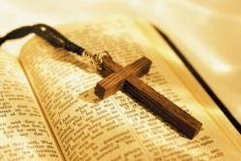
Jews
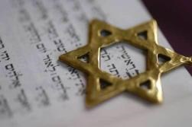

Death and Funeral Rites
RITE – a ritual or solemn ceremony

When people die, it is common to mark their death and celebrate their life in some sort of ceremony. Different religions have their own specific rituals and practices. This section gives details of how these ceremonies reflect beliefs about the afterlife.
Funeral rites
For many people, funeral rites are important. Why?
- A way of saying good-bye to the deceased;
- To thank for their lives;
- A time to value their contribution to their families and community;
- Gives hope to those who have lost someone important to them;
- Shows respect for the body of the dead person;
- It’s a time when a Christian’s soul moves from earth to heaven.

Christian funeral rites (Service)
The funeral is usually held a few days after the person has died.
A Christian can be buried or cremated.
The service starts with the vicar or priest reminding the congregation of the words of Jesus. Most funerals open with the words of John 11 – when Jesus raises Lazarus from the dead.
Jesus said, ‘I am the resurrection and the life. The one who believes in me will live, even though they die; and whoever lives by believing in me will never die.’ John 11: 25-26
Vicars/priests wear white- symbol of life after death/resurrection.
Prayers thanking God for the life of the person who has died and asking God to comfort others.
Hymns - After this, hymns that reflect the belief in life after death, or ones that offer comfort will be sung. Other readings that reflect Christian beliefs may be included too.
A tribute (short talk)–remembering the person who has died.
Catholic churches celebrate Mass (communion-bread and wine).
After the church, a service of committal by the grave- ‘Earth to earth, ashes to ashes, dust to dust …’ or a service in the crematorium which will be similar.
For those buried, a cross/stone will be placed, and Christians will visit the grave.
For those cremated, the ashes may be scattered.
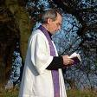

JUDAISM
In Judaism, the focus is on what happens during life, rather than being concerned about what may happen in the afterlife. Although most Jews do believe in the judgement of the deceased and their being reunited with God after death, there is not the emphasis on resurrection that is found in Christian ceremonies.
Judaism
- Reform and Orthodox Jews have different views and practices. However, both stress the importance of the synagogue in the funeral, and try to bury the body within 24 hours of death. However, not on Shabbat or the first or last days of a festival. If possible, the last words they hear should be the Shema: ‘Hear o Israel, the Lord is our God, the Lord is one.’
- Jews believe that someone who is dying or dead should not be left alone; the person should be given respect and company. The family should not bear all responsibility for this. Membership of a synagogue usually includes membership of a burial society, who makes the necessary arrangements.
- The holy society is called a chevra kaddisha.
- The Chevra Kaddisha do not get paid to care and stay with the body – it is considered an honour.
- Once the person has died, the body will not be left alone. The body will be washed thoroughly, male bodies by men, females by women, either in the Mikveh, home or mortuary.
- The body is dressed in a plain white cloth.
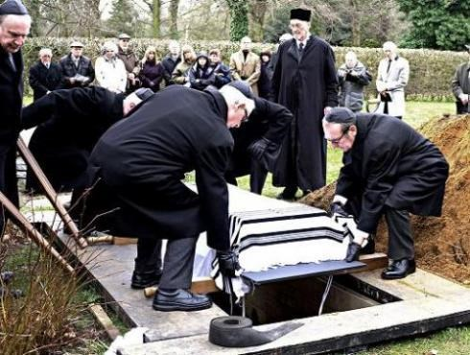
- It is then placed in a simple unpolished box with no handles or padding. This is to show that in death, all are equal. If the person is male, a tallit will be placed around the shoulders. One of the shawl’s fringes is cut. The coffin is covered with a plain black sheet.
- The funeral itself is a simple affair.
- Prayers are said, Psalms are read and the merits of the person who has died and their trust in God’s justice is stressed.
- Everyone then fulfils the mitzvah of escorting the body to the grave. Everyone will throw a spadeful of earth into the grave. Afterwards they wash their hands to show they are separated from the dead.
- The end of the funeral marks the beginning of mourning.
- The other sign that mourning has begun is the reciting of the Kaddish.
- Greetings are offered by mourners at this point, and during the week after the funeral: “I wish you a long life”.
- Those present will make a small tear in their clothes as a sign of their grief.
- On their return home, often a meal containing a hard boiled egg is eaten – symbol of new life.
- The close family of the deceased will stay at home for seven days and allow friends to take care of every day chores. This period is called shiva and allows people to withdraw from daily life and grieve.
- Mourners will sit on special low chairs, will not cut their hair or nails and cover mirrors to avoid tending to personal appearance. Sexual relations during this time are forbidden.
- During this week, music is not listened to and the wearing of leather shoes is avoided. A candle is kept burning day and night.
https://www.youtube.com/watch?v=9X-HnkZ-PUQ
[2:53 – 6:14, 7:04 - 8:05]
- Following shiva is shloshim. It lasts for 30 days after the funeral. The mourner returns to work, but things such as parties and dances are avoided.
- After 30 days, normal life is resumed, except for someone mourning a
parent.
During the year, a tombstone will be placed on the grave and there will be a short ceremony to mark the occasion.
- At the end of the year, the children will observe Yahrzeit (anniversary). This is a day of reflection and repentance, and so some Jews fast on it.
- On the eve of Yahrzeit, they burn a special Yahrzeit candle, which burns for 24 hours. This represents the souls of the departed. They may attend synagogue and recite Kaddish. They may also study the Torah and give to charity.
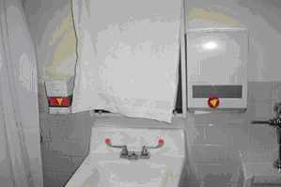
- On Yarzheit, the children visit the grave, often leaving a small stone on the tombstone.

Non-religious funeral services 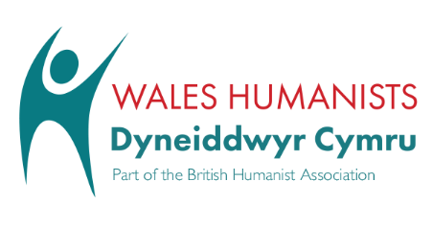
Many people today are uncomfortable with religious ceremonies and, as a result, non-religious funeral services are becoming increasingly popular. Many people want a more informal, personal ceremony, where they can choose the songs and readings and where there is no mention of God.
At a humanist funeral, those present will remember the life of the person who has died, reflecting on their contribution to the world and to others. It may include:
Music
A non-religious reflection on death
Readings of poetry
Reminiscences about the person
A eulogy (a description of why they were special)
Lighting candles
Moments of quiet reflection
The service will try to show respect for the dead person without suggesting that they are going to a better place. They will be remembered for their special, unique qualities, the life they led and the achievements they made.
http://www.bbc.co.uk/religion/religions/atheism/ritesrituals/funerals.shtml
https://humanism.org.uk/ceremonies/non-religious-funerals/
https://www.youtube.com/watch?v=wzTXicmkrQ4&feature=share

Exam Question practice and revision

KEY CONCEPTS – Within this unit, you must learn 8 key concepts. You must learn their meaning and be able to offer an example. This will be the (a) question in the exam. You will also be expected to use these terms within your answers.
KEY CONCEPT | MEANING / EXAMPLE?
Afterlife
Environmental
responsibility
Euthanasia
Evolution
Abortion
Quality of Life
Sanctity of Life
Soul

Question A
What is meant by ‘Sanctity of life’? [2]
_____________________________________________________________________________________________________________________________________________________________________________________________________________________________________________________________________________________________________________________________________

QUESTION B
(b) Describe how a religious believer would show environmental responsibility [5]
What is the success criteria for b questions?

..........................................................................................................................................................................................................................................................................................................................
.........................................................................................................................................................................................................................................................................................................................
..........................................................................................................................................................................................................................................................................................................................
..........................................................................................................................................................................................................................................................................................................................
..........................................................................................................................................................................................................................................................................................................................
..........................................................................................................................................................................................................................................................................................................................
..........................................................................................................................................................................................................................................................................................................................
..........................................................................................................................................................................................................................................................................................................................

Marked by | Mark/level | (+) | (-)
Peer

Teacher

My response to the above:

QUESTION C
(c) Explain from two religious traditions, the teachings on afterlife. [8]

What is the success criteria for a c question?

..........................................................................................................................................................................................................................................................................................................................
..........................................................................................................................................................................................................................................................................................................................
.........................................................................................................................................................................................................................................................................................................................
..........................................................................................................................................................................................................................................................................................................................
.........................................................................................................................................................................................................................................................................................................................
..........................................................................................................................................................................................................................................................................................................................
.............................................................................................................................................................
..........................................................................................................................................................................................................................................................................................................................
..........................................................................................................................................................................................................................................................................................................................
..........................................................................................................................................................................................................................................................................................................................

Marked by | Mark/level | (+) | (-)
Peers
/ yourself
Teacher

My response to the above:

Question d

(d) ‘All life is special’. Discuss this statement showing that you have considered more than one point of view. (You must include religious and non-religious beliefs in your answer). [15]
What is the success criteria for d question?

..........................................................................................................................................................................................................................................................................................................................
..........................................................................................................................................................................................................................................................................................................................
..........................................................................................................................................................................................................................................................................................................................
.........................................................................................................................................................................................................................................................................................................................
.........................................................................................................................................................................................................................................................................................................................
..........................................................................................................................................................................................................................................................................................................................
............................................................................................................................................................
..........................................................................................................................................................................................................................................................................................................................
..........................................................................................................................................................................................................................................................................................................................
..........................................................................................................................................................................................................................................................................................................................
.............................................................................................................................................................
..........................................................................................................................................................................................................................................................................................................................
..........................................................................................................................................................................................................................................................................................................................
..........................................................................................................................................................................................................................................................................................................................
..........................................................................................................................................................................................................................................................................................................................
..........................................................................................................................................................................................................................................................................................................................
..........................................................................................................................................................................................................................................................................................................................
..........................................................................................................................................................................................................................................................................................................................
.............................................................................................................................................................
..........................................................................................................................................................................................................................................................................................................................
..........................................................................................................................................................................................................................................................................................................................
..........................................................................................................................................................................................................................................................................................................................
..........................................................................................................................................................................................................................................................................................................................
..........................................................................................................................................................................................................................................................................................................................
..........................................................................................................................................................................................................................................................................................................................
..........................................................................................................................................................................................................................................................................................................................
..........................................................................................................................................................................................................................................................................................................................

Marked by | Mark/level | (+) | (-)
Peers
Teacher

My response to the above:

Self-evaluation of the unit – Death and the Afterlife
- Do you know your target?

- Test mark for this unit? % Grade:

- Are you on track?

If not, why?

- Do you have homework regularly?

- Do you know the success criteria to some questions?

- Have you self-assessed/assessed peers during this unit?

Standard of your work:
Happy with | Difficulties with
Teacher response?

