R.E REVISION

UNIT 1 – YEAR 10
Booklet 1 – CHRISTIANITY

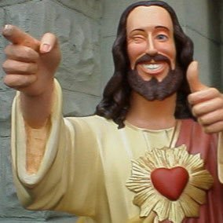

Name:

UNIT 1 Part A – CHRISTIANITY
These terms are the key concepts for this unit – Christianity. There are 13 terms you must learn for the exam! You must learn their meanings as well as provide an example for each. This will be question (a) in the exam. You will also use some of these concepts in every other answer.

God: Supreme, Ultimate being. Ultimate power given worship.
Omnibenevolent: All-loving and good e.g God.
Omnipotent: All-powerful, almighty and unlimited nature of God.
Omniscient: The all-knowing nature of God.
The Trinity: The Three persons of God – God the Father, Son and Holy Spirit.
Agape: Selfless, sacrificial, unconditional love. The highest types of love by Jesus’ sacrifice on the cross for others and his teachings e.g 'Love your neighbour'.
Divine Command Theory: The belief that something is right because God commands it.
Inter-faith dialogue: Different faith/religious communities/groups coming together to understand each other better and to serve the wider community with respect that allows them to live peacefully alongside each other in spite of differences in beliefs and ways of life.
Incarnation: ‘Made flesh.’ God became man/human in the person/form of Jesus.
Atonement: The belief that Jesus’ death and resurrection healed the rift between humans and God. Opening the way for God and people to be 'at one' again.
Holy Spirit: One of the three persons of the Holy Trinity. Jesus promised his disciples/followers that he would send the Holy Spirit after his Crucifixion and Resurrection. Christians believe that the Holy Spirit is present, as the power of God at work in the world.
Resurrection: The belief that Jesus rose from the dead on Easter Sunday, conquering death.
Messiah: The word means ‘the Anointed One'. The Messiah is the one believed to be sent by God to be humanity’s saviour. Christians believe this person to be Jesus.

GOD AND JESUS

God
- Creator and sustainer, omnipotence, omnibenevolence, omniscience, omnipresence
- Beliefs and teachings on Creation from the Genesis accounts (Genesis 1-3, Genesis 1:1-3)
- Nature of Humanity: image of God, soul, moral, free will, rational, creative, fallen, (Genesis 1-3, Genesis 1:26-28 and 2:15-17)
- Trinity: The three aspects of one God - Father (Luke 15:11-32), Son (John1:1-3, 14), Holy Spirit (John 14:25-26, Galatians 5:22-23)

Jesus as God Incarnate
- Son (John 1:1-3, 14), Holy Spirit (John 14:25-26, Galatians 5:22-23)
- Jesus as Messiah (Matthew 16:13-17), Saviour, Word: the Incarnation (John 1:1-3, 14), salvation and atonement (John 3:16, 14:6)
- Jesus' birth, (Matthew 1:18- 2:12 and Luke 1:26-35 and 2:21), death (Mark 15:1-39), resurrection (John 20:1-21) and ascension (Acts 1:9-11)

God

Christians believe in one God – monotheism who is eternal. They use several words to describe the nature of God:

CONCEPTS |  | MEANING
Creator | 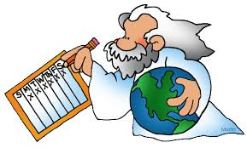 | God is the creator and giver of all life. He created humankind in his image. The universe was designed and made by God; it did not come by accident. E.g God created everything. ‘In the beginning God created the Heavens and the Earth.’ Gen 1:1.
Sustainer |  | God looks after everyone and everything, keeps everything in order and controls history - keeps it going. God created the universe, God did not abandon it. E.g God’s role as a sustainer is like a parent – a ‘Father’.
Omniblovence |  | All loving, good. God loved humanity that he sent Jesus to earth so that he could have eternal life. God is good and loving. E.g After God created the world he saw it as good. God created everyone to be equal.
Omnipotence  Moses -Plagues | 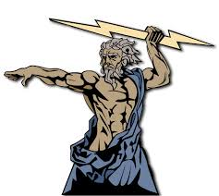 | God has power over everything he has created. E.g in the Old Testament, God told Moses to lead the Jews out of Egypt. God sent 10 plagues and parted the Red Sea to help the Jews escape from slavery.
Omniscient  Bruce Almighty |  | God knows everything because he created everything. God has plans for every person. E.g God having a direct influences over future events – Jesus was to be killed, Mary would have a son called Jesus.
Omnipresence |  | God is everywhere throughout time. E.g God influence all things, relationship with his creation.

How did the universe begin? Gen 1:1-3
For many religious believers, God is the cause/creator of the universe. There are many different views how the universe began.

GENESIS 1 - THE CREATION: Christians believe that God created the world. The story of creation can be found in the book of Genesis, the first book of the Bible. God created everything over seven days and ‘it was good.’
Day 1 - God created night and day. God called the light Day and the darkness Night.
Day 2 - God created the heavens. God made the heavens/sky and separated the waters.
Day 3 - God created land and plants. God said ‘Let the waters under the heavens be gathered together in one place, and let the dry land appear.’ ‘Let the earth put forth vegetation, plants yielding seed, and fruit trees bearing fruit in which is their seed, each according to its kind, upon the earth.’
Day 4 - God created the sun, moon and stars. God made the two lights to rule the day and night and the stars.
Day 5 - God created birds and fish. God said ‘Let the waters bring forth swarms of living creatures, and let birds fly above the earth across the heavens.’
Day 6 - God created living creatures including man. God said, ‘Let us make man in our image, after our likeness; and let them have dominion over the fish of the sea, and over the birds of the air, and over the cattle, and over all the earth, and over every creeping thing that creeps upon the earth.’
Day 7 – God rested: ‘And on the seventh day God finished his work which he had done, and he rested on the seventh day from all his work which he had done.’

https://www.truetube.co.uk/film/beginning

GENESIS 2: God made Adam first and placed him in paradise, the Garden of Eden. He was formed from the dust of the ground and the breath of God (soul) making him the son of the earth and a child to God. God creates Eve out of Adam’s ribs. People were created in God’s image. God gives them one rule - not to eat from the tree of knowledge.

GENESIS 3: The Fall Adam and Eve are tempted by the devil, in the form of a serpent, to eat the fruit from the tree against God’s will. In time, Eve gives in to the temptation, eats the fruit and gives some to Adam. They confess to God what they have done and as a punishment, He sends them out of the Garden of Eden. They are no longer allowed to eat from the tree of life, which has given them eternal life, so death enters the world.

LITERALIST views | NON-LITERALIST views
Some Christians believe that the world was created in 6 days as Genesis says. This is a literalist view - believing something exactly as it is stated. | Other Christians believe that Genesis shows that God created the world and that the world would not exist without God. But they also accept scientific ideas and say that it is God who made the Big Bang happen. It is a way of showing that God is powerful. This is called a non-literalist view.

What does the story in Genesis teach Christians?
- God created everything for a purpose.
- The world was created out of nothing, therefore God is powerful.
- The beginning of the world and life was no accident.
- God created the world on his own - He did not have any help from anyone else. This shows that He is powerful.
- The creation stories can be read as myth (and not just literally).
- The creation stories are eternal stories.
- They are relevant today as ever.
- Meaning of Genesis 1: God is responsible for the creation; people are important- People to be rulers of the world, and be good stewards. Shows the development of the world.
- Meaning of Genesis 2 and 3 - Concerns the beginnings of human life; the relationship between God and people was broken because Adam and Eve sinned by eating the apple.

The nature of humanity

1. After God finished creating the world, he said it was ‘good’. People were created in the image of God and God saw it was ‘very good’. God commanded that man was to look after and sustain the world, care for the earth and everthing in it. That is why Christians believe in stewardship – looking after the world.
2. Christians believe that God has given human beings a soul when he created them - the part of human nature which is spiritual and influences an individual’s personality. The soul allows people to relate and connect with God.
3.Free will – People ‘s ability to make choices in life. People were created with the ability to obey God or not - their choice. Eve chose to eat the fruit from the tree of life and disobey God. Some people turn against God-given reason and free will. People have abused the gift of free will and continue to sin e.g. crime, war.
4.Moral – When making moral a decision our free will helps us to judge if an action is right
or wrong. Immoral acts (wrong behaviour) separates people from God e.g Adam and Eve.
People are made in the image of God, but are sinful and need God’s forgiveness. People
have ‘dominion’ (power) over the earth, and must show stewardship. Jesus is a role
model for humans. God created people to have a moral sense. Animals have no moral
understanding. The 10 Commandments includes moral rules commanded by God e.g not to
steal, not to kill.
5.Rational – God created people to use their reason to make decisions. Christians believe
humans have God-given reason which divides humans form animals.
6.Creative – Humans have evolved into creative creatures. This is proof of God’s existence.
God passed on to humans the ability to create – e.g God created the plants, but wanted people to use their creativity how to use them. Plants are used for food, clothing, furniture,
medicine etc. Christians use their skills to show their faith and God’s given talents.
7.Fallen – Humans have God-given reason and free will to turn against God and 'fall'. The Fall (Genesis 3) shows when the relationship between God and people was broken. Jesus dying on behalf of people helped to restore the broken relationship with God

Trinity

Christians believe in One God. They think of God in three ways:
- God the Father
- God the Son
- God the Holy Spirit
These are not three different gods. The trinity is One God in three persons:

The three parts of the trinity do different things, although they work together.
- God is the Father – Creator
- Jesus is the Son – Saviour
- Holy Spirit – the one who gives new life
‘The Father, the Son and the Holy Spirit’ - The 3 in 1, and 1 in 3. This is called the Trinity – God in three forms.
Christian beliefs about God
One God.
Creator of the world- He looks after everyone and everything keeps everything in order and controls history- sustains it-keeps it going. He created the world alone, which shows that God is powerful (omnipotent).
God for humans is beyond all understanding, and is a mystery. God is the name man gives to the mystery of life and creation. God is infinite (no ending).
Everywhere (omnipresent) and all-knowing (omniscient).
Father - He loves his people like a Father, and cares for them. What does The Parable of the Prodigal Son by Jesus tell us about the role of God as a father?

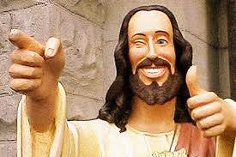

Christian beliefs about JesusWhat do we learn about God as the Son?

Jesus is the Son of God: Son of God - holy person. God incarnated himself (made himself a man), and was born on earth in the form of Jesus. Jesus was divine (part of God), and a human being at the same time.

Messia: Meaning - Anointed One – someone who has been chosen. Christians, believe he will return to earth again as a King and Judge and bring peace on earth.

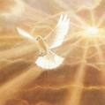
Atonement: Jesus’ death and resurrection healed the rift between God and people. Jesus would ‘take away the sin of the world.’

God incarnate -Jesus as God Incarnate = Jesus is God in human form. Incarnation means ‘made flesh’. God becoming human in the form of Jesus.

Word - Jesus was God from the beginning. Just as words help people to communicate, Jesus helped people to communicate with God. Christians can connect with God through worshipping Jesus.

Jesus is the Saviour: Meaning – saviour (saves), brings forgiveness. Jesus died on the cross so that people could have eternal life with God in heaven.

Christian beliefs about God the Holy Spirit
Invisible force or power that inspires Christians to do good things.
When Jesus left his disciples, they were worried; therefore, he told them that he would send a ‘comforter’ to help them- the Holy Spirit.
Gifts of the Holy Spirit:
“All this I have spoken while still with you. But the Advocate, the Holy Spirit, whom the Father will send in my name, will teach you all things and will remind you of everything I have said to you.”

“But the fruit of the Spirit is love, joy, peace, kindness, goodness, faithfulness, gentleness and self-control.”
Gifts of the Holy Spirit: guides people; performs miracles– heals people; preach; speaking in tongues – speaking a language others cannot understand (like Harry Potter can speak parcelmouth).

The Cruciﬁxion
- Jesus in conﬂict with the Jewish authorities.
- They accused him of blasphemy because he claimed to be able to forgive sins.
- His followers believed he was the Messiah- this led to his arrest.
- He was crucified – suffered.
- He’s cruciﬁed on Good Friday with two criminals.
- Crown of thorns on his head.
- Jesus prays on the cross.
- Jesus cried “My God, my God, why have you forsaken me?”
- Jesus dies on the cross. ‘From noon until three in the afternoon darkness came over all the land’.
- Christians believe Jesus was a God and human, he suffered like any other human being.
- Jesus’ suffering means that God understands human suffering.
https://www.truetube.co.uk/film/crucifixion-2014

Ascension
- After Jesus rose from the dead he appeared to the disciples and groups of other people.
- He ascended (rose up) to his father in heaven.
- For Christians, it marks an end of Jesus on earth as a human, and accepts Jesus’ spirit at work in the world.
- The idea of going suggests power and success.
- Jesus had become the most important person in human history.
- He now lives in God.
- Good has won over evil.

THE LIFE OF JESUS
BIRTH – MATTHEW https://www.youtube.com/watch?v=O9VyT9sY_Dc
- Mary was engaged to Joseph, but found out that she was going to have a baby by the Holy Spirit.
- Joseph was worried about this and planned to break off the engagement.
- An angel told him It was by the Holy Spirit that she had conceived.
- She would have a son and they were to name him Jesus.
- Jesus was born Bethlehem and Herod was the king.
- Men who studied the stars came to Jerusalem and asked,” Where is the baby born to be king of the Jews? We saw His star when it came up in the east and we have come to worship Him”.
- Herod called the visitors to a secret meeting and found out when the star had appeared.
- They went to Bethlehem and gave Him gifts of gold, frankincense and myrrh.
- God warned them in a dream not to go back to Herod.
- An angel spoke to Joseph in a dream and said “Herod will be looking for the child in order to kill him. So take your family to Egypt and stay there until I tell you to leave”.
- When Herod realised that he had been tricked he gave the order to kill all the boys in Bethlehem who were under two years old.
- After Herod died an Angel appeared to Joseph in a dream and told him to go back to Israel.
- Jesus as the Son of God – his birth was respectable- parents married, born in a house.
- Received gifts.
- Jesus as a Messiah, suggesting that his death would be important.

BIRTH - LUKE
- God sent the Angel Gabrielle to Nazareth.
- Told Mary that she would give birth to a child named Jesus.
- She was a virgin when she gave birth to Jesus.
- She will conceive through the Holy Spirit.
- The Emperor Augustus ordered a census.
- They had to stay in a stable.
- Mary gave birth to Jesus.
- There were shepherds taking care of their sheep.
- The shepherds went to Bethlehem and saw the baby lying in a manger.
- Jesus was circumcised.
- Jesus as a Messiah.
- Jesus as a human being – born in a stable, his parents were not married, visit by ordinary men, did not receive any gifts.

The Resurrection
- Important to Christians.
- When Jesus rose from the dead.
- Miracle- evidence that Jesus was God.
- On the Sunday after his cruciﬁxion, some of Jesus followers went to his tomb.
- The stone covering the tomb rolled away and Jesus’ body was not inside.
- Jesus appeared to Mary Magdalene in a garden, and his disciples.
- To be a Christian is to believe in the resurrection.
https://www.truetube.co.uk/film/resurrection-2014

LIFE OF JESUS

MORALITY
- Divine command/absolutist and situational/relativist approaches to ethical decision making
- Teachings of Jesus (Matthew 7:13-14 Matthew 25:31-46)
- Love / agapé (Luke 10:25-37; John 13:34-35)
- Forgiveness (Matthew 6:5-13; Matthew 18:21-22; Luke 23:34 Matthew 5:43-44)
- Treasures on earth / in Heaven (Matthew 6:19-21; Luke 16:19-31)

Morality deals with what’s right and wrong yn life.

- Absolutist - There is a right course of action that is true in all situations, regardless of culture, religious tradition, time or age. e.g. it’s always wrong to kill.
- Divine command - An action is good if it’s been commanded by God but evil if it’s been forbidden by God e.g murder is wrong for everyone,everywhere because God said in the Bible ‘Do not kill.’
- Situationalist / Relativist – Sometimes a different course of action might be needed in e.g. It’s usually wrong to kill but sometimes it might be necessary.

What did Jesus teach?
- WEALTH – The Rich man and Lazarus
- Good deeds will reward a person after death = heaven.
- In the parable – a rich man does nothing to help a beggar – Lazarus. When they die, the rich man goes to hell, and Lazarus to heaven.
- How a person lives their life will affect the next life. People fail to take notice of this message.
- FORGIVENESS
- Parable of the unforgiving servant.
- Jesus’ teaching: ‘Blessed are the merciful.’
- Jesus’ words on the cross, ‘Father, forgive them as they do not know what they are doing.’
- In the Lord’s Prayer, it says ‘Forgive us our trespasses as we forgive those who have trespassed against us.’
- Jesus said ‘Forgive, and you will be forgiven.’
- The reconciliation process cannot begin until the sufferer has forgiven the person causing the suffering.
- Forgiveness gets rid of hatred and revenge.
- AGAPE http://request.org.uk/issues/big-questions-what-is-love/
Selfless love. Highest type of love e.g Jesus died on the cross for others. Jesus said ‘love one another.’ Putting the welfare of others first. Love one another. Put others first.
- THE GOOD SAMARITAN https://www.youtube.com/watch?v=53Pqw20xK10 5.11.m
Jesus said: Jesus sais ‘love your neighbour as yourself.’ Who deserves love? Anyone who needs it. Love your enemies. The Golden Rule tells Christians to treat other people as they would like to be treated.

The Parable of the Sheep and Goats -- https://www.youtube.com/watch?v=iWSkdx-XwWY
Jesus uses a shepherd to divide the sheep from the goats in order to help people understand about what will happen at the end of time. People will be separated into 2 groups:
- Those who have lived a good life and believe in God will go to heaven.
- Those who refuse to believe in God and do bad things will go to hell.

Examples of morality today?

THE CHURCH

Diversity of Christianity: Catholic, Anglican, Church in Wales, non-conformist churches and chapels

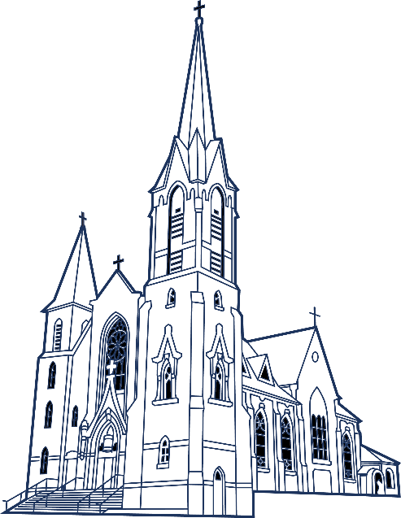

Christianity comes from the name ‘Jesus Christ.’ Christianity developed, and today there are 3 main branches:
- The Catholic Church
- Orthodox Church
- Protestant Church (Anglican, Methodists, Baptists)

ROLE OF THE LOCAL CHURCH

Worship Sunday school Meal for the homeless Food banks
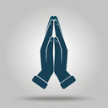
ROLE OF THE LOCAL CHURCH

Youch club Coffee morning for the elderly

Mother’s Union Creche fod young mothers and
children
Fairs to raise money Brownies, Guides

Christmas lunch for the elderly Shelter during emergencies
Services –Baptism, marriage, funeral
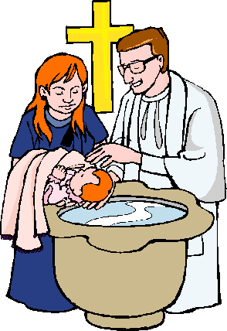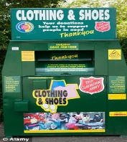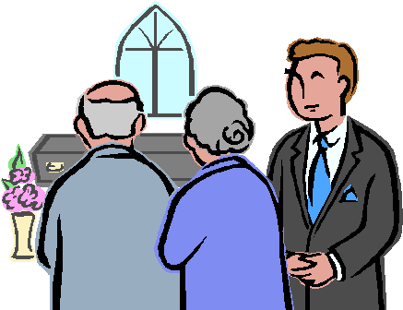

http://request.org.uk/life/church/what-is-church/

Describe the role of the church in its local community [5] Include the following :-
- To believers, it is a place of worship
- It provides fellowship
- Activities for children/educates children through the Sunday School
- Youth Club, ‘Ti a Fi’, Pensioners lunch club, Food Bank etc.
- Hold community events for young people, e.g. Scouts, Guides
- Moral and spiritual guidance
- A place to celebrate changing world rites/sacraments and/or festivals
- Supporting community causes
- The priest/minister can be a voice for the community
- Focus for charitable events and contact with schools.

Diverse features of churches and chapels and diversity of worship practices

Why worship in particular buildings?
- To worship God
- There is a special atmosphere there – God’s house
- An opportunity to worship with others and develop a sense of community
- It is a place which is used to celebrate life events, such as births, marriages and deaths
- The symbols/artefacts in the building can help the act of worship
- It is a tradition

Watch: https://www.truetube.co.uk/film/holy-cribs-anglican-church
http://request.org.uk/people/places/a-tour-of-a-welsh-chapel-english-and-cymraeg/

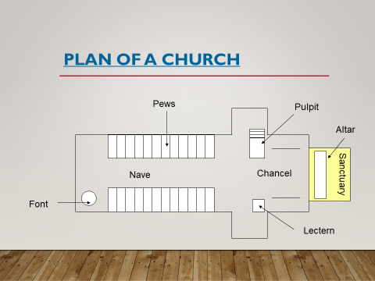
Features in the church
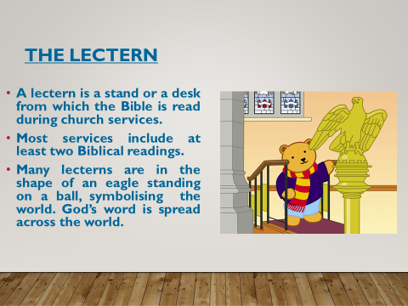
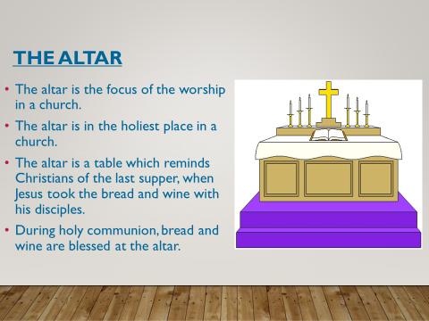

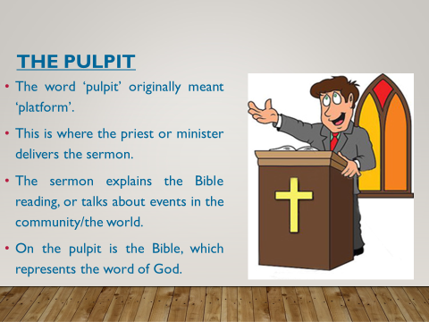
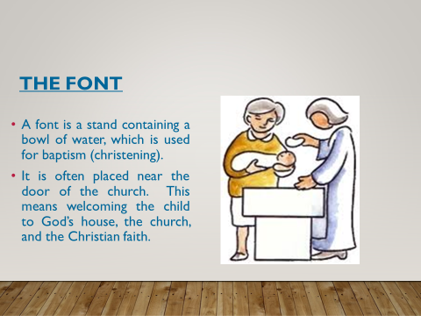
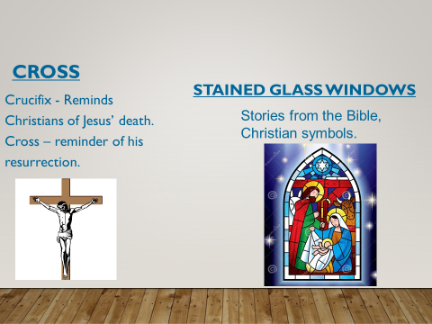

BAPTIST CHAPEL
Chapels tend to be simpler than Church buildings. Chapels don’r have a spire, and less symbols inside.
BAPTISTERY - A pool to baptise adults.

PULPIT - The main part in a chapel – this is where the minister will read the Bible and preaches.

COMMUNION TABLE - Not the most important feature. Communion will be given once a month and taken to the people in their seats.

Differences between a Church and a Chapel?
CHURCH | CHAPEL
What is worship?
- A way of communicating with God.
- Worship shows what Christians believe about God.
- Worship is the term used to describe the words and actions given to God.

Why worship?
- Communicate with God.
- Show faith
- Believers to come together as a community
- Way to give thanks to God, or ask for something
- Ten Commandments, it says to ‘keep the Sabbath day holy’ – commandment to worship God.
How do Christians worship God?
Praying | 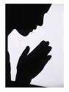 | A way of communicating with God—a conversation with God. Some Christians pray on their own  everyday or on special occasions. Jesus Christ gave an example of a prayer to his followers. People  pray for a variety of reasons for example to thank, to think about others, ask for help, ask for  forgiveness.
Sermon - Preaching | 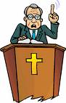 | Sharing the religion helps others to learn about the religion. The sermon is based on the Bible. It helps Christians to live a good moral life. The vicar might discuss important issues/events in the community ot in the world. It takes place at the pulpit.
Reading the Bible |  | God’s Word, used in every service. It has two parts —the old Testament and the  New Testament. It is used in every service and during special occasions such as  marriage, baptism, communion and festivals. It’s kept on the lectern, pulpit and altar.
Singing |  | A way of worshipping, to show that Christianity is something to be expressed through music. They show religious experiences. Christians worship this way during services on Sundays, marriage, funeral, communion. Some talk about God, Jesus, Biblical stories or special events.
Liturgical worship | 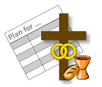 | Follow a set pattern as part of public worship e.g the communion service, following a service in a book.
Informal worship |  | Worship that does not follow a set pattern e.g modern Charismatic Christians involves falling, laughing, speaking in tongues beacuse of the of the work of the Holy Spirit.
Individual worship |  | Christians might worship alone e.g at home to form a personal relationship with God. Praying, meditate, study the Bible, singing hymns can be done at home.
Salvation Army | 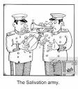 | Music is very important as part of worship. Some are members of a brass band.

Importance of prayer, communal and private - Matthew 6:5-13, 18:20

- Praying is a way of communicating with God.
- Praying was important in Jesus’ life.
- Jesus said that Christians should worship God in the correct spirit. Christians should worship God with all their mind, action and words.
- Christians pray for different reasons e.g: Confession, Repentance – saying sorry, Thanksgiving – giving thanks, ask for something.
- Jesus taught his disciples to pray, and encouraged them to pray to God as the Father.
- “ …But when you pray, go into your room, close the door and pray to your Father…. And when you pray, do not keep on babbling… because of their many words. Do not be like them, for your Father knows what you need before you ask him.” Matthew 6:5-8
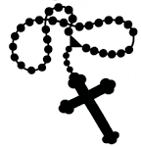
- Private prayer means to pray alone. This is important to Protestants as it’s a time
when they can personally connect with God.
Catholics, use a rosary to meditate and concentrate on the life of Jesus whilst praying.
- Communal prayer - praying with other Christians e.g during church services, or a meeting of Christians who have arranged to pray together. This can help Christians connect with each other and God, and help strengthen the Christian community. They might pray on behalf of individuals from the community e.g those who are ill or pray because of an event.
- Set prayers e.g the Lord’s Prayer is recited in most Christian services and is a prayer which Jesus used to help teach his followers to pray.

DIVERSITY

FEATURES | CATHOLICS | ANGLICAN (CHURCH) | PROTESTANT (CHAPEL)
AUTHORITY/ LEADER OFTHE DENOMINATION | The Pope  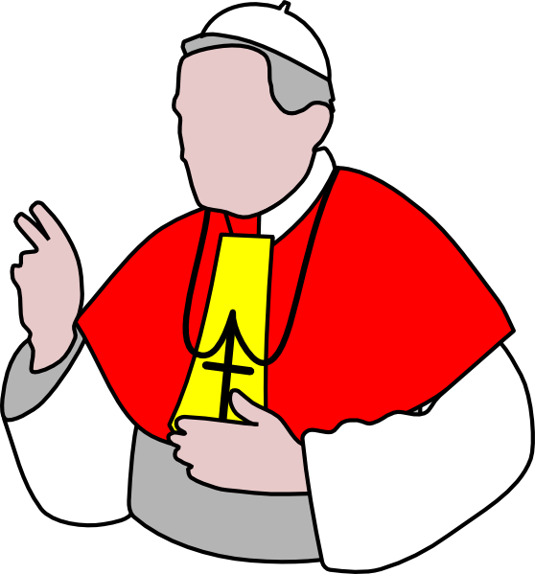 | Archbishop | Bible – God’s Word
WORSHIP | Formal – Liturgy  Set pattern – follow a service book | Liturgy - Set pattern – follow a service book and variety. | Listening to God’s word and sing his praises.
PRAYER | Priest leads the prayer. Private prayer with a rosary (prayer beads), communal prayer and set prayers.  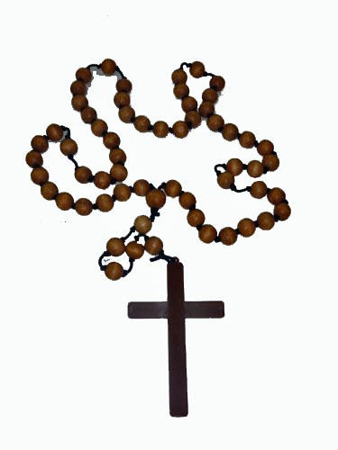 | Private prayer, communal prayer and set prayers. | Private prayer, communal prayer and set prayers.
LEADER | Priest | Vicar | Minister  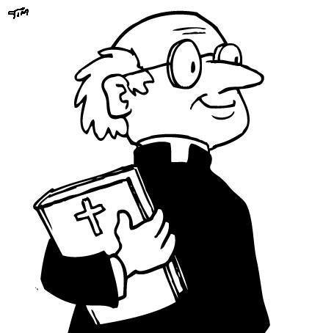
LEADER | Male | Male or female  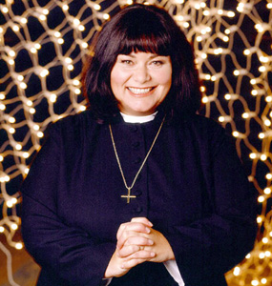 | Male or female
LEADER | Not allowed to marry | Allowed to marry | Allowed to marry
MAIN  FEATURE IN THE BUILDING | Altar  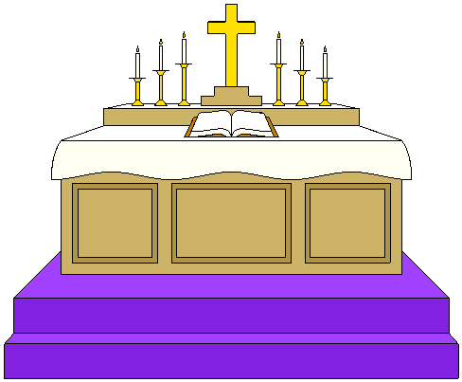 | Altar | Pulpit – Bible and sermon = God’s Word.
BUILDING | Shape of a cross. Spier (tower – pointing towards heaven). | Shape of a cross. Spier (tower pointing towards heaven).  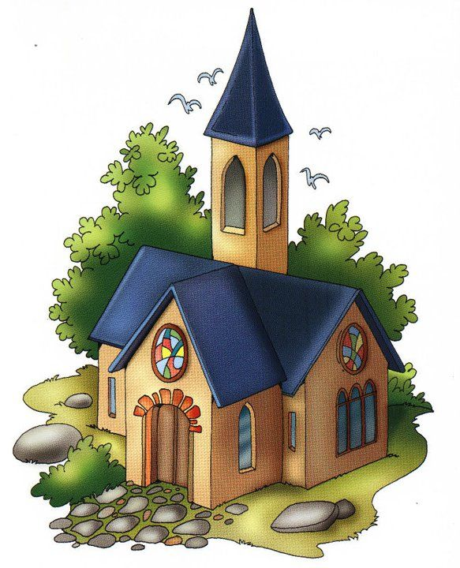 | Square and no spier.  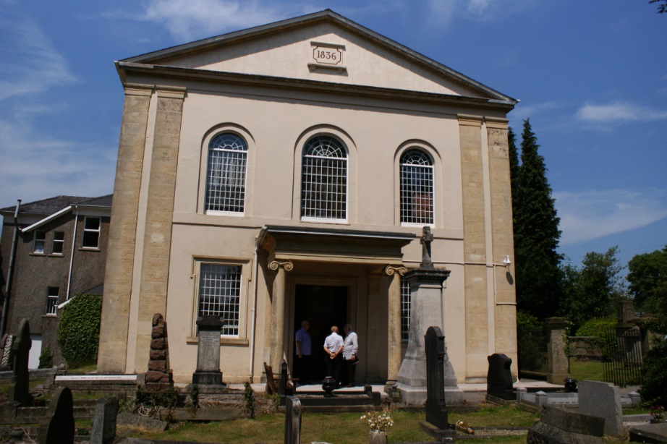
SERVICES  (SACRAMENTS) | 7 e.g baptism (babies), mass/communion (bread and wine), marriage. | Many e.g Baptism  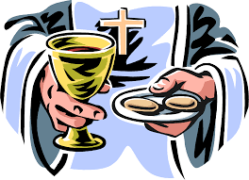  (babies), marriage communion. | They do have the communion, but not as often. Baptise adults.  Quakers, Salvation Army – no spe cial services of sacraments e.g communion, baptism.
SYMBOLS | Many e.g statues, cross, stained glass windows.  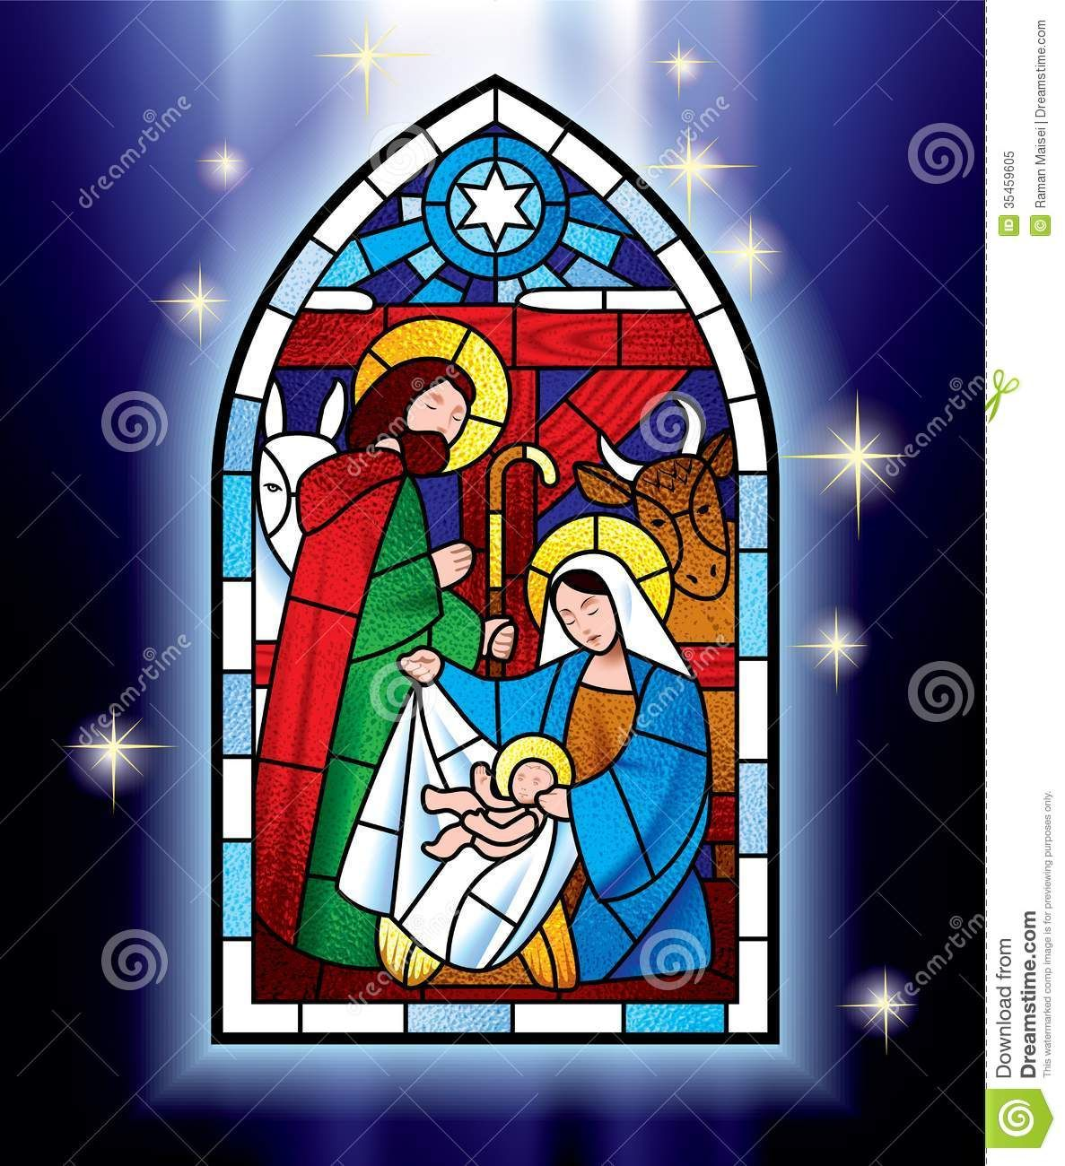 | Many e.g crucifix, cross, stained glass windows. | Plainer and simpler.

Social and community functions of churches

FOOD BANKS
Christians have a duty to care for the world. Jesus taught his followers have a duty to do good to others.
- This could be done by supporting food banks.
- Food banks provide food packages for people who are at risk of not being able to afford to feed themselves and their families.
- Food banks are collected in school, supermarkets, churches. Those who need help are given tokens for food which should last three days.
- Some churches will ask members of the community to donate items:
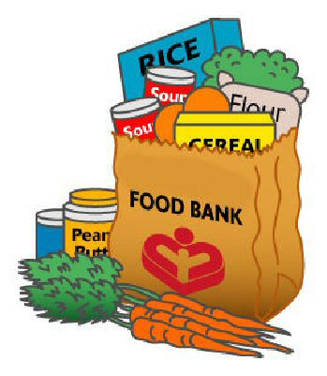
- tinned fish
- tinned meat
- fruit
- vegetables
- tea and coffee
- toilet paper
- cleaning products
- toiletries, such as soap and shampoo

THE SALVATION ARMY - https://vimeo.com/144131275
- The Bus project works in cities throughout the year. Support the homeless– urgent care.
- Programmes to help people who are addicted to drugs, alcoholics.
- Teach and give skills training.
- Help prisoners who are about to leave the jail.
- Collect clothing – clothes bank.
- Help to find missing people.
- Care for the elderly, providing meals, arrange clubs/activities, visit them in their homes.
- Help and support women and children who have suffered violence.
- Run creches, play clubs for children.
- Support people who are unemployed.
- Support people who have suffered from Slavery
- Forget Me Not Cafe, Wrexham- help people who suffer with dementia, their families and carers.
- Medical help.
- Salvation Army Churches provide shelter for the homeless during bad weather.

http://request.org.uk/issues/social-issues/big-issues-homelessness/

- Raise money for homelessness – Event Slippers for Shelter Cymru.
- Wales Prison Link - Give support and advice for the homeless before leaving prison.
- Shelter Cymru – helps home situations.
- Advice on debt.
- Arian Ifanc, Abertawe - Free service that helps young people aged between 16-24 with budgeting skills, e.g: How to save and plan for the future, Money lending, Debt advice, explain credit scoring and how to improve it.
‘Young Money’ is a project for young people 16-24. Teaches young people how to handle money.

Christian groups working for Social justice
http://request.org.uk/life/church/churches-together

Injustices in the world

Social justice
- Promoting a fair society by challenging injustice and ensure equal opportunities / rights.
- Many people in the world do not have social justice and do not have their basic needs.
- Christian churches are supportive and work together to fight against social injustice.
- Living in a multi-cultural society means there’s more need for people to work together.
- Unless religious believers come together and understand each other, and share their common beliefs in peace, conflict will always exist.
- Ways of doing this - visiting each other’s places of worship and seeing what they have in common. Go to Inter-faith Network meetings and hold Inter-faith Weeks.
- When people respect each other’s identity and faith, then it’s possible to work together and get along, regardless of any differences.

There are many Christian charities and groups that fight hard to make the world a fairer place for everyone.

TEARFUND - https://www.youtube.com/user/Tearfund
- Tearfund is a Christian charity that aims to help the poor.
- They base their work on Christian beliefs and teachings, such as love thy neighbour.
- They carry out their work through local churches and help to:
- campaign against poverty
- encourage self-help
- provide emergency aid when natural disasters happen
- spread the word of Jesus to be compassionate and help others
RECONCILIATION
Reconciliation: Reconciliation after an argument, and beginning to co-operate once more. Religions teach about forgiveness as it leads to moving forward and finding solutions.
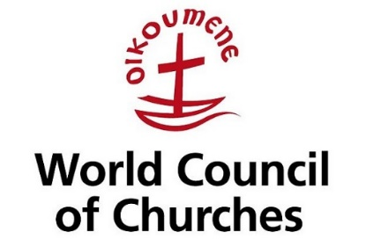

WORLD COUNCIL OF CHURCHES
- The World Council of Churches aims to bring Christian denominations together.
- It unites people who share the same faith/religion / denomination.
- Bring churches together after disasters/tragedies, and help respond to world
problems.
- Each year, the World Council of Churches holds a special week of prayer.

INTER-FAITH DIALOGUE
Inter-faith Dialogue: Different faith groups speaking to each other. There are many examples of local and national inter-faith networks and these help to solve misunderstandings.

Interfaith Wales
- It was set up in an attempt to promote better respect and understanding
between religious communities.
- It has different representatives from all the major world religions following the
terror attacks of 9/11.
- The 9/11 terror attacks were carried out by the terrorist group al-Qaeda on 11 September 2001. The attacks involved three planes being hijacked and crashed into the two towers of the World Trade Centers in New York and the Pentagon building in Arlington County, Virginia. 2,996 people were killed in the attacks.
- The main aims of Interfaith Wales are to increase knowledge and understanding of the different beliefs and practices of the different faith communities in Wales; promote good relationships between people of different faiths.
- They organise interfaith week which takes place every year to help raise awareness of different faiths.

Christian persecution today
Christian persecution refers to cruel treatment, often due to religion or belief. Jesus told Christians to spread the word of Christianity, and knew that this may put them in danger.
‘And you will be hated by all for my name’s sake. But he who endures to the end will be saved. ‘ (Jesus)

Christians are persecuted because of their beliefs. One example is an Islamic State forcing Christians out of their homes and bombing churches.
Open Doors help persecuted Christians by:
- training Christians and church leaders to support them through the trauma they may have suffered
- provide advice and support to Christians who have been victims of disaster
- speaking on behalf of Christians to help raise awareness of the situation they are in
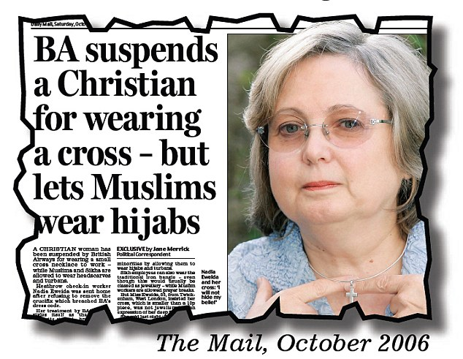
https://www.youtube.com/watch?v=6nA7rqqNTZg

