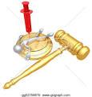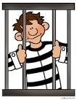**REVISION YEAR 10**

**RE**

**Booklet 4**

Issues of Good and evil

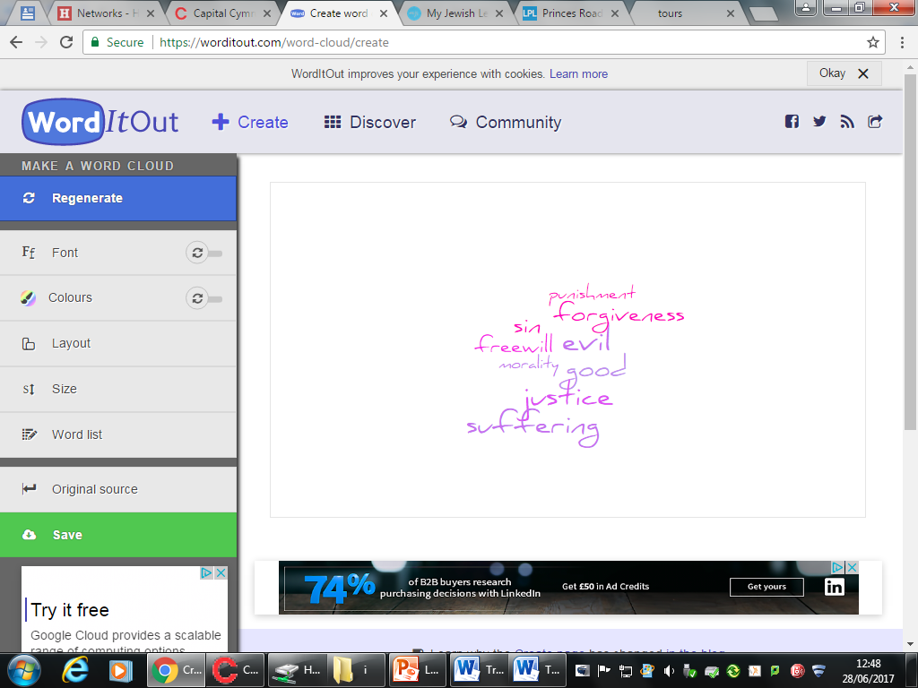

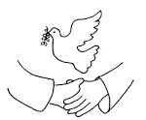

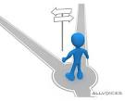



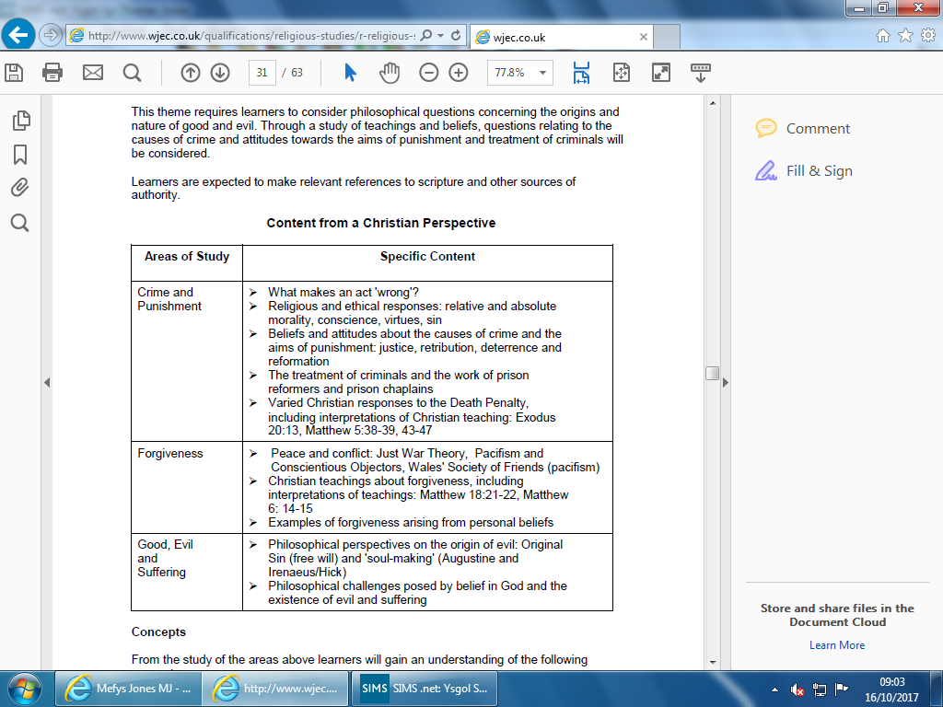

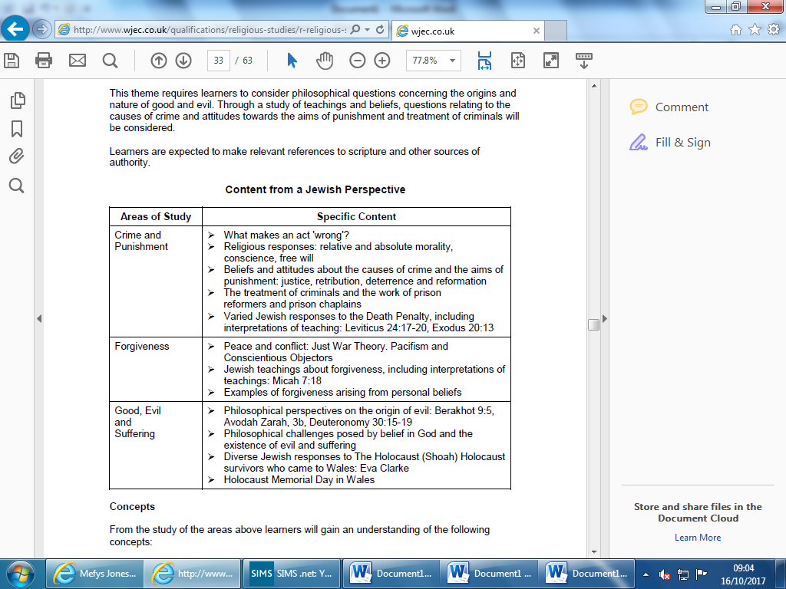

**KEY CONCEPTS –** within this unit, you must learn 9 key concepts. Learn their meaning and give examples. These will be the (a) question in the exam, and use them in other answers.

|  |  |
| --- | --- |
| **Key concept** | **Meaning / Example?** |
| **Good** | What is considered morally right, and to our advantage e.g help a person in need. |
| **Evil** | What is considered immoral and wrong e.g murder. |
| **Forgiveness** | To grant pardon for a wrongdoing; not wanting revenge against a wrongdoer e.g Gee Walker forgave those who murdered her son. |
| **Free will** | The ability to make choices e.g people make good choices in life – acts of kindness, MLK. |
| **Justice** | Fairness where everyone has equal provisions and opportunity e.g a criminal given the correct punishment for their crime. |
| **Morality** | Principles and standards determining which actions are right or wrong e.g keeping to the law of the land. |
| **Pacifism** | The belief that war and violence is wrong, unjust e.g Quakers are against war. |
| **Conscience** | A person’s moral sense of right and wrong. Religious people believe it’s the voice of God e.g to forgive, to make moral decisions such as abortion. |
| **Suffering** | Pain caused by illness, loss. Suffering can be physical, emotional, psychological or spiritual e.g Holocaust, natural distasters. |

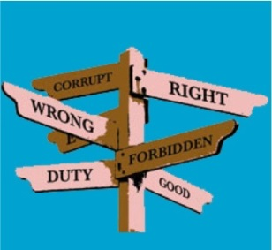**Making moral decisions**

People use a variety of sources to make decisions:

Scriptures Religious leaders Consience

Reasoning Free will Past experiences The Law

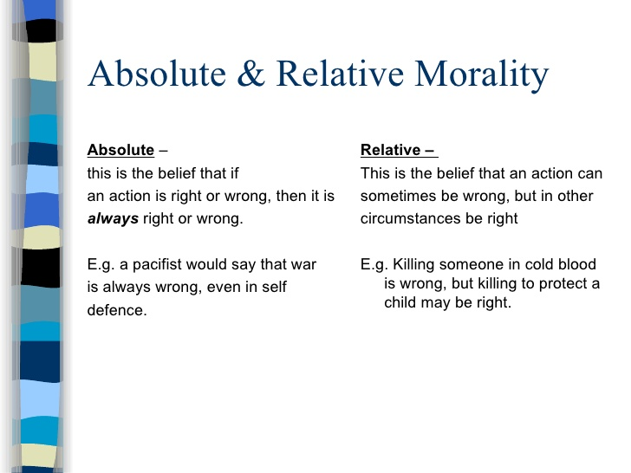****

**Religious Teachings on Morality (how to treat others)**

|  |  |
| --- | --- |
| Related image**Christianity** | E:\jewish symbol.jpg **Judaism** |
| The Golden rule – to treat others how you would like to be treated. | The Golden rule – to treat others how you would like to be treated. |
| Paul said – “Love your neighbour as yourself”. | The Talmud states 3 things that keeps the world a safe place – peace, truth and judgement. |
| Jesus said – “Love your enemies”. | 10 Commandments - People must live together in harmony, and respect one another. |
| 10 Commandments - People must in harmony, and respect one another. | Listen to your conscience – do not sin (do wrong). |
| Listen to your conscience – do not sin (do wrong). | Everyone has free will |
| Everyone has free will | Peace is the best thing within a community. |
| Following the example of Jesus is important – showing love, compassion and being kind. | **Pukakh Nefesh** – sometimes breaking a rule is ok if life is in danger (for the greater good). |
| Retaliating is wrong – better to pray/forgive. | Trying to get **justice** (fairness) is very important to a religious believer. |

|  |  |
| --- | --- |
| **CRIME** | **SIN** |
| Breaking The Law e.g. Speeding | Having an affair (adultery) – goes against 10 commandments |
| If you kill – you will be punished – sent to prison. | For **Christians**, sinful behaviour leads to personal suffering; offending God; cut off from the Church/Christian community; not allowed in heaven after death. |
| If you steal – you might have to do community service. | For **Jews**, those who sin will suffer in this life. |

**Crime –** An offence that is punishable by law e.g theft, violence.

Violence Broken home Poor education Poor parenting

Media Peer pressure

Unemployment Mental health issues Addiction Poverty

**Aims and Purpose of punishment**

Punishment is needed to have justice. For justice to be achieved, punishment must address the cause of the crime e.g should we give a murderer community service? Or a drug dealer a life sentence in a high security prison?

|  |  |
| --- | --- |
| **Aim of punishment** | **Meaning** |
| **Justice** | Justice is fairness. When talking about crime and punishment most people takes justice to mean that a criminal is caught, fairly tried in court and given a punishment which both fits the crime. Religions and governments focus on justice in society. |
| **Retribution** | This means revenge. ‘Getting even’ with a person means that the criminal suffers as they have made others suffer. For some, this is the only way that justice can be done. |
| **Deterrence** | To deter or put people off committing crime altogether e.g capital punishment. For deterrent to work, the criminals need to be made an example of in order to warn others in society not to commit crime. |
| **Reformation** | Reform offenders so that they can understand why they committed offences and to ‘fix’ these problems. Therapy, counselling, education or training can help. |

**Punishments:** Punish someone; inflict a penalty on a person e.g. penance; make someone suffer pain or loss due to bad behaviour e.g. prison/jail, fine.

Religious believers feel that it is important to help offenders so that they realise that what they have done is wrong, and to support them to better their ways.

 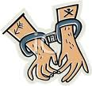  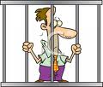

|  |  |
| --- | --- |
| Related image**Christian attitudes to punishment and justice** | E:\jewish symbol.jpg**Jewish attitudes to punishment and justice** |
| 1. Forgiveness not retribution (revenge). 2. Jesus said ‘Forgive, and you will be forgiven.’ 3. The reconciliation process cannot begin until the sufferer has forgiven the person causing the suffering. 4. Jesus’ words on the cross, ‘Father, forgive them as they do not know what they are doing.’ Christians should try to follow the example of Jesus who forgave those who betrayed him. 5. Justice -forgiveness and punishment should go together. 6. Jesus taught compassion not revenge. 7. Punishment should allow someone to reform to change their ways. 8. It’s important to recognise the causes of criminal behaviour e.g poverty, unemployment as a means of restoring social justice and preventing crime. 9. **Restorative justice**- a system of justice that helps criminals to make amends for their behaviour by meeting with their victim and apologising. 10. Example of Christians forgiving e.g. Martin Luther King forgiving those who tried to kill him. | 1. Teaching in the Tenakh on how to treat enemies – *‘Do not kill. Did you capture with your sword… set food and water before them so they may eat and drink…’* 2. Repentance is important (teshuvah). This means ‘returning’ - looking at elements in their lives where they are losing the battle and returning to the good way of living, and returning back to God. 3. Festival of Rosh Hashanah –allows Jews to apologise and forgive. 4. Only the sufferer can forgive. 5. Free will is important - people should take responsibilities over their actions. 6. Punishment should deter, protect society, provide retribution and promote justice 7. God created a just world. 8. Reform Jewish community are often active in protesting for the fair treatment of prisoners while in jail. 9. Jews teach that they should be forgiven; only the victim is able to forgive as no one can be forgiving on behalf of others. 10. Offenders should ask God’s forgiveness by avoiding repeat offending, giving money to charity and fasting. |

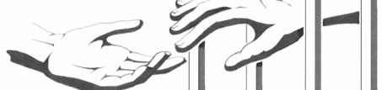**Prison Reformers**

**Prison reform** is the attempt to improve conditions inside **prisons**; establish a better justice system, or different punishments.

Britain has a proud history of prison reformers, who were inspired by their religious beliefs.

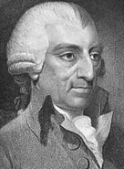**John Howard**

* Christian (Protestant).
* Inspected prisons in the late 18 th century.
* He found them dirty and corrupt, and gave evidence to Parliament with recommendations that conditions and practices should be improved.
* He called for basic but essential provisions e.g clean running water, separate cells from men and women, access to doctors, more prison officers to support and ensure the safety of inmates.

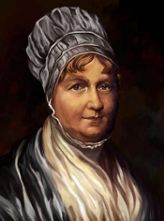**Elizabeth Fry**

* 19th century Quaker prison reformer.
* Dedicated her life to improve the state of British prisons after vising a Prison in London.
* She wanted education in prisons and reforming prisoners rather than isolating them from society.
* She’s famous for teaching female prisoners to read and write as well as holding Bible readings for inmates.

**Prisons in Wales**

* The prison population in England and Wales is 85,641.
* Re-offending rates are high.
* Re- offending costs us the equivalent of staging another Olympic games every year.
* 53% of the prison population have qualifications.
* Services for prisoners – drug rehabilitation, education, counselling, training for work.

**HMP Berwyn, Wrexham**

* HMP Berwyn, Wrexham, can hold more than 2,100 prisoners.
* Offenders will have a great opportunity to rehabilitate themselves.
* The prison was built at a cost of £212 million.
* The prison has colourful environments with wall art and showers, facility to learn new skills e.g joinery, carpentry and brick-laying.
* Each room will have a laptop, phone, shower and toilet. The laptops will not have access to the internet but will be used to arrange visits, order meals for the week and do their weekly shopping, complete any work related to their studies.
* The prison has new gyms, five-a-side pitches, library, visiting room, play area for children.

**Care for prisoners- prison chaplains**

**What is a chaplain?** Traditionally a chaplain is a minister, such as a priest, or rabbi. They are attached to non- religious institutions such as hospitals, prisons, schools or universities. Their job is to provide ‘pastoral’ care for patients, pupils or prisoners.

**A chaplain’s role?**

* Counselling to inmates, supporting them through their rehabilitation and seeing to their spiritual and religious needs.
* Fear, loneliness, guilt, concerns about family or children on the outside; all of these become the concern of the prison chaplain.
* Chaplains offer help for prisoners to re-enter the community, working with parole officers (a person that supports a prisoned on their release from prison).
* Families of inmates have access to prison chaplains.
* Chaplains do not have to be religious - 32% of the prison population are not religious.
* 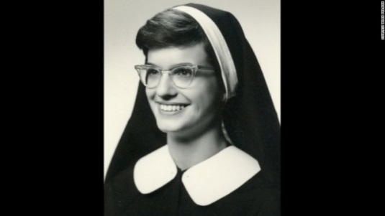Discussion groups, and counselling, such as bereavement support, for inmates.

**Helen Prejean**

* Helen Prejean is a Roman Catholic Nun - against the death penalty.
* 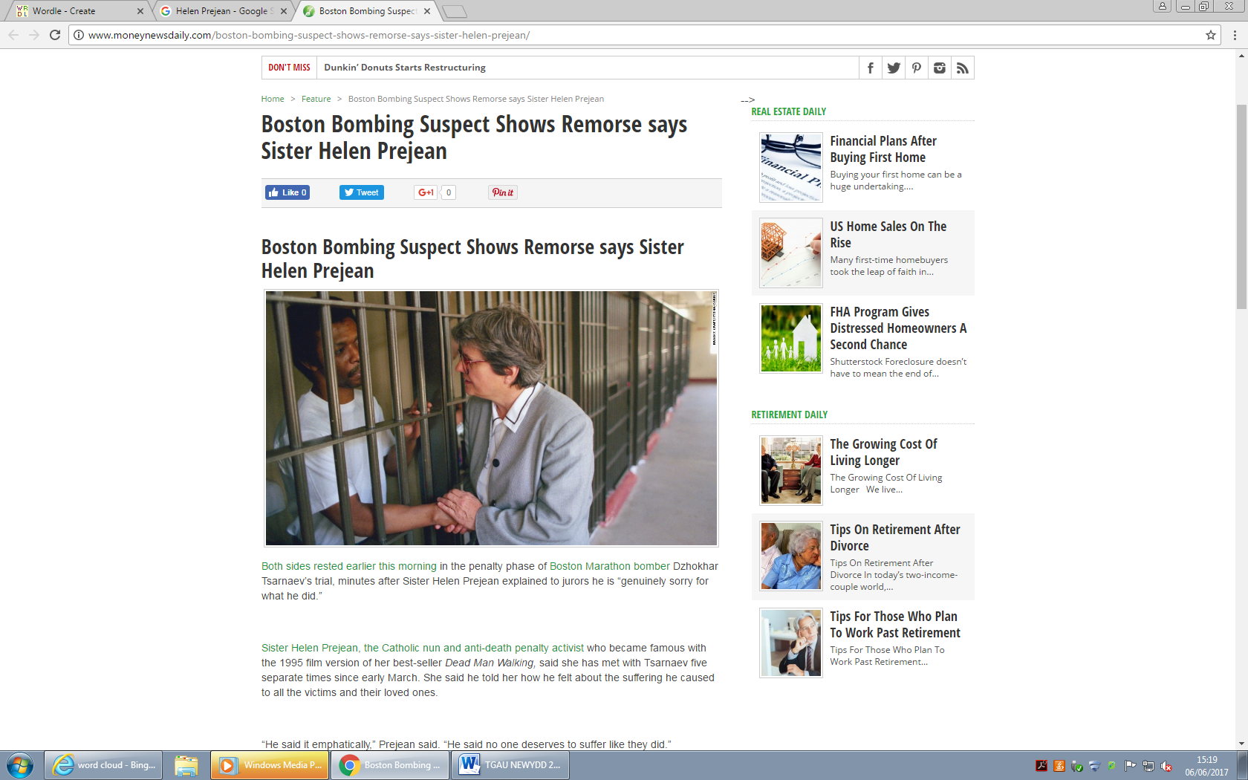She began her prison ministry in 1981, when she began writing to a death row inmate.

**DEATH PENALTY**

* When a person is put to death as a punishment for a crime.
* Abolished in the United Kingdom in 1969.
* Many attempts by the government to re-instate for some crimes.
* It’s still legal in over 80 different countries.
* Of the 50 States of America, 31 allow execution. Death row is the name given to the area was death penalty convicts reside in prison for the crimes of murder and treason.
* Methods of execution – lethal injection, electric chair, gas chamber, hanging.

|  |  |
| --- | --- |
| **FOR** | **AGAINST** |
| 1. Necessary for the greatest good of society. 2. Justice. 3. Punish dangerous criminals and remove them from society. 4. Execution is the only way to truly protect society from dangerous people. 5. Life terms in prison are very expensive- £40,000 a year. | 1. There is evidence that innocent people that have been executed. 2. The death penalty does not deter murderers 3. Only God has the right to end life. 4. Forgiveness is important. 5. Execution is morally wrong. 6. Life is sacred – should not be ended by people. 7. See below – Amnesty International. 8. The death penalty costs $3 million in the US. Life imprisonment costs $1.1 million in the US. |

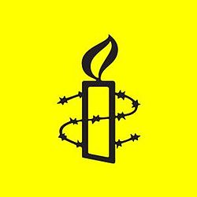

**Amnesty international**

* Amnesty is against the death penalty- for all crimes.
* It violates basic human rights in every case.
* Evidence shows that it does not stop crime.
* It discriminates. Statistics show that the death penalty is used against poor, minorities, and members of racial ethnic and religious communities.
* USA - you are more likely to receive the death penalty if the victims was white than if the victim was African American.

[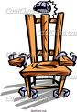](http://www.google.co.uk/imgres?imgurl=http://dir.coolclips.com/Services/Law_Enforcement/Death_Penalty/electric_chair_CoolClips_busi1270.jpg&imgrefurl=http://dir.coolclips.com/Services/Law_Enforcement/Death_Penalty/electric_chair_busi1270.html&usg=__jl4UkY9EMzyW601Rd_qsnoWbSX0=&h=383&w=262&sz=46&hl=en&start=4&zoom=1&itbs=1&tbnid=V0-UjWjJzOFm6M:&tbnh=123&tbnw=84&prev=/images?q%3Ddeath%2Bpenalty%2Bclipart%26hl%3Den%26gbv%3D2%26tbs%3Disch:1&ei=xyw0TdKQGdWAhAfy47yhCw) [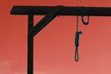](http://www.google.co.uk/imgres?imgurl=http://www.religionlink.com/clipart/deathpenalty.jpg&imgrefurl=http://www.religionlink.com/tip_051107.php&usg=__vE1Z2hRATTGOxmsfV2MAZNPtCjk=&h=320&w=480&sz=15&hl=en&start=38&zoom=0&itbs=1&tbnid=qqx6rwj-wJ0ZYM:&tbnh=86&tbnw=129&prev=/images?q%3Ddeath%2Bpenalty%2Bclipart%26start%3D20%26hl%3Den%26sa%3DN%26gbv%3D2%26ndsp%3D20%26tbs%3Disch:1&ei=8iw0TaqwKMyFhQfW3pWpCw) [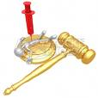](http://www.google.co.uk/imgres?imgurl=http://preview.canstockphoto.com/canstock1850406.png&imgrefurl=http://www.canstockphoto.com/lethal-injection-death-penalty-1850406.html&usg=__QYQ-RfFPo1EMVgHAZT4N1VCiim4=&h=275&w=275&sz=59&hl=en&start=39&zoom=0&itbs=1&tbnid=iY7m8mZ34Pfo_M:&tbnh=114&tbnw=114&prev=/images?q%3Ddeath%2Bpenalty%2Bclipart%26start%3D20%26hl%3Den%26sa%3DN%26gbv%3D2%26ndsp%3D20%26tbs%3Disch:1&ei=8iw0TaqwKMyFhQfW3pWpCw)

|  |
| --- |
| **Christian views to the death penalty?**[http://tbn2.google.com/images?q=tbn:eMbG0z1tYfrjgM:http://www.staffspasttrack.org.uk/exhibit/ilm/Image/Logo/CHRIST~1.gif](http://images.google.co.uk/imgres?imgurl=http://www.staffspasttrack.org.uk/exhibit/ilm/Image/Logo/CHRIST~1.gif&imgrefurl=http://www.staffspasttrack.org.uk/exhibit/ilm/Mourining%20and%20Remembrance/Types%20of%20funerals/Christian%20Funerals.htm&usg=__rf4RNx0px9ZxQznik9ex98Rrd3k=&h=46&w=50&sz=1&hl=en&start=8&tbnid=eMbG0z1tYfrjgM:&tbnh=46&tbnw=50&prev=/images?q%3Dchristian%2Bsymbol%26imgsz%3Dicon%26gbv%3D2%26hl%3Den)   * Ten Commandments- ‘Thou shall not kill.’ * All life is sacred. * Jesus taught compassion not revenge. * Old Testament – ‘an eye for an eye.’ * **Liberal Christians -**Execution goes against the sanctity of life; life is precious, only God should end it. * God only has the right to take life. * Teachings of Jesus*:* To be compassionate and forgiving. “Father forgives them for they know what they do”. * Reform is important- “turn the other cheek” and “love our enemies” (Matthew 5). Execution makes all of these impossible; The Golden rule is to do to others what you want to do to you. * **Quakers -** Campaigned against the death penalty since 1818. All human life should be respected as every person is a reflection of God. Punishments should be used to reform. First prison reformers were Quakers, who worked to maintain the dignity of prisoners. * **Conservative Christians -**Some Christians allow/agree with the death penalty. In the Old Testament, it says “Whoever sheds the blood of man, by man shall his blood be shed.” * The Old Testament lists capital offences including crimes such as magic and blasphemy, murder. Some would therefore argue that the death penalty should be approved as it was created by God. * **Catholic -** Has allowed but not encouraged the death penalty. In 1997 the Vatican issued a statement saying that execution was acceptable where the identity of the criminal was absolutely confirmed and where execution was the only means to protect society. |
| **Jewish view about the death penalty** [http://tbn0.google.com/images?q=tbn:MFmUb-xiFxFeRM:http://www.staffspasttrack.org.uk/exhibit/ilm/Image/Logo/Jewish.gif](http://images.google.co.uk/imgres?imgurl=http://www.staffspasttrack.org.uk/exhibit/ilm/Image/Logo/Jewish.gif&imgrefurl=http://www.staffspasttrack.org.uk/exhibit/ilm/&usg=__VGNdYDpexA6KD9Ew1-zx23U1Fbc=&h=39&w=50&sz=1&hl=en&start=1&tbnid=MFmUb-xiFxFeRM:&tbnh=39&tbnw=50&prev=/images?q%3Djewish%2Bsymbol%26imgsz%3Dicon%26gbv%3D2%26hl%3Den)   * In the Torah, some crimes were punishable by death. Deuteronomy 17:6 states ‘A person shall be put to death only on the testimony of two or more witnesses.’ * Leviticus 24:17-18 states, ‘Anyone who commits murder shall be put to death.’ * “One who takes a human life must be put to death. Leviticus 24:17-18 * If one inflicts injury on another person, he must pay as if the same injury were inflicted on him.” Leviticus 24:17-20 * **Orthodox Judaism -**It should be allowed for certain crimes, but used with caution. Israel allows the death penalty for acts of genocide, treason or murder; although in practice it is rarely used. * **10 Commandment –** “Do not kill” Exodus 20 * Now death penalty exists as a deterrent not retribution. * **Reform Judaism -** there is no persuasive evidence the death penalty serves as a deterrent to crime. The death penalty also goes against the commandment not to kill. |
| **Humanist attitudes -** Death penalty is generally opposed by humanists because they think killing is wrong, even when carried out by the state. You cannot reverse the death penalty. Humanist believes treating criminals fairly also helps to ensure that innocent suspects are treated fairly. |

**FORGIVENESS**

**Christian perspective**



**Jewish perspective**



**CONFLICT AND JUST WAR**

**What causes conflict?** Things happen on a daily basis to cause disagreements and conflict e.g. friends betray each other, people are selfish, people attack others, fighting, war.

**What do religions teach about conflict and war?[http://tbn2.google.com/images?q=tbn:eMbG0z1tYfrjgM:http://www.staffspasttrack.org.uk/exhibit/ilm/Image/Logo/CHRIST~1.gif](http://images.google.co.uk/imgres?imgurl=http://www.staffspasttrack.org.uk/exhibit/ilm/Image/Logo/CHRIST~1.gif&imgrefurl=http://www.staffspasttrack.org.uk/exhibit/ilm/Mourining%20and%20Remembrance/Types%20of%20funerals/Christian%20Funerals.htm&usg=__rf4RNx0px9ZxQznik9ex98Rrd3k=&h=46&w=50&sz=1&hl=en&start=8&tbnid=eMbG0z1tYfrjgM:&tbnh=46&tbnw=50&prev=/images?q%3Dchristian%2Bsymbol%26imgsz%3Dicon%26gbv%3D2%26hl%3Den)[http://tbn0.google.com/images?q=tbn:MFmUb-xiFxFeRM:http://www.staffspasttrack.org.uk/exhibit/ilm/Image/Logo/Jewish.gif](http://images.google.co.uk/imgres?imgurl=http://www.staffspasttrack.org.uk/exhibit/ilm/Image/Logo/Jewish.gif&imgrefurl=http://www.staffspasttrack.org.uk/exhibit/ilm/&usg=__VGNdYDpexA6KD9Ew1-zx23U1Fbc=&h=39&w=50&sz=1&hl=en&start=1&tbnid=MFmUb-xiFxFeRM:&tbnh=39&tbnw=50&prev=/images?q%3Djewish%2Bsymbol%26imgsz%3Dicon%26gbv%3D2%26hl%3Den)**

* Some say that religion is one of the causes of some war and violence in the world e.g. Protestants and Catholics; Israelis and Palestinians in Israel.
* Many religions such as Christians and Jews teach that violence and war are usually wrong, although some would argue that the Bible/Torah allows war. Some also teach that there are circumstances when believers have to ‘take up weapons’, because not doing so would result in even worse suffering and injustice.
* Christians such as the Quakers say that war is wrong, no matter what the situation is.
* Religious believers should use their conscience when trying to decide if war is right or not.

**Can a war ever be ‘just’?**

* Killing people is wrong.
* War is necessary to stop injustice.
* War causes harm to the innocent including animals.
* Some wars may stop genocide.

|  |
| --- |
| **Why do some Christians teach that war is wrong? [http://tbn2.google.com/images?q=tbn:eMbG0z1tYfrjgM:http://www.staffspasttrack.org.uk/exhibit/ilm/Image/Logo/CHRIST~1.gif](http://images.google.co.uk/imgres?imgurl=http://www.staffspasttrack.org.uk/exhibit/ilm/Image/Logo/CHRIST~1.gif&imgrefurl=http://www.staffspasttrack.org.uk/exhibit/ilm/Mourining%20and%20Remembrance/Types%20of%20funerals/Christian%20Funerals.htm&usg=__rf4RNx0px9ZxQznik9ex98Rrd3k=&h=46&w=50&sz=1&hl=en&start=8&tbnid=eMbG0z1tYfrjgM:&tbnh=46&tbnw=50&prev=/images?q%3Dchristian%2Bsymbol%26imgsz%3Dicon%26gbv%3D2%26hl%3Den)**  Some Christians, especially the Quakers believe that war is always wrong because:   * 10 commandments say ‘do not kill’. * Quakers are peace makers and refuse joining with the armed forces. * Jesus - ‘Love your enemies and pray for those who persecute you.’ * Everyone is created in Gods image – every life is holy. * Jesus - ‘Blessed are the peacemakers for they will be called children of God.’ * When Jesus was arrested, Simon Peter cut off the ear of a soldier. Jesus told him to put his weapon away. * **Just War theory -** Many believe that going to war is necessary sometimes. Saint Augustine and Saint Thomas Aquinas explained when this should happen: * When there is a just cause e.g. self-defence. * When the motives are right for war. * When it is the last resort – when everything else failed. * When the innocent is not harmed and the destruction is limited. * When there is a reasonable chance of success. * Many Christians agree with the Just War Theory. |
| **Jewish response to war** [http://tbn0.google.com/images?q=tbn:MFmUb-xiFxFeRM:http://www.staffspasttrack.org.uk/exhibit/ilm/Image/Logo/Jewish.gif](http://images.google.co.uk/imgres?imgurl=http://www.staffspasttrack.org.uk/exhibit/ilm/Image/Logo/Jewish.gif&imgrefurl=http://www.staffspasttrack.org.uk/exhibit/ilm/&usg=__VGNdYDpexA6KD9Ew1-zx23U1Fbc=&h=39&w=50&sz=1&hl=en&start=1&tbnid=MFmUb-xiFxFeRM:&tbnh=39&tbnw=50&prev=/images?q%3Djewish%2Bsymbol%26imgsz%3Dicon%26gbv%3D2%26hl%3Den)   * Early on in the religion, war was a religious duty for Jews. The Torah laws stated who were excused from military service e.g. a man who had just built a house, a newly married man. * Judaism is not a pacifist religion. By today, it is stressed that Jews is to go to war when every other possibility has failed. According to Rabbis, there is 3 different types of war:  1. Obligatory wars - Jews have been commanded by God to take part. 2. Defensive wars - Jews defend themselves against attacks made on them or their state BUT there needs to be strong evidence to support the action. 3. Optional wars – where war or fighting may be undertaken for very good reasons, and where negotiations or peace making are not possible.  * Is must be a last resort – peaceful means. * Every attempt must be made to limit killing. * According to many Rabbis, they should not go to war against a nation who have not attacked Israel, and only if the boundaries of Israel are under threat. * Judaism looks forward to a time of peace and harmony between all people in the world. Jews consider the Messianic Age to be a peaceful and harmonious one. Shalom is the Hebrew word for peace. * Judaism teaches that Prisoners of War should be treated well, and promotes Jews to feed their enemies and not to kill them. |

[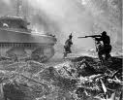](http://images.google.co.uk/imgres?imgurl=http://pastorsteveweaver.files.wordpress.com/2007/09/landing_at_war_03.jpg&imgrefurl=http://pastorsteveweaver.wordpress.com/2007/09/24/the-war-a-documentary/&usg=__MlBeC0oycsLevZFkcu8Y4fbca1g=&h=365&w=450&sz=51&hl=en&start=1&itbs=1&tbnid=eqex92Sj-E1WvM:&tbnh=103&tbnw=127&prev=/images?q%3Dwar%26hl%3Den%26sa%3DG%26g)[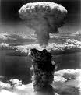](http://images.google.co.uk/imgres?imgurl=http://whitewhaletheatre.files.wordpress.com/2009/08/nuke-war-h0011.jpg&imgrefurl=http://whitewhaletheatre.wordpress.com/2009/08/02/the-theatre-wars/&usg=__DlwMQzeYuXxAlcvJM0zDwBDcYg0=&h=377&w=320&sz=27&hl=en&start=2&itbs=1&tbnid=6WG1VRQcz1-GdM:&tbnh=122&tbnw=104&prev=/images?q%3Dwar%26hl%3Den%26sa%3DG%26g)[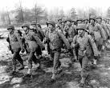](http://images.google.co.uk/imgres?imgurl=http://wikis.nyu.edu/ek6/modernamerica/uploads/AmericanPowerAmpCulturalHegemony.African-AmericanMusic/World20War20II20soldiers20training.jpg&imgrefurl=https://wikis.nyu.edu/ek6/modernamerica/index.php/AmericanPowerAmpCulturalHegemony/African-AmericanMusic&usg=__wsWE9mvqMUNn3zL229sFCtmmbi8=&h=520&w=650&sz=89&hl=en&start=7&itbs=1&tbnid=JsTtYq5Mi_vvEM:&tbnh=110&tbnw=137&prev=/images?q%3Dwar%26hl%3Den%26sa%3DG%26g)[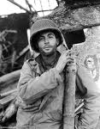](http://images.google.co.uk/imgres?imgurl=http://www.mpbonline.org/images/press%20release%20photo/TheWar1.jpg&imgrefurl=http://www.mpbonline.org/about_us/pr-contribute/070912-TheWar.htm&usg=__V66e6urFTYh_KlIEZYFijI53uwc=&h=4000&w=3122&sz=3544&hl=en&start=59&itbs=1&tbnid=b-pDZv-nq055ZM:&tbnh=150&tbnw=117&prev=/images?q%3Dwar%26start%3D54%26hl%3Den%26sa%3DN%26gbv%3D2%26nds)[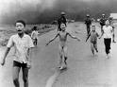](http://images.google.co.uk/imgres?imgurl=http://sinhale.files.wordpress.com/2009/11/vietnam-war-3.jpg&imgrefurl=http://sinhale.wordpress.com/2009/11/05/why-americans-are-unwilling-to-look-in-to-their-own-war-crimes/&usg=__UbKCnlqHxx3HfC96v-IJaxiAodE=&h=297&w=400&sz=82&hl=en&start=131&itbs=1&tbnid=qVxR7vJFREdPsM:&tbnh=92&tbnw=124&prev=/images?q%3Dwar%26start%3D126%26hl%3Den%26sa%3DN%26gbv%3D2%26nds)[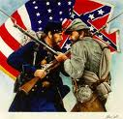](http://images.google.co.uk/imgres?imgurl=http://riverdaughter.files.wordpress.com/2009/06/civil-war-soldiers2.jpg&imgrefurl=http://riverdaughter.wordpress.com/2009/06/15/blaming-a-generation/&usg=__BgrVrzcrCC6ccMuDDnTgA_ILpHA=&h=435&w=449&sz=39&hl=en&start=74&itbs=1&tbnid=OCZN92QN_8HvHM:&tbnh=123&tbnw=127&prev=/images?q%3Dwar%26start%3D72%26hl%3Den%26sa%3DN%26gbv%3D2%26nds)

**Working for peace**

**Pacifism** - Any form of violence or war is unacceptable. Someone trying for peace and good will at all times. Being unwilling to use any force or violence e.g. not joining an army. No weapons.

**Conscientious Objectors -** People who has claimed the right to refuse to join the military service to fight based on freedom of thought, conscience, or religion.

**Pacifists – Society of Friends in Wales [http://tbn2.google.com/images?q=tbn:eMbG0z1tYfrjgM:http://www.staffspasttrack.org.uk/exhibit/ilm/Image/Logo/CHRIST~1.gif](http://images.google.co.uk/imgres?imgurl=http://www.staffspasttrack.org.uk/exhibit/ilm/Image/Logo/CHRIST~1.gif&imgrefurl=http://www.staffspasttrack.org.uk/exhibit/ilm/Mourining%20and%20Remembrance/Types%20of%20funerals/Christian%20Funerals.htm&usg=__rf4RNx0px9ZxQznik9ex98Rrd3k=&h=46&w=50&sz=1&hl=en&start=8&tbnid=eMbG0z1tYfrjgM:&tbnh=46&tbnw=50&prev=/images?q%3Dchristian%2Bsymbol%26imgsz%3Dicon%26gbv%3D2%26hl%3Den)**

**Quakers**/**Society of Friends** are pacifists. They believe that peace should be kept. They would not engage in war/conflict. Quakers are against fighting and during war, they oppose publicly and conscientiously. They are ready to go into battle by being responsible e.g driving an ambulance.

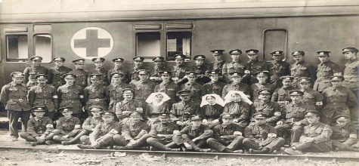

**Waldo Williams [http://tbn2.google.com/images?q=tbn:eMbG0z1tYfrjgM:http://www.staffspasttrack.org.uk/exhibit/ilm/Image/Logo/CHRIST~1.gif](http://images.google.co.uk/imgres?imgurl=http://www.staffspasttrack.org.uk/exhibit/ilm/Image/Logo/CHRIST~1.gif&imgrefurl=http://www.staffspasttrack.org.uk/exhibit/ilm/Mourining%20and%20Remembrance/Types%20of%20funerals/Christian%20Funerals.htm&usg=__rf4RNx0px9ZxQznik9ex98Rrd3k=&h=46&w=50&sz=1&hl=en&start=8&tbnid=eMbG0z1tYfrjgM:&tbnh=46&tbnw=50&prev=/images?q%3Dchristian%2Bsymbol%26imgsz%3Dicon%26gbv%3D2%26hl%3Den)**

* A Welsh poet. He was a Quaker (Christian).
* Quakers won’t join an army, and works against the use of weapons.
* Some Quakes will not join the medical troops to help those who are injured.
* Sent to jail for refusing to pay taxes to the government because he was against the British War in Korea.
* The British government had spent so much money on weapons in order to kill innocent lives in Korea.
* 16,000 Quakers refused to fight in the First World War and were sent to prison.

**[http://tbn0.google.com/images?q=tbn:MFmUb-xiFxFeRM:http://www.staffspasttrack.org.uk/exhibit/ilm/Image/Logo/Jewish.gif](http://images.google.co.uk/imgres?imgurl=http://www.staffspasttrack.org.uk/exhibit/ilm/Image/Logo/Jewish.gif&imgrefurl=http://www.staffspasttrack.org.uk/exhibit/ilm/&usg=__VGNdYDpexA6KD9Ew1-zx23U1Fbc=&h=39&w=50&sz=1&hl=en&start=1&tbnid=MFmUb-xiFxFeRM:&tbnh=39&tbnw=50&prev=/images?q%3Djewish%2Bsymbol%26imgsz%3Dicon%26gbv%3D2%26hl%3Den)** **JUDAISM** inspire non-violence. The Jewish Peace Fellowship supports conscientious objectors in order to abolish war and not to participate in war or military service.

[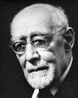](http://www.google.co.uk/imgres?imgurl=http://media-2.web.britannica.com/eb-media/53/13253-004-40594D34.jpg&imgrefurl=http://www.britannica.com/EBchecked/topic-art/48611/8676/Baeck-1948&usg=__tVT9OBZsgeONikL2JRjE69gA6Ss=&h=300&w=239&sz=15&hl=en&start=5&itbs=1&tbnid=Ktv6p6w9A_d-tM:&tbnh=116&tbnw=92&prev=/images?q%3DLeo%2BBaeck%26hl%3Den%26sa%3DG%26g)[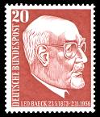](http://www.google.co.uk/imgres?imgurl=http://upload.wikimedia.org/wikipedia/commons/c/cc/DBP_278_Leo_Baeck_20_Pf_1957.jpg&imgrefurl=http://commons.wikimedia.org/wiki/File:DBP_278_Leo_Baeck_20_Pf_1957.jpg&usg=__84m6O-yTAz6-DUDx6-ouichmPgc=&h=840&w=720&sz=612&hl=en&start=26&itbs=1&tbnid=iLYhuSqWj2oN4M:&tbnh=145&tbnw=124&prev=/images?q%3DLeo%2BBaeck%26start%3D18%26hl%3Den%26sa%3DN%26gbv%3D2%26nds)

**LEO BAECK**

* Refused to flee when the Nazis came to force.
* Carried on to support the civil rights of Jews.
* Was sent to a concentration camp. After he was released, he worked with different religions.

|  |  |
| --- | --- |
| **Christianity [http://tbn2.google.com/images?q=tbn:eMbG0z1tYfrjgM:http://www.staffspasttrack.org.uk/exhibit/ilm/Image/Logo/CHRIST~1.gif](http://images.google.co.uk/imgres?imgurl=http://www.staffspasttrack.org.uk/exhibit/ilm/Image/Logo/CHRIST~1.gif&imgrefurl=http://www.staffspasttrack.org.uk/exhibit/ilm/Mourining%20and%20Remembrance/Types%20of%20funerals/Christian%20Funerals.htm&usg=__rf4RNx0px9ZxQznik9ex98Rrd3k=&h=46&w=50&sz=1&hl=en&start=8&tbnid=eMbG0z1tYfrjgM:&tbnh=46&tbnw=50&prev=/images?q%3Dchristian%2Bsymbol%26imgsz%3Dicon%26gbv%3D2%26hl%3Den)** | **Judaism** [http://tbn0.google.com/images?q=tbn:MFmUb-xiFxFeRM:http://www.staffspasttrack.org.uk/exhibit/ilm/Image/Logo/Jewish.gif](http://images.google.co.uk/imgres?imgurl=http://www.staffspasttrack.org.uk/exhibit/ilm/Image/Logo/Jewish.gif&imgrefurl=http://www.staffspasttrack.org.uk/exhibit/ilm/&usg=__VGNdYDpexA6KD9Ew1-zx23U1Fbc=&h=39&w=50&sz=1&hl=en&start=1&tbnid=MFmUb-xiFxFeRM:&tbnh=39&tbnw=50&prev=/images?q%3Djewish%2Bsymbol%26imgsz%3Dicon%26gbv%3D2%26hl%3Den) |
| 1. Showing love, compassion and kindness towards others follows Jesus’ example.  2. Jesus called on people to be ‘peacemakers’. Quakers are pacifists.  3. Retaliation is wrong; praying for those who are against you is better.  4. MLK – a person who used non-violent methods.  5.Golden Rule.  6. 10 Commandments urges people to live in harmony with others. | 1. A Jewish greeting is the word ‘Shalom’ meaning peace.  2. Jews hope for peace in the future.  3. The Talmud states 3 things that keep the world safe – peace, truth and judgement.  4. Peace – the ideal state. Something to be worked and hoped for. It’s the best thing for society.  5. Golden Rule.  6. The 10 Commandments urges people to live in harmony with others.  7. Jewish teachings inspire non-violence. The Jewish Peace Fellowship is an organisation that supports conscientious objectors e.g. to abolish war or refrain from taking part. |

**Forgiveness**

[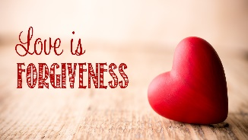](https://www.google.co.uk/url?sa=i&rct=j&q=&esrc=s&source=images&cd=&cad=rja&uact=8&ved=0ahUKEwjV3ofO7fzWAhUSbFAKHQOqAxYQjRwIBw&url=http://eastpointfellowship.com/sermons/love-is-forgiveness/&psig=AOvVaw3Cl5ZRFu5w0pzMjLcFyGM0&ust=1508508244294465)

**Forgiveness – to grant pardon for a wrongdoing. Give up on revenge against a wrongdoer.**

|  |  |
| --- | --- |
| **SITUATIONS WHERE IT IS POSSIBLE TO FORGIVE** | **SITUATIONS WHERE IT IS NOT POSSIBLE TO FORGIVE** |
|  |  |

Religions say it isn’t easy to forgive.

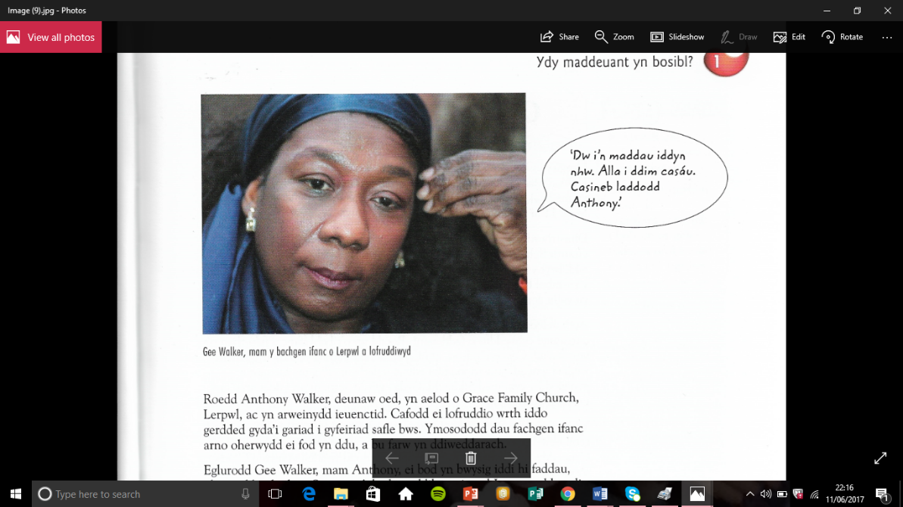**Forgiveness – Personal Beliefs**

**Gee Walker**

I forgive them. I can’t hate. Hate is what killed Anthony.

Anthony Walker was murdered because he was black. Gee Walker, Anthony’s mum, explained that it’s important for her to forgive as she is a Christian and follows Jesus’ example when he showed forgiveness. It’s important to respond to racism and hate with tolerance and love – the only way of overcoming racism. When asked if she forgives the murderers of her son for the sake of them; she said that she does for the sake of herself and her son Anthony. She said:

***“Not forgiving is a heavy weight. It is a heavy burden to carry. I have seen what this does to people. They turn bitter and angry. I do not want to be that way. I do not want to be a sufferer in two ways. In my heart I have the love and pain that I feel over Anthony and there is no space for anything else.”***

**What did Julie Nicholson say about forgiveness?**

[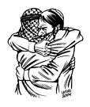](http://www.google.co.uk/imgres?imgurl=http://www.anis-online.de/0/rooms/latuff/Forgiveness.jpg&imgrefurl=http://www.anis-online.de/1/rooms/latuff/forgiveness.htm&usg=__J1WbSJeQNelrzfzQjfcH5ErP2xs=&h=600&w=506&sz=74&hl=en&start=11&um=1&itbs=1&tbnid=ytdxsEZl6LAUsM:&tbnh=135&tbnw=114&prev=/images?q%3Dforgiveness%26um%3D1%26hl%3Den%26tbs%3Disch:1)[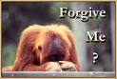](http://www.google.co.uk/imgres?imgurl=http://www.psychologytoday.com/files/u45/forgive.gif&imgrefurl=http://www.psychologytoday.com/blog/dont-delay/200804/forgiveness&usg=__dnCPruJTWNin1-5IIpphPrshL2s=&h=258&w=382&sz=24&hl=en&start=20&um=1&itbs=1&tbnid=9mlCD6r4xv3ZYM:&tbnh=83&tbnw=123&prev=/images?q%3Dforgiveness%26start%3D18%26um%3D1%26hl%3Den%26sa%3DN%26ndsp%3D18%26tbs%3Disch:1)[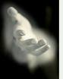](http://www.google.co.uk/imgres?imgurl=http://thatwoman.files.wordpress.com/2009/12/forgiveness-1.jpg&imgrefurl=http://thatwoman.wordpress.com/2009/12/21/chris-miss-time-chris-ritchey/&usg=__snr9Yey1CrmbPOoFsTKg6Ala36k=&h=200&w=160&sz=5&hl=en&start=57&um=1&itbs=1&tbnid=weoreV9gvOAIEM:&tbnh=104&tbnw=83&prev=/images?q%3Dforgiveness%26start%3D54%26um%3D1%26hl%3Den%26sa%3DN%26ndsp%3D18%26tbs%3Disch:1)[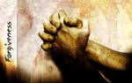](http://www.google.co.uk/imgres?imgurl=http://wendyusuallywanders.files.wordpress.com/2008/06/forgiveness.jpg&imgrefurl=http://wendyusuallywanders.wordpress.com/2008/06/01/forgiveness/&usg=__Rk-7FtRUgwEdWbHc-peZfOAEKcA=&h=900&w=1440&sz=273&hl=en&start=1&um=1&itbs=1&tbnid=CTuEEiO1Av2tYM:&tbnh=94&tbnw=150&prev=/images?q%3Dforgiveness%26um%3D1%26hl%3Den%26sa%3DN%26ndsp%3D18%26tbs%3Disch:1)

**Christianity and Forgiveness [http://tbn2.google.com/images?q=tbn:eMbG0z1tYfrjgM:http://www.staffspasttrack.org.uk/exhibit/ilm/Image/Logo/CHRIST~1.gif](http://images.google.co.uk/imgres?imgurl=http://www.staffspasttrack.org.uk/exhibit/ilm/Image/Logo/CHRIST~1.gif&imgrefurl=http://www.staffspasttrack.org.uk/exhibit/ilm/Mourining%20and%20Remembrance/Types%20of%20funerals/Christian%20Funerals.htm&usg=__rf4RNx0px9ZxQznik9ex98Rrd3k=&h=46&w=50&sz=1&hl=en&start=8&tbnid=eMbG0z1tYfrjgM:&tbnh=46&tbnw=50&prev=/images?q%3Dchristian%2Bsymbol%26imgsz%3Dicon%26gbv%3D2%26hl%3Den)**

Martin Luther King is famous for his non-violence methods and reconciliation. Christians teach that forgiveness is important.

**Christianity [http://tbn2.google.com/images?q=tbn:eMbG0z1tYfrjgM:http://www.staffspasttrack.org.uk/exhibit/ilm/Image/Logo/CHRIST~1.gif](http://images.google.co.uk/imgres?imgurl=http://www.staffspasttrack.org.uk/exhibit/ilm/Image/Logo/CHRIST~1.gif&imgrefurl=http://www.staffspasttrack.org.uk/exhibit/ilm/Mourining%20and%20Remembrance/Types%20of%20funerals/Christian%20Funerals.htm&usg=__rf4RNx0px9ZxQznik9ex98Rrd3k=&h=46&w=50&sz=1&hl=en&start=8&tbnid=eMbG0z1tYfrjgM:&tbnh=46&tbnw=50&prev=/images?q%3Dchristian%2Bsymbol%26imgsz%3Dicon%26gbv%3D2%26hl%3Den)**

1. Jesus’ words on the cross, ‘Father, forgive them as they do not know what they are doing.’
2. Jesus helped many e.g. Zaccheus. Jesus visited him even though he was a cheat and was selfish, and gave him a new sense of life and purpose for him.
3. Example of Christians forgiving e.g. MLK forgiving those who tried to kill him.
4. In the Lord’s Prayer, it says ‘Forgive us our trespasses as we forgive those who have trespassed against us.’
5. Jesus said ‘Forgive, and you will be forgiven.’

[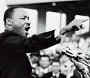](http://www.google.co.uk/imgres?imgurl=http://md-phw.de/weiss/audioblog/wp-content/uploads/martin-luther-king-2.jpg&imgrefurl=http://md-phw.de/weiss/audioblog/seminar-politische-reden/martin-luther-king-verlaufsskizze/&usg=__DFJGW9n3XRQ0m_B9bklpIZnncPQ=&h=300&w=347&sz=53&hl=en&start=23&um=1&itbs=1&tbnid=M929sbVQg9a56M:&tbnh=104&tbnw=120&prev=/images?q%3Dmartin%2Bluther%2Bking%26start%3D18%26um%3D1%26hl%3Den%26sa%3DN%26ndsp%3D18%26tbs%3Disch:1)

1. The reconciliation process cannot begin until the sufferer has forgiven the person causing the suffering.
2. MLK said, “*Forgiveness creates the atmosphere for* *a fresh start and a new*

*beginning. Forgiveness means reconciliation, a coming together again’.*

1. “Then Peter came to Jesus and asked, *“Lord, how many times shall forgive my brother or sister who sins against me? Up to seven times?” Jesus answered, “I tell you, not seven times, but at least seventy-seven times!”*
2. Jesus said *“If you forgive other people when they sin against you, God will also forgive you”.*

*10.***The Parable of the Unforgiving Servant** We must forgive others in order to be forgiven ourselves. In the parable, the servant refuses to forgive a friend for borrowing a small sum of money when he had received a large sum of money from his master. This teaches Christians to forgive many times because they will be forgiven by God for all of their sins.

11. Catholics ask for forgiveness through confession and say prayers.

**Judaism** [http://tbn0.google.com/images?q=tbn:MFmUb-xiFxFeRM:http://www.staffspasttrack.org.uk/exhibit/ilm/Image/Logo/Jewish.gif](http://images.google.co.uk/imgres?imgurl=http://www.staffspasttrack.org.uk/exhibit/ilm/Image/Logo/Jewish.gif&imgrefurl=http://www.staffspasttrack.org.uk/exhibit/ilm/&usg=__VGNdYDpexA6KD9Ew1-zx23U1Fbc=&h=39&w=50&sz=1&hl=en&start=1&tbnid=MFmUb-xiFxFeRM:&tbnh=39&tbnw=50&prev=/images?q%3Djewish%2Bsymbol%26imgsz%3Dicon%26gbv%3D2%26hl%3Den)

1. Teaching in the Tenakh on how to treat enemies – ‘Do not kill. Did you capture with your sword… set food and water before them so they may eat and drink…’
2. Repentance is important (teshuvah). This means ‘returning’ - looking at elements in their lives where they are losing the battle and returning to the good way of living, and returning back to God.
3. Festival of Rosh Hashanah – Festival which allows Jews to apologise and forgive.
4. Only the sufferer/victim can forgive.
5. Micah 7:18 – Humans should follow the example of God, whose love cannot allow him not to forgive.
6. It is a Mitzvot duty to forgive.
7. The Torah forbids Jews from taking revenge or bearing grudges.
8. It’s believed that humans are responsible for their actions.

**Example of forgiveness that derives from personal beliefs – Eva Kor**

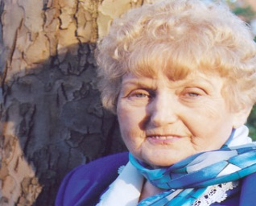**At the age of ten, twins Eva and Miriam Mozes, were taken to Auschwitz where Dr Josef Mengele used them for medical experiments. Both survived, but Miriam died in 1993 as a consequence of the experiments done to her as a child. Eva Kor has since spoken about her experiences at Auschwitz.**

*‘Miriam and I were to be used as human guinea pigs. During our time in Auschwitz we starved for food. Because we were twins, we were used in a variety of experiments. Three times a week we’d be placed naked in a room, for 6–8 hours, to be measured and studied. A friend challenged me to forgive Dr Mengele too. At first, I was adamant that I could never forgive but then I realized I had the power now…the power to forgive. It was my right to use it. No one could take it away. On 27 January 1995, at the 50th anniversary of the liberation of Auschwitz, I stood by the gas chambers with my children. I read my document of forgiveness and signed it. As I did, I felt a burden of pain was lifted from me. I was no longer in the grip of hate; I was finally free. The day I forgave the Nazis, I forgave my parents whom I hated all my life for not having saved me from Auschwitz. Then I forgave myself for hating my parents. Forgiveness is nothing more than an act of self-healing and self-empowerment. I call it a miracle medicine. It is free, it works and has no side effects.*

*I believe every human being has the right to live without the pain of the past. For most people, there is a big obstacle to forgiveness because society expects revenge. I always wonder if my dead loved ones would want me to live with pain and anger until the end of my life. Some survivors do not want to let go of the pain. Forgiveness is as personal as chemotherapy – I do it for myself.’*

**Good, Evil and Suffering**

**Christian**



**Jewish**



**What is ‘good’?** Good can mean different things to different people. A person’s ideas about good can depend on the experiences they have had through life down to the moral codes they have learnt from others.

**Nature of good**

* Good is when there is no evil.
* Something that is wanted or desired.
* Something which is morally right to believe or do.
* Being caring, charitable or selfless is ‘good’.
* If you are someone who shows compassion to others, treat everyone equally or someone who sacrifices themselves for others can be considered good.
* MLK, Mother Teresa can be considered good people. Each one of these people have shown compassion, love and selflessness towards others.
* People do good because of their ‘free will.’
* Good can come from factors such as childhood, family, friends.
* Good actions come from our **conscience** and **free will.**

|  |  |
| --- | --- |
| **CHRISTIAN ATTITUDES TO GOOD**Related image | **JEWISH ATTITUDES TO GOOD**E:\jewish symbol.jpg |
| 1. The world was created by God. After each day of creation ‘this is good.’ 2. God gave humans the ability to use **free will.** Human beings have the choice to do good or evil, right or wrong. 3. Free will - the story of ‘The Fall’ – ‘The Original Sin’ – the first ever sin committed by human beings. (Adam & Eve).   **GENESIS 3 – THE FALL**  Adam and Eve are tempted by the devil, in the form of a serpent, to eat the fruit from the tree against God’s will. In time, Eve gives in to the temptation, eats the fruit and gives some to Adam. They confess to God what they have done and as a punishment, He sends them out of the Garden of Eden to live somewhere else on the earth. They are no longer allowed to eat from the tree of life, which has given them eternal life, so death enters the world.   1. The 10 Commandments are rules given by God which leads them to live a moral and good life. 2. It’s a duty for Christians to treat others as Jesus did e.g.  * ‘Love each other as I have loved you. Greater love has no one than this: to lay down one’s life for one’s friends. ‘ * ‘Judge not, that you shall not be judged.’ | 1. God is good and will always protect and care for people. 2. To see the goodness of God, Jews look to the creation of the world. 3. God gave humans free will so that they could choose whether to worship him or not. 4. Jews use the Torah to give them guidance in how to live a good life and perform good actions. 5. 613 mitzvot (rules) to follow. These help them understand how to be in everyday life and become good Jews. 6. People are born with the potential to do good – Yetzer ha tov, but also with the impulse to do wrong - Yetzer ha ra. 7. There is no belief in evil beings such as the devil because it is only the Yetzer ha ra that is within everyone which creates the evil in the world. 8. The Torah teaches that God has given Jews a choice – free will. As human beings they were made in the image of God and it is believed that they have a mind and soul to help them with that choice. 9. Examples of good is helping others such as using pushkes in the home, giving to Tzedek, Mitzvah Day and Gemilut Hasadim. 10. It isn’t possible to hide acts of evil from God. If any harm is done to other human beings, they must forgive before God can forgive. |

|  |  |
| --- | --- |
| **MORAL EVIL** | **NATURAL EVIL** |
| Human actions cause moral evil.  If the action is morally wrong then it is a moral evil e.g. bullying, stealing, revenge or murder. | Events which have nothing to do with humans, e.g. natural disasters   * like volcanic eruptions, tsunamis, earthquakes. * These cannot be stopped or affected by humans. This can also mean disease and illness. |

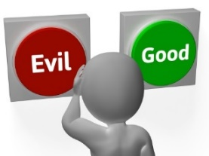**WHAT IS EVIL?** There are two different types of evil in the world:

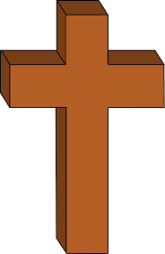**Christian attitudes to evil**

What causes evil and suffering? Christians believe that God created people with free will and can choose to do good or evil. If they choose evil this leads to suffering.

Some Christians argue that evil is the absence of good. Others say evil comes from Satan. The world is not perfect – it’s just a natural happening.

**Suffering helps humans understand Jesus -**Christians point to the example of Jesus as a way of explaining suffering and its purpose. Jesus chose to suffer pain to achieve greater good.

**Soul-making:** Some Christians believe that God allows evil because suffering through evil is necessary for individuals to develop their moral souls. We call this **soul-making**. We need to learn morality and develop good qualities e.g being honest and good. Our suffering and the suffering of others are needed for us to learn lessons about what is good.

**St. Irenaeus** (AD 130-202)**.** Was a Father of the early Christian Church. He believed that humankind was not created perfect, but needed growth to become perfect and moral e.g obeying God’s laws.

**St. Augustine –** A Christian thinker. He believed that things were created good, but free will helped things to grow away from good to become evil. Humans use their free will to choose to do evil. Natural evils become evil when they come into contact with people: diseases and volcanos become evil when humans put themselves in harm’s way. He believed that we cannot understand the mind of God and what may appear on the face of it, may not be evil at all: humans cannot judge God.

**John Hick** (1922-2012)

* Agrees with Irenaeus’ theory. God created humans with the potential for spiritual growth.
* The process of soul-making is a response to evil in the world. If murder, cancer and natural evils did not exist, we could not develop and perfect ourselves.
* There’s some suffering in the world that we can never understand, which proves that we can never really understand God’s reason or plan.
* Humans are born with a great distance between them and God.

**Original Sin-** Remember the story of THE FALL.The first sin ever committed – when Adam and Eve ate the forbidden fruit. The action that brought sin and evil into the world.

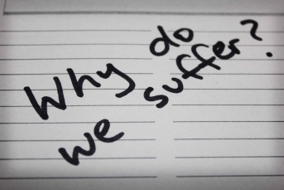**Life as a test -** Many Christians believe that life is a test. The way people react to suffering and evil determines whether they go to heaven or hell in the afterlife.The **story of Job** in the Bible gives Christians an example of how suffering can come to anyone, even the most holy and good, we will be judged on how we behaved throughout our suffering. Job suffers. His friends try to convince him that he is suffering due to his own past sins. Job questions God on this but is given no direct answers. He somehow keeps his faith in God and is rewarded when his suffering is bought to an end.

**Evil and suffering as beyond human understanding**

* The story of Job- we should not question why we suffer, but accept that we do suffer.
* Many say that ‘God works in mysterious ways’ and he has reasons for letting evil and suffering happen, but humans will never be able to understand the mind of God.
* Many accept that God has chosen suffering for us and that he has a purpose.

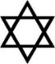

**JEWISH ATTITUDES TO EVIL**

* On one hand, evil exists due free will – in Genesis it is explained that God gave humanity free will and therefore the ability to choose between good and evil.
* Evil also comes from God as he can use it to cause suffering and discipline, punish or test.
* The story of Job in the Torah demonstrates that even good people can experience suffering through evil. God sends suffering to test Job’s faith but Job does not know why he’s made to suffer. In the end, he learns not to question what God does, but to accept things as they are.
* The Talmud says: ‘And you shall love the Lord your God, with all your heart and all your soul and with all that you have.’ (Berakhot 9.5)
* The Talmud makes it clear that idol worshipping is evil because it is denying God. This is explained in Avodah Zarah 3b.
* This teaches Jews to welcome both good and evil in their lives, as both are sent by God and have purpose. Jews believe that the punishment for being tempted by evil is death and the reward for resisting temptation is protection (Torah).

**SUFFERING**

**Natural suffering** – caused by events beyond human control e.g earthquakes, floods, disease.

**Human suffering** – caused by the actions of people – murder, rape, terrorism.

**Christianity and suffering [http://tbn2.google.com/images?q=tbn:eMbG0z1tYfrjgM:http://www.staffspasttrack.org.uk/exhibit/ilm/Image/Logo/CHRIST~1.gif](http://images.google.co.uk/imgres?imgurl=http://www.staffspasttrack.org.uk/exhibit/ilm/Image/Logo/CHRIST~1.gif&imgrefurl=http://www.staffspasttrack.org.uk/exhibit/ilm/Mourining%20and%20Remembrance/Types%20of%20funerals/Christian%20Funerals.htm&usg=__rf4RNx0px9ZxQznik9ex98Rrd3k=&h=46&w=50&sz=1&hl=en&start=8&tbnid=eMbG0z1tYfrjgM:&tbnh=46&tbnw=50&prev=/images?q%3Dchristian%2Bsymbol%26imgsz%3Dicon%26gbv%3D2%26hl%3Den)** Christians believe that suffering is a part of life – it cannot be escaped. Reasons:

1. Free will – The Bible describes how God created the world, including people – Adam and Eve. He gave them free will – the ability to do good and evil. God told them to behave well, and not to eat the fruit from the tree. Both decided not to listen to God, and ate the fruit. Both were therefore selfish and did evil, rather than respecting God and doing good. Christians teach that people are not perfect, but must try to avoid suffering in life.
2. To some Christians e.g. Pentecostals, the ‘perfect’ world God created has been polluted (destroyed), because of the sin of man, therefore ‘natural’ suffering/disasters happens.
3. Suffering can provide inner strength to people, and help them to overcome the suffering. The story of Job in the Bible is an example of this. Job was a rich farmer, but his family and animals die. The story offers 3 reasons for the suffering:

* Suffering is a test – God wants to see if Job turns his back on him. Job does not lose his faith in God.
* His suffering was a punishment for his sins – This is what Jobs’ friends think. God told him that he had not sinned.

1. Suffering is a part of Gods’ plan, and beyond the understanding of people – Job accepts that God ruled the situation, and once this happens, his suffering stops. Stories from the Bible such as Job, teach Christians that anyone can suffer and if you keep going in suffering it can strengthen faith in God.
2. Christians think about Jesus – chose to suffer pain for the sake of others. The death and resurrection of Jesus was going to bring an end to death and suffering. His resurrection offers hope and heaven.
3. For Catholics suffering is the result for the Original sin
4. Suffering lets us appreciate good in the world and allows us to grow closer to Jesus, who also suffered.

**Judaism and Suffering** [http://tbn0.google.com/images?q=tbn:MFmUb-xiFxFeRM:http://www.staffspasttrack.org.uk/exhibit/ilm/Image/Logo/Jewish.gif](http://images.google.co.uk/imgres?imgurl=http://www.staffspasttrack.org.uk/exhibit/ilm/Image/Logo/Jewish.gif&imgrefurl=http://www.staffspasttrack.org.uk/exhibit/ilm/&usg=__VGNdYDpexA6KD9Ew1-zx23U1Fbc=&h=39&w=50&sz=1&hl=en&start=1&tbnid=MFmUb-xiFxFeRM:&tbnh=39&tbnw=50&prev=/images?q%3Djewish%2Bsymbol%26imgsz%3Dicon%26gbv%3D2%26hl%3Den)

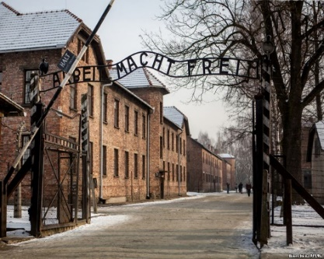

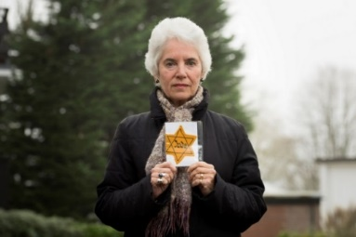**The Holocaust:** The word Holocaust means ‘a burnt offering’. Between 1933 and 1945, Jews suffered **persecution.** Hitler and the Nazis discriminated the Jews. The Laws meant Jews were banned from parks, theatres and universities; forced to lose jobs. Jews were put in ghettos. Whole communities were wiped out. This was called ‘the Final Solution’. Jews were killed in concentration/death camps. 6 million Jews were killed. Others that lived, were left homeless and refugees in their own homeland.

**Eva Clarke: A Holocaust survivor in Wales**

Eva Clarke- concentration camp in Austria, 1945. She and her mother were the only survivors of their family. 15 members were killed in Auschwitz-Birkenau. When Eva’s father was sent to Auschwitz and shot dead, her mother was sent to a camp in Austria. She gave birth to Eva here. The camp was liberated by American soldiers. The family moved to Cardiff.

**Holocaust Memorial Day** [http://tbn0.google.com/images?q=tbn:MFmUb-xiFxFeRM:http://www.staffspasttrack.org.uk/exhibit/ilm/Image/Logo/Jewish.gif](http://images.google.co.uk/imgres?imgurl=http://www.staffspasttrack.org.uk/exhibit/ilm/Image/Logo/Jewish.gif&imgrefurl=http://www.staffspasttrack.org.uk/exhibit/ilm/&usg=__VGNdYDpexA6KD9Ew1-zx23U1Fbc=&h=39&w=50&sz=1&hl=en&start=1&tbnid=MFmUb-xiFxFeRM:&tbnh=39&tbnw=50&prev=/images?q%3Djewish%2Bsymbol%26imgsz%3Dicon%26gbv%3D2%26hl%3Den)The Holocaust is remembered with other examples of genocide on 27th January, the day when the concentration camps at Auschwitz in Poland were liberated. The anniversary is marked by events across the world, including Wales e.g. National service of remembrance, exhibitions of the Holocaust and the Jewish faith, schools participated in assemblies and lessons. *‘Holocaust Memorial Day is a time when we learn the lessons of the past.’*

**Where is God?** [http://tbn0.google.com/images?q=tbn:MFmUb-xiFxFeRM:http://www.staffspasttrack.org.uk/exhibit/ilm/Image/Logo/Jewish.gif](http://images.google.co.uk/imgres?imgurl=http://www.staffspasttrack.org.uk/exhibit/ilm/Image/Logo/Jewish.gif&imgrefurl=http://www.staffspasttrack.org.uk/exhibit/ilm/&usg=__VGNdYDpexA6KD9Ew1-zx23U1Fbc=&h=39&w=50&sz=1&hl=en&start=1&tbnid=MFmUb-xiFxFeRM:&tbnh=39&tbnw=50&prev=/images?q%3Djewish%2Bsymbol%26imgsz%3Dicon%26gbv%3D2%26hl%3Den)

* For some Jews, their experiences during the Holocaust were so bad they stopped believing in God. Many questioned how a loving, just God could allow such a tragedy.
* Many survivors could not reconcile their suffering and personal loss with the God that they had believed in before the War.
* They felt abandoned by the God who, they had believed, was their protector and provider.
* Others continued to practice their religion.
* Some risked their lives to be able to keep holy days and pray while in the concentration camps and ghettos. Believing in God became the key to their ability to survive.

**Judaism and Suffering**

1. Suffering is a result of Free Will. In the Torah, God gave people free will.
2. People could choose between doing good and evil.
3. Suffering comes from God – way of disciplining, punish and test people.
4. The story of Job in the Bible – Job was a rich farmer. A good, holy man. He lost everything, and faced suffering. His friends believed he suffered due to his sins in the past. Job could not understand his suffering although accepted that God ruled everything.
5. Many Jews believe that God makes the decisions of what happens in life.
6. For centuries, Jews have suffered because of their beliefs e.g.
7. Jews believe that God judges, and that there will be punishment for evil. Rosh Hashanah and Yom Kippur festivals provide Jews with the opportunity to think about their good and bad deeds, and try to make things right.

**Suffering, good and evil -**Religious and non-religious people believe it’s important to help those around them who are suffering. **Are we free to choose?**

**The problem of evil and suffering**

Evil and suffering in the world creates many problems. God is believed to be omnibenevolent (all loving), omnipotent (all powerful) and omniscient (all knowing). Because of this, evil should not really exist- but it does. There are numbers of possibilities:

* God is not powerful enough to stop evil.
* God does not know that evil is happening.
* God does not love us enough to want to stop the evil.

Many say God has a plan for everyone and there is a purpose to life.

Fate – The idea that the outcome is predetermined or unchangeable.

Free Will – humans have free choices in life. Humans were created with the ability to obey God or not, according to their own choice.

Predestination – all events have been willed by God. God has already chosen who will enter heaven.

**Religious teachings about the problem of evil and suffering**

|  |  |
| --- | --- |
| **Christians [http://tbn2.google.com/images?q=tbn:eMbG0z1tYfrjgM:http://www.staffspasttrack.org.uk/exhibit/ilm/Image/Logo/CHRIST~1.gif](http://images.google.co.uk/imgres?imgurl=http://www.staffspasttrack.org.uk/exhibit/ilm/Image/Logo/CHRIST~1.gif&imgrefurl=http://www.staffspasttrack.org.uk/exhibit/ilm/Mourining%20and%20Remembrance/Types%20of%20funerals/Christian%20Funerals.htm&usg=__rf4RNx0px9ZxQznik9ex98Rrd3k=&h=46&w=50&sz=1&hl=en&start=8&tbnid=eMbG0z1tYfrjgM:&tbnh=46&tbnw=50&prev=/images?q%3Dchristian%2Bsymbol%26imgsz%3Dicon%26gbv%3D2%26hl%3Den)** | **Jewish** [http://tbn0.google.com/images?q=tbn:MFmUb-xiFxFeRM:http://www.staffspasttrack.org.uk/exhibit/ilm/Image/Logo/Jewish.gif](http://images.google.co.uk/imgres?imgurl=http://www.staffspasttrack.org.uk/exhibit/ilm/Image/Logo/Jewish.gif&imgrefurl=http://www.staffspasttrack.org.uk/exhibit/ilm/&usg=__VGNdYDpexA6KD9Ew1-zx23U1Fbc=&h=39&w=50&sz=1&hl=en&start=1&tbnid=MFmUb-xiFxFeRM:&tbnh=39&tbnw=50&prev=/images?q%3Djewish%2Bsymbol%26imgsz%3Dicon%26gbv%3D2%26hl%3Den) |
| * Free will is given by God to human beings. * Humans are able to choose to do good or evil. * Catholics - belief because of the Original Sin, humans find it easier to do wrong. With the help of God people can choose to do good. * Those who sin can try to gain forgiveness and do right through prayer. * Fate is not a Christian idea and the majority of Christians don't believe their life is totally planned out for them. * Some Protestants believe in predestination – God has already chosen who is to reach salvation. | * Many Jews believe that what happens in life is decided by God. * In the Talmud, there is a description of an unborn child being shown the fate that awaits it. * Predestination exists, but so does free will. * Jews believe that everyone is responsible for their own actions, but God chooses the final outcome. * The Talmud - everyone learning the law so that they can properly understand the difference between good and bad behaviour. * Whether a person is good or bad is part of their free will. |