GCSE - REVISION
RELIGIOUS STUDIES
UNIT 1 – YEAR 10
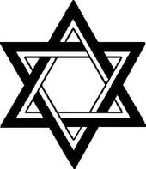
BOOKLET 2-JUDAISM
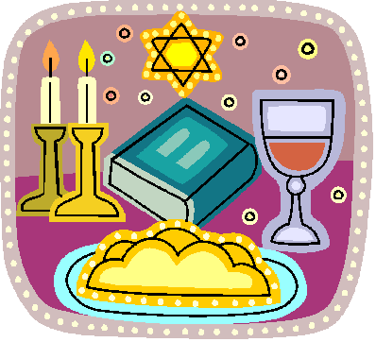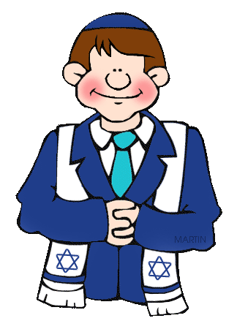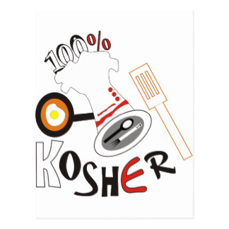
Name:
Beliefs
The concept of God
- Jewish belief in one, creative, omnipotent, omnipresent, omnibenevolent God (Gen 1:3-5, Ex 20:1-17)
- Belief in the teachings of the Shema, such as the concept of one God
- God as transcendent above and beyond all earthly things (Isaiah 55:8-9)
- God as eternal, merciful and a judge (punishes, rewards and forgives)
Practices that demonstrate beliefs about God
- Reciting the Shema in the morning and evening
- Reasons why God must not be depicted in art and sometimes his full name is not used (G-d)
- Reasons why kippah is worn
- Reasons why Jewish men (some Liberal Jewish women) wear tallith

KEY CONCEPTS – 12 key terms. Learn the meaning of each word. Question A in the exam. You should use some of these words in every answer.
Key Concept | Meaning/example?
Omnipotence | God is all-powerful e.g Creation of the world.
Orthodox | A Jew who keeps faithfully to the religion e.g study of the Torah, attend the synagogue daily, keep the Sabbath, religious festivals, and the food laws.
Aron Hakodesh | A cabinet with the Torah scrolls. The ark is the holiest place in the synagogue because it has the sacred writings of Judaism and it represents the original ark of the Jewish people.
Omni benevolence | All-loving and good e.g God.
Reform | A Jew who adapted from Orthodox Judaism to meet the demands of modern life, simplifying or rejecting traditional religious law and custom e.g keep some of the rules.
Rabbi | A spiritual leader within the Jewish community and a chief religious official of a Synagogue who delivers a sermon. A Jewish teacher; qualified to answer questions of Jewish law.
Shema | A prayer said twice a day showing Jewish faith – there’s only one God. It’s placed in the mezuzah and tefilin.
Shabbat | Jewish day of rest. Begins at sunset on Friday and end on nightfall on Saturday.
Kippah | A cap worn by Jewish boys and men (sometimes reform women) during services. Shows respect to God, reminds them of God’s presence.
Synagogue | A Jewish house of prayer and worship; an assembly or group of Jews worshipping; House of Law; School.
Kashrut | Jewish law dealing with what foods can and cannot be eaten e.g Kosher – fit to eat.
Ner Tamid | Everlasting light which burns above / in front of the Ark. Symbolises God’s everlasting presence.

Orthodox | Reform | Liberal | Secular
Keeps faithfully to the beliefs and practices. Live as close to the teachings of the Torah as possible e.g the 613 mitzvot. | Jewish law is given by God, but people can choose which laws to follow. Religion should move with the times. | Religion should fit into modern ways of thinking – up to the individual to make their own mind up. | Some Jews don’t believe in God. They are born to Jewish parents but don’t keep religious practices and teachings of Judaism. Many are proud to be Jewish and follow some traditions.

ONE GOD
Only One God should be worshipped.
The Shema says ‘Hear, Oh Israel: the Lord our God, the Lord is One.’
Maimonides said that there is no language to describe how unique God is.

God is Omnipotent – He created the world and has power and control over it.

God is Omnibenevolent – God is a God of justice. God rewards and punishes. God is all-loving and good.

God is Omnipresent – God is everywhere. He’s always close to people.

In the Torah, God commands that no Jew shall make an image of God: “You shall not make for yourself an image in the form of anything… You shall not bow down to them or worship them…” (Exodus)
There are no images of God in Synagogues, only letters of the Hebrew alphabet.
Some strict Jews use the word Hashem or write the word G-d instead of ‘God’.

WHAT DO JEWS BELIEVE ABOUT GOD?

AS LAWGIVER
- Jews believe that God gave laws and rules for all Jews to keep in order to have a fair society.
- Jews have 613 Mitzvot which they must keep.
- The Mitzvot deal with worship, keeping festivals and issues such as divorce and food. By keeping the Mitzvot, Jews are worshipping God.
- God gave the Ten Commandments – a framework for a just/good society.

GOD AS CREATOR
- The Torah tells us that God created the world: 'In the beginning God created the heaven and earth.’ God created day and night, the world, flowers, animals. Sixth day he created human beings and gives them responsibilities - to look after his creation (be good stewards):“So God created mankind in his own image… God blessed them and said to them, “Be fruitful and increase in number...” (Genesis 1.)
- God is responsible for creating everything on earth.
- For many Jews, the world is too complex and beautiful to have been created by accident, so it must have had a creator.
- Jews celebrate Shabbat to celebrate the creation.

- GOD AS JUDGE
- God who will judge every person.
- God will always be fair.
- God does not enjoy judging people wrongly so every judgement is made justly.
- The festival of Rosh Hashanah celebrates the creation of the world and God will judge everyone during this festival.
- They believe God comes with scales to weigh the Mizvot in every person. He will put their good deeds on one side and their bad deeds on the other.
- As God is a just God, Jews have 10 days between Rosh Hashanah and another festival called Yom Kippur (Day of Atonement) where they have a chance to apologise for the bad things which they have done and ask for forgiveness.

“For my thoughts are not your thoughts, neither are your ways my ways,” declares the Lord. “As the heavens are higher than the earth, so are my ways higher than your ways and my thoughts than your thoughts.”

Isaiah 55:8-9
THE SHEMA
- A special prayer is recited twice a day - every morning and every evening.
- This prayer shows the belief in one God and confirms their belief in him too.
- It commands Jews to worship God.
- The Shema should be passed from generation to generation.
- In the synagogue Jews will recite the prayer making sure that every word is pronounced clearly and they cover their eyes with their right hand.
“Here Israel! The LORD our God, the Lord is one. You are to love the LORD your God with all your heart, and with all your soul and all your power.”
- First section of the prayer - God insists that his people obey him with all their heart.
- God is the God of the Jewish people.
- Jews should love God.
- Jews should recite the prayer whilst standing and facing Jerusalem.
- The Shema is a morning and evening prayer, which can be recited in the home or in the Synagogue and the prayer is recited as the Torah scroll is taken out of the ark (in the Synagogue) on the Sabbath and other important festivals.
- Jews recite the Shema on his death-bed or anyone else who is present can recite the prayer and help the dying Jew to declare their faith in God.
- The command to recite the Shema does not apply to women, but some do retie it.
- Parents will teach their children to recite the Shema.
- Important to recite the Shema because – God commands it; it’s tradition; ensures continuation of Judaism.

ITEMS WORN FOR WORSHIP?
Many Jews believe that they have a duty to wear certain items for worship.
KIPPAH
- Cap worn by Jewish boys and men (sometimes women) during services.
- Reminder of God’s presence.
- Show respect to God.
- Show’s Jewish identity.

TALLITHm = Prayer shawl
- Fringed shawl worn during morning prayers.
- The tzizit (tassels) represent the 613 mitzvot given by God to the Jews.
- The tziizit reminded Jews that God is the lawgiver.
- Tzizit – 4 corners of the tallith worn during services in the synagogue.
- Men wear the tallith for worship, but some Reform women will wear the tallith for worship.
THE SYNAGOGUE
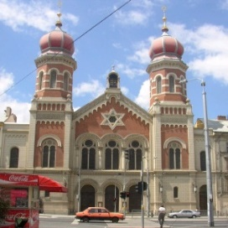
Sacred place and Worship in the synagogue
- The synagogue: a place for prayer, study, celebration, and assembly
- Differences in tradition: Orthodox, Reform, Liberal
- The importance of the synagogue: internal features- aron hakodesh, ner tamid, bimah, Torah, Ten Commandments, seating
- Reading of the Torah during synagogue worship
- Diverse practices within Orthodox and Reform synagogues – worship and the role and gender of the Rabbi

What is a Synagogue?
- A Jewish place of worship, and means ’to come together’ or ‘assembly’.
- Synagogues usually offer 3 services a day.
- Special services will be held during festivals e.g. Shabbat.
- Within Orthodox, 10 men must be present to conduct a service known as the MINYAN.
- Many will attend regularly, whilst others only on certain times of the year e.g. Yom Kippur.
Bet Midrash /Shul  School 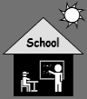 | Library, Torah study, children are taught religious education, learn Hebrew.
Bet Tefillah  House of Prayer 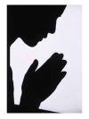 | Community prayer services. Prayer with 10 adult men – Minyan. Orthodox – go to the synagogue each evening to pray.
Bet Din  House of Law  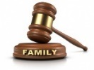 | Advice by Rabbi e.g Kashrut laws; divorce.
Bet Knesset  A meeting place | Celebrate festivals,  Social activities – coffee mornings. Rites of passage e.g Bar Mitzvah, wedding
- Normally built facing Jerusalem. This is where the Temple was, and the Western wall of the Temple still remains.

Features inside a Synagogue
Feature |  | Purpose
Ark /  Aron Hakodesh | 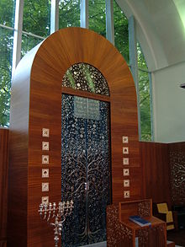 | A cupboard which keep the Torah scrolls. Some will close with a decorated curtain/doors. During certain prayers, the doors and curtain of the ark may be opened or closed e.g. open during Yom Kippur. It is the most important feature within the Synagogue. The ark faces Jerusalem.
Bimah | 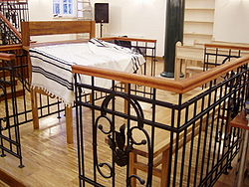 | A raised platform / reading desk  It’s in the centre of the Synagogue (Orthodox) so that everyone can see and hear as this is where the Torah is read, by members of the congregation or the Rabbi. The Torah scroll will be brought from the ark to the Bimah during services.
Ner Tamid | 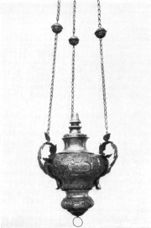 | Everlasting light  In front and above the aron hakodesh, the light represents Gods everlasting presence; God is with them at all times. This is kept burning/lit. It reminds the Jews of the Menorah that was used to light the Temple.
Torah | 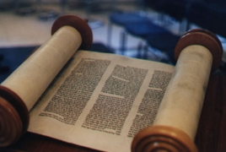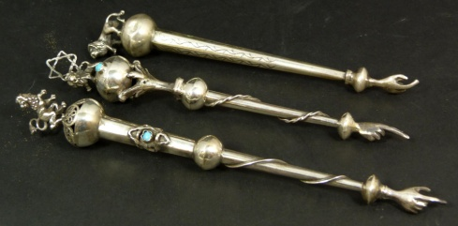 | The Torah scrolls are the most sacred part of any synagogue. They are made from kosher animal skin and are hand written by a scribe. It contains the Five Books of Moses and are read during services. Different ones are used for different services e.g. one for Shabbat service (sidra). It’s so holy that one must not touch the scroll, therefore Jews will use a yad (pointer) to read from the Torah.
Ten Commandments | 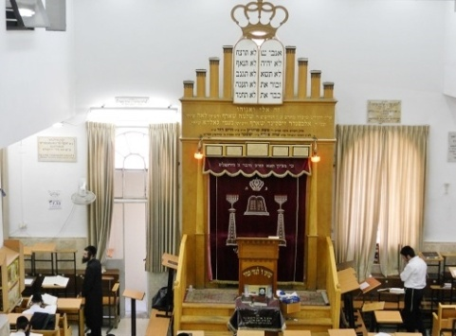 | Jews believe that God gave to Moses the duties that are expected of all Jews. These are in the Torah. The Ten Commandments are a framework of how society should behave. They should be kept by every Jew. They are important to Jewish beliefs and practice. The 10 Commandments are part of the 613 Mitzvot that should be kept.  First 4 = people’s duties to God. E.g. “Remember the Sabbath, and keep it holy.”  The other 6 = deal with how people should treat one another e.g. “Do not steal” “Do not kill”.
Seating | 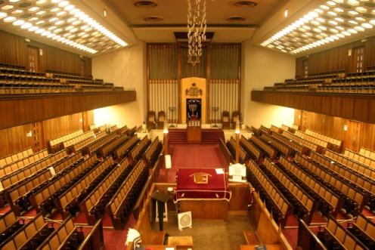 | Women will sit apart from the men in an orthodox synagogue. In a women’s gallery on the first floor, or a separate section if only one level. This is to make sure that the men are not distracted during services, worship and prayer. Women only have to keep the negative mitzvoth, therefore does not have to take part in services of worship). The men will sit on the ground floor to take part in the services. By sitting away from the women and children they can concentrate on the worship/ service.  **Reform synagogue-men and women sit together**

Reading of the Torah during Synagogue worship

What is the Torah?
- The Torah is the first part of the Jewish Bible.
- Torah= the five books of Moses which are Genesis; Exodus; Leviticus; Numbers and Deuteronomy.
- Jews believe that God gave the Torah to Moses on Mount Sinai.
- They believe that the Torah shows how God wants Jews to live. It contains 613 commandments.
- The Torah is written in Hebrew.
- The word Torah has various meanings - teaching, instruction, and law.
- One portion of the Torah is read every week at the Shabbat service. It takes a year to read the Torah.

Use of the Torah during services
- The Torah reading service begins when a Jew is given the honour of opening the Ark and taking out the Torah, with respect. The Torah scrolls are taken out from the Ark (Aron hakodesh) and portions read in the synagogue three times each week. The main reading is on the morning of Shabbat (Sabbath).
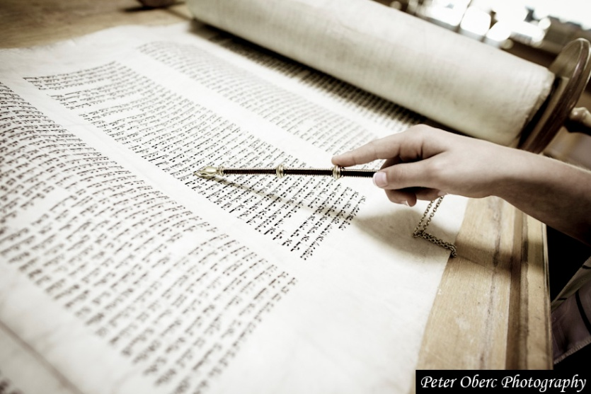
- The Torah is taken to the Bimah.

- As the Torah Scroll passes, members of the congregation kiss it or try to touch it with their Tallit as a sign of love and respect.

- The scrolls are not touched once placed on the Bimah. A pointer or Yad (hand) is used instead. This is in the shape of a hand with an outstretched finger. The reading or chanting is performed by a person who has been trained in this task. It may be carried out by the rabbi. It’s a great honour for a member of the congregation to read during a synagogue service. This is called Aliyah which is Hebrew for going up.
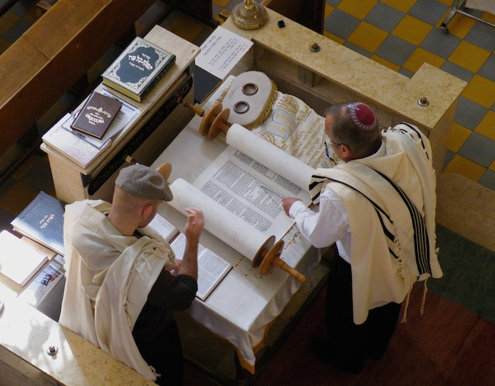

The Torah will be read during: -

1 | Daily services | Usually 3 times a day.
2 | Festivals | Shabbat; Rosh Hashanah; Yom Kippur; Pesach.  The readings will be relevant to the occasion e.g. on Shabbat they will read parts of the Torah remembering God creating the world in 6 days and resting on the 7th day.
3 | Rites of passage | Brit Milah; Bar/Bat Mitzvah. E.g. the boy will read a passage from the Torah during his Bar Mitzvah as he is now Son of the Commandment.

Diverse practices within Orthodox and Reform synagogue
Judaism is a diverse religion. Practices and traditions vary from one Jew to another. There are differences between the same group e.g maybe 2 ‘orthodox’ Jews might do things very differently!
Differences between orthodox and reform worship:

Orthodox | Reform
Seating  Men & women sit apart | Seating  Men & women can sit together
Language  Mostly in Hebrew | Language  Mostly in the local language, and perhaps some in Hebrew.
Dress  Formal; women dress modestly; men wear kippah/tallit/teffilin. | Dress  Casual; optional to wear prayer shawl/teffilin.
Rabbi  Men only! | Rabbi  Men or women!
Music  No music! | Music  Music allowed – used often; sometimes cantor will use instrumental whilst chanting prayers.
Length of services  Tend to be quite long e.g. Shabbat service on a Saturday morning can be up to 4 hours long! | Length of services  Shorter services.
Services  Will generally have daily services & services during festivals e.g Shabbat | Services  Many do not hold daily services, just for Shabbat and major festivals e.g Yom Kippur.
Shabbat service  Will hold a service Friday evening – start time vary due to time of sunset. Will also have a lengthy Saturday morning service. | Shabbat service  Will hold a service Friday evening. Generally, no Saturday morning service.

RABBI
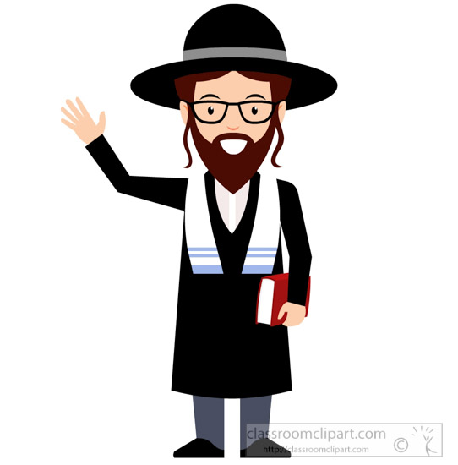
- A religious teacher/leader.
- Makes decisions on Jewish law.
- Often leads worship in the synagogue.
- Takes charge of the synagogue.
- Teach and gives religious guidance/offers advice. Leads services e.g Shabbat/festivals.
- Reform synagogues – allow men and women to be rabbis.
- Orthodox synagogues in Britain - only men are allowed to be rabbis. (In America, some female rabbis).

Worship in the home
- The importance of the home for worship in Judaism: challenges and benefits of observing Shabbat (Exodus 20:8-10)
- Observing kashrut (kosher, treifa, parev, shechitah)
- Separation of milk and meat in a kosher kitchen (Leviticus 11:1-24, Exodus 23:19)

IMPORTANCE OF THE HOME
- After the destruction of the Temple, worship moved from the Temple to the home and the synagogue.
- The home was regarded as a 'small sanctuary' or 'small temple.'
- The home became part of religious activities like Shabbat.
- Everything which takes place in the home reminds the Jews of God.
- The main events of Jewish life are prepared or held in the home e.g circumcision, mourning practices, festivals.
- Jewish children are educated in the home.
- Children can learn in several ways, such as copying or repeating what their parents do - kedusha.
- In the home parents to teach their children the history of the religion e.g. the Holocaust.
- Jewish values and beliefs are taught.
- Jewish identity is shaped.
- Worship and prayer takes place at the home.
- Recite the Shema every day at home.
- Keep kashrut.
- Mezuzah on the front door post – God’s protection of the house.

Observing Shabbat: Exodus 20:8-10
‘Remember the Sabbath day, by keeping it holy... the Lord blessed the Sabbath day and made it holy.’
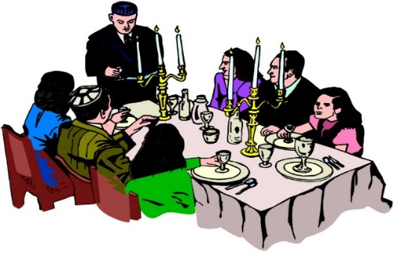
What is Shabbat?
- Every week Jews observe a holy day called Shabbat.
- Shabbat is the most holy day, apart from Yom Kippur.
- Shabbat is a day of complete rest.
- It’s a day which is given to studying the Torah, praying, and spending valuable time with the family.
- Remind Jews of creation.
- In the Talmud, God told Moses, “I have an important gift in my treasury, its name is ‘Saboth’. Go and tell the Israelites that I wish to give it to them”. It’s a gift given by God.
- It’s a chance “…to rest from the burden of work in order to gain some information and pray some more, and to enable people to meet and discuss …” – this is the Shabbat.

When is Shabbat celebrated? Shabbat begins at sunset on Friday evening … … and continues until three stars appear in the sky on Saturday night.
Preparations before Shabbat:
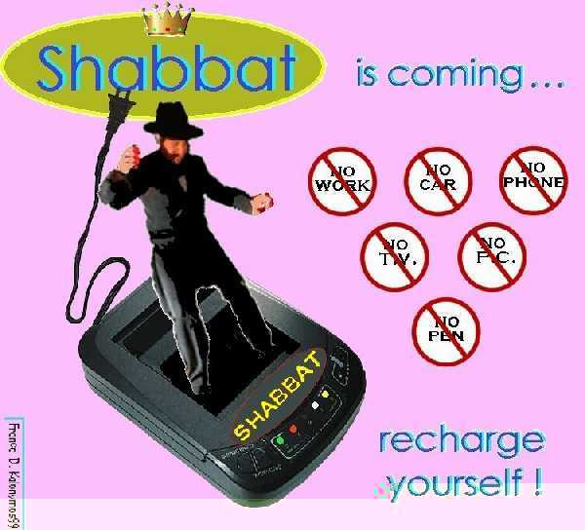
- All the preparations must be made as no Jews can do any work during Shabbat itself e.g shopping or cooking.
- The best crockery and dishes will be taken out.
- The table will be laid, remembering the candlesticks, the challot and the wine.
- The house must be cleaned and tidied.
- Television and other electrical items will be covered as the use of electricity is not allowed during Shabbat.
- Jews will wash to be pure.
- Wear their best clothes in order to be ready to welcome Shabbat.

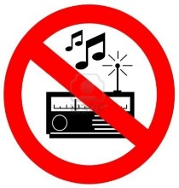
The 39 Melachot
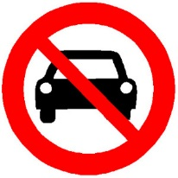
During Shabbat, Jews are not allowed to do any work (unless lives are in danger). These rules have been adapted to suit modern life today. On Shabbat there are 39 melachah which are forbidden e.g. driving a car, using electricity, carrying objects from a private place to a public place (and vice versa), cooking and writing.

Why are Jews not allowed to work?

By not working or using any energy during Shabbat, Jews have a chance to enjoy themselves in ways which are different to other days of the week. It’s time for the family to spend time together in order to help keep Jewish families close.

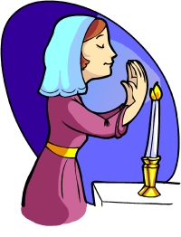
Friday evening: Welcoming Shabbat
The mother welcomes Shabbat to the home.

Before sunset on Friday evening, the mother will light two candles. She will do this just before the sun sets as Jews are not permitted to light a fire on Shabbat itself.

She lights two candles to represent the two commandments in the Torah, which are:

“Remember the Sabbath day” and “Observe the Sabbath day”

She will make a gesture with her hands as though she was welcoming Shabbat into her home, cover her eyes with her hands, say a blessing in Hebrew, say a short prayer on behalf of her family.

This will be a holy time for the family, and after this, Shabbat has arrived.

After welcoming Shabbat ...
- After welcoming Shabbat into the home, the Jewish men will walk to the Synagogue for afternoon prayers.
- At the end of the service the Rabbi will take a cup of wine and say a blessing which gives thanks to God for giving Shabbat to Jews. This blessing is called kiddush.
- Before leaving the Synagogue, Jews will shake hands and wish each other a Shabbat Shalom (peaceful Shabbat).

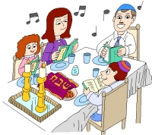
Friday night meal
After returning home from the synagogue, the father will
- Sit with his family by the table
- Bless his children in Hebrew
- Recite the kiddush
- Nobody will eat from the moment Shabbat starts until they hear the kiddush.
- The father will bless the Challot which represents manna (the miraculous bread which the Israelis ate in the wilderness).
- The father will dip pieces of the Challot in salt (to remind them of the sacrifices which took place in the Temple long ago) before sharing them.
- Then the meal will begin. This is a special meal as the Jews eat special foods and sing between the courses, stories from the Torah are read.
- It is a relaxed and slow meal and a special time for the family to enjoy time together.

Saturday morning during Shabbat
In the synagogue ...
- The service in the Synagogue lasts longer than the usual weekly service.
- The Rabbi will read a special part of the Sefer Torah called the Sidra.
- During Sidra, 8 men are called to say blessings at particular times. The 8th man will read the haftarah.
- Invited speakers will then say some words and the Rabbi will use this opportunity to encourage Jews to keep Judaism or will teach them something new.
- Before leaving the Synagogue, everyone will wish each other ‘Shabbat Shalom’ once more.

In the home ...
- After arriving home, the family will have another meal, similar to the Friday evening meal.
- The father will recite kiddush and will bless the challot, but will not bless the children.
- After the meal, Jews will entertain themselves, making sure they keep to the 39 melachot.
- Later in the afternoon, the Jewish men will walk to the Synagogue. They will read the first part of the previous week’s sidra from the sefer Torah then will study until it gets dark.

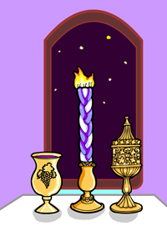
The end of Shabbat ...Shabbat ends when 3 stars appear in the sky on Saturday night.
- A special service will be held in the Synagogue.
- The congregation will recite the prayers of the week and ask for God’s blessing for the following week.
- At the end of the service the rabbi will perform havdalah (separation), a ceremony to mark the end of the holy day. He will bless a cup of wine and spices. He will give a third blessing over candlelight to show that Jews are relighting the fire once more. He blesses the wine once more and the holy day is separated from the ordinary day.
- As soon as the father returns from the synagogue he will also perform havdalah.
- Following this, Jews can begin to use electricity etc.

‘CELEBRATING SHABBAT IS TOO MUCH TROUBLE.’

Agree | Disagree
Possibility that the true meaning will be lost as it happens too often | Opportunity for the family to spend time together
Perhaps people see it as a burden every week | Opportunity to rest every week
The preparations for celebrating Shabbat take a lot of time e.g cleaning the house and preparing food | An opportunity to worship God and study the Torah
It happens every week so maybe people do not enjoy celebrating it | It is one of God’s commands and so Jews should be happy to celebrate it every week
There are other festivals which the Jews could set aside to worship God e.g Pesach | A chance to think about God every week and take time from their busy lives
It is not possible for us to set aside a whole day of rest in our society today | A way to pass on traditions from one generation to the next

Jewsish views
- One of the 10 Commandments
- Gift from God
- Emulates God resting on the 7the day after creating the world.
- Keep to the covenant.
- Mitzvot.
Differences between the practices and opinion of Orthodox and Reformed Jews regarding observing Shabbat

- Shabbat is important to many non-religious Jews as well as religious Jews.
- Orthodox Jews keep to all the rules which mean it is not permitted to do any work unless it’s a matter of life and death.
- Orthodox Jews and Reform Jews tend to follow the original rule in Exodus which is ‘do not work’ and regard it as a day of rest rather than a day to avoid doing particular activities.
- For non-Orthodox Jews (Reform, Liberal) Shabbat is a day for staying home from work but the use of technology is allowed.
- Jews disagree about whether or not it’s acceptable to drive a car to the synagogue. Driving a car involves creating a spark, or lighting a fire, which is regarded as ‘work’, but many Reform Jews argue that ‘work’ which helps to make Shabbat more holy (e.g. in order to go to the synagogue) is acceptable and can be justified.
- Many Reform Jews believe that speaking to friends/family on the phone or even driving a car to see them is acceptable.
- Many Orthodox Jews will switch the phone off or pull plugs from the socket to obey the rules.

Why do Jews observe Shabbat? The importance of observing Shabbat
- Jews remember and celebrate God’s creation of the world. When they rest, they follow the same pattern as God because God also rested on the 7th day after creating the world.
- The Ten Commandments say that they must keep the Sabbath-‘Remember the Sabbath day by keeping it holy’ (Exodus). It’s one of the 613 mitzvot which Jews keep as part of their Covenant with God.
- Jews remember the time when they were slaves of the Pharoah in Egypt and so they celebrate Shabbat every week in order to celebrate their freedom to rest today.
- Shabbat is a time for relaxing and spending valuable time with the family as family unity is very important to Jews. It unites Jews as families and socially, historically, and geographically.
- According to many Jews, Shabbat is the most important ‘festival’ or day of the year.
- Shabbat is regarded as a gift from God when the problems of the week can be forgotten.
- Even during times of Jewish persecution, Jews would make every effort to celebrate Shabbat as it was so important to them.
- Observing Shabbat is a part of Jewish identity and has helped to keep the religion alive.

Challenges to observing Shabbat in the modern world
- Some Jews believe that keeping all the rules go against the nature and meaning of Shabbat.
- It means making a great effort that they do not do any sort of ‘work’ – a lot of preparations beforehand. This means that Shabbat can be more trouble that it is worth.
- Jews are not permitted to use a car on the Shabbat and this is a problem for Jews who do not live near a synagogue and for other social reasons.
- Some would say that Shabbat is boring and repetitive because it happens every week. It loses its worth and status as it happens too often.
- It’s not easy for Jews to socialise with non-Jewish friends during Shabbat even though the weekend is a convenient time for them to meet.
- Jews must come home from school or work early in the winter to prepare for and welcome Shabbat. This means that children will miss out on their education and it could be difficult for a Jew to find a job which offers flexible hours or which allows them to leave work early.

Kashrut: Jewish rules about food
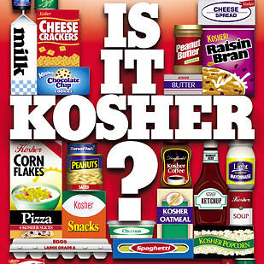
Kosher – Meaning = ‘correct’ or ‘suitable’. Foods which Jews are permitted to eat.
Treifa – Meaning = ‘broken’. Foods which Jews are not permitted to eat.
Parev - ‘neutral’ foods. Jews are permitted to eat these with meat or milk e.g veg, fruit, eggs. They do not contain meat or dairy.
Shochet – a Jewish butcher.
Shechitah – the Jewish way of slaughtering/killing an animal without pain.
Kashrut - Jewish food rules.
‘Observing kosher’ is an important part of Jewish culture which means that they are more than just religious rules, mitzvot.

Kosher animals - In order for the animal to be kosher is must have the following two features:
- Split hooves
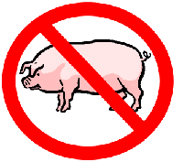
- It chews the cud* (*Cud is the name given on the small balls of grass which some animals form in their stomachs after grazing. They regurgitate the grass to their mouths and chew it a second time before digesting it).
- Kosher animals: beef and lamb. Treifa animals: pig (ham, bacon, pork). No shell-fish.

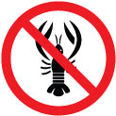
Kosher fish
In order for fish to be kosher they must have the following two features:
- fins
- Scales
- Kosher fish: Trout, salmon, tuna. Treifa fish: crab, lobster, prawns.

Kosher birds
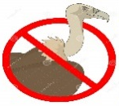
- A list of animals which Jews cannot eat is given in the Torah. Many are birds of prey.
- Examples of kosher birds: chicken, turkey. Examples of treifa birds: eagle, vulture.
- A Kosher animal/bird can be treifa if there’s something wrong with its internal organs.

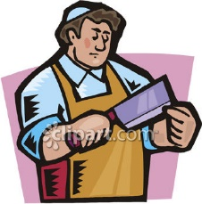
Shechitah: The Jewish way of slaughtering animals
- To be Kosher, animals and birds must be slaughtered in a particular way and the name of this method is Shechitah carried out by a trained butcher (shochet).
- Quick incision across the throat using a very sharp knife. The knife cuts smoothly through the vein which lowers the blood pressure in the brain and the animal is unconscious immediately. The animal is already dead.
- The blood must be drawn out, in 4 stages which include:
1. Soaking the meat in water for 30 minutes
2. Keeping the meat separately on thin boards so that the blood can flow away
3. Covering every part of the meat with salt for an hour
4. Rinsing the meat to get rid of the salt to carry out God’s will, because ‘the blood is the life.’

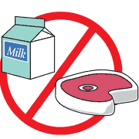
Separating meat and dairy in a kosher kitchen
‘Do not cook a young goat in its mother’s milk.’ Exodus 23:19
Over the years, Jews have interpreted this above rule from the Torah to mean that Jews who keep kosher homes should not eat meat and dairy products together.
Mixing meat and dairy products
- Jews do not eat meat and dairy products together in the same meal.
- They must be kept apart when eating, preparing food and kept apart in the kitchen.
- Different crockery and cutlery are used, and these are washed and dried in a separate bowl and using different tea towels.
- They must wait a few hours after eating meat before eating anything which milk, and around half an hour before eating meat after eating dairy products.
- If meat or dairy products are mixed Jews ask for the advice of the rabbi, who decides if the food and equipment are still kosher.
Buying kosher food
- Rabbis will show that the food is kosher using the label which is printed on the packet. This label is called hechsher.
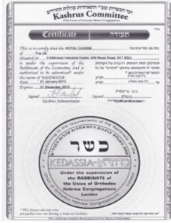
- Today, food carry the hechsher label e.g sweets, chocolate, soup, margarine, oil, biscuits, butter, and cheese.
- Most of these foods are produced in Israel or the USA.
- It’s easier to keep a kosher home today than at any other time in the past.
- The kosher butcher shop will show the licence given by the rabbis.
- They often send inspectors out to look at the shop.
- If the butcher is selling food which is not kosher, then the shop will lose its licence.

The importance of observing Kashrut
- A command from God (mitzvah). According the Orthodox Jews, God’s Word is the Torah. What right do they have to choose and select which rules to keep?
- Judaism is a way of life – eating is part of everyday life.
- The home – the centre of the religion.
- Worshipping God on a basic level – thinking about God and respecting him even when eating.
- Show and keep their identity. It unites them as Jews, as God’s Chosen people. Promotes a feeling of unity and closeness.
- Practices self-discipline. Disciplines people towards the holiness of the Covenant. Set apart. ‘Holy = ‘apart’.
- Shows their belief in God and that they accept his demands.
- Shows that they belong to a group of special and different people. Feeling of belonging, as though they are part of a close family.
- Keeps the tradition. An important part of their heritage.

Different opinions between Orthodox Jews and Reformed Jews regarding observing Kashrut
- Orthodox Jews will keep a kosher kitchen but some Orthodox Jews will choose to be vegetarian in order to avoid the problem of having to have two sets of kitchen items; or if they choose to eat meat they will only do so in a kosher restaurant.
- Reform Jews will tend to stick to the rule of not mixing meat and dairy products, but not all believe that it is necessary that an animal is slaughtered in the shechitah method or that all the blood must be removed from a kosher animal.
- Most Reform Jews do not believe that they must have the seal of approval of rabbis for parev foods and fruit and vegetables.
- Not every Reform Jew is overly concerned with eating foods which have been prepared by non-Jewish people using non-kosher saucepans, cutlery etc.
- Orthodox Jews believe that no meal can be kosher if it’s been prepared by a non-Jew.
- For many secular and Reform Jews, observing kosher has more to do with being faithful to Jewish traditions rather than keeping strictly to the mitzvot in the Torah.
- Many Orthodox Jewish practices go beyond the words of the Torah but Reformed Jews would argue that the Torah could be interpreted in different ways.
- Secular and Reform Jews could argue that kashrut rules were not divine rules originally, but were introduced for health and safety reasons e.g. drawing the blood from meat and salting it are ways of preserving it and keeping it fresh, and checking fruit and vegetables for insects and bugs is a sensible idea!
- The morality of shechitah is a debatable issue in Judaism. While some Jews argue that it is important that they are given the right to use the shechitah method for religious freedom, others feel that civil authorities have a right to ban it for animal welfare reasons.

