Leadership Standards Self Review. LSSR
WG: Professional standards for teaching and leadership (9/2018)

Teachers (and leaders) exhibit high professional standards in values, dispositions and the practice of teaching.
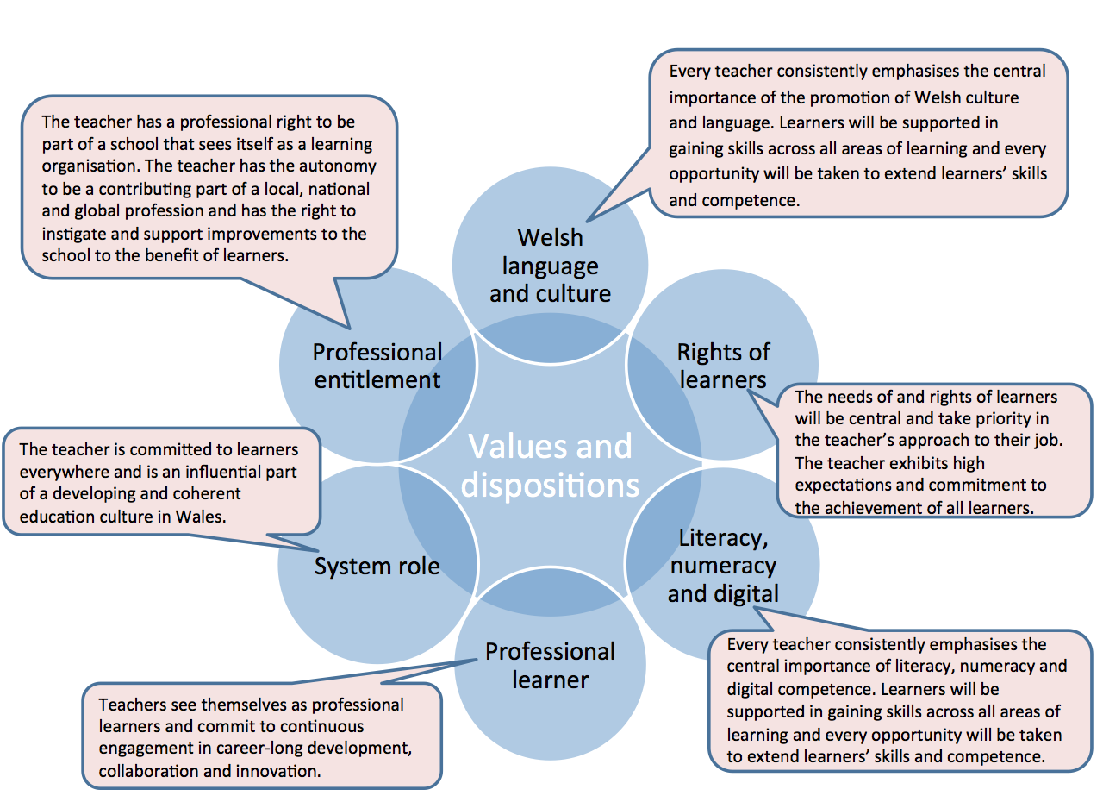

Descriptors for formal leadership roles (the five dimensions). My log / evidence to demonstrate development.
Word Count 3000 words excluding words currently in the document. (3397)
PEDAGOGY – ‘is paramount’
The teacher in a formal leadership role exercises accountability for the pedagogy of others by creating and sustaining the conditions to realise the four purposes
for learners and achieve the best for them in terms of standards, well-being in progress.

Refining teaching
Promoting the pedagogic vision for 2025
Sustaining highly effective teaching
Ensuring that strategy and infrastructure are fit for purpose
Creating the effective and inclusive learning environment
Advancing pedagogic approaches
Listening to learners
Advancing learning
Promoting Welsh language and culture
Ensuring the four for purposes for learners
Exploiting subject disciplines in areas of learning
Driving a real life authentic contexts
Using cross-curricular themes
Influencing learners
Accepting accountability for outcomes and learn well-being
Ensuring and protecting learner entitlement
Monitoring and evaluating impact
Reporting on effectiveness

COLLABORATION – ‘allows it to spread’
The teacher in a formal leadership role builds a climate of mutual support in which effective collaboration flourishes within and beyond the school to spread effective pedagogy.

Seeking advice and support
Sustaining a collaborative culture
Working productively with external agencies
Engaging with the widest school community
Enabling continuous improvement

PROFESSIONAL LEARNING – ‘takes it deeper’
The teacher in a formal leadership role stimulates an appetite for professional learning that is valued, has impact upon pedagogy and supports professional
growth across a learning community within and beyond the school

Wider reading and research outlooks
Professional networks and communities
Supporting growth and system-wide leadership
Supporting growth in others
Continuing professional learning for all staff

INNOVATION – ‘moves it forward’
The teacher in formal leadership role ensures a positive climate for innovation that is coherent and manageable and outcomes are evaluated, disseminated and applied.

Towards 2025
Developing new techniques
Seeking and extending best practice
Evaluating the impact of changes in practice

LEADERSHIP – ‘helps it grow’
The teacher in a formal leadership role works intelligently to bring coherence, clarity and a shared commitment to realizing the vision from pedagogy, learners,
colleagues and the wider community.

Promoting teaching and leadership in Wales
Exercising corporate responsibility in all colleagues
Empowering others
Delegation and empowerment
Supporting other settings

